**.NET Core**

**Xamarin Forms + Prism**

**Xamarin Classic + MVVM Cross**



**Soccer Example**

By Zulu

Medellín 2020

**Index**

**Soccer example: functionality matrix** **4**

**Create the Solution** **5**

**Web First Part** **8**

Create the Database 8

Modify DB 12

Add unique index 21

Upload Images and improve the Teams CRUD 22

Seed the DB with initial data 44

Adding a controller without wizard 61

Add User Identities 118

Implementing login and logout in Web 136

Add API 143

Publish on Azure 162

**App Xamarin Forms First Part** **166**

List the tournaments 167

Navigate to groups page 175

Show groups in a listview grouped 181

Show Matches 190

Add tabbed page 196

Add a Master Detail 207

Add SfBusyIndicator 217

Check the internet connection 220

Multi Language in Xamarin Forms 221

Adding Styles 241

Add Icon & Splash to Xamarin Forms 247

GIT Workshop 249

**Web Second Part** **251**

Redirect Pages 251

Self-registration of users 253

Modifying users 263

Languages for API messages 271

Add API for predictions 275

Add Tokens Generation 280

Confirm Email Registration 283

Password Recovery 292

Close match 299

Prepare the API for new functionality in App 310

Account 310

Predictions 322

Improve delete dialogs 329

**App Xamarin Forms Second Part** **332**

Login 332

Register users from App 356

Adding a picture to users 382

Recover Password From App in Xamarin Forms 390

Modify User From App in Xamarin Forms 399

Modify Password From App in Xamarin Forms 418

Make predictions 429

Show positions for tournament 468

Show my positions (in general) 480

Login with Facebook 490

Create a Facebook App 491

General Setup 499

Integration with Soccer App 505

Push notifications 525

Setup Android Services 525

Android Implementation 532

Create a notification dispatcher 545

Modify the backend to send notifications 548

Setup iOS Services 551

iOS Implementation 571

**End** **576**

# Soccer example: functionality matrix

|  |  |  |  |
| --- | --- | --- | --- |
| **Functionality** | **Web** | | **App** |
| **Admin** | **User** | **User** |
| Login | X | X | X |
| Register |  | X | X |
| Modify profile | X | X | X |
| Recover password | X | X | X |
| Admin managers | X |  |  |
| Admin competitions | X |  |  |
| Admin users | X |  |  |
| Admin teams | X |  |  |
| Show competitions | X | X | X |
| Make beats |  | X | X |
| Show results | X | X | X |
| Show positions | X | X | X |

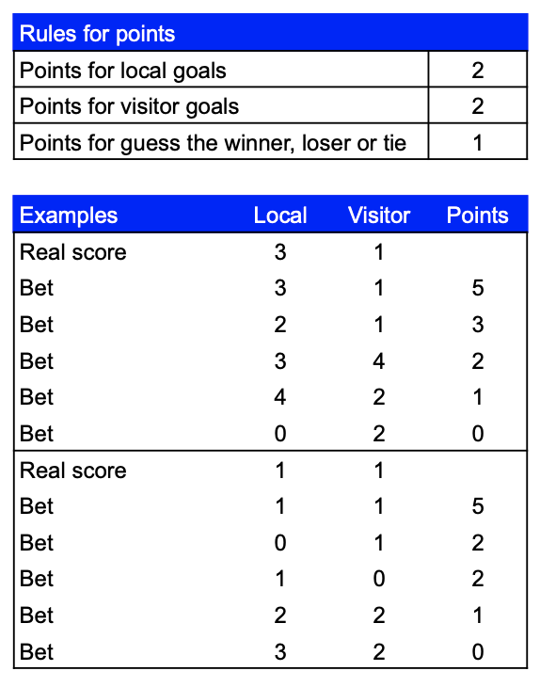

# Create the Solution

**Note:** all the code are in: <https://github.com/Zulu55/Soccer2>

Create the following solution:



In Visual Studio, you must build something similar to:

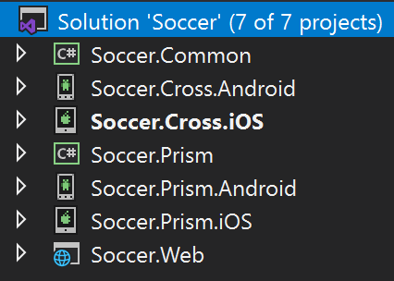

# Web First Part

## Create the Database



**Note**: in this project we’ll work with entity framework code first, if you want to work with EF database first, I recommend this article: <https://docs.microsoft.com/en-us/ef/core/get-started/aspnetcore/existing-db>

1. Create the **TeamEntity** class:

using System.ComponentModel.DataAnnotations;

namespace Soccer.Web.Data.Entities

{

public class TeamEntity

{

public int Id { get; set; }

[MaxLength(100, ErrorMessage = "The {0} field can not have more than {1} characters.")]

[Required(ErrorMessage = "The field {0} is mandatory.")]

public string Name { get; set; }

[Display(Name = "Logo")]

public string LogoPath { get; set; }

}

}

1. Create the **DataContext** class:

using Microsoft.EntityFrameworkCore;

using Soccer.Web.Data.Entities;

namespace Soccer.Web.Data

{

public class DataContext : DbContext

{

public DataContext(DbContextOptions<DataContext> options) : base(options)

{

}

public DbSet<TeamEntity> Teams { get; set; }

}

}

1. Add the connection string to the configuration json file: **appsettings.json** (see the SQL Server Object Explorer):

{

"Logging": {

"LogLevel": {

"Default": "Warning"

}

},

"AllowedHosts": "*",

"ConnectionStrings": {

"DefaultConnection": "Server=(localdb)\\MSSQLLocalDB;Database=Soccer;Trusted_Connection=True;MultipleActiveResultSets=true"

}

}

**Note**: You must be sure of the servers names in your installation, you can check it out by clicking in SQL Server Object Explorer:

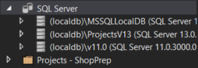

In this case, there are three available servers: (localdb)\MSSQLLocalDB, (localdb)\ProjectsV13 and (localdb)\v11.0. Or you can explore your server by clicking on “Add SQL Server” icon:

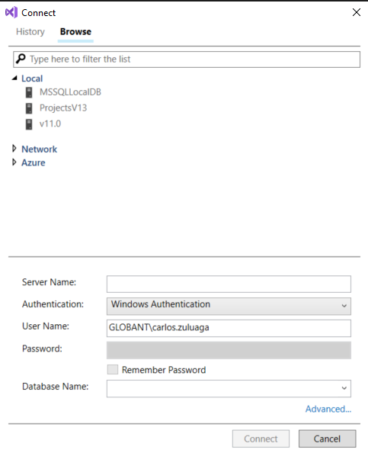

1. Add the database injection in **Startup** class

public void ConfigureServices(IServiceCollection services)

{

services.Configure<CookiePolicyOptions>(options =>

{

options.CheckConsentNeeded = context => true;

options.MinimumSameSitePolicy = SameSiteMode.None;

});

services.AddDbContext<DataContext>(cfg =>

{

cfg.UseSqlServer(Configuration.GetConnectionString("DefaultConnection"));

});

services.AddMvc().SetCompatibilityVersion(CompatibilityVersion.Version_2_1);

}

1. Save changes and run those commands by command line in the same folder that is the web project:

PM> add-migration InitialDb

PM> update-database

1. Add the Teams menu and test the DB connection.

<ul class="nav navbar-nav">

<li><a asp-area="" asp-controller="Home" asp-action="Index">Home</a></li>

<li><a asp-area="" asp-controller="Home" asp-action="About">About</a></li>

<li><a asp-area="" asp-controller="Home" asp-action="Contact">Contact</a></li>

<li><a asp-area="" asp-controller="Teams" asp-action="Index">Owners</a></li>

</ul>

## Modify DB

We will complete the DB initially with these entities and relationships:



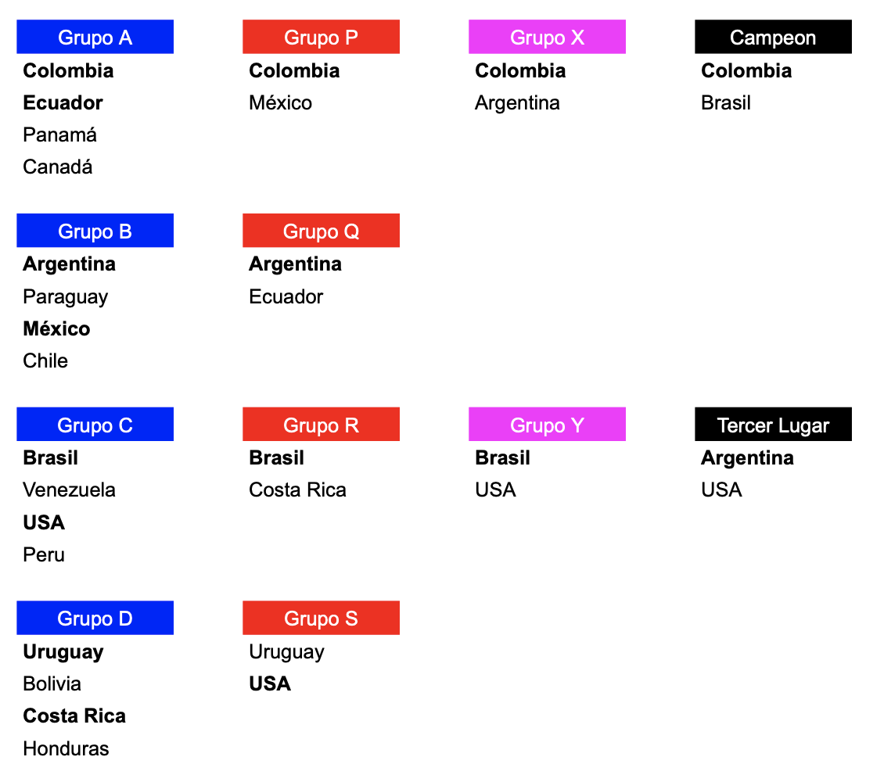

1. Add the **TournamentEntity**:

using System;

using System.ComponentModel.DataAnnotations;

namespace Soccer.Web.Data.Entities

{

public class TournamentEntity

{

public int Id { get; set; }

[MaxLength(100, ErrorMessage = "The {0} field can not have more than {1} characters.")]

[Required(ErrorMessage = "The field {0} is mandatory.")]

public string Name { get; set; }

[DataType(DataType.DateTime)]

[Display(Name = "Start Date")]

[DisplayFormat(DataFormatString = "{0:yyyy/MM/dd}", ApplyFormatInEditMode = false)]

public DateTime StartDate { get; set; }

[Display(Name = "Start Date")]

[DisplayFormat(DataFormatString = "{0:yyyy/MM/dd}", ApplyFormatInEditMode = false)]

public DateTime StartDateLocal => StartDate.ToLocalTime();

[DataType(DataType.DateTime)]

[Display(Name = "End Date")]

[DisplayFormat(DataFormatString = "{0:yyyy/MM/dd}", ApplyFormatInEditMode = false)]

public DateTime EndDate { get; set; }

[Display(Name = "End Date")]

[DisplayFormat(DataFormatString = "{0:yyyy/MM/dd}", ApplyFormatInEditMode = false)]

public DateTime EndDateLocal => EndDate.ToLocalTime();

[Display(Name = "Is Active?")]

public bool IsActive { get; set; }

[Display(Name = "Logo")]

public string LogoPath { get; set; }

}

}

1. Add the **GroupEntity**:

using System.ComponentModel.DataAnnotations;

namespace Soccer.Web.Data.Entities

{

public class GroupEntity

{

public int Id { get; set; }

[MaxLength(30, ErrorMessage = "The {0} field can not have more than {1} characters.")]

[Required(ErrorMessage = "The field {0} is mandatory.")]

public string Name { get; set; }

public TournamentEntity Tournament { get; set; }

}

}

1. Modify the **TournamentEntity**:

[Display(Name = "Is Active?")]

public bool IsActive { get; set; }

public ICollection<GroupEntity> Groups { get; set; }

}

1. Add the **GroupDetailEntity**:

using System.ComponentModel.DataAnnotations;

namespace Soccer.Web.Data.Entities

{

public class GroupDetailEntity

{

public int Id { get; set; }

public TeamEntity Team { get; set; }

[Display(Name = "Matches Played")]

public int MatchesPlayed { get; set; }

[Display(Name = "Matches Won")]

public int MatchesWon { get; set; }

[Display(Name = "Matches Tied")]

public int MatchesTied { get; set; }

[Display(Name = "Matches Lost")]

public int MatchesLost { get; set; }

public int Points => MatchesWon * 3 + MatchesTied;

[Display(Name = "Goals For")]

public int GoalsFor { get; set; }

[Display(Name = "Goals Against")]

public int GoalsAgainst { get; set; }

public int GoalDifference => GoalsFor - GoalsAgainst;

public GroupEntity Group { get; set; }

}

}

1. Modify the **GroupEntity**:

public TournamentEntity Tournament { get; set; }

public ICollection<GroupDetailEntity> GroupDetails { get; set; }

}

1. Modify the **TeamEntity**:

[Display(Name = "Logo")]

public string LogoPath { get; set; }

public ICollection<GroupDetailEntity> GroupDetails { get; set; }

}

1. Add the **MatchEntity**:

using System;

using System.ComponentModel.DataAnnotations;

namespace Soccer.Web.Data.Entities

{

public class MatchEntity

{

public int Id { get; set; }

[DataType(DataType.DateTime)]

[DisplayFormat(DataFormatString = "{0:yyyy/MM/dd hh:mm}", ApplyFormatInEditMode = false)]

public DateTime Date { get; set; }

public DateTime DateLocal => Date.ToLocalTime();

public TeamEntity Local { get; set; }

public TeamEntity Visitor { get; set; }

[Display(Name = "Goals Local")]

public int GoalsLocal { get; set; }

[Display(Name = "Goals Visitor")]

public int GoalsVisitor { get; set; }

[Display(Name = "Is Closed?")]

public bool IsClosed { get; set; }

public GroupEntity Group { get; set; }

}

}

1. Modify **GroupEntity**:

public ICollection<GroupDetailEntity> GroupDetails { get; set; }

public ICollection<MatchEntity> Matches { get; set; }

}

1. Update the **DataContext**:

using Microsoft.EntityFrameworkCore;

using Soccer.Web.Data.Entities;

namespace Soccer.Web.Data

{

public class DataContext : DbContext

{

public DataContext(DbContextOptions<DataContext> options) : base(options)

{

}

public DbSet<GroupDetailEntity> GroupDetails { get; set; }

public DbSet<GroupEntity> Groups { get; set; }

public DbSet<MatchEntity> Matches { get; set; }

public DbSet<TeamEntity> Teams { get; set; }

public DbSet<TournamentEntity> Tournaments { get; set; }

}

}

1. Save all and run this commands:

PM> add-migration TournamentEntities

PM> update-database

1. Test it.

## Add unique index

1. Add this method to **DataContext**:

protected override void OnModelCreating(ModelBuilder builder)

{

base.OnModelCreating(builder);

builder.Entity<TeamEntity>()

.HasIndex(t => t.Name)

.IsUnique();

}

1. Add the migration, update the database and test it.
2. Modify those methods on **TeamsController**:

try

{

await _context.SaveChangesAsync();

return RedirectToAction(nameof(Index));

}

catch (Exception ex)

{

if (ex.InnerException.Message.Contains("duplicate"))

{

ModelState.AddModelError(string.Empty, "Already there is a record with the same plaque.");

}

else

{

ModelState.AddModelError(string.Empty, ex.InnerException.Message);

}

}

1. Test it.

## Upload Images and improve the Teams CRUD









1. Add the model **TeamViewModel**:

using Microsoft.AspNetCore.Http;

using Soccer.Web.Data.Entities;

using System.ComponentModel.DataAnnotations;

namespace Soccer.Web.Models

{

public class TeamViewModel : TeamEntity

{

[Display(Name = "Logo")]

public IFormFile LogoFile { get; set; }

}

}

1. Add the folder **Teams** on **wwwroot/images**
2. Add the interface **IImageHelper**:

using System.Threading.Tasks;

using Microsoft.AspNetCore.Http;

namespace Soccer.Web.Helpers

{

public interface IImageHelper

{

Task<string> UploadImageAsync(IFormFile imageFile, string folder);

}

}

1. Add the class **ImageHelper**:

using Microsoft.AspNetCore.Http;

using System;

using System.IO;

using System.Threading.Tasks;

namespace Soccer.Web.Helpers

{

public class ImageHelper : IImageHelper

{

public async Task<string> UploadImageAsync(IFormFile imageFile, string folder)

{

string guid = Guid.NewGuid().ToString();

string file = $"{guid}.jpg";

string path = Path.Combine(

Directory.GetCurrentDirectory(),

$"wwwroot\\images\\{folder}",

file);

using (FileStream stream = new FileStream(path, FileMode.Create))

{

await imageFile.CopyToAsync(stream);

}

return $"~/images/{folder}/{file}";

}

}

}

1. Add the injection on **Startup**:

services.AddDbContext<DataContext>(cfg =>

{

cfg.UseSqlServer(Configuration.GetConnectionString("SoccerConnection"));

});

services.AddScoped<IImageHelper, ImageHelper>();

services.AddMvc().SetCompatibilityVersion(CompatibilityVersion.Version_2_1);

}

1. Add the interface **IConverterHelper**:

using Soccer.Web.Data.Entities;

using Soccer.Web.Models;

namespace Soccer.Web.Helpers

{

public interface IConverterHelper

{

TeamEntity ToTeamEntity(TeamViewModel model, string path, bool isNew);

TeamViewModel ToTeamViewModel(TeamEntity teamEntity);

}

}

1. Add the class **ConverterHelper**:

using Soccer.Web.Data.Entities;

using Soccer.Web.Models;

namespace Soccer.Web.Helpers

{

public class ConverterHelper : IConverterHelper

{

public TeamEntity ToTeamEntity(TeamViewModel model, string path, bool isNew)

{

return new TeamEntity

{

Id = isNew ? 0 : model.Id,

LogoPath = path,

Name = model.Name

};

}

public TeamViewModel ToTeamViewModel(TeamEntity teamEntity)

{

return new TeamViewModel

{

Id = teamEntity.Id,

LogoPath = teamEntity.LogoPath,

Name = teamEntity.Name

};

}

}

}

1. Add the injection on **Startup**:

services.AddScoped<IImageHelper, ImageHelper>();

services.AddScoped<IConverterHelper, ConverterHelper>();

services.AddMvc().SetCompatibilityVersion(CompatibilityVersion.Version_2_1);

}

1. Modify the **TeamsController**:

using Microsoft.AspNetCore.Mvc;

using Microsoft.EntityFrameworkCore;

using Soccer.Web.Data;

using Soccer.Web.Data.Entities;

using Soccer.Web.Helpers;

using Soccer.Web.Models;

using System.Linq;

using System.Threading.Tasks;

namespace Soccer.Web.Controllers

{

public class TeamsController : Controller

{

private readonly DataContext _context;

private readonly IImageHelper _imageHelper;

private readonly IConverterHelper _converterHelper;

public TeamsController(

DataContext context,

IImageHelper imageHelper,

IConverterHelper converterHelper)

{

_context = context;

_imageHelper = imageHelper;

_converterHelper = converterHelper;

}

public async Task<IActionResult> Index()

{

return View(await _context.Teams.OrderBy(t => t.Name).ToListAsync());

}

public async Task<IActionResult> Details(int? id)

{

if (id == null)

{

return NotFound();

}

var teamEntity = await _context.Teams

.FirstOrDefaultAsync(m => m.Id == id);

if (teamEntity == null)

{

return NotFound();

}

return View(teamEntity);

}

public IActionResult Create()

{

return View();

}

[HttpPost]

[ValidateAntiForgeryToken]

public async Task<IActionResult> Create(TeamViewModel model)

{

if (ModelState.IsValid)

{

var path = string.Empty;

if (model.LogoFile != null)

{

path = await _imageHelper.UploadImageAsync(model.LogoFile, "Teams");

}

var team = _converterHelper.ToTeamEntity(model, path, true);

_context.Add(team);

try

{

await _context.SaveChangesAsync();

return RedirectToAction(nameof(Index));

}

catch (Exception ex)

{

if (ex.InnerException.Message.Contains("duplicate"))

{

ModelState.AddModelError(string.Empty, "Already there is a record with the same name.");

}

else

{

ModelState.AddModelError(string.Empty, ex.InnerException.Message);

}

}

}

return View(model);

}

public async Task<IActionResult> Edit(int? id)

{

if (id == null)

{

return NotFound();

}

TeamEntity teamEntity = await _context.Teams.FindAsync(id);

if (teamEntity == null)

{

return NotFound();

}

TeamViewModel model = _converterHelper.ToTeamViewModel(teamEntity);

return View(model);

}

[HttpPost]

[ValidateAntiForgeryToken]

public async Task<IActionResult> Edit(TeamViewModel model)

{

if (ModelState.IsValid)

{

if (ModelState.IsValid)

{

var path = model.LogoPath;

if (model.LogoFile != null)

{

path = await _imageHelper.UploadImageAsync(model.LogoFile, "Teams");

}

TeamEntity team = _converterHelper.ToTeamEntity(model, path, false);

_context.Update(team);

try

{

await _context.SaveChangesAsync();

return RedirectToAction(nameof(Index));

}

catch (Exception ex)

{

if (ex.InnerException.Message.Contains("duplicate"))

{

ModelState.AddModelError(string.Empty, "Already there is a record with the same name.");

}

else

{

ModelState.AddModelError(string.Empty, ex.InnerException.Message);

}

}

}

return View(model);

}

public async Task<IActionResult> Delete(int? id)

{

if (id == null)

{

return NotFound();

}

var teamEntity = await _context.Teams

.FirstOrDefaultAsync(m => m.Id == id);

if (teamEntity == null)

{

return NotFound();

}

_context.Teams.Remove(teamEntity);

await _context.SaveChangesAsync();

return RedirectToAction(nameof(Index));

}

}

}

1. Modify the view **Index** on **Teams**:

@model IEnumerable<Soccer.Web.Data.Entities.TeamEntity>

@{

ViewData["Title"] = "Index";

}

<h2>Teams</h2>

<p>

<a asp-action="Create" class="btn btn-primary">Create New</a>

</p>

<table class="table">

<thead>

<tr>

<th>

@Html.DisplayNameFor(model => model.Name)

</th>

<th>

@Html.DisplayNameFor(model => model.LogoPath)

</th>

<th></th>

</tr>

</thead>

<tbody>

@foreach (var item in Model)

{

<tr>

<td>

@Html.DisplayFor(modelItem => item.Name)

</td>

<td>

@if (!string.IsNullOrEmpty(item.LogoPath))

{

<img src="@Url.Content(item.LogoPath)" alt="Image" style="width:100px;height:100px;max-width: 100%; height: auto;" />

}

</td>

<td>

<a asp-action="Edit" asp-route-id="@item.Id" class="btn btn-warning">Edit</a>

<a asp-action="Details" asp-route-id="@item.Id" class="btn btn-info">Details</a>

<a asp-action="Delete" asp-route-id="@item.Id" class="btn btn-danger">Delete</a>

</td>

</tr>

}

</tbody>

</table>

1. Add the partial view **_Team** on **Teams**:

@model Soccer.Web.Models.TeamViewModel

<div class="form-group">

<label asp-for="Name" class="control-label"></label>

<input asp-for="Name" class="form-control" />

<span asp-validation-for="Name" class="text-danger"></span>

</div>

<div class="form-group">

<label asp-for="LogoFile" class="control-label"></label>

<input asp-for="LogoFile" class="form-control" type="file" />

<span asp-validation-for="LogoFile" class="text-danger"></span>

</div>

1. Modify the view **Create** on **Teams**:

@model Soccer.Web.Models.TeamViewModel

@{

ViewData["Title"] = "Create";

}

<h2>Create</h2>

<h4>Team</h4>

<hr />

<div class="row">

<div class="col-md-4">

<form asp-action="Create" enctype="multipart/form-data">

<div asp-validation-summary="ModelOnly" class="text-danger"></div>

<partial name="_Team"/>

<div class="form-group">

<input type="submit" value="Create" class="btn btn-primary" />

<a asp-action="Index" class="btn btn-success">Back to List</a>

</div>

</form>

</div>

</div>

@section Scripts {

@{await Html.RenderPartialAsync("_ValidationScriptsPartial");}

}

1. Modify the view **Edit** on **Teams**:

@model Soccer.Web.Models.TeamViewModel

@{

ViewData["Title"] = "Edit";

}

<h2>Edit</h2>

<h4>Team</h4>

<hr />

<div class="row">

<div class="col-md-4">

<form asp-action="Edit" enctype="multipart/form-data">

<div asp-validation-summary="ModelOnly" class="text-danger"></div>

<input type="hidden" asp-for="Id" />

<input type="hidden" asp-for="LogoPath" />

<partial name="_Team" />

<div class="form-group">

<input type="submit" value="Save" class="btn btn-primary" />

<a asp-action="Index" class="btn btn-success">Back to List</a>

</div>

</form>

</div>

</div>

@section Scripts {

@{await Html.RenderPartialAsync("_ValidationScriptsPartial");}

}

1. Modify the view **Details** on **Teams**:

@model Soccer.Web.Data.Entities.TeamEntity

@{

ViewData["Title"] = "Details";

}

<h2>Details</h2>

<div>

<h4>Team</h4>

<hr />

<dl class="dl-horizontal">

<dt>

@Html.DisplayNameFor(model => model.Name)

</dt>

<dd>

@Html.DisplayFor(model => model.Name)

</dd>

<dt>

@Html.DisplayNameFor(model => model.LogoPath)

</dt>

<dd>

@if (!string.IsNullOrEmpty(Model.LogoPath))

{

<img src="@Url.Content(Model.LogoPath)" alt="Image" style="width:200px;height:200px;max-width: 100%; height: auto;" />

}

</dd>

</dl>

</div>

<div>

<a asp-action="Edit" asp-route-id="@Model.Id" class="btn btn-warning">Edit</a>

<a asp-action="Index" class="btn btn-success">Back to List</a>

</div>

1. Delete the view **Delete** on **Teams**.
2. Test it.
3. Add the partial view **_DeleteDialog** on **Shared**:

<div class="modal fade" id="deleteDialog" tabindex="-1" role="dialog" aria-labelledby="exampleModalLabel" aria-hidden="true">

<div class="modal-dialog" role="document">

<div class="modal-content">

<div class="modal-header">

<h5 class="modal-title" id="exampleModalLabel">Delete Item</h5>

<button type="button" class="close" data-dismiss="modal" aria-label="Close">

<span aria-hidden="true">&times;</span>

</button>

</div>

<div class="modal-body">

<p>Do you want to delete the record?</p>

</div>

<div class="modal-footer">

<button type="button" class="btn btn-primary" data-dismiss="modal">Close</button>

<button type="button" class="btn btn-danger" id="btnYesDelete">Delete</button>

</div>

</div>

</div>

</div>

1. Modify the view **Index** on **Teams**:

@model IEnumerable<Soccer.Web.Data.Entities.TeamEntity>

@{

ViewData["Title"] = "Index";

}

<link rel="stylesheet" href="https://cdn.datatables.net/1.10.19/css/jquery.dataTables.min.css" />

<br />

<p>

<a asp-action="Create" class="btn btn-primary">Create New</a>

</p>

<div class="row">

<div class="col-md-12">

<div class="panel panel-default">

<div class="panel-heading">

<h3 class="panel-title">Teams</h3>

</div>

<div class="panel-body">

<table class="table table-hover table-responsive table-striped" id="MyTable">

<thead>

<tr>

<th>

@Html.DisplayNameFor(model => model.Name)

</th>

<th>

@Html.DisplayNameFor(model => model.LogoPath)

</th>

<th></th>

</tr>

</thead>

<tbody>

@foreach (var item in Model)

{

<tr>

<td>

@Html.DisplayFor(modelItem => item.Name)

</td>

<td>

@if (!string.IsNullOrEmpty(item.LogoPath))

{

<img src="@Url.Content(item.LogoPath)" alt="Image" style="width:100px;height:100px;max-width: 100%; height: auto;" />

}

</td>

<td>

<a asp-action="Edit" asp-route-id="@item.Id" class="btn btn-warning">Edit</a>

<a asp-action="Details" asp-route-id="@item.Id" class="btn btn-info">Details</a>

<button data-id="@item.Id" class="btn btn-danger deleteItem" data-toggle="modal" data-target="#deleteDialog"><i class="glyphicon glyphicon-trash"></i></button>

</td>

</tr>

}

</tbody>

</table>

</div>

</div>

</div>

</div>

<partial name="_DeleteDialog" />

@section Scripts {

@{await Html.RenderPartialAsync("_ValidationScriptsPartial");}

<script src="//cdn.datatables.net/1.10.19/js/jquery.dataTables.min.js"></script>

<script type="text/javascript">

$(document).ready(function () {

$('#MyTable').DataTable();

// Delete item

var item_to_delete;

$('.deleteItem').click((e) => {

item_to_delete = e.currentTarget.dataset.id;

});

$("#btnYesDelete").click(function () {

window.location.href = '/Teams/Delete/' + item_to_delete;

});

});

</script>

}

1. Test it.

## Seed the DB with initial data

1. Copy the files in <https://drive.google.com/drive/u/0/folders/1OoLJpV_sdg05aK8RGZ0OHhRE47K5W8k5> to **images/Teams**.
2. Copy the files in <https://drive.google.com/drive/u/0/folders/1oXwnx7j36GKRb20EDkkKyeFzhQNVFGrj> to **images/Tournamens**.
3. Create the **SeedDb** class, with your population data logic:

using Soccer.Web.Data.Entities;

using System;

using System.Collections.Generic;

using System.Linq;

using System.Threading.Tasks;

namespace Soccer.Web.Data

{

public class SeedDb

{

private readonly DataContext _context;

public SeedDb(DataContext context)

{

_context = context;

}

public async Task SeedAsync()

{

await _context.Database.EnsureCreatedAsync();

await CheckTeamsAsync();

await CheckTournamentsAsync();

}

private async Task CheckTeamsAsync()

{

if (!_context.Teams.Any())

{

AddTeam("America");

AddTeam("Argentina");

AddTeam("Bolivia");

AddTeam("Brasil");

AddTeam("Bucaramanga");

AddTeam("Canada");

AddTeam("Chile");

AddTeam("Colombia");

AddTeam("Costa Rica");

AddTeam("Ecuador");

AddTeam("Honduras");

AddTeam("Junior");

AddTeam("Medellin");

AddTeam("Mexico");

AddTeam("Millonarios");

AddTeam("Nacional");

AddTeam("Once Caldas");

AddTeam("Panama");

AddTeam("Paraguay");

AddTeam("Peru");

AddTeam("Santa Fe");

AddTeam("Uruguay");

AddTeam("USA");

AddTeam("Venezuela");

await _context.SaveChangesAsync();

}

}

private void AddTeam(string name)

{

_context.Teams.Add(new TeamEntity { Name = name, LogoPath = $"~/images/Teams/{name}.jpg" });

}

private async Task CheckTournamentsAsync()

{

if (!_context.Tournaments.Any())

{

var startDate = DateTime.Today.AddMonths(2).ToUniversalTime();

var endDate = DateTime.Today.AddMonths(3).ToUniversalTime();

_context.Tournaments.Add(new TournamentEntity

{

StartDate = startDate,

EndDate = endDate,

IsActive = true,

LogoPath = $"~/images/Tournaments/Copa America 2020.png",

Name = "Copa America 2020",

Groups = new List<GroupEntity>

{

new GroupEntity

{

Name = "A",

GroupDetails = new List<GroupDetailEntity>

{

new GroupDetailEntity { Team = _context.Teams.FirstOrDefault(t => t.Name == "Colombia") },

new GroupDetailEntity { Team = _context.Teams.FirstOrDefault(t => t.Name == "Ecuador") },

new GroupDetailEntity { Team = _context.Teams.FirstOrDefault(t => t.Name == "Panama") },

new GroupDetailEntity { Team = _context.Teams.FirstOrDefault(t => t.Name == "Canada") }

},

Matches = new List<MatchEntity>

{

new MatchEntity

{

Date = startDate.AddHours(14),

Local = _context.Teams.FirstOrDefault(t => t.Name == "Colombia"),

Visitor = _context.Teams.FirstOrDefault(t => t.Name == "Ecuador")

},

new MatchEntity

{

Date = startDate.AddHours(17),

Local = _context.Teams.FirstOrDefault(t => t.Name == "Panama"),

Visitor = _context.Teams.FirstOrDefault(t => t.Name == "Canada")

},

new MatchEntity

{

Date = startDate.AddDays(4).AddHours(14),

Local = _context.Teams.FirstOrDefault(t => t.Name == "Colombia"),

Visitor = _context.Teams.FirstOrDefault(t => t.Name == "Panama")

},

new MatchEntity

{

Date = startDate.AddDays(4).AddHours(17),

Local = _context.Teams.FirstOrDefault(t => t.Name == "Ecuador"),

Visitor = _context.Teams.FirstOrDefault(t => t.Name == "Canada")

},

new MatchEntity

{

Date = startDate.AddDays(9).AddHours(16),

Local = _context.Teams.FirstOrDefault(t => t.Name == "Canada"),

Visitor = _context.Teams.FirstOrDefault(t => t.Name == "Colombia")

},

new MatchEntity

{

Date = startDate.AddDays(9).AddHours(16),

Local = _context.Teams.FirstOrDefault(t => t.Name == "Ecuador"),

Visitor = _context.Teams.FirstOrDefault(t => t.Name == "Panama")

}

}

},

new GroupEntity

{

Name = "B",

GroupDetails = new List<GroupDetailEntity>

{

new GroupDetailEntity { Team = _context.Teams.FirstOrDefault(t => t.Name == "Argentina") },

new GroupDetailEntity { Team = _context.Teams.FirstOrDefault(t => t.Name == "Paraguay") },

new GroupDetailEntity { Team = _context.Teams.FirstOrDefault(t => t.Name == "Mexico") },

new GroupDetailEntity { Team = _context.Teams.FirstOrDefault(t => t.Name == "Chile") }

},

Matches = new List<MatchEntity>

{

new MatchEntity

{

Date = startDate.AddDays(1).AddHours(14),

Local = _context.Teams.FirstOrDefault(t => t.Name == "Argentina"),

Visitor = _context.Teams.FirstOrDefault(t => t.Name == "Paraguay")

},

new MatchEntity

{

Date = startDate.AddDays(1).AddHours(17),

Local = _context.Teams.FirstOrDefault(t => t.Name == "Mexico"),

Visitor = _context.Teams.FirstOrDefault(t => t.Name == "Chile")

},

new MatchEntity

{

Date = startDate.AddDays(5).AddHours(14),

Local = _context.Teams.FirstOrDefault(t => t.Name == "Argentina"),

Visitor = _context.Teams.FirstOrDefault(t => t.Name == "Mexico")

},

new MatchEntity

{

Date = startDate.AddDays(5).AddHours(17),

Local = _context.Teams.FirstOrDefault(t => t.Name == "Paraguay"),

Visitor = _context.Teams.FirstOrDefault(t => t.Name == "Chile")

},

new MatchEntity

{

Date = startDate.AddDays(10).AddHours(16),

Local = _context.Teams.FirstOrDefault(t => t.Name == "Chile"),

Visitor = _context.Teams.FirstOrDefault(t => t.Name == "Argentina")

},

new MatchEntity

{

Date = startDate.AddDays(10).AddHours(16),

Local = _context.Teams.FirstOrDefault(t => t.Name == "Paraguay"),

Visitor = _context.Teams.FirstOrDefault(t => t.Name == "Mexico")

}

}

},

new GroupEntity

{

Name = "C",

GroupDetails = new List<GroupDetailEntity>

{

new GroupDetailEntity { Team = _context.Teams.FirstOrDefault(t => t.Name == "Brasil") },

new GroupDetailEntity { Team = _context.Teams.FirstOrDefault(t => t.Name == "Venezuela") },

new GroupDetailEntity { Team = _context.Teams.FirstOrDefault(t => t.Name == "USA") },

new GroupDetailEntity { Team = _context.Teams.FirstOrDefault(t => t.Name == "Peru") }

},

Matches = new List<MatchEntity>

{

new MatchEntity

{

Date = startDate.AddDays(2).AddHours(14),

Local = _context.Teams.FirstOrDefault(t => t.Name == "Brasil"),

Visitor = _context.Teams.FirstOrDefault(t => t.Name == "Venezuela")

},

new MatchEntity

{

Date = startDate.AddDays(2).AddHours(17),

Local = _context.Teams.FirstOrDefault(t => t.Name == "USA"),

Visitor = _context.Teams.FirstOrDefault(t => t.Name == "Peru")

},

new MatchEntity

{

Date = startDate.AddDays(6).AddHours(14),

Local = _context.Teams.FirstOrDefault(t => t.Name == "Brasil"),

Visitor = _context.Teams.FirstOrDefault(t => t.Name == "USA")

},

new MatchEntity

{

Date = startDate.AddDays(6).AddHours(17),

Local = _context.Teams.FirstOrDefault(t => t.Name == "Venezuela"),

Visitor = _context.Teams.FirstOrDefault(t => t.Name == "Peru")

},

new MatchEntity

{

Date = startDate.AddDays(11).AddHours(16),

Local = _context.Teams.FirstOrDefault(t => t.Name == "Peru"),

Visitor = _context.Teams.FirstOrDefault(t => t.Name == "Brasil")

},

new MatchEntity

{

Date = startDate.AddDays(11).AddHours(16),

Local = _context.Teams.FirstOrDefault(t => t.Name == "Venezuela"),

Visitor = _context.Teams.FirstOrDefault(t => t.Name == "USA")

}

}

},

new GroupEntity

{

Name = "D",

GroupDetails = new List<GroupDetailEntity>

{

new GroupDetailEntity { Team = _context.Teams.FirstOrDefault(t => t.Name == "Uruguay") },

new GroupDetailEntity { Team = _context.Teams.FirstOrDefault(t => t.Name == "Bolivia") },

new GroupDetailEntity { Team = _context.Teams.FirstOrDefault(t => t.Name == "Costa Rica") },

new GroupDetailEntity { Team = _context.Teams.FirstOrDefault(t => t.Name == "Honduras") }

},

Matches = new List<MatchEntity>

{

new MatchEntity

{

Date = startDate.AddDays(3).AddHours(14),

Local = _context.Teams.FirstOrDefault(t => t.Name == "Uruguay"),

Visitor = _context.Teams.FirstOrDefault(t => t.Name == "Bolivia")

},

new MatchEntity

{

Date = startDate.AddDays(3).AddHours(17),

Local = _context.Teams.FirstOrDefault(t => t.Name == "Costa Rica"),

Visitor = _context.Teams.FirstOrDefault(t => t.Name == "Honduras")

},

new MatchEntity

{

Date = startDate.AddDays(7).AddHours(14),

Local = _context.Teams.FirstOrDefault(t => t.Name == "Uruguay"),

Visitor = _context.Teams.FirstOrDefault(t => t.Name == "Costa Rica")

},

new MatchEntity

{

Date = startDate.AddDays(7).AddHours(17),

Local = _context.Teams.FirstOrDefault(t => t.Name == "Bolivia"),

Visitor = _context.Teams.FirstOrDefault(t => t.Name == "Honduras")

},

new MatchEntity

{

Date = startDate.AddDays(12).AddHours(16),

Local = _context.Teams.FirstOrDefault(t => t.Name == "Honduras"),

Visitor = _context.Teams.FirstOrDefault(t => t.Name == "Uruguay")

},

new MatchEntity

{

Date = startDate.AddDays(12).AddHours(16),

Local = _context.Teams.FirstOrDefault(t => t.Name == "Bolivia"),

Visitor = _context.Teams.FirstOrDefault(t => t.Name == "Costa Rica")

}

}

}

}

});

startDate = DateTime.Today.AddMonths(1).ToUniversalTime();

endDate = DateTime.Today.AddMonths(4).ToUniversalTime();

_context.Tournaments.Add(new TournamentEntity

{

StartDate = startDate,

EndDate = endDate,

IsActive = true,

LogoPath = $"~/images/Tournaments/Liga Aguila 2020-I.png",

Name = "Liga Aguila 2020-I",

Groups = new List<GroupEntity>

{

new GroupEntity

{

Name = "A",

GroupDetails = new List<GroupDetailEntity>

{

new GroupDetailEntity { Team = _context.Teams.FirstOrDefault(t => t.Name == "America") },

new GroupDetailEntity { Team = _context.Teams.FirstOrDefault(t => t.Name == "Bucaramanga") },

new GroupDetailEntity { Team = _context.Teams.FirstOrDefault(t => t.Name == "Junior") },

new GroupDetailEntity { Team = _context.Teams.FirstOrDefault(t => t.Name == "Medellin") }

},

Matches = new List<MatchEntity>

{

new MatchEntity

{

Date = startDate.AddHours(14),

Local = _context.Teams.FirstOrDefault(t => t.Name == "America"),

Visitor = _context.Teams.FirstOrDefault(t => t.Name == "Bucaramanga")

},

new MatchEntity

{

Date = startDate.AddHours(17),

Local = _context.Teams.FirstOrDefault(t => t.Name == "Junior"),

Visitor = _context.Teams.FirstOrDefault(t => t.Name == "Medellin")

},

new MatchEntity

{

Date = startDate.AddDays(4).AddHours(14),

Local = _context.Teams.FirstOrDefault(t => t.Name == "America"),

Visitor = _context.Teams.FirstOrDefault(t => t.Name == "Junior")

},

new MatchEntity

{

Date = startDate.AddDays(4).AddHours(17),

Local = _context.Teams.FirstOrDefault(t => t.Name == "Bucaramanga"),

Visitor = _context.Teams.FirstOrDefault(t => t.Name == "Medellin")

},

new MatchEntity

{

Date = startDate.AddDays(9).AddHours(14),

Local = _context.Teams.FirstOrDefault(t => t.Name == "Medellin"),

Visitor = _context.Teams.FirstOrDefault(t => t.Name == "America")

},

new MatchEntity

{

Date = startDate.AddDays(9).AddHours(17),

Local = _context.Teams.FirstOrDefault(t => t.Name == "Bucaramanga"),

Visitor = _context.Teams.FirstOrDefault(t => t.Name == "Junior")

},

new MatchEntity

{

Date = startDate.AddDays(15).AddHours(14),

Local = _context.Teams.FirstOrDefault(t => t.Name == "Bucaramanga"),

Visitor = _context.Teams.FirstOrDefault(t => t.Name == "America")

},

new MatchEntity

{

Date = startDate.AddDays(15).AddHours(17),

Local = _context.Teams.FirstOrDefault(t => t.Name == "Medellin"),

Visitor = _context.Teams.FirstOrDefault(t => t.Name == "Junior")

},

new MatchEntity

{

Date = startDate.AddDays(19).AddHours(14),

Local = _context.Teams.FirstOrDefault(t => t.Name == "Junior"),

Visitor = _context.Teams.FirstOrDefault(t => t.Name == "America")

},

new MatchEntity

{

Date = startDate.AddDays(19).AddHours(17),

Local = _context.Teams.FirstOrDefault(t => t.Name == "Medellin"),

Visitor = _context.Teams.FirstOrDefault(t => t.Name == "Bucaramanga")

},

new MatchEntity

{

Date = startDate.AddDays(19).AddHours(14),

Local = _context.Teams.FirstOrDefault(t => t.Name == "America"),

Visitor = _context.Teams.FirstOrDefault(t => t.Name == "Medellin")

},

new MatchEntity

{

Date = startDate.AddDays(19).AddHours(17),

Local = _context.Teams.FirstOrDefault(t => t.Name == "Junior"),

Visitor = _context.Teams.FirstOrDefault(t => t.Name == "Bucaramanga")

}

}

},

new GroupEntity

{

Name = "B",

GroupDetails = new List<GroupDetailEntity>

{

new GroupDetailEntity { Team = _context.Teams.FirstOrDefault(t => t.Name == "Millonarios") },

new GroupDetailEntity { Team = _context.Teams.FirstOrDefault(t => t.Name == "Nacional") },

new GroupDetailEntity { Team = _context.Teams.FirstOrDefault(t => t.Name == "Once Caldas") },

new GroupDetailEntity { Team = _context.Teams.FirstOrDefault(t => t.Name == "Santa Fe") }

},

Matches = new List<MatchEntity>

{

new MatchEntity

{

Date = startDate.AddDays(1).AddHours(14),

Local = _context.Teams.FirstOrDefault(t => t.Name == "Millonarios"),

Visitor = _context.Teams.FirstOrDefault(t => t.Name == "Nacional")

},

new MatchEntity

{

Date = startDate.AddDays(1).AddHours(17),

Local = _context.Teams.FirstOrDefault(t => t.Name == "Once Caldas"),

Visitor = _context.Teams.FirstOrDefault(t => t.Name == "Santa Fe")

},

new MatchEntity

{

Date = startDate.AddDays(5).AddHours(14),

Local = _context.Teams.FirstOrDefault(t => t.Name == "Millonarios"),

Visitor = _context.Teams.FirstOrDefault(t => t.Name == "Once Caldas")

},

new MatchEntity

{

Date = startDate.AddDays(5).AddHours(17),

Local = _context.Teams.FirstOrDefault(t => t.Name == "Nacional"),

Visitor = _context.Teams.FirstOrDefault(t => t.Name == "Santa Fe")

},

new MatchEntity

{

Date = startDate.AddDays(10).AddHours(16),

Local = _context.Teams.FirstOrDefault(t => t.Name == "Santa Fe"),

Visitor = _context.Teams.FirstOrDefault(t => t.Name == "Millonarios")

},

new MatchEntity

{

Date = startDate.AddDays(10).AddHours(16),

Local = _context.Teams.FirstOrDefault(t => t.Name == "Nacional"),

Visitor = _context.Teams.FirstOrDefault(t => t.Name == "Once Caldas")

},

new MatchEntity

{

Date = startDate.AddDays(16).AddHours(14),

Local = _context.Teams.FirstOrDefault(t => t.Name == "Nacional"),

Visitor = _context.Teams.FirstOrDefault(t => t.Name == "Millonarios")

},

new MatchEntity

{

Date = startDate.AddDays(16).AddHours(17),

Local = _context.Teams.FirstOrDefault(t => t.Name == "Santa Fe"),

Visitor = _context.Teams.FirstOrDefault(t => t.Name == "Once Caldas")

},

new MatchEntity

{

Date = startDate.AddDays(20).AddHours(14),

Local = _context.Teams.FirstOrDefault(t => t.Name == "Once Caldas"),

Visitor = _context.Teams.FirstOrDefault(t => t.Name == "Millonarios")

},

new MatchEntity

{

Date = startDate.AddDays(20).AddHours(17),

Local = _context.Teams.FirstOrDefault(t => t.Name == "Santa Fe"),

Visitor = _context.Teams.FirstOrDefault(t => t.Name == "Nacional")

},

new MatchEntity

{

Date = startDate.AddDays(35).AddHours(16),

Local = _context.Teams.FirstOrDefault(t => t.Name == "Millonarios"),

Visitor = _context.Teams.FirstOrDefault(t => t.Name == "Santa Fe")

},

new MatchEntity

{

Date = startDate.AddDays(35).AddHours(16),

Local = _context.Teams.FirstOrDefault(t => t.Name == "Once Caldas"),

Visitor = _context.Teams.FirstOrDefault(t => t.Name == "Nacional")

}

}

}

}

});

await _context.SaveChangesAsync();

}

}

}

}

1. Modify the **Program** class:

using Microsoft.AspNetCore;

using Microsoft.AspNetCore.Hosting;

using Microsoft.Extensions.DependencyInjection;

using Soccer.Web.Data;

namespace Soccer.Web

{

public class Program

{

public static void Main(string[] args)

{

IWebHost host = CreateWebHostBuilder(args).Build();

RunSeeding(host);

host.Run();

}

private static void RunSeeding(IWebHost host)

{

IServiceScopeFactory scopeFactory = host.Services.GetService<IServiceScopeFactory>();

using (IServiceScope scope = scopeFactory.CreateScope())

{

SeedDb seeder = scope.ServiceProvider.GetService<SeedDb>();

seeder.SeedAsync().Wait();

}

}

public static IWebHostBuilder CreateWebHostBuilder(string[] args)

{

return WebHost.CreateDefaultBuilder(args).UseStartup<Startup>();

}

}

}

1. Add the injection for the seeder in **Startup**:

services.AddDbContext<DataContext>(cfg =>

{

cfg.UseSqlServer(Configuration.GetConnectionString("SoccerConnection"));

});

services.AddTransient<SeedDb>();

services.AddScoped<IImageHelper, ImageHelper>();

services.AddScoped<IConverterHelper, ConverterHelper>();

services.AddMvc().SetCompatibilityVersion(CompatibilityVersion.Version_2_1);

1. Test it.

## Adding a controller without wizard

1. Add the class **TournamentsController**:

using Microsoft.AspNetCore.Mvc;

using Microsoft.EntityFrameworkCore;

using Soccer.Web.Data;

using System.Linq;

using System.Threading.Tasks;

namespace Soccer.Web.Controllers

{

public class TournamentsController : Controller

{

private readonly DataContext _context;

public TournamentsController(DataContext context)

{

_context = context;

}

public async Task<IActionResult> Index()

{

return View(await _context

.Tournaments

.Include(t => t.Groups)

.OrderBy(t => t.StartDate)

.ToListAsync());

}

}

}

1. Add the view **Index** on **TournamentsController**:

@model IEnumerable<Soccer.Web.Data.Entities.TournamentEntity>

@{

ViewData["Title"] = "Index";

}

<link rel="stylesheet" href="https://cdn.datatables.net/1.10.19/css/jquery.dataTables.min.css" />

<br />

<p>

<a asp-action="Create" class="btn btn-primary">Create New</a>

</p>

<div class="row">

<div class="col-md-12">

<div class="panel panel-default">

<div class="panel-heading">

<h3 class="panel-title">Tournaments</h3>

</div>

<div class="panel-body">

<table class="table table-hover table-responsive table-striped" id="MyTable">

<thead>

<tr>

<th>

@Html.DisplayNameFor(model => model.StartDate)

</th>

<th>

@Html.DisplayNameFor(model => model.EndDate)

</th>

<th>

@Html.DisplayNameFor(model => model.LogoPath)

</th>

<th>

@Html.DisplayNameFor(model => model.Name)

</th>

<th>

@Html.DisplayNameFor(model => model.IsActive)

</th>

<th>

# Groups

</th>

<th></th>

</tr>

</thead>

<tbody>

@foreach (var item in Model)

{

<tr>

<td>

@Html.DisplayFor(modelItem => item.StartDateLocal)

</td>

<td>

@Html.DisplayFor(modelItem => item.EndDateLocal)

</td>

<td>

@if (!string.IsNullOrEmpty(item.LogoPath))

{

<img src="@Url.Content(item.LogoPath)" alt="Image" style="width:100px;height:100px;max-width: 100%; height: auto;" />

}

</td>

<td>

@Html.DisplayFor(modelItem => item.Name)

</td>

<td>

@Html.DisplayFor(modelItem => item.IsActive)

</td>

<td>

@Html.DisplayFor(modelItem => item.Groups.Count)

</td>

<td>

<a asp-action="Edit" asp-route-id="@item.Id" class="btn btn-warning">Edit</a>

<a asp-action="Details" asp-route-id="@item.Id" class="btn btn-info">Details</a>

<button data-id="@item.Id" class="btn btn-danger deleteItem" data-toggle="modal" data-target="#deleteDialog"><i class="glyphicon glyphicon-trash"></i></button>

</td>

</tr>

}

</tbody>

</table>

</div>

</div>

</div>

</div>

<partial name="_DeleteDialog" />

@section Scripts {

@{await Html.RenderPartialAsync("_ValidationScriptsPartial");}

<script src="//cdn.datatables.net/1.10.19/js/jquery.dataTables.min.js"></script>

<script type="text/javascript">

$(document).ready(function () {

$('#MyTable').DataTable();

// Delete item

var item_to_delete;

$('.deleteItem').click((e) => {

item_to_delete = e.currentTarget.dataset.id;

});

$("#btnYesDelete").click(function () {

window.location.href = '/Tournaments/Delete/' + item_to_delete;

});

});

</script>

}

1. Add the class **TournamentViewModel**:

using Microsoft.AspNetCore.Http;

using Soccer.Web.Data.Entities;

using System.ComponentModel.DataAnnotations;

namespace Soccer.Web.Models

{

public class TournamentViewModel : TournamentEntity

{

[Display(Name = "Logo")]

public IFormFile LogoFile { get; set; }

}

}

1. Add those methods to **IConverterHelper**:

TournamentEntity ToTournamentEntity(TournamentViewModel model, string path, bool isNew);

TournamentViewModel ToTournamentViewModel(TournamentEntity tournamentEntity);

1. Add the implementation to **ConverterHelper**:

public TournamentEntity ToTournamentEntity(TournamentViewModel model, string path, bool isNew)

{

return new TournamentEntity

{

EndDate = model.EndDate.ToUniversalTime(),

Groups = model.Groups,

Id = isNew ? 0 : model.Id,

IsActive = model.IsActive,

LogoPath = path,

Name = model.Name,

StartDate = model.StartDate.ToUniversalTime()

};

}

public TournamentViewModel ToTournamentViewModel(TournamentEntity tournamentEntity)

{

return new TournamentViewModel

{

EndDate = tournamentEntity.EndDate,

Groups = tournamentEntity.Groups,

Id = tournamentEntity.Id,

IsActive = tournamentEntity.IsActive,

LogoPath = tournamentEntity.LogoPath,

Name = tournamentEntity.Name,

StartDate = tournamentEntity.StartDate

};

}

1. Add those methods on **TournamentsController**:

public IActionResult Create()

{

return View();

}

[HttpPost]

[ValidateAntiForgeryToken]

public async Task<IActionResult> Create(TournamentViewModel model)

{

if (ModelState.IsValid)

{

string path = string.Empty;

if (model.LogoFile != null)

{

path = await _imageHelper.UploadImageAsync(model.LogoFile, "Tournaments");

}

var tournament = _converterHelper.ToTournamentEntity(model, path, true);

_context.Add(tournament);

await _context.SaveChangesAsync();

return RedirectToAction(nameof(Index));

}

return View(model);

}

1. Add the partial view **_Tournament** on **TournamentsController**:

@model Soccer.Web.Models.TournamentViewModel

<div class="form-group">

<label asp-for="Name" class="control-label"></label>

<input asp-for="Name" class="form-control" />

<span asp-validation-for="Name" class="text-danger"></span>

</div>

<div class="form-group">

<label asp-for="LogoFile" class="control-label"></label>

<input asp-for="LogoFile" class="form-control" type="file" />

<span asp-validation-for="LogoFile" class="text-danger"></span>

</div>

<div class="form-group">

<label asp-for="StartDate" class="control-label"></label>

<input asp-for="StartDate" class="form-control" />

<span asp-validation-for="StartDate" class="text-danger"></span>

</div>

<div class="form-group">

<label asp-for="EndDate" class="control-label"></label>

<input asp-for="EndDate" class="form-control" />

<span asp-validation-for="EndDate" class="text-danger"></span>

</div>

<div class="form-group">

<div class="checkbox">

<label>

<input asp-for="IsActive" /> @Html.DisplayNameFor(model => model.IsActive)

</label>

</div>

</div>

1. Add the view **Create** a **TournamentsController**:

@model Soccer.Web.Models.TournamentViewModel

@{

ViewData["Title"] = "Create";

}

<h2>Create</h2>

<h4>Tournament</h4>

<hr />

<div class="row">

<div class="col-md-4">

<form asp-action="Create" enctype="multipart/form-data">

<div asp-validation-summary="ModelOnly" class="text-danger"></div>

<partial name="_Tournament" />

<div class="form-group">

<input type="submit" value="Create" class="btn btn-primary" />

<a asp-action="Index" class="btn btn-success">Back to List</a>

</div>

</form>

</div>

</div>

@section Scripts {

@{await Html.RenderPartialAsync("_ValidationScriptsPartial");}

}

1. Test it.
2. Add those methods to **TournamentsController**:

public async Task<IActionResult> Edit(int? id)

{

if (id == null)

{

return NotFound();

}

TournamentEntity tournamentEntity = await _context.Tournaments.FindAsync(id);

if (tournamentEntity == null)

{

return NotFound();

}

TournamentViewModel model = _converterHelper.ToTournamentViewModel(tournamentEntity);

return View(model);

}

[HttpPost]

[ValidateAntiForgeryToken]

public async Task<IActionResult> Edit(TournamentViewModel model)

{

if (ModelState.IsValid)

{

string path = model.LogoPath;

if (model.LogoFile != null)

{

path = await _imageHelper.UploadImageAsync(model.LogoFile, "Tournaments");

}

TournamentEntity tournamentEntity = _converterHelper.ToTournamentEntity(model, path, false);

_context.Update(tournamentEntity);

await _context.SaveChangesAsync();

return RedirectToAction(nameof(Index));

}

return View(model);

}

1. Add the view **Edit** to **TournamentsController**:

@model Soccer.Web.Models.TournamentViewModel

@{

ViewData["Title"] = "Edit";

}

<h2>Edit</h2>

<h4>Tournament</h4>

<hr />

<div class="row">

<div class="col-md-4">

<form asp-action="Edit" enctype="multipart/form-data">

<div asp-validation-summary="ModelOnly" class="text-danger"></div>

<input type="hidden" asp-for="Id" />

<input type="hidden" asp-for="LogoPath" />

<partial name="_Tournament" />

<div class="form-group">

<input type="submit" value="Save" class="btn btn-primary" />

<a asp-action="Index" class="btn btn-success">Back to List</a>

</div>

</form>

</div>

<div class="col-md-4">

@if (!string.IsNullOrEmpty(Model.LogoPath))

{

<img src="@Url.Content(Model.LogoPath)" alt="Image" style="width:200px;height:200px;max-width: 100%; height: auto;" />

}

</div>

</div>

@section Scripts {

@{await Html.RenderPartialAsync("_ValidationScriptsPartial");}

}

1. Test it.
2. Add this method to **TournamentsController**:

public async Task<IActionResult> Delete(int? id)

{

if (id == null)

{

return NotFound();

}

var tournamentEntity = await _context.Tournaments

.FirstOrDefaultAsync(m => m.Id == id);

if (tournamentEntity == null)

{

return NotFound();

}

_context.Tournaments.Remove(tournamentEntity);

await _context.SaveChangesAsync();

return RedirectToAction(nameof(Index));

}

1. Test it.
2. Add this method to **TournamentsController**:

public async Task<IActionResult> Details(int? id)

{

if (id == null)

{

return NotFound();

}

var tournamentEntity = await _context.Tournaments

.Include(t => t.Groups)

.ThenInclude(t => t.Matches)

.ThenInclude(t => t.Local)

.Include(t => t.Groups)

.ThenInclude(t => t.Matches)

.ThenInclude(t => t.Visitor)

.Include(t => t.Groups)

.ThenInclude(t => t.GroupDetails)

.FirstOrDefaultAsync(m => m.Id == id);

if (tournamentEntity == null)

{

return NotFound();

}

return View(tournamentEntity);

}

1. Add the view **Details** to **TournamentsController**:

@model Soccer.Web.Data.Entities.TournamentEntity

@{

ViewData["Title"] = "Details";

}

<link rel="stylesheet" href="https://cdn.datatables.net/1.10.19/css/jquery.dataTables.min.css" />

<h2>Details</h2>

<div>

<h4>Tournament</h4>

<hr />

<div class="row">

<div class="col-md-4">

<dl class="dl-horizontal">

<dt>

@Html.DisplayNameFor(model => model.Name)

</dt>

<dd>

@Html.DisplayFor(model => model.Name)

</dd>

<dt>

@Html.DisplayNameFor(model => model.StartDateLocal)

</dt>

<dd>

@Html.DisplayFor(model => model.StartDateLocal)

</dd>

<dt>

@Html.DisplayNameFor(model => model.EndDateLocal)

</dt>

<dd>

@Html.DisplayFor(model => model.EndDateLocal)

</dd>

<dt>

@Html.DisplayNameFor(model => model.IsActive)

</dt>

<dd>

@Html.DisplayFor(model => model.IsActive)

</dd>

<dt>

# Groups

</dt>

<dd>

@Html.DisplayFor(model => model.Groups.Count)

</dd>

</dl>

</div>

<div class="col-md-4">

@if (!string.IsNullOrEmpty(Model.LogoPath))

{

<img src="@Url.Content(Model.LogoPath)" alt="Image" style="width:150px;height:150px;max-width: 100%; height: auto;" />

}

</div>

</div>

</div>

<div>

<a asp-action="Edit" asp-route-id="@Model.Id" class="btn btn-warning">Edit</a>

<a asp-action="AddGroup" asp-route-id="@Model.Id" class="btn btn-primary">Add Group</a>

<a asp-action="Index" class="btn btn-success">Back to List</a>

</div>

<br/>

<div class="row">

<div class="col-md-12">

<div class="panel panel-default">

<div class="panel-heading">

<h3 class="panel-title">Groups</h3>

</div>

<div class="panel-body">

<table class="table table-hover table-responsive table-striped" id="MyTable">

<thead>

<tr>

<th>

@Html.DisplayNameFor(model => model.Name)

</th>

<th>

# Teams

</th>

<th>

# Matches

</th>

<th></th>

</tr>

</thead>

<tbody>

@foreach (var item in Model.Groups.OrderBy(g => g.Name))

{

<tr>

<td>

@Html.DisplayFor(modelItem => item.Name)

</td>

<td>

@Html.DisplayFor(modelItem => item.GroupDetails.Count)

</td>

<td>

@Html.DisplayFor(modelItem => item.Matches.Count)

</td>

<td>

<a asp-action="EditGroup" asp-route-id="@item.Id" class="btn btn-warning"><i class="glyphicon glyphicon-pencil"></i></a>

<a asp-action="DetailsGroup" asp-route-id="@item.Id" class="btn btn-info"><i class="glyphicon glyphicon glyphicon-align-justify"></i></a>

<button data-id="@item.Id" class="btn btn-danger deleteItem" data-toggle="modal" data-target="#deleteDialog"><i class="glyphicon glyphicon-trash"></i></button>

</td>

</tr>

}

</tbody>

</table>

</div>

</div>

</div>

</div>

<partial name="_DeleteDialog" />

@section Scripts {

@{await Html.RenderPartialAsync("_ValidationScriptsPartial");}

<script src="//cdn.datatables.net/1.10.19/js/jquery.dataTables.min.js"></script>

<script type="text/javascript">

$(document).ready(function () {

$('#MyTable').DataTable();

// Delete item

var item_to_delete;

$('.deleteItem').click((e) => {

item_to_delete = e.currentTarget.dataset.id;

});

$("#btnYesDelete").click(function () {

window.location.href = '/Teams/DeleteGroup/' + item_to_delete;

});

});

</script>

}

1. Test it.
2. Add those methods to **GroupViewModel**:

using Soccer.Web.Data.Entities;

namespace Soccer.Web.Models

{

public class GroupViewModel : GroupEntity

{

public int TournamentId { get; set; }

}

}

1. Add those methods to **IConverterHelper**:

Task<GroupEntity> ToGroupEntityAsync(GroupViewModel model, bool isNew);

GroupViewModel ToGroupViewModel(GroupEntity groupEntity);

1. Add those methods to **ConverterHelper**:

private readonly DataContext _context;

public ConverterHelper(DataContext context)

{

_context = context;

}

public async Task<GroupEntity> ToGroupEntityAsync(GroupViewModel model, bool isNew)

{

return new GroupEntity

{

GroupDetails = model.GroupDetails,

Id = isNew ? 0 : model.Id,

Matches = model.Matches,

Name = model.Name,

Tournament = await _context.Tournaments.FindAsync(model.TournamentId)

};

}

public GroupViewModel ToGroupViewModel(GroupEntity groupEntity)

{

return new GroupViewModel

{

GroupDetails = groupEntity.GroupDetails,

Id = groupEntity.Id,

Matches = groupEntity.Matches,

Name = groupEntity.Name,

Tournament = groupEntity.Tournament,

TournamentId = groupEntity.Tournament.Id

};

}

1. Add those methods to **TournamentController**:

public async Task<IActionResult> AddGroup(int? id)

{

if (id == null)

{

return NotFound();

}

var tournamentEntity = await _context.Tournaments.FindAsync(id);

if (tournamentEntity == null)

{

return NotFound();

}

var model = new GroupViewModel

{

Tournament = tournamentEntity,

TournamentId = tournamentEntity.Id

};

return View(model);

}

[HttpPost]

[ValidateAntiForgeryToken]

public async Task<IActionResult> AddGroup(GroupViewModel model)

{

if (ModelState.IsValid)

{

var groupEntity = await _converterHelper.ToGroupEntityAsync(model, true);

_context.Add(groupEntity);

await _context.SaveChangesAsync();

return RedirectToAction($"{nameof(Details)}/{model.TournamentId}");

}

return View(model);

}

1. Add the partial view **_Group** in **TournamentsController**:

@model Soccer.Web.Models.GroupViewModel

<div class="form-group">

<label asp-for="Name" class="control-label"></label>

<input asp-for="Name" class="form-control" />

<span asp-validation-for="Name" class="text-danger"></span>

</div>

1. Add the view **AddGroup** in **TournamentsController**:

@model Soccer.Web.Models.GroupViewModel

@{

ViewData["Title"] = "Create";

}

<h2>Create</h2>

<h4>Group to tournament: @Model.Tournament.Name</h4>

<hr />

<div class="row">

<div class="col-md-4">

<form asp-action="AddGroup" enctype="multipart/form-data">

<div asp-validation-summary="ModelOnly" class="text-danger"></div>

<input type="hidden" asp-for="TournamentId" />

<partial name="_Group" />

<div class="form-group">

<input type="submit" value="Create" class="btn btn-primary" />

<a asp-action="Details" asp-route-id="@Model.TournamentId" class="btn btn-success">Back to List</a>

</div>

</form>

</div>

</div>

@section Scripts {

@{await Html.RenderPartialAsync("_ValidationScriptsPartial");}

}

1. Add those methods to **TournamentController**:

public async Task<IActionResult> EditGroup(int? id)

{

if (id == null)

{

return NotFound();

}

var groupEntity = await _context.Groups

.Include(g => g.Tournament)

.FirstOrDefaultAsync(g => g.Id == id);

if (groupEntity == null)

{

return NotFound();

}

var model = _converterHelper.ToGroupViewModel(groupEntity);

return View(model);

}

[HttpPost]

[ValidateAntiForgeryToken]

public async Task<IActionResult> EditGroup(GroupViewModel model)

{

if (ModelState.IsValid)

{

var groupEntity = await _converterHelper.ToGroupEntityAsync(model, false);

_context.Update(groupEntity);

await _context.SaveChangesAsync();

return RedirectToAction($"{nameof(Details)}/{model.TournamentId}");

}

return View(model);

}

1. Add the view **EditGroup** in **TournamentsController**:.

@model Soccer.Web.Models.GroupViewModel

@{

ViewData["Title"] = "Edit";

}

<h2>Edit</h2>

<h4>Group to tournament: @Model.Tournament.Name</h4>

<hr />

<div class="row">

<div class="col-md-4">

<form asp-action="EditGroup" enctype="multipart/form-data">

<div asp-validation-summary="ModelOnly" class="text-danger"></div>

<input type="hidden" asp-for="TournamentId" />

<input type="hidden" asp-for="Id" />

<partial name="_Group" />

<div class="form-group">

<input type="submit" value="Save" class="btn btn-primary" />

<a asp-action="Details" asp-route-id="@Model.TournamentId" class="btn btn-success">Back to List</a>

</div>

</form>

</div>

</div>

@section Scripts {

@{await Html.RenderPartialAsync("_ValidationScriptsPartial");}

}

1. Test it.
2. Add this method to **TournamentsController**:

public async Task<IActionResult> DeleteGroup(int? id)

{

if (id == null)

{

return NotFound();

}

var groupEntity = await _context.Groups

.Include(g => g.Tournament)

.FirstOrDefaultAsync(m => m.Id == id);

if (groupEntity == null)

{

return NotFound();

}

_context.Groups.Remove(groupEntity);

await _context.SaveChangesAsync();

return RedirectToAction($"{nameof(Details)}/{groupEntity.Tournament.Id}");

}

1. Test it.
2. Add this method to **TournamentsController**:

public async Task<IActionResult> DetailsGroup(int? id)

{

if (id == null)

{

return NotFound();

}

var groupEntity = await _context.Groups

.Include(g => g.Matches)

.ThenInclude(g => g.Local)

.Include(g => g.Matches)

.ThenInclude(g => g.Visitor)

.Include(g => g.Tournament)

.Include(g => g.GroupDetails)

.ThenInclude(gd => gd.Team)

.FirstOrDefaultAsync(g =>g.Id == id);

if (groupEntity == null)

{

return NotFound();

}

return View(groupEntity);

}

1. Add the view **DetailsGroup** to **TournamentsController**:

@model Soccer.Web.Data.Entities.GroupEntity

@{

ViewData["Title"] = "Details";

}

<link rel="stylesheet" href="https://cdn.datatables.net/1.10.19/css/jquery.dataTables.min.css" />

<h2>Details</h2>

<div>

<h4>Group</h4>

<hr />

<div class="row">

<div class="col-md-4">

<dl class="dl-horizontal">

<dt>

Tournament

</dt>

<dd>

@Html.DisplayFor(model => model.Tournament.Name)

</dd>

<dt>

Group

</dt>

<dd>

@Html.DisplayFor(model => model.Name)

</dd>

<dt>

# Teams

</dt>

<dd>

@Html.DisplayFor(model => model.GroupDetails.Count)

</dd>

<dt>

# Matches

</dt>

<dd>

@Html.DisplayFor(model => model.Matches.Count)

</dd>

</dl>

</div>

<div class="col-md-4">

@if (!string.IsNullOrEmpty(Model.Tournament.LogoPath))

{

<img src="@Url.Content(Model.Tournament.LogoPath)" alt="Image" style="width:150px;height:150px;max-width: 100%; height: auto;" />

}

</div>

</div>

</div>

<div>

<a asp-action="EditGroup" asp-route-id="@Model.Id" class="btn btn-warning">Edit</a>

<a asp-action="AddGroupDetail" asp-route-id="@Model.Id" class="btn btn-primary">Add Team</a>

<a asp-action="AddMatch" asp-route-id="@Model.Id" class="btn btn-default">Add Match</a>

<a asp-action="Details" asp-route-id="@Model.Tournament.Id" class="btn btn-success">Back to List</a>

</div>

<br />

@if (Model.GroupDetails.Count != 0)

{

<div class="row">

<div class="col-md-12">

<div class="panel panel-default">

<div class="panel-heading">

<h3 class="panel-title">Teams</h3>

</div>

<div class="panel-body">

<table class="table table-hover table-responsive table-striped" id="MyTableTeams">

<thead>

<tr>

<th>

@Html.DisplayNameFor(model => model.GroupDetails.FirstOrDefault().Team.LogoPath)

</th>

<th>

@Html.DisplayNameFor(model => model.GroupDetails.FirstOrDefault().Team.Name)

</th>

<th>

@Html.DisplayNameFor(model => model.GroupDetails.FirstOrDefault().MatchesPlayed)

</th>

<th>

@Html.DisplayNameFor(model => model.GroupDetails.FirstOrDefault().MatchesWon)

</th>

<th>

@Html.DisplayNameFor(model => model.GroupDetails.FirstOrDefault().MatchesTied)

</th>

<th>

@Html.DisplayNameFor(model => model.GroupDetails.FirstOrDefault().MatchesLost)

</th>

<th>

@Html.DisplayNameFor(model => model.GroupDetails.FirstOrDefault().Points)

</th>

<th>

@Html.DisplayNameFor(model => model.GroupDetails.FirstOrDefault().GoalsFor)

</th>

<th>

@Html.DisplayNameFor(model => model.GroupDetails.FirstOrDefault().GoalsAgainst)

</th>

<th>

@Html.DisplayNameFor(model => model.GroupDetails.FirstOrDefault().GoalDifference)

</th>

<th width="100px"></th>

</tr>

</thead>

<tbody>

@foreach (var item in Model.GroupDetails

.OrderByDescending(g => g.Points)

.ThenByDescending(g => g.GoalDifference)

.ThenByDescending(g => g.GoalsFor))

{

<tr>

<td>

@if (!string.IsNullOrEmpty(item.Team.LogoPath))

{

<img src="@Url.Content(item.Team.LogoPath)" alt="Image" style="width:50px;height:50px;max-width: 100%; height: auto;" />

}

</td>

<td>

@Html.DisplayFor(modelItem => item.Team.Name)

</td>

<td>

@Html.DisplayFor(modelItem => item.MatchesPlayed)

</td>

<td>

@Html.DisplayFor(modelItem => item.MatchesWon)

</td>

<td>

@Html.DisplayFor(modelItem => item.MatchesTied)

</td>

<td>

@Html.DisplayFor(modelItem => item.MatchesLost)

</td>

<td>

@Html.DisplayFor(modelItem => item.Points)

</td>

<td>

@Html.DisplayFor(modelItem => item.GoalsFor)

</td>

<td>

@Html.DisplayFor(modelItem => item.GoalsAgainst)

</td>

<td>

@Html.DisplayFor(modelItem => item.GoalDifference)

</td>

<td>

<a asp-action="EditGroupDetail" asp-route-id="@item.Id" class="btn btn-warning"><i class="glyphicon glyphicon-pencil"></i></a>

<button data-id="@item.Id" class="btn btn-danger deleteItem" data-toggle="modal" data-target="#deleteDialog"><i class="glyphicon glyphicon-trash"></i></button>

</td>

</tr>

}

</tbody>

</table>

</div>

</div>

</div>

</div>

}

<br />

@if (Model.GroupDetails.Count != 0 && Model.GroupDetails.FirstOrDefault().Group.Matches.Count != 0)

{

<div class="row">

<div class="col-md-12">

<div class="panel panel-default">

<div class="panel-heading">

<h3 class="panel-title">Matches</h3>

</div>

<div class="panel-body">

<table class="table table-hover table-responsive table-striped" id="MyTable">

<thead>

<tr>

<th>

@Html.DisplayNameFor(model => model.GroupDetails.FirstOrDefault().Group.Matches.FirstOrDefault().Date)

</th>

<th>

Local

</th>

<th>

@Html.DisplayNameFor(model => model.GroupDetails.FirstOrDefault().Group.Matches.FirstOrDefault().GoalsLocal)

</th>

<th>

@Html.DisplayNameFor(model => model.GroupDetails.FirstOrDefault().Group.Matches.FirstOrDefault().GoalsVisitor)

</th>

<th>

Visitor

</th>

<th>

@Html.DisplayNameFor(model => model.GroupDetails.FirstOrDefault().Group.Matches.FirstOrDefault().IsClosed)

</th>

<th width="150px"></th>

</tr>

</thead>

<tbody>

@foreach (var item in Model.GroupDetails.FirstOrDefault().Group.Matches

.OrderBy(m => m.Date))

{

<tr>

<td>

@Html.DisplayFor(modelItem => item.DateLocal)

</td>

<td>

@if (!string.IsNullOrEmpty(item.Local.LogoPath))

{

<img src="@Url.Content(item.Local.LogoPath)" alt="Image" style="width:50px;height:50px;max-width: 100%; height: auto;" />

}

</td>

<td>

@Html.DisplayFor(modelItem => item.GoalsLocal)

</td>

<td>

@Html.DisplayFor(modelItem => item.GoalsVisitor)

</td>

<td>

@if (!string.IsNullOrEmpty(item.Visitor.LogoPath))

{

<img src="@Url.Content(item.Visitor.LogoPath)" alt="Image" style="width:50px;height:50px;max-width: 100%; height: auto;" />

}

</td>

<td>

@Html.DisplayFor(modelItem => item.IsClosed)

</td>

<td>

<a asp-action="EditMatch" asp-route-id="@item.Id" class="btn btn-warning"><i class="glyphicon glyphicon-pencil"></i></a>

<a asp-action="CloseMatch" asp-route-id="@item.Id" class="btn btn-info"><i class="glyphicon glyphicon-check"></i></a>

<button data-id="@item.Id" class="btn btn-danger deleteItemMath" data-toggle="modal" data-target="#deleteDialog"><i class="glyphicon glyphicon-trash"></i></button>

</td>

</tr>

}

</tbody>

</table>

</div>

</div>

</div>

</div>

}

<partial name="_DeleteDialog" />

@section Scripts {

@{await Html.RenderPartialAsync("_ValidationScriptsPartial");}

<script src="//cdn.datatables.net/1.10.19/js/jquery.dataTables.min.js"></script>

<script type="text/javascript">

$(document).ready(function () {

$('#MyTable').DataTable();

// Delete item

var item_to_delete;

var toDelete;

$('.deleteItem').click((e) => {

toDelete = 1;

item_to_delete = e.currentTarget.dataset.id;

});

$('.deleteItemMath').click((e) => {

toDelete = 2;

item_to_delete = e.currentTarget.dataset.id;

});

$("#btnYesDelete").click(function () {

if (toDelete == 1) {

window.location.href = '/Tournaments/DeleteGroupDetail/' + item_to_delete;

} else {

window.location.href = '/Tournaments/DeleteMatch/' + item_to_delete;

}

});

});

</script>

}

1. Test it.
2. Add the interface **ICombosHelper**:

using Microsoft.AspNetCore.Mvc.Rendering;

using System.Collections.Generic;

namespace Soccer.Web.Helpers

{

public interface ICombosHelper

{

IEnumerable<SelectListItem> GetComboTeams();

}

}

1. Add the class **CombosHelper**:

using Microsoft.AspNetCore.Mvc.Rendering;

using Soccer.Web.Data;

using System.Collections.Generic;

using System.Linq;

namespace Soccer.Web.Helpers

{

public class CombosHelper : ICombosHelper

{

private readonly DataContext _context;

public CombosHelper(DataContext context)

{

_context = context;

}

public IEnumerable<SelectListItem> GetComboTeams()

{

List<SelectListItem> list = _context.Teams.Select(t => new SelectListItem

{

Text = t.Name,

Value = $"{t.Id}"

})

.OrderBy(t => t.Text)

.ToList();

list.Insert(0, new SelectListItem

{

Text = "[Select a team...]",

Value = "0"

});

return list;

}

}

}

1. Setup the new injection in **Startup**:

services.AddTransient<SeedDb>();

services.AddScoped<IImageHelper, ImageHelper>();

services.AddScoped<IConverterHelper, ConverterHelper>();

services.AddScoped<ICombosHelper, CombosHelper>();

services.AddMvc().SetCompatibilityVersion(CompatibilityVersion.Version_2_1);

1. Add the class **GroupDetailViewModel**:

using Microsoft.AspNetCore.Mvc.Rendering;

using Soccer.Web.Data.Entities;

using System.Collections.Generic;

using System.ComponentModel.DataAnnotations;

namespace Soccer.Web.Models

{

public class GroupDetailViewModel : GroupDetailEntity

{

public int GroupId { get; set; }

[Required(ErrorMessage = "The field {0} is mandatory.")]

[Display(Name = "Team")]

[Range(1, int.MaxValue, ErrorMessage = "You must select a team.")]

public int TeamId { get; set; }

public IEnumerable<SelectListItem> Teams { get; set; }

}

}

1. Add those methods to **IConverterHelper**:

Task<GroupDetailEntity> ToGroupDetailEntityAsync(GroupDetailViewModel model, bool isNew);

GroupDetailViewModel ToGroupDetailViewModel(GroupDetailEntity groupDetailEntity);

1. Add those methods to **ConverterHelper**:

public async Task<GroupDetailEntity> ToGroupDetailEntityAsync(GroupDetailViewModel model, bool isNew)

{

return new GroupDetailEntity

{

GoalsAgainst = model.GoalsAgainst,

GoalsFor = model.GoalsFor,

Group = await _context.Groups.FindAsync(model.GroupId),

Id = isNew ? 0 : model.Id,

MatchesLost = model.MatchesLost,

MatchesPlayed = model.MatchesPlayed,

MatchesTied = model.MatchesTied,

MatchesWon = model.MatchesWon,

Team = await _context.Teams.FindAsync(model.TeamId)

};

}

public GroupDetailViewModel ToGroupDetailViewModel(GroupDetailEntity groupDetailEntity)

{

return new GroupDetailViewModel

{

GoalsAgainst = groupDetailEntity.GoalsAgainst,

GoalsFor = groupDetailEntity.GoalsFor,

Group = groupDetailEntity.Group,

GroupId = groupDetailEntity.Group.Id,

Id = groupDetailEntity.Id,

MatchesLost = groupDetailEntity.MatchesLost,

MatchesPlayed = groupDetailEntity.MatchesPlayed,

MatchesTied = groupDetailEntity.MatchesTied,

MatchesWon = groupDetailEntity.MatchesWon,

Team = groupDetailEntity.Team,

TeamId = groupDetailEntity.Team.Id,

Teams = _combosHelper.GetComboTeams()

};

}

1. Add those methods to **TournamentsController**:

public async Task<IActionResult> AddGroupDetail(int? id)

{

if (id == null)

{

return NotFound();

}

var groupEntity = await _context.Groups.FindAsync(id);

if (groupEntity == null)

{

return NotFound();

}

var model = new GroupDetailViewModel

{

Group = groupEntity,

GroupId = groupEntity.Id,

Teams = _combosHelper.GetComboTeams()

};

return View(model);

}

[HttpPost]

[ValidateAntiForgeryToken]

public async Task<IActionResult> AddGroupDetail(GroupDetailViewModel model)

{

if (ModelState.IsValid)

{

var groupDetailEntity = await _converterHelper.ToGroupDetailEntityAsync(model, true);

_context.Add(groupDetailEntity);

await _context.SaveChangesAsync();

return RedirectToAction($"{nameof(DetailsGroup)}/{model.GroupId}");

}

model.Teams = _combosHelper.GetComboTeams();

return View(model);

}

1. Add the partial view **_GroupDetail** on **TournamentsController**:

@model Soccer.Web.Models.GroupDetailViewModel

<div class="form-group">

<label asp-for="TeamId" class="control-label"></label>

<select asp-for="TeamId" asp-items="Model.Teams" class="form-control"></select>

<span asp-validation-for="TeamId" class="text-danger"></span>

</div>

<div class="form-group">

<label asp-for="MatchesPlayed" class="control-label"></label>

<input asp-for="MatchesPlayed" class="form-control" />

<span asp-validation-for="MatchesPlayed" class="text-danger"></span>

</div>

<div class="form-group">

<label asp-for="MatchesWon" class="control-label"></label>

<input asp-for="MatchesWon" class="form-control" />

<span asp-validation-for="MatchesWon" class="text-danger"></span>

</div>

<div class="form-group">

<label asp-for="MatchesTied" class="control-label"></label>

<input asp-for="MatchesTied" class="form-control" />

<span asp-validation-for="MatchesTied" class="text-danger"></span>

</div>

<div class="form-group">

<label asp-for="MatchesLost" class="control-label"></label>

<input asp-for="MatchesLost" class="form-control" />

<span asp-validation-for="MatchesLost" class="text-danger"></span>

</div>

<div class="form-group">

<label asp-for="GoalsFor" class="control-label"></label>

<input asp-for="GoalsFor" class="form-control" />

<span asp-validation-for="GoalsFor" class="text-danger"></span>

</div>

<div class="form-group">

<label asp-for="GoalsAgainst" class="control-label"></label>

<input asp-for="GoalsAgainst" class="form-control" />

<span asp-validation-for="GoalsAgainst" class="text-danger"></span>

</div>

1. Add the view **AddGroupDetail** on **TournamentsController**:

@model Soccer.Web.Models.GroupDetailViewModel

@{

ViewData["Title"] = "Create";

}

<h2>Add</h2>

<h4>Team to group: @Model.Group.Name</h4>

<hr />

<div class="row">

<div class="col-md-4">

<form asp-action="AddGroupDetail" enctype="multipart/form-data">

<div asp-validation-summary="ModelOnly" class="text-danger"></div>

<input type="hidden" asp-for="GroupId" />

<partial name="_GroupDetail" />

<div class="form-group">

<input type="submit" value="Create" class="btn btn-primary" />

<a asp-action="DetailsGroup" asp-route-id="@Model.GroupId" class="btn btn-success">Back to List</a>

</div>

</form>

</div>

</div>

@section Scripts {

@{await Html.RenderPartialAsync("_ValidationScriptsPartial");}

}

1. Test it.
2. Add the **MatchViewModel**:

using Microsoft.AspNetCore.Mvc.Rendering;

using Soccer.Web.Data.Entities;

using System.Collections.Generic;

using System.ComponentModel.DataAnnotations;

namespace Soccer.Web.Models

{

public class MatchViewModel : MatchEntity

{

public int GroupId { get; set; }

[Required(ErrorMessage = "The field {0} is mandatory.")]

[Display(Name = "Local")]

[Range(1, int.MaxValue, ErrorMessage = "You must select a team.")]

public int LocalId { get; set; }

[Required(ErrorMessage = "The field {0} is mandatory.")]

[Display(Name = "Visitor")]

[Range(1, int.MaxValue, ErrorMessage = "You must select a team.")]

public int VisitorId { get; set; }

public IEnumerable<SelectListItem> Teams { get; set; }

}

}

1. Add this method to **ICombosHelper**:

IEnumerable<SelectListItem> GetComboTeams(int id);

1. Add this method to **CombosHelper**:

public IEnumerable<SelectListItem> GetComboTeams(int id)

{

var list = _context.GroupDetails

.Include(gd => gd.Team)

.Where(gd => gd.Group.Id == id)

.Select(gd => new SelectListItem

{

Text = gd.Team.Name,

Value = $"{gd.Team.Id}"

})

.OrderBy(t => t.Text)

.ToList();

list.Insert(0, new SelectListItem

{

Text = "[Select a team...]",

Value = "0"

});

return list;

}

1. Add those method to **IConverterHelper**:

Task<MatchEntity> ToMatchEntityAsync(MatchViewModel model, bool isNew);

MatchViewModel ToMatchViewModel(MatchEntity matchEntity);

1. Add those method to **ConverterHelper**:

public async Task<MatchEntity> ToMatchEntityAsync(MatchViewModel model, bool isNew)

{

return new MatchEntity

{

Date = model.Date.ToUniversalTime(),

GoalsLocal = model.GoalsLocal,

GoalsVisitor = model.GoalsVisitor,

Group = await _context.Groups.FindAsync(model.GroupId),

Id = isNew ? 0 : model.Id,

IsClosed = model.IsClosed,

Local = await _context.Teams.FindAsync(model.LocalId),

Visitor = await _context.Teams.FindAsync(model.VisitorId)

};

}

public MatchViewModel ToMatchViewModel(MatchEntity matchEntity)

{

return new MatchViewModel

{

Date = matchEntity.Date.ToLocalTime(),

GoalsLocal = matchEntity.GoalsLocal,

GoalsVisitor = matchEntity.GoalsVisitor,

Group = matchEntity.Group,

GroupId = matchEntity.Group.Id,

Id = matchEntity.Id,

IsClosed = matchEntity.IsClosed,

Local = matchEntity.Local,

LocalId = matchEntity.Local.Id,

Teams = _combosHelper.GetComboTeams(matchEntity.Group.Id),

Visitor = matchEntity.Visitor,

VisitorId = matchEntity.Visitor.Id

};

}

1. Add those method to **TournamentsController**:

public async Task<IActionResult> AddMatch(int? id)

{

if (id == null)

{

return NotFound();

}

var groupEntity = await _context.Groups.FindAsync(id);

if (groupEntity == null)

{

return NotFound();

}

var model = new MatchViewModel

{

Group = groupEntity,

GroupId = groupEntity.Id,

Teams = _combosHelper.GetComboTeams(groupEntity.Id)

};

return View(model);

}

[HttpPost]

[ValidateAntiForgeryToken]

public async Task<IActionResult> AddMatch(MatchViewModel model)

{

if (ModelState.IsValid)

{

if (model.LocalId != model.VisitorId)

{

var matchEntity = await _converterHelper.ToMatchEntityAsync(model, true);

_context.Add(matchEntity);

await _context.SaveChangesAsync();

return RedirectToAction($"{nameof(DetailsGroup)}/{model.GroupId}");

}

ModelState.AddModelError(string.Empty, "The local and visitor must be differents teams.");

}

model.Group = await _context.Groups.FindAsync(model.GroupId);

model.Teams = _combosHelper.GetComboTeams(model.GroupId);

return View(model);

}

1. Add the partial view **_Match** on **TournamentsController**:

@model Soccer.Web.Models.MatchViewModel

<div class="form-group">

<label asp-for="Date" class="control-label"></label>

<input asp-for="Date" class="form-control" />

<span asp-validation-for="Date" class="text-danger"></span>

</div>

<div class="form-group">

<label asp-for="LocalId" class="control-label"></label>

<select asp-for="LocalId" asp-items="Model.Teams" class="form-control"></select>

<span asp-validation-for="LocalId" class="text-danger"></span>

</div>

<div class="form-group">

<label asp-for="VisitorId" class="control-label"></label>

<select asp-for="VisitorId" asp-items="Model.Teams" class="form-control"></select>

<span asp-validation-for="VisitorId" class="text-danger"></span>

</div>

<div class="form-group">

<label asp-for="GoalsLocal" class="control-label"></label>

<input asp-for="GoalsLocal" class="form-control" />

<span asp-validation-for="GoalsLocal" class="text-danger"></span>

</div>

<div class="form-group">

<label asp-for="GoalsVisitor" class="control-label"></label>

<input asp-for="GoalsVisitor" class="form-control" />

<span asp-validation-for="GoalsVisitor" class="text-danger"></span>

</div>

<div class="form-group">

<div class="checkbox">

<label>

<input asp-for="IsClosed" /> @Html.DisplayNameFor(model => model.IsClosed)

</label>

</div>

</div>

1. Add the view **AddMatch** on **TournamentsController**:

@model Soccer.Web.Models.MatchViewModel

@{

ViewData["Title"] = "Create";

}

<h2>Add</h2>

<h4>Match to group: @Model.Group.Name</h4>

<hr />

<div class="row">

<div class="col-md-4">

<form asp-action="AddMatch" enctype="multipart/form-data">

<div asp-validation-summary="ModelOnly" class="text-danger"></div>

<input type="hidden" asp-for="GroupId" />

<partial name="_Match" />

<div class="form-group">

<input type="submit" value="Create" class="btn btn-primary" />

<a asp-action="DetailsGroup" asp-route-id="@Model.GroupId" class="btn btn-success">Back to List</a>

</div>

</form>

</div>

</div>

@section Scripts {

@{await Html.RenderPartialAsync("_ValidationScriptsPartial");}

}

1. Add those methods to **TournamentsController**:

public async Task<IActionResult> EditGroupDetail(int? id)

{

if (id == null)

{

return NotFound();

}

var groupDetailEntity = await _context.GroupDetails

.Include(gd => gd.Group)

.Include(gd => gd.Team)

.FirstOrDefaultAsync(gd => gd.Id == id);

if (groupDetailEntity == null)

{

return NotFound();

}

var model = _converterHelper.ToGroupDetailViewModel(groupDetailEntity);

return View(model);

}

[HttpPost]

[ValidateAntiForgeryToken]

public async Task<IActionResult> EditGroupDetail(GroupDetailViewModel model)

{

if (ModelState.IsValid)

{

var groupDetailEntity = await _converterHelper.ToGroupDetailEntityAsync(model, false);

_context.Update(groupDetailEntity);

await _context.SaveChangesAsync();

return RedirectToAction($"{nameof(DetailsGroup)}/{model.GroupId}");

}

return View(model);

}

1. Add the view **EditGroupDetail** on **TournamentsController**:

@model Soccer.Web.Models.GroupDetailViewModel

@{

ViewData["Title"] = "Edit";

}

<h2>Edit</h2>

<h4>Team in group: @Model.Group.Name</h4>

<hr />

<div class="row">

<div class="col-md-4">

<form asp-action="EditGroupDetail" enctype="multipart/form-data">

<div asp-validation-summary="ModelOnly" class="text-danger"></div>

<input type="hidden" asp-for="GroupId" />

<input type="hidden" asp-for="Id" />

<partial name="_GroupDetail" />

<div class="form-group">

<input type="submit" value="Save" class="btn btn-primary" />

<a asp-action="DetailsGroup" asp-route-id="@Model.GroupId" class="btn btn-success">Back to List</a>

</div>

</form>

</div>

</div>

@section Scripts {

@{await Html.RenderPartialAsync("_ValidationScriptsPartial");}

}

1. Test it.
2. Add those methods to **TournamentController**:

public async Task<IActionResult> EditMatch(int? id)

{

if (id == null)

{

return NotFound();

}

var matchEntity = await _context.Matches

.Include(m => m.Group)

.Include(m => m.Local)

.Include(m => m.Visitor)

.FirstOrDefaultAsync(m => m.Id == id);

if (matchEntity == null)

{

return NotFound();

}

var model = _converterHelper.ToMatchViewModel(matchEntity);

return View(model);

}

[HttpPost]

[ValidateAntiForgeryToken]

public async Task<IActionResult> EditMatch(MatchViewModel model)

{

if (ModelState.IsValid)

{

var matchEntity = await _converterHelper.ToMatchEntityAsync(model, false);

_context.Update(matchEntity);

await _context.SaveChangesAsync();

return RedirectToAction($"{nameof(DetailsGroup)}/{model.GroupId}");

}

return View(model);

}

1. Add the view **EditMatch** on **TournamentController**:

@model Soccer.Web.Models.MatchViewModel

@{

ViewData["Title"] = "Edit";

}

<h2>Match</h2>

<h4>Match to group: @Model.Group.Name</h4>

<hr />

<div class="row">

<div class="col-md-4">

<form asp-action="EditMatch" enctype="multipart/form-data">

<div asp-validation-summary="ModelOnly" class="text-danger"></div>

<input type="hidden" asp-for="GroupId" />

<input type="hidden" asp-for="Id" />

<partial name="_Match" />

<div class="form-group">

<input type="submit" value="Save" class="btn btn-primary" />

<a asp-action="DetailsGroup" asp-route-id="@Model.GroupId" class="btn btn-success">Back to List</a>

</div>

</form>

</div>

</div>

@section Scripts {

@{await Html.RenderPartialAsync("_ValidationScriptsPartial");}

}

1. Test it.
2. Add those methods to **TournamentsController**:

public async Task<IActionResult> DeleteGroupDetail(int? id)

{

if (id == null)

{

return NotFound();

}

var groupDetailEntity = await _context.GroupDetails

.Include(gd => gd.Group)

.FirstOrDefaultAsync(gd => gd.Id == id);

if (groupDetailEntity == null)

{

return NotFound();

}

_context.GroupDetails.Remove(groupDetailEntity);

await _context.SaveChangesAsync();

return RedirectToAction($"{nameof(DetailsGroup)}/{groupDetailEntity.Group.Id}");

}

public async Task<IActionResult> DeleteMatch(int? id)

{

if (id == null)

{

return NotFound();

}

var matchEntity = await _context.Matches

.Include(m => m.Group)

.FirstOrDefaultAsync(m => m.Id == id);

if (matchEntity == null)

{

return NotFound();

}

_context.Matches.Remove(matchEntity);

await _context.SaveChangesAsync();

return RedirectToAction($"{nameof(DetailsGroup)}/{matchEntity.Group.Id}");

}

1. Test it.

## Add User Identities

Before to continue, please set nullable the goal fields:

[Display(Name = "Goals Local")]

public int? GoalsLocal { get; set; }

[Display(Name = "Goals Visitor")]

public int? GoalsVisitor { get; set; }

We’ll complete out database with this entities:



1. Add the enum **UserType**:

namespace Soccer.Common.Enums

{

public enum UserType

{

Admin,

User

}

}

1. Create your own **UserEntity** class inherit from **IdentityUser** class:

using Microsoft.AspNetCore.Identity;

using System.ComponentModel.DataAnnotations;

using Soccer.Common.Enums;

namespace Soccer.Web.Data.Entities

{

public class UserEntity : IdentityUser

{

[Display(Name = "Document")]

[MaxLength(20, ErrorMessage = "The {0} field can not have more than {1} characters.")]

[Required(ErrorMessage = "The field {0} is mandatory.")]

public string Document { get; set; }

[Display(Name = "First Name")]

[MaxLength(50, ErrorMessage = "The {0} field can not have more than {1} characters.")]

[Required(ErrorMessage = "The field {0} is mandatory.")]

public string FirstName { get; set; }

[Display(Name = "Last Name")]

[MaxLength(50, ErrorMessage = "The {0} field can not have more than {1} characters.")]

[Required(ErrorMessage = "The field {0} is mandatory.")]

public string LastName { get; set; }

[MaxLength(100, ErrorMessage = "The {0} field can not have more than {1} characters.")]

public string Address { get; set; }

[Display(Name = "Picture")]

public string PicturePath { get; set; }

[Display(Name = "User Type")]

public UserType UserType { get; set; }

[Display(Name = "Favorite Team")]

public TeamEntity Team { get; set; }

public string FullName => $"{FirstName} {LastName}";

public string FullNameWithDocument => $"{FirstName} {LastName} - {Document}";

}

}

1. Modify the **TeamEntity**:

public ICollection<GroupDetailEntity> GroupDetails { get; set; }

public ICollection<UserEntity> Users { get; set; }

}

1. Add the **PredictionEntity**:

using System.ComponentModel.DataAnnotations;

namespace Soccer.Web.Data.Entities

{

public class PredictionEntity

{

public int Id { get; set; }

public MatchEntity Match { get; set; }

public UserEntity User { get; set; }

[Display(Name = "Goals Local")]

public int? GoalsLocal { get; set; }

[Display(Name = "Goals Visitor")]

public int? GoalsVisitor { get; set; }

public int Points { get; set; }

}

}

1. Modify the **MatchEntity**:

public GroupEntity Group { get; set; }

public ICollection<PredictionEntity> Predictions { get; set; }

}

1. Modify the **UserEntity**:

public string FullNameWithDocument => $"{FirstName} {LastName} - {Document}";

public ICollection<PredictionEntity> Predictions { get; set; }

}

1. Modify the data context class:

using Microsoft.AspNetCore.Identity.EntityFrameworkCore;

using Microsoft.EntityFrameworkCore;

using Soccer.Web.Data.Entities;

namespace Soccer.Web.Data

{

public class DataContext : IdentityDbContext<UserEntity>

{

public DataContext(DbContextOptions<DataContext> options) : base(options)

{

}

public DbSet<GroupDetailEntity> GroupDetails { get; set; }

public DbSet<GroupEntity> Groups { get; set; }

public DbSet<MatchEntity> Matches { get; set; }

public DbSet<PredictionEntity> Predictions { get; set; }

public DbSet<TeamEntity> Teams { get; set; }

public DbSet<TournamentEntity> Tournaments { get; set; }

}

}

1. Create the interface **IUserHelper**:

using Microsoft.AspNetCore.Identity;

using Soccer.Web.Data.Entities;

using System.Threading.Tasks;

namespace Soccer.Web.Helpers

{

public interface IUserHelper

{

Task<UserEntity> GetUserByEmailAsync(string email);

Task<IdentityResult> AddUserAsync(UserEntity user, string password);

Task CheckRoleAsync(string roleName);

Task AddUserToRoleAsync(UserEntity user, string roleName);

Task<bool> IsUserInRoleAsync(UserEntity user, string roleName);

}

}

1. In the same folder add the implementation (**UserHelper**):

using Microsoft.AspNetCore.Identity;

using Soccer.Web.Data.Entities;

using System.Threading.Tasks;

namespace Soccer.Web.Helpers

{

public class UserHelper : IUserHelper

{

private readonly UserManager<UserEntity> _userManager;

private readonly RoleManager<IdentityRole> _roleManager;

public UserHelper(

UserManager<UserEntity> userManager,

RoleManager<IdentityRole> roleManager)

{

_userManager = userManager;

_roleManager = roleManager;

}

public async Task<IdentityResult> AddUserAsync(UserEntity user, string password)

{

return await _userManager.CreateAsync(user, password);

}

public async Task AddUserToRoleAsync(UserEntity user, string roleName)

{

await _userManager.AddToRoleAsync(user, roleName);

}

public async Task CheckRoleAsync(string roleName)

{

var roleExists = await _roleManager.RoleExistsAsync(roleName);

if (!roleExists)

{

await _roleManager.CreateAsync(new IdentityRole

{

Name = roleName

});

}

}

public async Task<UserEntity> GetUserByEmailAsync(string email)

{

return await _userManager.FindByEmailAsync(email);

}

public async Task<bool> IsUserInRoleAsync(UserEntity user, string roleName)

{

return await _userManager.IsInRoleAsync(user, roleName);

}

}

}

1. Add the injection in **Startup**:

services.AddScoped<ICombosHelper, CombosHelper>();

services.AddScoped<IUserHelper, UserHelper>();

services.AddMvc().SetCompatibilityVersion(CompatibilityVersion.Version_2_1);

1. Modify the **SeedDb**:

private readonly DataContext _context;

private readonly IUserHelper _userHelper;

public SeedDb(

DataContext context,

IUserHelper userHelper)

{

_context = context;

_userHelper = userHelper;

}

public async Task SeedAsync()

{

await _context.Database.EnsureCreatedAsync();

await CheckRolesAsync();

await CheckTeamsAsync();

await CheckTournamentsAsync();

await CheckUserAsync("1010", "Juan", "Zuluaga", "jzuluaga55@gmail.com", "350 634 2747", "Calle Luna Calle Sol", UserType.Admin);

await CheckUserAsync("2020", "Juan", "Zuluaga", "jzuluaga55@hotmail.com", "350 634 2747", "Calle Luna Calle Sol", UserType.User);

await CheckUserAsync("3030", "Juan", "Zuluaga", "carlos.zuluaga@globant.com", "350 634 2747", "Calle Luna Calle Sol", UserType.User);

await CheckUserAsync("4040", "Juan", "Zuluaga", "juanzuluaga2480@correo.itm.edu.co", "350 634 2747", "Calle Luna Calle Sol", UserType.User);

await CheckPreditionsAsync();

}

private async Task CheckPreditionsAsync()

{

if (!_context.Predictions.Any())

{

foreach (var user in _context.Users)

{

if (user.UserType == UserType.User)

{

AddPrediction(user);

}

}

await _context.SaveChangesAsync();

}

}

private void AddPrediction(UserEntity user)

{

var random = new Random();

foreach (var match in _context.Matches)

{

_context.Predictions.Add(new PredictionEntity

{

GoalsLocal = random.Next(0, 5),

GoalsVisitor = random.Next(0, 5),

Match = match,

User = user

});

}

}

private async Task<UserEntity> CheckUserAsync(

string document,

string firstName,

string lastName,

string email,

string phone,

string address,

UserType userType)

{

var user = await _userHelper.GetUserByEmailAsync(email);

if (user == null)

{

user = new UserEntity

{

FirstName = firstName,

LastName = lastName,

Email = email,

UserName = email,

PhoneNumber = phone,

Address = address,

Document = document,

Team = _context.Teams.FirstOrDefault(),

UserType = userType

};

await _userHelper.AddUserAsync(user, "123456");

await _userHelper.AddUserToRoleAsync(user, userType.ToString());

}

return user;

}

private async Task CheckRolesAsync()

{

await _userHelper.CheckRoleAsync(UserType.Admin.ToString());

await _userHelper.CheckRoleAsync(UserType.User.ToString());

}

private async Task CheckTeamsAsync()

{

1. Add those teams in SeedDB, previously search the images… take note for this page, It will change your live ([www.google.com](http://www.google.com)):

AddTeam("Ajax");

AddTeam("America");

AddTeam("Argentina");

AddTeam("Barcelona");

AddTeam("Bayer Leverkusen");

AddTeam("Bolivia");

AddTeam("Borussia Dortmund");

AddTeam("Brasil");

AddTeam("Bucaramanga");

AddTeam("Canada");

AddTeam("Chelsea");

AddTeam("Chile");

AddTeam("Colombia");

AddTeam("Costa Rica");

AddTeam("Ecuador");

AddTeam("Honduras");

AddTeam("Inter Milan");

AddTeam("Junior");

AddTeam("Juventus");

AddTeam("Liverpool");

AddTeam("Medellin");

AddTeam("Mexico");

AddTeam("Millonarios");

AddTeam("Nacional");

AddTeam("Once Caldas");

AddTeam("Panama");

AddTeam("Paraguay");

AddTeam("Peru");

AddTeam("PSG");

AddTeam("Real Madrid");

AddTeam("Santa Fe");

AddTeam("Uruguay");

AddTeam("USA");

AddTeam("Venezuela");

Add this tournament:

startDate = DateTime.Today.AddMonths(1).ToUniversalTime();

endDate = DateTime.Today.AddMonths(2).ToUniversalTime();

_context.Tournaments.Add(new TournamentEntity

{

StartDate = startDate,

EndDate = endDate,

IsActive = true,

LogoPath = $"~/images/Tournaments/Champions 2020.png",

Name = "Champions 2020",

Groups = new List<GroupEntity>

{

new GroupEntity

{

Name = "A",

GroupDetails = new List<GroupDetailEntity>

{

new GroupDetailEntity { Team = _context.Teams.FirstOrDefault(t => t.Name == "Ajax") },

new GroupDetailEntity { Team = _context.Teams.FirstOrDefault(t => t.Name == "Barcelona") }

},

Matches = new List<MatchEntity>

{

new MatchEntity

{

Date = startDate.AddHours(14),

Local = _context.Teams.FirstOrDefault(t => t.Name == "Ajax"),

Visitor = _context.Teams.FirstOrDefault(t => t.Name == "Barcelona")

},

new MatchEntity

{

Date = startDate.AddHours(17),

Local = _context.Teams.FirstOrDefault(t => t.Name == "Barcelona"),

Visitor = _context.Teams.FirstOrDefault(t => t.Name == "Ajax")

}

}

},

new GroupEntity

{

Name = "B",

GroupDetails = new List<GroupDetailEntity>

{

new GroupDetailEntity { Team = _context.Teams.FirstOrDefault(t => t.Name == "Bayer Leverkusen") },

new GroupDetailEntity { Team = _context.Teams.FirstOrDefault(t => t.Name == "Chelsea") }

},

Matches = new List<MatchEntity>

{

new MatchEntity

{

Date = startDate.AddDays(1).AddHours(14),

Local = _context.Teams.FirstOrDefault(t => t.Name == "Bayer Leverkusen"),

Visitor = _context.Teams.FirstOrDefault(t => t.Name == "Chelsea")

},

new MatchEntity

{

Date = startDate.AddDays(1).AddHours(17),

Local = _context.Teams.FirstOrDefault(t => t.Name == "Chelsea"),

Visitor = _context.Teams.FirstOrDefault(t => t.Name == "Bayer Leverkusen")

}

}

},

new GroupEntity

{

Name = "C",

GroupDetails = new List<GroupDetailEntity>

{

new GroupDetailEntity { Team = _context.Teams.FirstOrDefault(t => t.Name == "Borussia Dortmund") },

new GroupDetailEntity { Team = _context.Teams.FirstOrDefault(t => t.Name == "Inter Milan") }

},

Matches = new List<MatchEntity>

{

new MatchEntity

{

Date = startDate.AddDays(1).AddHours(14),

Local = _context.Teams.FirstOrDefault(t => t.Name == "Borussia Dortmund"),

Visitor = _context.Teams.FirstOrDefault(t => t.Name == "Inter Milan")

},

new MatchEntity

{

Date = startDate.AddDays(1).AddHours(17),

Local = _context.Teams.FirstOrDefault(t => t.Name == "Inter Milan"),

Visitor = _context.Teams.FirstOrDefault(t => t.Name == "Borussia Dortmund")

}

}

},

new GroupEntity

{

Name = "D",

GroupDetails = new List<GroupDetailEntity>

{

new GroupDetailEntity { Team = _context.Teams.FirstOrDefault(t => t.Name == "PSG") },

new GroupDetailEntity { Team = _context.Teams.FirstOrDefault(t => t.Name == "Real Madrid") }

},

Matches = new List<MatchEntity>

{

new MatchEntity

{

Date = startDate.AddDays(1).AddHours(14),

Local = _context.Teams.FirstOrDefault(t => t.Name == "PSG"),

Visitor = _context.Teams.FirstOrDefault(t => t.Name == "Real Madrid")

},

new MatchEntity

{

Date = startDate.AddDays(1).AddHours(17),

Local = _context.Teams.FirstOrDefault(t => t.Name == "Real Madrid"),

Visitor = _context.Teams.FirstOrDefault(t => t.Name == "PSG")

}

}

}

}

});

1. Drop the database and add the new migrations with those commands:

PM> drop-database

PM> add-migration Users

PM> update-database

1. Modify the configuration to setup the new functionality:

public void ConfigureServices(IServiceCollection services)

{

services.Configure<CookiePolicyOptions>(options =>

{

options.CheckConsentNeeded = context => true;

options.MinimumSameSitePolicy = SameSiteMode.None;

});

services.AddIdentity<UserEntity, IdentityRole>(cfg =>

{

cfg.User.RequireUniqueEmail = true;

cfg.Password.RequireDigit = false;

cfg.Password.RequiredUniqueChars = 0;

cfg.Password.RequireLowercase = false;

cfg.Password.RequireNonAlphanumeric = false;

cfg.Password.RequireUppercase = false;

}).AddEntityFrameworkStores<DataContext>();

services.AddDbContext<DataContext>(cfg =>

{

cfg.UseSqlServer(Configuration.GetConnectionString("SoccerConnection"));

});

services.AddTransient<SeedDb>();

services.AddScoped<IImageHelper, ImageHelper>();

services.AddScoped<IConverterHelper, ConverterHelper>();

services.AddScoped<ICombosHelper, CombosHelper>();

services.AddScoped<IUserHelper, UserHelper>();

services.AddMvc().SetCompatibilityVersion(CompatibilityVersion.Version_2_1);

}

public void Configure(IApplicationBuilder app, IHostingEnvironment env)

{

if (env.IsDevelopment())

{

app.UseDeveloperExceptionPage();

}

else

{

app.UseExceptionHandler("/Home/Error");

app.UseHsts();

}

app.UseHttpsRedirection();

app.UseStaticFiles();

app.UseAuthentication();

app.UseCookiePolicy();

app.UseMvc(routes =>

{

routes.MapRoute(

name: "default",

template: "{controller=Home}/{action=Index}/{id?}");

});

}

1. Test it.

## Implementing login and logout in Web

1. Create the **LoginViewModel**:

using System.ComponentModel.DataAnnotations;

namespace Soccer.Web.Models

{

public class LoginViewModel

{

[Required]

[EmailAddress]

public string Username { get; set; }

[Required]

[MinLength(6)]

public string Password { get; set; }

public bool RememberMe { get; set; }

}

}

1. Add those methods to interface **IUserHelper**:

Task<SignInResult> LoginAsync(LoginViewModel model);

Task LogoutAsync();

And Implementation **UserHelper**:

private readonly UserManager<UserEntity> _userManager;

private readonly RoleManager<IdentityRole> _roleManager;

private readonly SignInManager<UserEntity> _signInManager;

public UserHelper(

UserManager<UserEntity> userManager,

RoleManager<IdentityRole> roleManager,

SignInManager<UserEntity> signInManager)

{

_userManager = userManager;

_roleManager = roleManager;

_signInManager = signInManager;

}

public async Task<SignInResult> LoginAsync(LoginViewModel model)

{

return await _signInManager.PasswordSignInAsync(

model.Username,

model.Password,

model.RememberMe,

false);

}

public async Task LogoutAsync()

{

await _signInManager.SignOutAsync();

}

1. Create the **AccountController**:

using Microsoft.AspNetCore.Mvc;

using Soccer.Web.Helpers;

using Soccer.Web.Models;

using System;

using System.Collections.Generic;

using System.Linq;

using System.Threading.Tasks;

namespace Soccer.Web.Controllers

{

public class AccountController : Controller

{

private readonly IUserHelper _userHelper;

public AccountController(IUserHelper userHelper)

{

_userHelper = userHelper;

}

public IActionResult Login()

{

if (User.Identity.IsAuthenticated)

{

return RedirectToAction("Index", "Home");

}

return View();

}

[HttpPost]

public async Task<IActionResult> Login(LoginViewModel model)

{

if (ModelState.IsValid)

{

var result = await _userHelper.LoginAsync(model);

if (result.Succeeded)

{

if (Request.Query.Keys.Contains("ReturnUrl"))

{

return Redirect(Request.Query["ReturnUrl"].First());

}

return RedirectToAction("Index", "Home");

}

ModelState.AddModelError(string.Empty, "Email or password incorrect.");

}

return View(model);

}

public async Task<IActionResult> Logout()

{

await _userHelper.LogoutAsync();

return RedirectToAction("Index", "Home");

}

}

}

1. Create the view for login:

@model Soccer.Web.Models.LoginViewModel

@{

ViewData["Title"] = "Login";

}

<h2>Login</h2>

<div class="row">

<div class="col-md-4 offset-md-4">

<form method="post">

<div asp-validation-summary="ModelOnly"></div>

<div class="form-group">

<label asp-for="Username">Username</label>

<input asp-for="Username" class="form-control" />

<span asp-validation-for="Username" class="text-warning"></span>

</div>

<script src="~/lib/jquery-validation/dist/jquery.validate.js"></script>

<div class="form-group">

<label asp-for="Password">Password</label>

<input asp-for="Password" type="password" class="form-control" />

<span asp-validation-for="Password" class="text-warning"></span>

</div>

<div class="form-group">

<div class="form-check">

<input asp-for="RememberMe" type="checkbox" class="form-check-input" />

<label asp-for="RememberMe" class="form-check-label">Remember Me?</label>

</div>

<span asp-validation-for="RememberMe" class="text-warning"></span>

</div>

<div class="form-group">

<input type="submit" value="Login" class="btn btn-success" />

<a asp-action="Register" class="btn btn-primary">Register New User</a>

</div>

</form>

</div>

</div>

@section Scripts {

@{await Html.RenderPartialAsync("_ValidationScriptsPartial");}

}

1. Add the annotation authorize to **TeamsController** and **TournamentsController**:

[Authorize(Roles = "Admin")]

1. Modify the menu:

<div class="navbar-collapse collapse">

<ul class="nav navbar-nav">

<li><a asp-area="" asp-controller="Home" asp-action="Index">Home</a></li>

<li><a asp-area="" asp-controller="Home" asp-action="About">About</a></li>

<li><a asp-area="" asp-controller="Home" asp-action="Contact">Contact</a></li>

@if (User.Identity.IsAuthenticated && User.IsInRole("Admin"))

{

<li><a asp-area="" asp-controller="Teams" asp-action="Index">Teams</a></li>

<li><a asp-area="" asp-controller="Tournaments" asp-action="Index">Tournaments</a></li>

}

</ul>

<ul class="nav navbar-nav navbar-right">

@if (User.Identity.IsAuthenticated)

{

<li><a asp-area="" asp-controller="Account" asp-action="ChangeUser">@User.Identity.Name</a></li>

<li><a asp-area="" asp-controller="Account" asp-action="Logout">Logout</a></li>

}

else

{

<li><a asp-area="" asp-controller="Account" asp-action="Login">Login</a></li>

}

</ul>

</div>

1. Test it.

## Add API

1. Add an API for **TeamsEntity**:

using Microsoft.AspNetCore.Mvc;

using Microsoft.EntityFrameworkCore;

using Soccer.Web.Data;

using Soccer.Web.Data.Entities;

using System.Collections.Generic;

using System.Linq;

using System.Threading.Tasks;

namespace Soccer.Web.Controllers.API

{

[Route("api/[controller]")]

[ApiController]

public class TeamsController : ControllerBase

{

private readonly DataContext _context;

public TeamsController(DataContext context)

{

_context = context;

}

[HttpGet]

public IEnumerable<TeamEntity> GetTeams()

{

return _context.Teams;

}

[HttpGet("{id}")]

public async Task<IActionResult> GetTeamEntity([FromRoute] int id)

{

if (!ModelState.IsValid)

{

return BadRequest(ModelState);

}

var teamEntity = await _context.Teams.FindAsync(id);

if (teamEntity == null)

{

return NotFound();

}

return Ok(teamEntity);

}

[HttpPut("{id}")]

public async Task<IActionResult> PutTeamEntity([FromRoute] int id, [FromBody] TeamEntity teamEntity)

{

if (!ModelState.IsValid)

{

return BadRequest(ModelState);

}

if (id != teamEntity.Id)

{

return BadRequest();

}

_context.Entry(teamEntity).State = EntityState.Modified;

try

{

await _context.SaveChangesAsync();

}

catch (DbUpdateConcurrencyException)

{

if (!TeamEntityExists(id))

{

return NotFound();

}

else

{

throw;

}

}

return NoContent();

}

[HttpPost]

public async Task<IActionResult> PostTeamEntity([FromBody] TeamEntity teamEntity)

{

if (!ModelState.IsValid)

{

return BadRequest(ModelState);

}

_context.Teams.Add(teamEntity);

await _context.SaveChangesAsync();

return CreatedAtAction("GetTeamEntity", new { id = teamEntity.Id }, teamEntity);

}

[HttpDelete("{id}")]

public async Task<IActionResult> DeleteTeamEntity([FromRoute] int id)

{

if (!ModelState.IsValid)

{

return BadRequest(ModelState);

}

TeamEntity teamEntity = await _context.Teams.FindAsync(id);

if (teamEntity == null)

{

return NotFound();

}

_context.Teams.Remove(teamEntity);

await _context.SaveChangesAsync();

return Ok(teamEntity);

}

private bool TeamEntityExists(int id)

{

return _context.Teams.Any(e => e.Id == id);

}

}

}

1. Ensure that this property on postmant configuration is off:

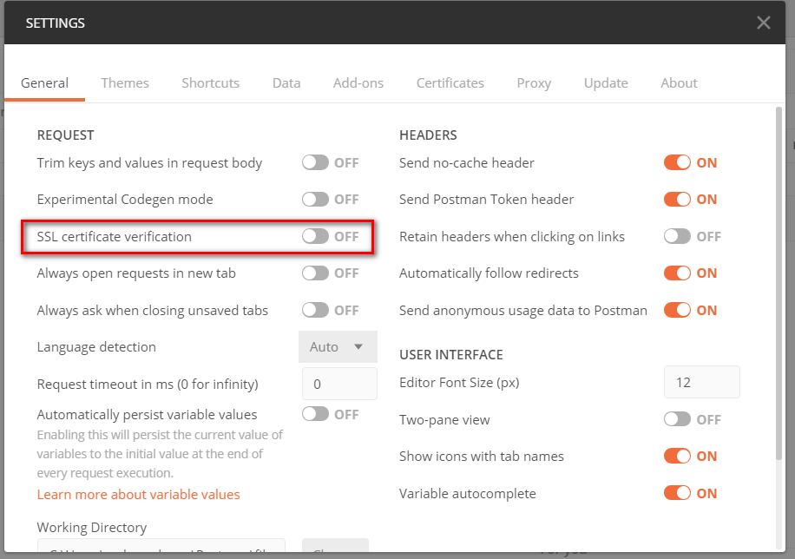

1. Test it.
2. For security reasons, delete the unnecessary methods:.

using Microsoft.AspNetCore.Mvc;

using Soccer.Web.Data;

using Soccer.Web.Data.Entities;

using System.Collections.Generic;

using System.Threading.Tasks;

namespace Soccer.Web.Controllers.API

{

[Route("api/[controller]")]

[ApiController]

public class TeamsController : ControllerBase

{

private readonly DataContext _context;

public TeamsController(DataContext context)

{

_context = context;

}

[HttpGet]

public IEnumerable<TeamEntity> GetTeams()

{

return _context.Teams;

}

[HttpGet("{id}")]

public async Task<IActionResult> GetTeamEntity([FromRoute] int id)

{

if (!ModelState.IsValid)

{

return BadRequest(ModelState);

}

TeamEntity teamEntity = await _context.Teams.FindAsync(id);

if (teamEntity == null)

{

return NotFound();

}

return Ok(teamEntity);

}

}

}

1. Now add an API for **TournamentsEntity**:

using Microsoft.AspNetCore.Mvc;

using Microsoft.EntityFrameworkCore;

using Soccer.Web.Data;

using Soccer.Web.Data.Entities;

using System.Collections.Generic;

using System.Threading.Tasks;

namespace Soccer.Web.Controllers.API

{

[Route("api/[controller]")]

[ApiController]

public class TournamentsController : ControllerBase

{

private readonly DataContext _context;

public TournamentsController(DataContext context)

{

_context = context;

}

[HttpGet]

public async Task<IActionResult> GetTeams()

{

List<TournamentEntity> tournaments = await _context.Tournaments.ToListAsync();

return Ok(tournaments);

}

}

}

1. Test it.
2. Modify to add groups:

[HttpGet]

public async Task<IActionResult> GetTeams()

{

List<TournamentEntity> tournaments = await _context.Tournaments

.Include(t => t.Groups)

.ToListAsync();

return Ok(tournaments);

}

1. What happened? We have a circular reference, to solve, add the following models:
2. Add the **TeamResponse**:

namespace Soccer.Common.Models

{

public class TeamResponse

{

public int Id { get; set; }

public string Name { get; set; }

public string LogoPath { get; set; }

}

}

1. Add the **GroupDetailResponse**:

namespace Soccer.Common.Models

{

public class GroupDetailResponse

{

public int Id { get; set; }

public TeamResponse Team { get; set; }

public int MatchesPlayed { get; set; }

public int MatchesWon { get; set; }

public int MatchesTied { get; set; }

public int MatchesLost { get; set; }

public int Points => MatchesWon * 3 + MatchesTied;

public int GoalsFor { get; set; }

public int GoalsAgainst { get; set; }

public int GoalDifference => GoalsFor - GoalsAgainst;

}

}

1. Add the **MatchResponse**:

using System;

using System.Collections.Generic;

namespace Soccer.Common.Models

{

public class MatchResponse

{

public int Id { get; set; }

public DateTime Date { get; set; }

public DateTime DateLocal => Date.ToLocalTime();

public TeamResponse Local { get; set; }

public TeamResponse Visitor { get; set; }

public int? GoalsLocal { get; set; }

public int? GoalsVisitor { get; set; }

public bool IsClosed { get; set; }

public ICollection<PredictionResponse> Predictions { get; set; }

}

}

1. Add the **GroupResponse**:

using System.Collections.Generic;

namespace Soccer.Common.Models

{

public class GroupResponse

{

public int Id { get; set; }

public string Name { get; set; }

public ICollection<GroupDetailResponse> GroupDetails { get; set; }

public ICollection<MatchResponse> Matches { get; set; }

}

}

1. Add the **UserResponse**:

using Soccer.Common.Enums;

namespace Soccer.Common.Models

{

public class UserResponse

{

public string Id { get; set; }

public string Email { get; set; }

public string PhoneNumber { get; set; }

public string Document { get; set; }

public string FirstName { get; set; }

public string LastName { get; set; }

public string Address { get; set; }

public string PicturePath { get; set; }

public UserType UserType { get; set; }

public TeamResponse Team { get; set; }

public string FullName => $"{FirstName} {LastName}";

public string FullNameWithDocument => $"{FirstName} {LastName} - {Document}";

}

}

1. Add the **PredictionResponse**:

namespace Soccer.Common.Models

{

public class PredictionResponse

{

public int Id { get; set; }

public int? GoalsLocal { get; set; }

public int? GoalsVisitor { get; set; }

public int Points { get; set; }

public UserResponse User { get; set; }

public MatchResponse Match { get; set; }

}

}

1. Add the **TournamentResponse**:

using System;

using System.Collections.Generic;

namespace Soccer.Common.Models

{

public class TournamentResponse

{

public int Id { get; set; }

public string Name { get; set; }

public DateTime StartDate { get; set; }

public DateTime StartDateLocal => StartDate.ToLocalTime();

public DateTime EndDate { get; set; }

public DateTime EndDateLocal => EndDate.ToLocalTime();

public bool IsActive { get; set; }

public string LogoPath { get; set; }

public ICollection<GroupResponse> Groups { get; set; }

}

}

1. Add those methods to **IConverterHelper**:

TournamentResponse ToTournamentResponse(TournamentEntity tournamentEntity);

List<TournamentResponse> ToTournamentResponse(List<TournamentEntity> tournamentEntities);

1. Add those methods to **ConverterHelper**:

public TournamentViewModel ToTournamentViewModel(TournamentEntity tournamentEntity)

{

return new TournamentViewModel

{

EndDate = tournamentEntity.EndDate,

Groups = tournamentEntity.Groups,

Id = tournamentEntity.Id,

IsActive = tournamentEntity.IsActive,

LogoPath = tournamentEntity.LogoPath,

Name = tournamentEntity.Name,

StartDate = tournamentEntity.StartDate

};

}

public TournamentResponse ToTournamentResponse(TournamentEntity tournamentEntity)

{

return new TournamentResponse

{

EndDate = tournamentEntity.EndDate,

Id = tournamentEntity.Id,

IsActive = tournamentEntity.IsActive,

LogoPath = tournamentEntity.LogoPath,

Name = tournamentEntity.Name,

StartDate = tournamentEntity.StartDate,

Groups = tournamentEntity.Groups.Select(g => new GroupResponse

{

Id = g.Id,

Name = g.Name,

GroupDetails = g.GroupDetails.Select(gd => new GroupDetailResponse

{

GoalsAgainst = gd.GoalsAgainst,

GoalsFor = gd.GoalsFor,

Id = gd.Id,

MatchesLost = gd.MatchesLost,

MatchesPlayed = gd.MatchesPlayed,

MatchesTied = gd.MatchesTied,

MatchesWon = gd.MatchesWon,

Team = ToTeamResponse(gd.Team)

}).ToList(),

Matches = g.Matches.Select(m => new MatchResponse

{

Date = m.Date,

GoalsLocal = m.GoalsLocal,

GoalsVisitor = m.GoalsVisitor,

Id = m.Id,

IsClosed = m.IsClosed,

Local = ToTeamResponse(m.Local),

Visitor = ToTeamResponse(m.Visitor),

Predictions = m.Predictions.Select(p => new PredictionResponse

{

GoalsLocal = p.GoalsLocal,

GoalsVisitor = p.GoalsVisitor,

Id = p.Id,

Points = p.Points,

User = ToUserResponse(p.User)

}).ToList()

}).ToList()

}).ToList()

};

}

public List<TournamentResponse> ToTournamentResponse(List<TournamentEntity> tournamentEntities)

{

List<TournamentResponse> list = new List<TournamentResponse>();

foreach (TournamentEntity tournamentEntity in tournamentEntities)

{

list.Add(ToTournamentResponse(tournamentEntity));

}

return list;

}

private UserResponse ToUserResponse(UserEntity user)

{

if (user == null)

{

return null;

}

return new UserResponse

{

Address = user.Address,

Document = user.Document,

Email = user.Email,

FirstName = user.FirstName,

Id = user.Id,

LastName = user.LastName,

PhoneNumber = user.PhoneNumber,

PicturePath = user.PicturePath,

Team = ToTeamResponse(user?.Team),

UserType = user.UserType

};

}

private TeamResponse ToTeamResponse(TeamEntity team)

{

if (team == null)

{

return null;

}

return new TeamResponse

{

Id = team.Id,

LogoPath = team.LogoPath,

Name = team.Name

};

}

1. Modify the **TournamentsController** API:

using Microsoft.AspNetCore.Mvc;

using Microsoft.EntityFrameworkCore;

using Soccer.Web.Data;

using Soccer.Web.Data.Entities;

using Soccer.Web.Helpers;

using System.Collections.Generic;

using System.Threading.Tasks;

namespace Soccer.Web.Controllers.API

{

[Route("api/[controller]")]

[ApiController]

public class TournamentsController : ControllerBase

{

private readonly DataContext _context;

private readonly IConverterHelper _converterHelper;

public TournamentsController(

DataContext context,

IConverterHelper converterHelper)

{

_context = context;

_converterHelper = converterHelper;

}

[HttpGet]

public async Task<IActionResult> GetTeams()

{

List<TournamentEntity> tournaments = await _context.Tournaments

.Include(t => t.Groups)

.ThenInclude(g => g.GroupDetails)

.ThenInclude(gd => gd.Team)

.Include(t => t.Groups)

.ThenInclude(g => g.Matches)

.ThenInclude(m => m.Local)

.Include(t => t.Groups)

.ThenInclude(g => g.Matches)

.ThenInclude(m => m.Visitor)

.ToListAsync();

return Ok(_converterHelper.ToTournamentResponse(tournaments));

}

}

}

1. Test it.

## Publish on Azure

1. Publish on azure

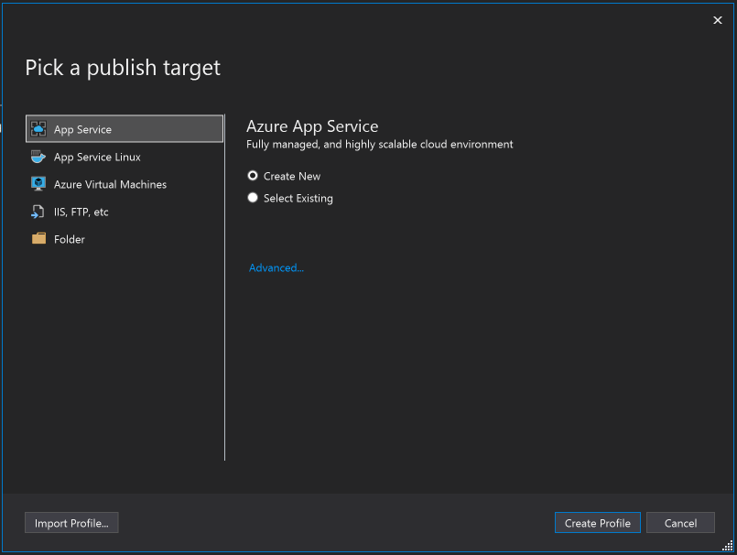

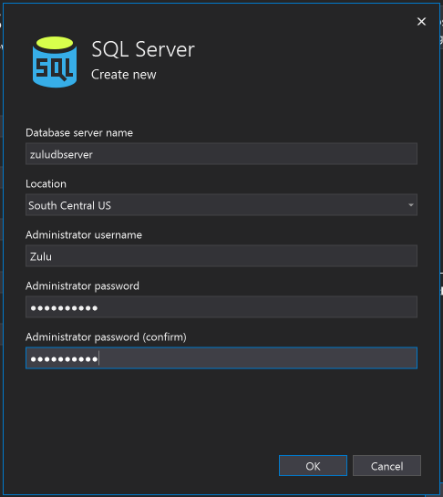

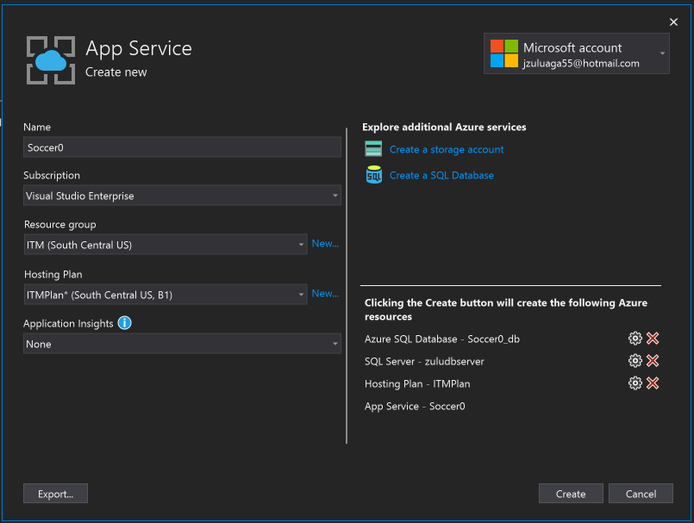

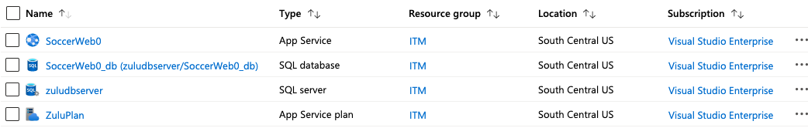

1. Add an image for “no image”.
2. Then, fix the correct route for images on **TeamEntity**, **TournamentEntity**, **TeamResponse** and **TournamentResponse**:

public string LogoFullPath => string.IsNullOrEmpty(LogoPath)

? "https://SoccerWeb0.azurewebsites.net//images/noimage.png"

: $"https://SoccerWeb0.azurewebsites.net{LogoPath.Substring(1)}";

1. Publish again.
2. Test it.

# 

# App Xamarin Forms First Part



## List the tournaments

We are going to build this screen:

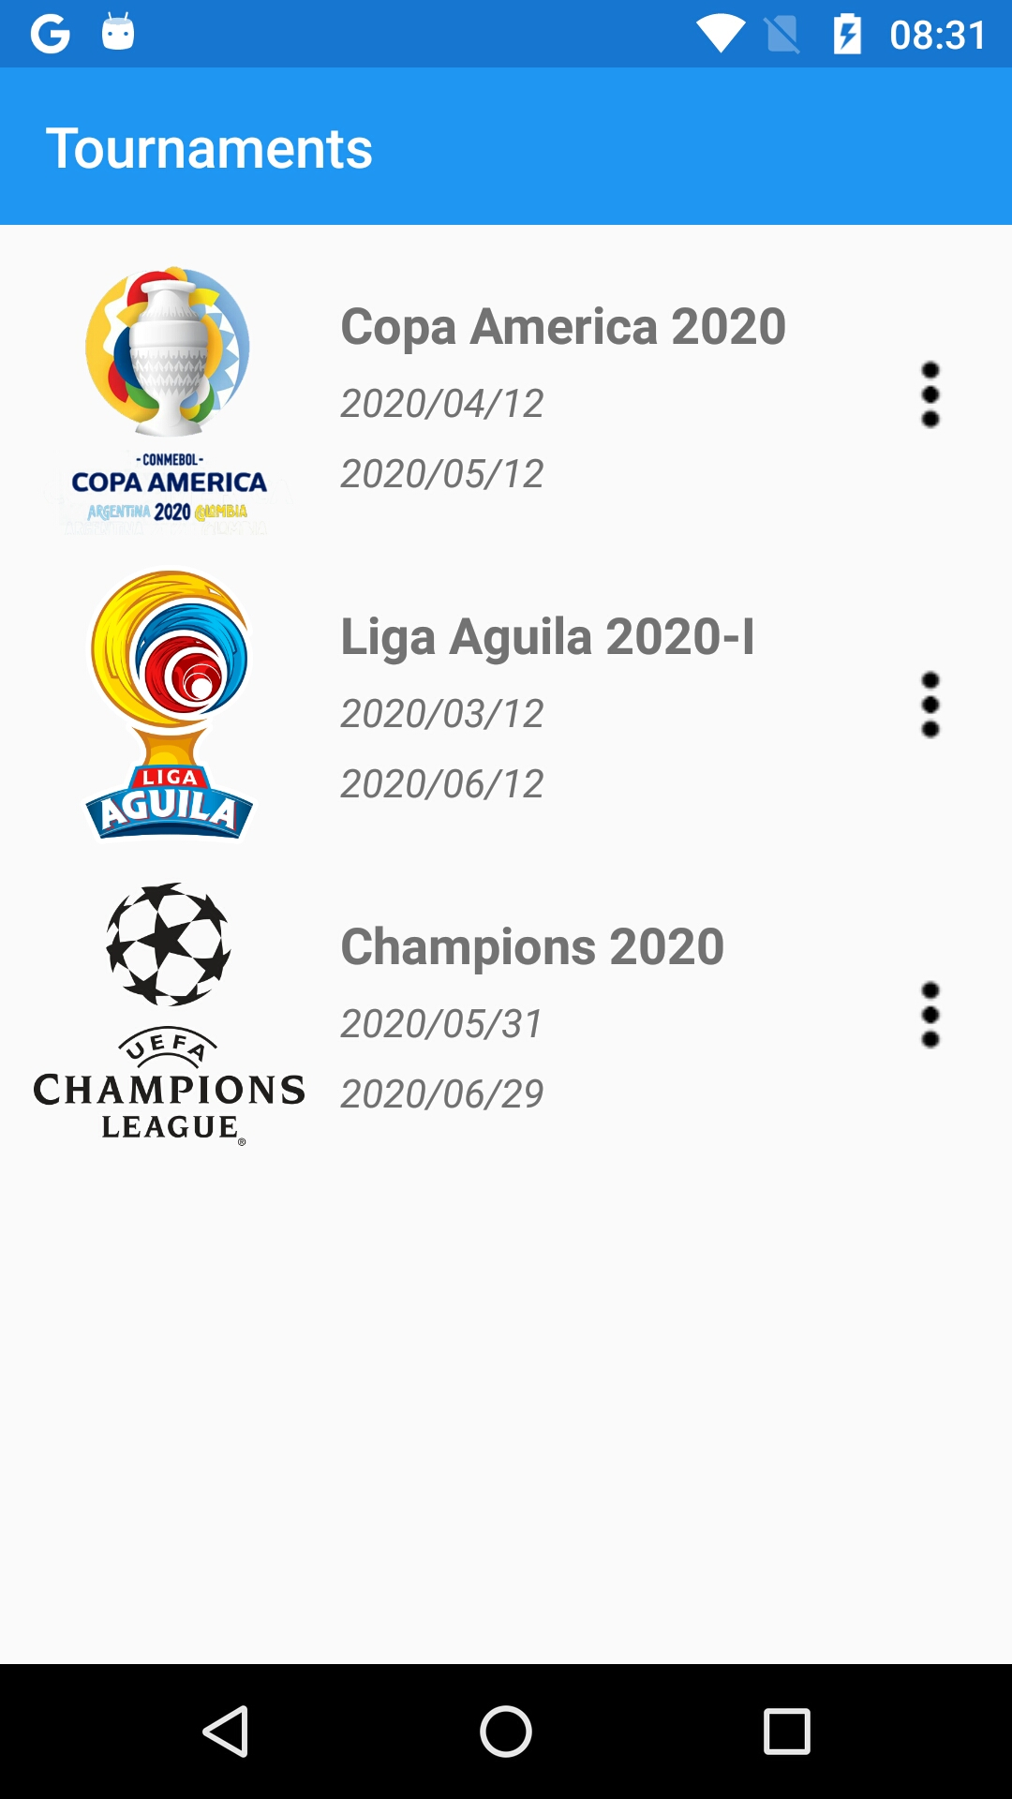

1. Delete the **MainPage** and **MainPageViewModel.**
2. Update the nuggets to latest versions on Prism projects.
3. Add the nugget **Xamarin.FFImageLoading.Forms** to all Prism projects.
4. Initialize the **Xamarin.FFImageLoading.Forms** on Android:

global::Xamarin.Forms.Forms.Init(this, bundle);

FFImageLoading.Forms.Platform.CachedImageRenderer.Init(true);

LoadApplication(new App(new AndroidInitializer()));

1. Initialize the **Xamarin.FFImageLoading.Forms** on iO:

global::Xamarin.Forms.Forms.Init();

FFImageLoading.Forms.Platform.CachedImageRenderer.Init();

LoadApplication(new App(new iOSInitializer()));

1. Add the icon ic_more_vert.png (<https://romannurik.github.io/AndroidAssetStudio/index.html>).
2. Add the class **Response**:

namespace Soccer.Common.Models

{

public class Response

{

public bool IsSuccess { get; set; }

public string Message { get; set; }

public object Result { get; set; }

}

}

1. Add the **IApiService**:

using Soccer.Common.Models;

using System.Threading.Tasks;

namespace Soccer.Common.Services

{

public interface IApiService

{

Task<Response> GetListAsync<T>(string urlBase, string servicePrefix, string controller);

}

}

1. Add the **ApiService**:

using Newtonsoft.Json;

using Soccer.Common.Models;

using System;

using System.Collections.Generic;

using System.Net.Http;

using System.Text;

using System.Threading.Tasks;

namespace Soccer.Common.Services

{

public class ApiService : IApiService

{

public async Task<Response> GetListAsync<T>(

string urlBase,

string servicePrefix,

string controller)

{

try

{

var client = new HttpClient

{

BaseAddress = new Uri(urlBase),

};

var url = $"{servicePrefix}{controller}";

var response = await client.GetAsync(url);

var result = await response.Content.ReadAsStringAsync();

if (!response.IsSuccessStatusCode)

{

return new Response

{

IsSuccess = false,

Message = result,

};

}

var list = JsonConvert.DeserializeObject<List<T>>(result);

return new Response

{

IsSuccess = true,

Result = list

};

}

catch (Exception ex)

{

return new Response

{

IsSuccess = false,

Message = ex.Message

};

}

}

}

}

1. Add the injection for the service on **App**:

protected override void RegisterTypes(IContainerRegistry containerRegistry)

{

containerRegistry.Register<IApiService, ApiService>();

containerRegistry.RegisterForNavigation<NavigationPage>();

containerRegistry.RegisterForNavigation<TournamentsPage, TournamentsPageViewModel>();

}

1. Add the a parameter in the Resource Dictionary, I mean on **App.xaml**:

<?xml version="1.0" encoding="utf-8" ?>

<prism:PrismApplication xmlns="http://xamarin.com/schemas/2014/forms"

xmlns:x="http://schemas.microsoft.com/winfx/2009/xaml"

xmlns:prism="clr-namespace:Prism.DryIoc;assembly=Prism.DryIoc.Forms"

x:Class="Soccer.Prism.App">

<Application.Resources>

<ResourceDictionary>

<!-- Parameters -->

<x:String x:Key="UrlAPI">https://SoccerWeb0.azurewebsites.net/</x:String>

</ResourceDictionary>

</Application.Resources>

</prism:PrismApplication>

1. Add the **TournamentsPage**:

<?xml version="1.0" encoding="utf-8" ?>

<ContentPage xmlns="http://xamarin.com/schemas/2014/forms"

xmlns:x="http://schemas.microsoft.com/winfx/2009/xaml"

xmlns:prism="http://prismlibrary.com"

xmlns:ffimageloading="clr-namespace:FFImageLoading.Forms;assembly=FFImageLoading.Forms"

prism:ViewModelLocator.AutowireViewModel="True"

x:Class="Soccer.Prism.Views.TournamentsPage"

Title="{Binding Title}">

<StackLayout Padding="5">

<CollectionView ItemsSource="{Binding Tournaments}">

<CollectionView.ItemsLayout>

<GridItemsLayout Orientation="Vertical"/>

</CollectionView.ItemsLayout>

<CollectionView.ItemTemplate>

<DataTemplate>

<Grid>

<Grid.ColumnDefinitions>

<ColumnDefinition Width="Auto" />

<ColumnDefinition Width="*" />

<ColumnDefinition Width="Auto" />

</Grid.ColumnDefinitions>

<ffimageloading:CachedImage Grid.Column="0"

Aspect="AspectFill"

Source="{Binding LogoFullPath}"

CacheDuration= "50"

Margin="5"

RetryCount= "3"

RetryDelay= "600"

WidthRequest="100"/>

<StackLayout Grid.Column="1"

VerticalOptions="Center">

<Label Text="{Binding Name}"

FontAttributes="Bold"

FontSize="Medium"

LineBreakMode="TailTruncation" />

<Label Text="{Binding StartDateLocal, StringFormat='{0:yyyy/MM/dd}'}"

LineBreakMode="TailTruncation"

FontAttributes="Italic"

VerticalOptions="End" />

<Label Text="{Binding EndDateLocal, StringFormat='{0:yyyy/MM/dd}'}"

LineBreakMode="TailTruncation"

FontAttributes="Italic"

VerticalOptions="End" />

</StackLayout>

<Image Grid.Column="2"

Source="ic_more_vert"/>

</Grid>

</DataTemplate>

</CollectionView.ItemTemplate>

</CollectionView>

</StackLayout>

</ContentPage>

1. Modify the **TournamentsPageViewModel**:

using Prism.Navigation;

using Soccer.Common.Models;

using Soccer.Common.Services;

using System.Collections.Generic;

namespace Soccer.Prism.ViewModels

{

public class TournamentsPageViewModel : ViewModelBase

{

private readonly IApiService _apiService;

private List<TournamentResponse> _tournaments;

public TournamentsPageViewModel(

INavigationService navigationService,

IApiService apiService) : base(navigationService)

{

_apiService = apiService;

Title = "Tourmanments";

LoadTournamentsAsync();

}

public List<TournamentResponse> Tournaments

{

get => _tournaments;

set => SetProperty(ref _tournaments, value);

}

private async void LoadTournamentsAsync()

{

string url = App.Current.Resources["UrlAPI"].ToString();

Response response = await _apiService.GetListAsync<TournamentResponse>(

url,

"/api",

"/Tournaments");

if (!response.IsSuccess)

{

await App.Current.MainPage.DisplayAlert(

"Error",

response.Message,

"Accept");

return;

}

Tournaments = (List<TournamentResponse>)response.Result;

}

}

}

1. Test it.

## Navigate to groups page

1. Add the **GroupsPage**, initially with this layout:

<?xml version="1.0" encoding="utf-8" ?>

<ContentPage xmlns="http://xamarin.com/schemas/2014/forms"

xmlns:x="http://schemas.microsoft.com/winfx/2009/xaml"

xmlns:prism="http://prismlibrary.com"

prism:ViewModelLocator.AutowireViewModel="True"

x:Class="Soccer.Prism.Views.GroupsPage"

Title="{Binding Title}">

</ContentPage>

1. Modify the **GroupsPageViewModel**:

using Prism.Navigation;

using Soccer.Common.Models;

namespace Soccer.Prism.ViewModels

{

public class GroupsPageViewModel : ViewModelBase

{

private TournamentResponse _tournament;

public GroupsPageViewModel(INavigationService navigationService) : base(navigationService)

{

Title = "Groups";

}

public TournamentResponse Tournament

{

get => _tournament;

set => SetProperty(ref _tournament, value);

}

public override void OnNavigatedTo(INavigationParameters parameters)

{

base.OnNavigatedTo(parameters);

if (parameters.ContainsKey("tournament"))

{

Tournament = parameters.GetValue<TournamentResponse>("tournament");

Title = Tournament.Name;

}

}

}

}

1. Add the **TournamentItemViewModel**:

using Prism.Commands;

using Prism.Navigation;

using Soccer.Common.Models;

namespace Soccer.Prism.ViewModels

{

public class TournamentItemViewModel : TournamentResponse

{

private readonly INavigationService _navigationService;

private DelegateCommand _selectTournamentCommand;

public TournamentItemViewModel(INavigationService navigationService)

{

_navigationService = navigationService;

}

public DelegateCommand SelectTournamentCommand => _selectTournamentCommand ?? (_selectTournamentCommand = new DelegateCommand(SelectTournamentAsync));

private async void SelectTournamentAsync()

{

NavigationParameters parameters = new NavigationParameters

{

{ "tournament", this }

};

await _navigationService.NavigateAsync("GroupsPage", parameters);

}

}

}

1. Modify the **TournamentsPage**:

<Grid>

<Grid.GestureRecognizers>

<TapGestureRecognizer Command="{Binding SelectTournamentCommand}"/>

</Grid.GestureRecognizers>

<Grid.ColumnDefinitions>

1. Modify the **TournamentItemViewModel**:

using Prism.Navigation;

using Soccer.Common.Models;

using Soccer.Common.Services;

using System.Collections.Generic;

using System.Linq;

namespace Soccer.Prism.ViewModels

{

public class TournamentsPageViewModel : ViewModelBase

{

private readonly INavigationService _navigationService;

private readonly IApiService _apiService;

private List<TournamentItemViewModel> _tournaments;

public TournamentsPageViewModel(

INavigationService navigationService,

IApiService apiService) : base(navigationService)

{

_navigationService = navigationService;

_apiService = apiService;

Title = "Tournaments";

LoadTournamentsAsync();

}

public List<TournamentItemViewModel> Tournaments

{

get => _tournaments;

set => SetProperty(ref _tournaments, value);

}

private async void LoadTournamentsAsync()

{

string url = App.Current.Resources["UrlAPI"].ToString();

Response response = await _apiService.GetListAsync<TournamentResponse>(

url,

"/api",

"/Tournaments");

if (!response.IsSuccess)

{

await App.Current.MainPage.DisplayAlert(

"Error",

response.Message,

"Accept");

return;

}

List<TournamentResponse> list = (List<TournamentResponse>)response.Result;

Tournaments = list.Select(t => new TournamentItemViewModel(_navigationService)

{

EndDate = t.EndDate,

Groups = t.Groups,

Id = t.Id,

IsActive = t.IsActive,

LogoPath = t.LogoPath,

Name = t.Name,

StartDate = t.StartDate

}).ToList();

}

}

}

1. Test it.

## 

## Show groups in a listview grouped

We are going to make this screen:

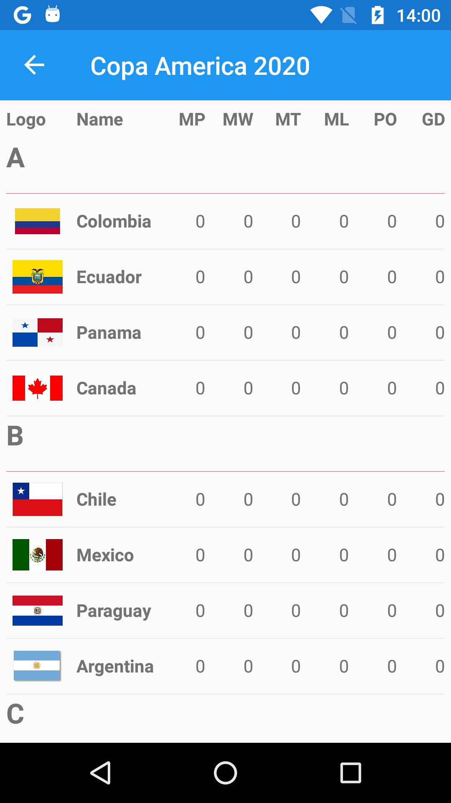

1. Create the class **Group**:

using System.Collections.Generic;

namespace Soccer.Common.Models

{

public class Group : List<GroupDetailResponse>

{

public string Name { get; set; }

public List<GroupDetailResponse> Teams => this;

}

}

1. Create the interface **ITransformHelper**:

using Soccer.Common.Models;

using System.Collections.Generic;

namespace Soccer.Common.Helpers

{

public interface ITransformHelper

{

List<Group> ToGroups(List<GroupResponse> groupResponses);

}

}

1. Create the class **TransformHelper**:

using Soccer.Common.Models;

using System.Collections.Generic;

using System.Linq;

namespace Soccer.Common.Helpers

{

public class TransformHelper : ITransformHelper

{

public List<Group> ToGroups(List<GroupResponse> groupResponses)

{

List<Group> list = new List<Group>();

foreach (GroupResponse groupResponse in groupResponses)

{

Group group = new Group();

foreach (GroupDetailResponse groupDetail in groupResponse.GroupDetails

.OrderByDescending(gd => gd.Points)

.ThenByDescending(gd => gd.GoalDifference)

.ThenByDescending(gd => gd.GoalsFor))

{

group.Add(groupDetail);

}

group.Name = groupResponse.Name;

list.Add(group);

}

return list;

}

}

}

1. Add the injection on **App**:

containerRegistry.Register<IApiService, ApiService>();

containerRegistry.Register<ITransformHelper, TransformHelper>();

containerRegistry.RegisterForNavigation<NavigationPage>();

1. Modify the **GroupsPage**:

<?xml version="1.0" encoding="utf-8" ?>

<ContentPage xmlns="http://xamarin.com/schemas/2014/forms"

xmlns:x="http://schemas.microsoft.com/winfx/2009/xaml"

xmlns:prism="http://prismlibrary.com"

xmlns:ffimageloading="clr-namespace:FFImageLoading.Forms;assembly=FFImageLoading.Forms"

prism:ViewModelLocator.AutowireViewModel="True"

x:Class="Soccer.Prism.Views.GroupsPage"

Title="{Binding Title}">

<StackLayout Padding="5">

<Grid>

<Grid.RowDefinitions>

<RowDefinition Height="Auto"/>

</Grid.RowDefinitions>

<Grid.ColumnDefinitions>

<ColumnDefinition Width="50" />

<ColumnDefinition Width="2*" />

<ColumnDefinition Width="*" />

<ColumnDefinition Width="*" />

<ColumnDefinition Width="*" />

<ColumnDefinition Width="*" />

<ColumnDefinition Width="*" />

</Grid.ColumnDefinitions>

<Label Grid.Column="0"

FontAttributes="Bold"

Text="Logo"/>

<Label Grid.Column="1"

FontAttributes="Bold"

Text="Name"/>

<Label Grid.Column="2"

HorizontalTextAlignment="End"

FontAttributes="Bold"

Text="MP"/>

<Label Grid.Column="3"

HorizontalTextAlignment="End"

FontAttributes="Bold"

Text="MW"/>

<Label Grid.Column="4"

HorizontalTextAlignment="End"

FontAttributes="Bold"

Text="MT"/>

<Label Grid.Column="5"

HorizontalTextAlignment="End"

FontAttributes="Bold"

Text="ML"/>

<Label Grid.Column="6"

HorizontalTextAlignment="End"

FontAttributes="Bold"

Text="PO"/>

<Label Grid.Column="7"

HorizontalTextAlignment="End"

FontAttributes="Bold"

Text="GD"/>

</Grid>

<ListView ItemsSource="{Binding Groups}"

IsGroupingEnabled="true">

<ListView.GroupHeaderTemplate>

<DataTemplate>

<ViewCell>

<Label FontAttributes="Bold"

FontSize="Large"

Text="{Binding Name}"/>

</ViewCell>

</DataTemplate>

</ListView.GroupHeaderTemplate>

<ListView.ItemTemplate>

<DataTemplate>

<ViewCell>

<Grid>

<Grid.ColumnDefinitions>

<ColumnDefinition Width="Auto" />

<ColumnDefinition Width="2*" />

<ColumnDefinition Width="*" />

<ColumnDefinition Width="*" />

<ColumnDefinition Width="*" />

<ColumnDefinition Width="*" />

<ColumnDefinition Width="*" />

</Grid.ColumnDefinitions>

<ffimageloading:CachedImage Grid.Column="0"

Aspect="AspectFit"

CacheDuration= "50"

Margin="5"

RetryCount= "3"

RetryDelay= "600"

Source="{Binding Team.LogoFullPath}"

WidthRequest="45"/>

<Label Grid.Column="1"

FontAttributes="Bold"

Text="{Binding Team.Name}"

VerticalOptions="Center"/>

<Label Grid.Column="2"

HorizontalTextAlignment="End"

Text="{Binding MatchesPlayed}"

VerticalOptions="Center" />

<Label Grid.Column="3"

HorizontalTextAlignment="End"

Text="{Binding MatchesWon}"

VerticalOptions="Center" />

<Label Grid.Column="4"

HorizontalTextAlignment="End"

Text="{Binding MatchesTied}"

VerticalOptions="Center" />

<Label Grid.Column="5"

HorizontalTextAlignment="End"

Text="{Binding MatchesLost}"

VerticalOptions="Center" />

<Label Grid.Column="6"

HorizontalTextAlignment="End"

Text="{Binding Points}"

VerticalOptions="Center" />

<Label Grid.Column="7"

HorizontalTextAlignment="End"

Text="{Binding GoalDifference}"

VerticalOptions="Center" />

</Grid>

</ViewCell>

</DataTemplate>

</ListView.ItemTemplate>

</ListView>

</StackLayout>

</ContentPage>

1. Modify the **TournamentResponse**:

public List<GroupResponse> Groups { get; set; }

1. Modify the **GroupsPageViewModel**:

using Prism.Navigation;

using Soccer.Common.Helpers;

using Soccer.Common.Models;

using System.Collections.Generic;

namespace Soccer.Prism.ViewModels

{

public class GroupsPageViewModel : ViewModelBase

{

private readonly ITransformHelper _transformHelper;

private TournamentResponse _tournament;

private List<Group> _groups;

public GroupsPageViewModel(

INavigationService navigationService,

ITransformHelper transformHelper) : base(navigationService)

{

_transformHelper = transformHelper;

Title = "Groups";

}

public List<Group> Groups

{

get => _groups;

set => SetProperty(ref _groups, value);

}

public override void OnNavigatedTo(INavigationParameters parameters)

{

base.OnNavigatedTo(parameters);

if (parameters.ContainsKey("tournament"))

{

_tournament = parameters.GetValue<TournamentResponse>("tournament");

Title = _tournament.Name;

Groups = _transformHelper.ToGroups(_tournament.Groups);

}

}

}

}

1. Test it.

## 

## Show Matches

We are going to build this screen:

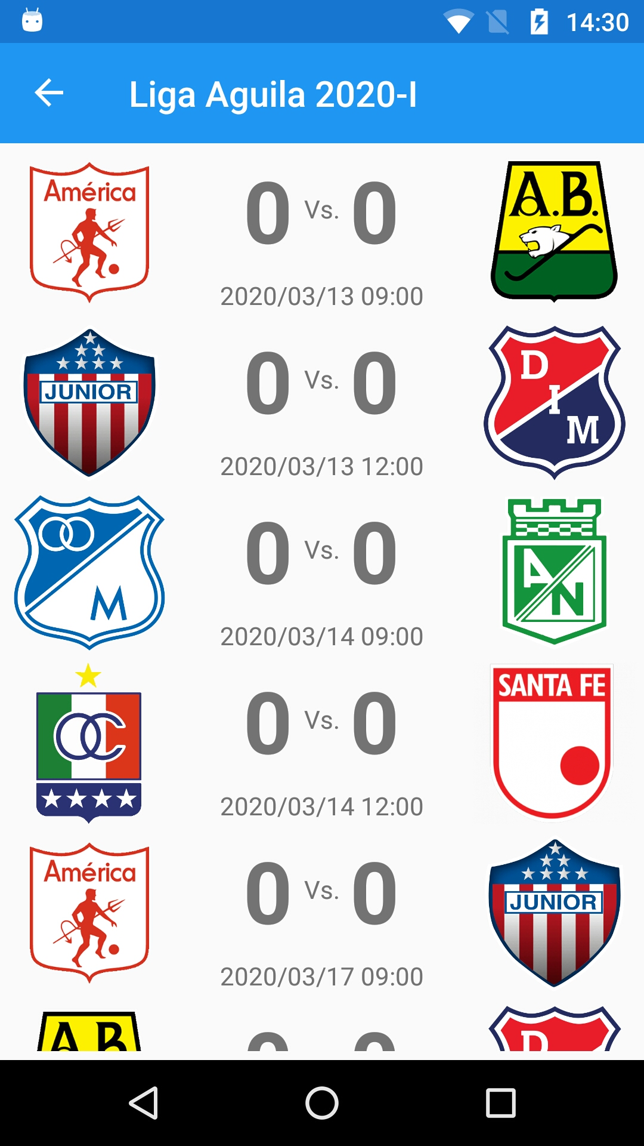

1. Add the **MatchesPage**:

<?xml version="1.0" encoding="utf-8" ?>

<ContentPage xmlns="http://xamarin.com/schemas/2014/forms"

xmlns:x="http://schemas.microsoft.com/winfx/2009/xaml"

xmlns:prism="http://prismlibrary.com"

xmlns:ffimageloading="clr-namespace:FFImageLoading.Forms;assembly=FFImageLoading.Forms"

prism:ViewModelLocator.AutowireViewModel="True"

x:Class="Soccer.Prism.Views.MatchesPage"

Title="{Binding Title}">

<StackLayout Padding="5">

<CollectionView ItemsSource="{Binding Matches}">

<CollectionView.ItemsLayout>

<GridItemsLayout Orientation="Vertical"

VerticalItemSpacing="5"/>

</CollectionView.ItemsLayout>

<CollectionView.ItemTemplate>

<DataTemplate>

<StackLayout>

<Grid>

<Grid.ColumnDefinitions>

<ColumnDefinition Width="Auto" />

<ColumnDefinition Width="*" />

<ColumnDefinition Width="Auto" />

</Grid.ColumnDefinitions>

<ffimageloading:CachedImage Grid.Column="0"

Aspect="AspectFit"

CacheDuration= "50"

HeightRequest="90"

RetryCount= "3"

RetryDelay= "600"

Source="{Binding Local.LogoFullPath}"

WidthRequest="90"/>

<StackLayout Grid.Column="1"

VerticalOptions="Center">

<StackLayout HorizontalOptions="Center"

Orientation="Horizontal">

<Label FontAttributes="Bold"

FontSize="48"

Text="{Binding GoalsLocal}"/>

<Label Text="Vs."

VerticalOptions="Center"/>

<Label FontAttributes="Bold"

FontSize="48"

Text="{Binding GoalsVisitor}"/>

</StackLayout>

<StackLayout Orientation="Horizontal"

HorizontalOptions="Center">

<Label Text="{Binding DateLocal, StringFormat='{0:yyyy/MM/dd HH:mm}'}"

VerticalOptions="Center" />

</StackLayout>

</StackLayout>

<ffimageloading:CachedImage Grid.Column="2"

Aspect="AspectFit"

CacheDuration= "50"

HeightRequest="90"

RetryCount= "3"

RetryDelay= "600"

Source="{Binding Visitor.LogoFullPath}"

WidthRequest="90"/>

</Grid>

</StackLayout>

</DataTemplate>

</CollectionView.ItemTemplate>

</CollectionView>

</StackLayout>

</ContentPage>

1. Modify the **MatchesPageViewModel**:

using Prism.Navigation;

using Soccer.Common.Models;

using System.Collections.Generic;

using System.Linq;

namespace Soccer.Prism.ViewModels

{

public class MatchesPageViewModel : ViewModelBase

{

private TournamentResponse _tournament;

private List<MatchResponse> _matches;

public MatchesPageViewModel(INavigationService navigationService) : base(navigationService)

{

Title = "Matches";

}

public List<MatchResponse> Matches

{

get => _matches;

set => SetProperty(ref _matches, value);

}

public override void OnNavigatedTo(INavigationParameters parameters)

{

base.OnNavigatedTo(parameters);

_tournament = parameters.GetValue<TournamentResponse>("tournament");

Title = _tournament.Name;

List<MatchResponse> matches = new List<MatchResponse>();

foreach (GroupResponse group in _tournament.Groups)

{

matches.AddRange(group.Matches);

}

Matches = matches.OrderBy(m => m.Date).ToList();

}

}

}

1. Modify the **TournamentItemViewModel**:

await _navigationService.NavigateAsync(nameof(MatchesPage), parameters);

1. Test it.
2. To avoid duplicated lines, move the template to resource dictionary:

<!-- Data Templates -->

<DataTemplate x:Key="MatchTemplate">

<StackLayout>

<Grid>

<Grid.ColumnDefinitions>

<ColumnDefinition Width="Auto" />

<ColumnDefinition Width="*" />

<ColumnDefinition Width="Auto" />

</Grid.ColumnDefinitions>

<ffimageloading:CachedImage Grid.Column="0"

Aspect="AspectFit"

CacheDuration= "50"

HeightRequest="90"

RetryCount= "3"

RetryDelay= "600"

Source="{Binding Local.LogoFullPath}"

WidthRequest="90"/>

<StackLayout Grid.Column="1"

VerticalOptions="Center">

<StackLayout HorizontalOptions="Center"

Orientation="Horizontal">

<Label FontAttributes="Bold"

FontSize="48"

Text="{Binding GoalsLocal}"/>

<Label Text="Vs."

VerticalOptions="Center"/>

<Label FontAttributes="Bold"

FontSize="48"

Text="{Binding GoalsVisitor}"/>

</StackLayout>

<StackLayout Orientation="Horizontal"

HorizontalOptions="Center">

<Label Text="{Binding DateLocal, StringFormat='{0:yyyy/MM/dd HH:mm}'}"

VerticalOptions="Center" />

</StackLayout>

</StackLayout>

<ffimageloading:CachedImage Grid.Column="2"

Aspect="AspectFit"

CacheDuration= "50"

HeightRequest="90"

RetryCount= "3"

RetryDelay= "600"

Source="{Binding Visitor.LogoFullPath}"

WidthRequest="90"/>

</Grid>

</StackLayout>

</DataTemplate>

1. Modify the **MatchesPage** and **ClosedMatchesPage** for:

<CollectionView ItemsSource="{Binding Matches}"

ItemTemplate="{StaticResource MatchTemplate}">

<CollectionView.ItemsLayout>

<GridItemsLayout Orientation="Vertical"

VerticalItemSpacing="5"/>

</CollectionView.ItemsLayout>

</CollectionView>

1. Test it.

## Add tabbed page

We are going to build this screen:

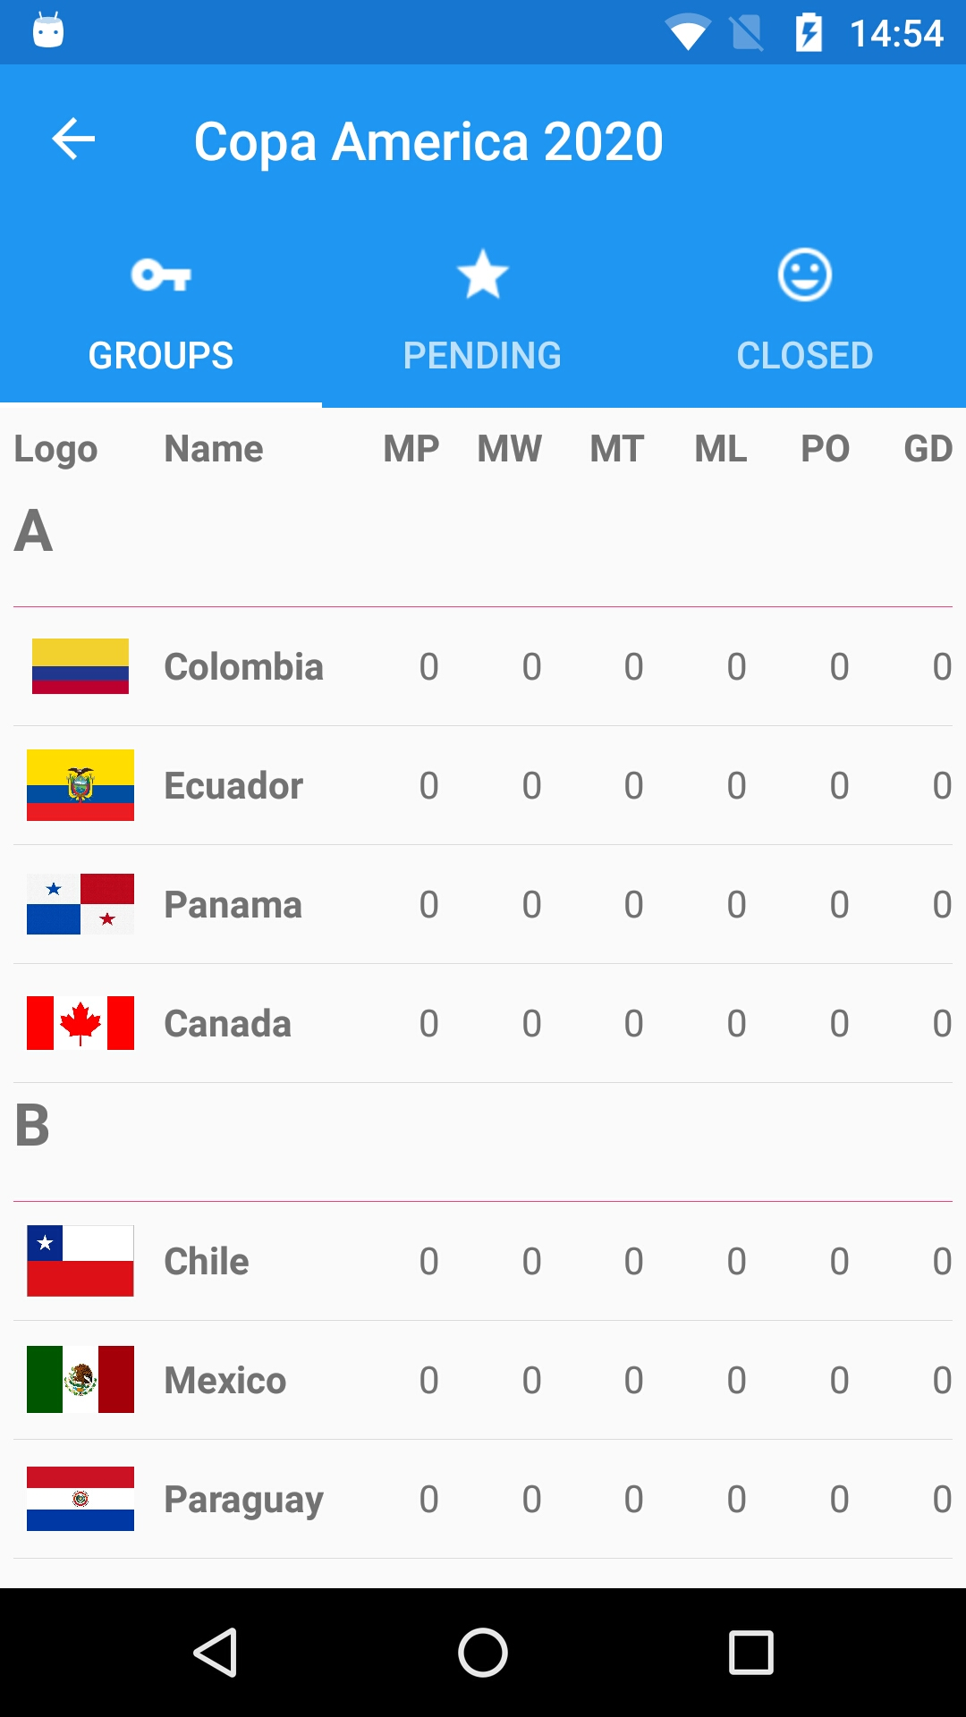

1. Add the icons: **ic_action_tag_faces**, **ic_action_vpn_key** and **ic_action_grade**.
2. Add the **ClosedMatchesPage**:

<?xml version="1.0" encoding="utf-8" ?>

<ContentPage xmlns="http://xamarin.com/schemas/2014/forms"

xmlns:x="http://schemas.microsoft.com/winfx/2009/xaml"

xmlns:prism="http://prismlibrary.com"

xmlns:ffimageloading="clr-namespace:FFImageLoading.Forms;assembly=FFImageLoading.Forms"

prism:ViewModelLocator.AutowireViewModel="True"

x:Class="Soccer.Prism.Views.ClosedMatchesPage"

Title="{Binding Title}">

<StackLayout Padding="5">

<CollectionView ItemsSource="{Binding Matches}"

ItemTemplate="{StaticResource MatchTemplate}">

<CollectionView.ItemsLayout>

<GridItemsLayout Orientation="Vertical"

VerticalItemSpacing="5"/>

</CollectionView.ItemsLayout>

</CollectionView>

</StackLayout>

</ContentPage>

1. Modify the **ClosedMatchesPageViewModel**:

using Prism.Navigation;

using Soccer.Common.Models;

using System.Collections.Generic;

using System.Linq;

namespace Soccer.Prism.ViewModels

{

public class ClosedMatchesPageViewModel : ViewModelBase

{

private TournamentResponse _tournament;

private List<MatchResponse> _matches;

public ClosedMatchesPageViewModel(INavigationService navigationService) : base(navigationService)

{

Title = "Closed";

}

public List<MatchResponse> Matches

{

get => _matches;

set => SetProperty(ref _matches, value);

}

public override void OnNavigatedTo(INavigationParameters parameters)

{

base.OnNavigatedTo(parameters);

if (parameters.ContainsKey("tournament"))

{

_tournament = parameters.GetValue<TournamentResponse>("tournament");

List<MatchResponse> matches = new List<MatchResponse>();

foreach (GroupResponse group in _tournament.Groups)

{

matches.AddRange(group.Matches);

}

Matches = matches.Where(m => m.IsClosed).OrderBy(m => m.Date).ToList();

}

}

}

}

1. Modify the **GroupsPage**:

x:Class="Soccer.Prism.Views.GroupsPage"

IconImageSource="ic_action_vpn_key"

Title="{Binding Title}"

1. Modify the **MatchesPage**:

x:Class="Soccer.Prism.Views.MatchesPage"

IconImageSource="ic_action_grade"

Title="{Binding Title}">

1. Modify the **ClosedMatchesPage**:

x:Class="Soccer.Prism.Views.ClosedMatchesPage"

IconImageSource="ic_action_tag_faces"

Title="{Binding Title}">

1. Modify the **GroupsPageViewModel**:

Title = "Groups";

1. Modify the **MatchesPageViewModel**:

Title = "Pending";

1. Add the **TournamentTabbedPage**:

<?xml version="1.0" encoding="utf-8" ?>

<TabbedPage xmlns="http://xamarin.com/schemas/2014/forms"

xmlns:x="http://schemas.microsoft.com/winfx/2009/xaml"

xmlns:prism="clr-namespace:Prism.Mvvm;assembly=Prism.Forms"

xmlns:local="clr-namespace:Soccer.Prism.Views"

prism:ViewModelLocator.AutowireViewModel="True"

x:Class="Soccer.Prism.Views.PropertyTabbedPage"

Title="{Binding Title}">

<TabbedPage.Children>

<local:GroupsPage />

<local:MatchesPage />

<local:ClosedMatchesPage />

</TabbedPage.Children>

</TabbedPage>

1. Modify the **TournamentTabbedPageViewModel**:

using Prism.Navigation;

using Soccer.Common.Models;

namespace Soccer.Prism.ViewModels

{

public class TournamentTabbedPageViewModel : ViewModelBase

{

private TournamentResponse _tournament;

public TournamentTabbedPageViewModel(INavigationService navigationService) : base(navigationService)

{

Title = "Tournament";

}

public override void OnNavigatedTo(INavigationParameters parameters)

{

base.OnNavigatedTo(parameters);

if (parameters.ContainsKey("tournament"))

{

_tournament = parameters.GetValue<TournamentResponse>("tournament");

Title = _tournament.Name;

}

}

}

}

1. Test it.
2. Add the NuGet **Xam.Plugins.Settings** in **Common** project.
3. Add the **Settings** class:

using Plugin.Settings;

using Plugin.Settings.Abstractions;

namespace Soccer.Common.Helpers

{

public static class Settings

{

private const string _tournament = "tournament";

private static readonly string _stringDefault = string.Empty;

private static ISettings AppSettings => CrossSettings.Current;

public static string Tournament

{

get => AppSettings.GetValueOrDefault(_tournament, _stringDefault);

set => AppSettings.AddOrUpdateValue(_tournament, value);

}

}

}

1. Modify the **TournamentItemViewModel**:

private async void SelectTournamentAsync()

{

NavigationParameters parameters = new NavigationParameters

{

{ "tournament", this }

};

Settings.Tournament = JsonConvert.SerializeObject(this);

await _navigationService.NavigateAsync(nameof(TournamentTabbedPage), parameters);

}

1. Modify the **MatchesPageViewModel**:

using Newtonsoft.Json;

using Prism.Navigation;

using Soccer.Common.Helpers;

using Soccer.Common.Models;

using System;

using System.Collections.Generic;

using System.Linq;

namespace Soccer.Prism.ViewModels

{

public class MatchesPageViewModel : ViewModelBase

{

private TournamentResponse _tournament;

private List<MatchResponse> _matches;

public MatchesPageViewModel(INavigationService navigationService) : base(navigationService)

{

Title = "Pending";

LoadMatches();

}

public List<MatchResponse> Matches

{

get => _matches;

set => SetProperty(ref _matches, value);

}

private void LoadMatches()

{

_tournament = JsonConvert.DeserializeObject<TournamentResponse>(Settings.Tournament);

List<MatchResponse> matches = new List<MatchResponse>();

foreach (GroupResponse group in _tournament.Groups)

{

matches.AddRange(group.Matches);

}

Matches = matches.Where(m => !m.IsClosed).OrderBy(m => m.Date).ToList();

}

}

}

1. Modify the **ClosedMatchesPageViewModel**:

using Newtonsoft.Json;

using Prism.Navigation;

using Soccer.Common.Helpers;

using Soccer.Common.Models;

using System.Collections.Generic;

using System.Linq;

namespace Soccer.Prism.ViewModels

{

public class ClosedMatchesPageViewModel : ViewModelBase

{

private TournamentResponse _tournament;

private List<MatchResponse> _matches;

public ClosedMatchesPageViewModel(INavigationService navigationService) : base(navigationService)

{

Title = "Closed";

LoadMatches();

}

public List<MatchResponse> Matches

{

get => _matches;

set => SetProperty(ref _matches, value);

}

private void LoadMatches()

{

_tournament = JsonConvert.DeserializeObject<TournamentResponse>(Settings.Tournament);

List<MatchResponse> matches = new List<MatchResponse>();

foreach (GroupResponse group in _tournament.Groups)

{

matches.AddRange(group.Matches);

}

Matches = matches.Where(m => m.IsClosed).OrderBy(m => m.Date).ToList();

}

}

}

1. Test it.

## 

## Add a Master Detail

We are going to create this screen:

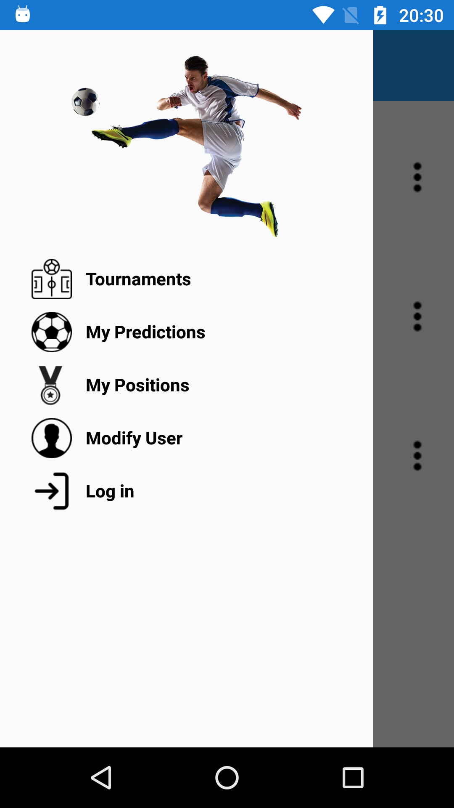

1. Add the **Menu** model:

namespace Soccer.Common.Models

{

public class Menu

{

public string Icon { get; set; }

public string Title { get; set; }

public string PageName { get; set; }

}

}

1. Add the **MenuItemViewModel** view model:

using Soccer.Common.Models;

using Prism.Commands;

using Prism.Navigation;

namespace Soccer.Prism.ViewModels

{

public class MenuItemViewModel : Menu

{

private readonly INavigationService _navigationService;

private DelegateCommand _selectMenuCommand;

public MenuItemViewModel(INavigationService navigationService)

{

_navigationService = navigationService;

}

public DelegateCommand SelectMenuCommand => _selectMenuCommand ?? (_selectMenuCommand = new DelegateCommand(SelectMenuAsync));

private async void SelectMenuAsync()

{

await _navigationService.NavigateAsync($"/SoccerMasterDetailPage/NavigationPage/{PageName}");

}

}

}

1. Add an image for the logo.
2. Add the **MasterDetailPage** called **SoccerMasterDetailPage**:

<?xml version="1.0" encoding="utf-8" ?>

<MasterDetailPage xmlns="http://xamarin.com/schemas/2014/forms"

xmlns:x="http://schemas.microsoft.com/winfx/2009/xaml"

xmlns:prism="http://prismlibrary.com"

prism:ViewModelLocator.AutowireViewModel="True"

x:Class="Soccer.Prism.Views.SoccerMasterDetailPage">

<MasterDetailPage.Master>

<ContentPage Title="Menu">

<StackLayout Padding="20">

<Image HeightRequest="150"

Source="soccer"/>

<ListView BackgroundColor="Transparent"

ItemsSource="{Binding Menus}"

HasUnevenRows="True"

SeparatorVisibility="None">

<ListView.ItemTemplate>

<DataTemplate>

<ViewCell>

<Grid>

<Grid.GestureRecognizers>

<TapGestureRecognizer Command="{Binding SelectMenuCommand}"/>

</Grid.GestureRecognizers>

<Grid.ColumnDefinitions>

<ColumnDefinition Width="Auto"></ColumnDefinition>

<ColumnDefinition Width="*"></ColumnDefinition>

</Grid.ColumnDefinitions>

<Image Grid.Column="0"

HeightRequest="32"

Margin="5"

Source="{Binding Icon}"

WidthRequest="32"/>

<Label Grid.Column="1"

FontAttributes="Bold"

VerticalOptions="Center"

TextColor="Black"

Text="{Binding Title}"/>

</Grid>

</ViewCell>

</DataTemplate>

</ListView.ItemTemplate>

</ListView>

</StackLayout>

</ContentPage>

</MasterDetailPage.Master>

</MasterDetailPage>

1. Add the images for menu icons.
2. Modify the **SoccerMasterDetailPageViewModel**:

using Newtonsoft.Json;

using Prism.Navigation;

using Soccer.Common.Helpers;

using Soccer.Common.Models;

using System.Collections.Generic;

using System.Collections.ObjectModel;

using System.Linq;

namespace Soccer.Prism.ViewModels

{

public class SoccerMasterDetailPageViewModel : ViewModelBase

{

private readonly INavigationService _navigationService;

public SoccerMasterDetailPageViewModel(INavigationService navigationService) : base(navigationService)

{

_navigationService = navigationService;

LoadMenus();

}

public ObservableCollection<MenuItemViewModel> Menus { get; set; }

private void LoadMenus()

{

List<Menu> menus = new List<Menu>

{

new Menu

{

Icon = "tournament",

PageName = "TournamentsPage",

Title = "Tournaments"

},

new Menu

{

Icon = "prediction",

PageName = "MyPredictionsPage",

Title = "My Predictions"

},

new Menu

{

Icon = "medal",

PageName = "MyPositionsPage",

Title = "My Positions"

},

new Menu

{

Icon = "user",

PageName = "ModifyUserPage",

Title = "Modify User"

},

new Menu

{

Icon = "login",

PageName = "LoginPage",

Title = "Login"

}

};

Menus = new ObservableCollection<MenuItemViewModel>(

menus.Select(m => new MenuItemViewModel(_navigationService)

{

Icon = m.Icon,

PageName = m.PageName,

Title = m.Title

}).ToList());

}

}

}

1. Add the page **MyPredictionsPage** initially with this layout:

<?xml version="1.0" encoding="utf-8" ?>

<ContentPage xmlns="http://xamarin.com/schemas/2014/forms"

xmlns:x="http://schemas.microsoft.com/winfx/2009/xaml"

xmlns:prism="http://prismlibrary.com"

prism:ViewModelLocator.AutowireViewModel="True"

x:Class="Soccer.Prism.Views.SoccerHistoryPage"

Title="{Binding Title}">

</ContentPage>

1. Modify the **MyPredictionsPageViewModel**:

using Prism.Navigation;

namespace Soccer.Prism.ViewModels

{

public class MyPredictionsPageViewModel : ViewModelBase

{

public MyPredictionsPageViewModel(INavigationService navigationService) : base(navigationService)

{

Title = "My Predictions";

}

}

}

1. Add the page **MyPositionsPage** initially with this layout:

<?xml version="1.0" encoding="utf-8" ?>

<ContentPage xmlns="http://xamarin.com/schemas/2014/forms"

xmlns:x="http://schemas.microsoft.com/winfx/2009/xaml"

xmlns:prism="http://prismlibrary.com"

prism:ViewModelLocator.AutowireViewModel="True"

x:Class="Soccer.Prism.Views.GroupPage"

Title="{Binding Title}">

</ContentPage>

1. Modify the **MyPositionsPageViewModel**:

using Prism.Navigation;

namespace Soccer.Prism.ViewModels

{

public class MyPositionsPageViewModel : ViewModelBase

{

public MyPositionsPageViewModel(INavigationService navigationService) : base(navigationService)

{

Title = "My Positions";

}

}

}

1. Add the page **ModifyUserPage** initially with this layout:

<?xml version="1.0" encoding="utf-8" ?>

<ContentPage xmlns="http://xamarin.com/schemas/2014/forms"

xmlns:x="http://schemas.microsoft.com/winfx/2009/xaml"

xmlns:prism="http://prismlibrary.com"

prism:ViewModelLocator.AutowireViewModel="True"

x:Class="Soccer.Prism.Views.ModifyUserPage"

Title="{Binding Title}">

</ContentPage>

1. Modify the **ModifyUserPageViewModel**:

using Prism.Navigation;

namespace Soccer.Prism.ViewModels

{

public class ModifyUserPageViewModel : ViewModelBase

{

public ModifyUserPageViewModel(INavigationService navigationService) : base(navigationService)

{

Title = "Modify User";

}

}

}

1. Add the page **LoginPage** initially with this layout:

<?xml version="1.0" encoding="utf-8" ?>

<ContentPage xmlns="http://xamarin.com/schemas/2014/forms"

xmlns:x="http://schemas.microsoft.com/winfx/2009/xaml"

xmlns:prism="http://prismlibrary.com"

prism:ViewModelLocator.AutowireViewModel="True"

x:Class="Soccer.Prism.Views.LoginPage"

Title="{Binding Title}">

</ContentPage>

1. Modify the **LoginPageViewModel**:

using Prism.Navigation;

namespace Soccer.Prism.ViewModels

{

public class LoginPageViewModel : ViewModelBase

{

public LoginPageViewModel(INavigationService navigationService) : base(navigationService)

{

Title = "Login";

}

}

}

1. Modify the **App**:

protected override async void OnInitialized()

{

InitializeComponent();

await NavigationService.NavigateAsync("/SoccerMasterDetailPage/NavigationPage/HomePage");

}

1. Test it.

## Add SfBusyIndicator

1. Get a Sync Fusion license: <https://www.syncfusion.com/account/downloads>.
2. Add the NuGet **Syncfusion.Xamarin.SfBusyIndicator** to all mobile projects.
3. Add your license in **App.xaml.cs**:

protected override async void OnInitialized()

{

SyncfusionLicenseProvider.RegisterLicense("MjExMTY0QDMxMzcyZTM0MmUzMEc1K2xKbkhrV2RmMHByRXF6YUJDQlQ3RkxLZ3hxOVlyMHY0T1RiSUFEZUk9");

InitializeComponent();

await NavigationService.NavigateAsync("SoccerMasterDetailPage/NavigationPage/HomePage");

}

1. Modify the **MainActivity**:

global::Xamarin.Forms.Forms.Init(this, bundle);

new SfBusyIndicatorRenderer();

FFImageLoading.Forms.Platform.CachedImageRenderer.Init(true);

LoadApplication(new App(new AndroidInitializer()));

1. Modify the **AppDelegate**:

global::Xamarin.Forms.Forms.Init();

FFImageLoading.Forms.Platform.CachedImageRenderer.Init();

new SfBusyIndicatorRenderer();

LoadApplication(new App(new iOSInitializer()));

1. Modify the **TournamentsPage**:

<?xml version="1.0" encoding="utf-8" ?>

<ContentPage xmlns="http://xamarin.com/schemas/2014/forms"

xmlns:x="http://schemas.microsoft.com/winfx/2009/xaml"

xmlns:prism="http://prismlibrary.com"

xmlns:busyindicator="clr-namespace:Syncfusion.SfBusyIndicator.XForms;assembly=Syncfusion.SfBusyIndicator.XForms"

prism:ViewModelLocator.AutowireViewModel="True"

x:Class="Soccer.Prism.Views.SoccerHistoryPage"

Title="{Binding Title}">

<AbsoluteLayout>

<StackLayout AbsoluteLayout.LayoutBounds="0,0,1,1"

AbsoluteLayout.LayoutFlags="All"

Padding="5">

<StackLayout Orientation="Horizontal">

<Label Text="Plaque"

VerticalOptions="Center"/>

...

</StackLayout>

<busyindicator:SfBusyIndicator AnimationType="Gear"

AbsoluteLayout.LayoutBounds=".5,.5,.5,.5"

AbsoluteLayout.LayoutFlags="All"

BackgroundColor="Silver"

HorizontalOptions="Center"

TextColor="White"

IsVisible="{Binding IsRunning}"

Title="Loading..."

VerticalOptions="Center"

ViewBoxWidth="80"

ViewBoxHeight="80" />

</AbsoluteLayout>

</ContentPage>

1. Modify the **TournamentsPageViewModel**:

private bool _isRunning;

…

public bool IsRunning

{

get => _isRunning;

set => SetProperty(ref _isRunning, value);

}

...

IsRunning = true;

string url = App.Current.Resources["UrlAPI"].ToString();

Response response = await _apiService.GetSoccerAsync(Plaque, url, "api", "/Soccers");

IsRunning = false;

1. Test it.

## Check the internet connection

1. Add the NuGet **Xam.Plugin.Connectivity** to all prism projects and **Common** too
2. Add the method to **IApiservice**:

Task<bool> CheckConnectionAsync(string url);

1. Add the method to **Apiservice**:

public async Task<bool> CheckConnectionAsync(string url)

{

if (!CrossConnectivity.Current.IsConnected)

{

return false;

}

return await CrossConnectivity.Current.IsRemoteReachable(url);

}

1. Modify the **TournamentsPageViewModel**:

IsRunning = true;

var url = App.Current.Resources["UrlAPI"].ToString();

var connection = await _apiService.CheckConnectionAsync(url);

if (!connection)

{

IsRunning = false;

await App.Current.MainPage.DisplayAlert("Error", "Check the internet connection.", "Accept");

return;

}

Response response = await _apiService.GetListAsync<TournamentResponse>(

url,

"/api",

"/Tournaments");

IsRunning = false;

1. Test it.

## Multi Language in Xamarin Forms

1. If you don’t have the ResX Manager Tool, install from: <https://marketplace.visualstudio.com/items?itemName=TomEnglert.ResXManager>
2. In **Prism** project add the folder **Resources** and inside it, add the resource call **Resource**, add some literals and translate with the ResX Manager tool. The default resource language must be Public, the others in no code generation.



**English**

<data name="Error" xml:space="preserve">

<value>Error</value>

</data>

<data name="ConnectionError" xml:space="preserve">

<value>Check the internet connection.</value>

</data>

<data name="Accept" xml:space="preserve">

<value>Accept</value>

</data>

**Spanish**

<data name="Error" xml:space="preserve">

<value>Error</value>

</data>

<data name="ConnectionError" xml:space="preserve">

<value>Compruebe la conexión a Internet</value>

</data>

<data name="Accept" xml:space="preserve">

<value>Aceptar</value>

</data>

**French**

<data name="Error" xml:space="preserve">

<value>Erreur</value>

</data>

<data name="ConnectionError" xml:space="preserve">

<value>Vérifiez la connexion Internet</value>

</data>

<data name="Accept" xml:space="preserve">

<value>Accepter</value>

</data>

1. In common project add the folder **Interfaces**, inside it, add the interface **ILocalize**.

using System.Globalization;

namespace Soccer.Prism.Interfaces

{

public interface ILocalize

{

CultureInfo GetCurrentCultureInfo();

void SetLocale(CultureInfo ci);

}

}

1. In the folder **Helpers** add the class **PlatformCulture**.

using System;

namespace Soccer.Prism.Helpers

{

public class PlatformCulture

{

public string PlatformString { get; private set; }

public string LanguageCode { get; private set; }

public string LocaleCode { get; private set; }

public PlatformCulture(string platformCultureString)

{

if (string.IsNullOrEmpty(platformCultureString))

{

throw new ArgumentException("Expected culture identifier", "platformCultureString"); // in C# 6 use nameof(platformCultureString)

}

PlatformString = platformCultureString.Replace("_", "-"); // .NET expects dash, not underscore

var dashIndex = PlatformString.IndexOf("-", StringComparison.Ordinal);

if (dashIndex > 0)

{

var parts = PlatformString.Split('-');

LanguageCode = parts[0];

LocaleCode = parts[1];

}

else

{

LanguageCode = PlatformString;

LocaleCode = "";

}

}

public override string ToString()

{

return PlatformString;

}

}

}

1. In **Prism** project add folder **Helpers**  and add the class **Languages** with the literals.

using Soccer.Prism.Interfaces;

using Soccer.Prism.Resources;

using System.Globalization;

using Xamarin.Forms;

namespace Soccer.Prism.Helpers

{

public static class Languages

{

static Languages()

{

CultureInfo ci = DependencyService.Get<ILocalize>().GetCurrentCultureInfo();

Resource.Culture = ci;

Culture = ci.Name;

DependencyService.Get<ILocalize>().SetLocale(ci);

}

public static string Culture { get; set; }

public static string Accept => Resource.Accept;

public static string ConnectionError => Resource.ConnectionError;

public static string Error => Resource.Error;

}

}

1. Implement the interface in **iOS** in the folder **Implementations**.

using Foundation;

using System.Globalization;

using System.Threading;

using Soccer.Prism.Helpers;

using Soccer.Prism.Interfaces;

using Xamarin.Forms;

[assembly: Dependency(typeof(Soccer.Prism.iOS.Implementations.Localize))]

namespace Soccer.Prism.iOS.Implementations

{

public class Localize : ILocalize

{

public CultureInfo GetCurrentCultureInfo()

{

string netLanguage = "en";

if (NSLocale.PreferredLanguages.Length > 0)

{

string pref = NSLocale.PreferredLanguages[0];

netLanguage = iOSToDotnetLanguage(pref);

}

// this gets called a lot - try/catch can be expensive so consider caching or something

CultureInfo ci = null;

try

{

ci = new System.Globalization.CultureInfo(netLanguage);

}

catch (CultureNotFoundException)

{

// iOS locale not valid .NET culture (eg. "en-ES" : English in Spain)

// fallback to first characters, in this case "en"

try

{

string fallback = ToDotnetFallbackLanguage(new PlatformCulture(netLanguage));

ci = new CultureInfo(fallback);

}

catch (CultureNotFoundException)

{

// iOS language not valid .NET culture, falling back to English

ci = new CultureInfo("en");

}

}

return ci;

}

public void SetLocale(CultureInfo ci)

{

Thread.CurrentThread.CurrentCulture = ci;

Thread.CurrentThread.CurrentUICulture = ci;

}

private string iOSToDotnetLanguage(string iOSLanguage)

{

string netLanguage = iOSLanguage;

//certain languages need to be converted to CultureInfo equivalent

switch (iOSLanguage)

{

case "ms-MY": // "Malaysian (Malaysia)" not supported .NET culture

case "ms-SG": // "Malaysian (Singapore)" not supported .NET culture

netLanguage = "ms"; // closest supported

break;

case "gsw-CH": // "Schwiizertüütsch (Swiss German)" not supported .NET culture

netLanguage = "de-CH"; // closest supported

break;

// add more application-specific cases here (if required)

// ONLY use cultures that have been tested and known to work

}

return netLanguage;

}

private string ToDotnetFallbackLanguage(PlatformCulture platCulture)

{

string netLanguage = platCulture.LanguageCode; // use the first part of the identifier (two chars, usually);

switch (platCulture.LanguageCode)

{

case "pt":

netLanguage = "pt-PT"; // fallback to Portuguese (Portugal)

break;

case "gsw":

netLanguage = "de-CH"; // equivalent to German (Switzerland) for this app

break;

// add more application-specific cases here (if required)

// ONLY use cultures that have been tested and known to work

}

return netLanguage;

}

}

}

1. Add this lintes into the **info.plist**.

<key>CFBundleLocalizations</key>

<array>

<string>es</string>

<string>fr</string>

</array>

<key>CFBundleDevelopmentRegion</key>

<string>en</string>

1. Implement the interface in **Android** in the folder **Implementations**.

using System.Globalization;

using System.Threading;

using Soccer.Prism.Helpers;

using Soccer.Prism.Interfaces;

using Xamarin.Forms;

[assembly: Dependency(typeof(Soccer.Prism.Droid.Implementations.Localize))]

namespace Soccer.Prism.Droid.Implementations

{

public class Localize : ILocalize

{

public CultureInfo GetCurrentCultureInfo()

{

string netLanguage = "en";

Java.Util.Locale androidLocale = Java.Util.Locale.Default;

netLanguage = AndroidToDotnetLanguage(androidLocale.ToString().Replace("_", "-"));

// this gets called a lot - try/catch can be expensive so consider caching or something

CultureInfo ci = null;

try

{

ci = new CultureInfo(netLanguage);

}

catch (CultureNotFoundException)

{

// iOS locale not valid .NET culture (eg. "en-ES" : English in Spain)

// fallback to first characters, in this case "en"

try

{

string fallback = ToDotnetFallbackLanguage(new PlatformCulture(netLanguage));

ci = new CultureInfo(fallback);

}

catch (CultureNotFoundException)

{

// iOS language not valid .NET culture, falling back to English

ci = new CultureInfo("en");

}

}

return ci;

}

public void SetLocale(CultureInfo ci)

{

Thread.CurrentThread.CurrentCulture = ci;

Thread.CurrentThread.CurrentUICulture = ci;

}

private string AndroidToDotnetLanguage(string androidLanguage)

{

string netLanguage = androidLanguage;

//certain languages need to be converted to CultureInfo equivalent

switch (androidLanguage)

{

case "ms-BN": // "Malaysian (Brunei)" not supported .NET culture

case "ms-MY": // "Malaysian (Malaysia)" not supported .NET culture

case "ms-SG": // "Malaysian (Singapore)" not supported .NET culture

netLanguage = "ms"; // closest supported

break;

case "in-ID": // "Indonesian (Indonesia)" has different code in .NET

netLanguage = "id-ID"; // correct code for .NET

break;

case "gsw-CH": // "Schwiizertüütsch (Swiss German)" not supported .NET culture

netLanguage = "de-CH"; // closest supported

break;

// add more application-specific cases here (if required)

// ONLY use cultures that have been tested and known to work

}

return netLanguage;

}

private string ToDotnetFallbackLanguage(PlatformCulture platCulture)

{

string netLanguage = platCulture.LanguageCode; // use the first part of the identifier (two chars, usually);

switch (platCulture.LanguageCode)

{

case "gsw":

netLanguage = "de-CH"; // equivalent to German (Switzerland) for this app

break;

// add more application-specific cases here (if required)

// ONLY use cultures that have been tested and known to work

}

return netLanguage;

}

}

}

1. Modify the **TournamentsPageViewModel**:

if (!connection)

{

IsRunning = false;

await App.Current.MainPage.DisplayAlert(Languages.Error, Languages.ConnectionError, Languages.Accept);

return;

}

Response response = await _apiService.GetListAsync<TournamentResponse>(url, "/api", "/Tournaments");

IsRunning = false;

if (!response.IsSuccess)

{

await App.Current.MainPage.DisplayAlert(Languages.Error, response.Message, Languages.Accept);

return;

}

1. Test it.
2. Now to translate literals directly in the XAML add the class **TranslateExtension** in folder **Helpers**:

using System;

using System.Globalization;

using System.Reflection;

using System.Resources;

using Soccer.Prism.Interfaces;

using Xamarin.Forms;

using Xamarin.Forms.Xaml;

namespace Soccer.Prism.Helpers

{

[ContentProperty("Text")]

public class TranslateExtension : IMarkupExtension

{

private readonly CultureInfo ci;

private const string ResourceId = "Soccer.Prism.Resources.Resource";

private static readonly Lazy<ResourceManager> ResMgr =

new Lazy<ResourceManager>(() => new ResourceManager(

ResourceId,

typeof(TranslateExtension).GetTypeInfo().Assembly));

public TranslateExtension()

{

ci = DependencyService.Get<ILocalize>().GetCurrentCultureInfo();

}

public string Text { get; set; }

public object ProvideValue(IServiceProvider serviceProvider)

{

if (Text == null)

{

return "";

}

var translation = ResMgr.Value.GetString(Text, ci);

if (translation == null)

{

#if DEBUG

throw new ArgumentException(

string.Format(

"Key '{0}' was not found in resources '{1}' for culture '{2}'.",

Text, ResourceId, ci.Name), "Text");

#else

translation = Text; // returns the key, which GETS DISPLAYED TO THE USER

#endif

}

return translation;

}

}

}

1. Complete the literals:

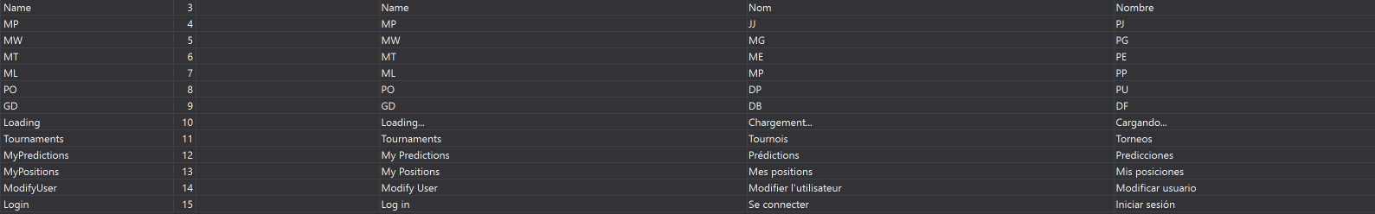

**English**

<data name="Name" xml:space="preserve">

<value>Name</value>

</data>

<data name="MP" xml:space="preserve">

<value>MP</value>

</data>

<data name="MW" xml:space="preserve">

<value>MW</value>

</data>

<data name="MT" xml:space="preserve">

<value>MT</value>

</data>

<data name="ML" xml:space="preserve">

<value>ML</value>

</data>

<data name="PO" xml:space="preserve">

<value>PO</value>

</data>

<data name="GD" xml:space="preserve">

<value>GD</value>

</data>

<data name="Loading" xml:space="preserve">

<value>Loading...</value>

</data>

<data name="Tournaments" xml:space="preserve">

<value>Tournaments</value>

</data>

<data name="MyPredictions" xml:space="preserve">

<value>My Predictions</value>

</data>

<data name="MyPositions" xml:space="preserve">

<value>My Positions</value>

</data>

<data name="ModifyUser" xml:space="preserve">

<value>Modify User</value>

</data>

<data name="Login" xml:space="preserve">

<value>Log in</value>

</data>

**Spanish**

<data name="MP" xml:space="preserve">

<value>PJ</value>

</data>

<data name="MW" xml:space="preserve">

<value>PG</value>

</data>

<data name="MT" xml:space="preserve">

<value>PE</value>

</data>

<data name="ML" xml:space="preserve">

<value>PP</value>

</data>

<data name="PO" xml:space="preserve">

<value>PU</value>

</data>

<data name="GD" xml:space="preserve">

<value>DF</value>

</data>

<data name="Name" xml:space="preserve">

<value>Nombre</value>

</data>

<data name="Loading" xml:space="preserve">

<value>Cargando...</value>

</data>

<data name="Tournaments" xml:space="preserve">

<value>Torneos</value>

</data>

<data name="MyPredictions" xml:space="preserve">

<value>Predicciones</value>

</data>

<data name="MyPositions" xml:space="preserve">

<value>Mis posiciones</value>

</data>

<data name="ModifyUser" xml:space="preserve">

<value>Modificar usuario</value>

</data>

<data name="Login" xml:space="preserve">

<value>Iniciar sesión</value>

</data>

**French**

<data name="MP" xml:space="preserve">

<value>JJ</value>

</data>

<data name="MW" xml:space="preserve">

<value>MG</value>

</data>

<data name="MT" xml:space="preserve">

<value>ME</value>

</data>

<data name="ML" xml:space="preserve">

<value>MP</value>

</data>

<data name="PO" xml:space="preserve">

<value>DP</value>

</data>

<data name="GD" xml:space="preserve">

<value>DB</value>

</data>

<data name="Name" xml:space="preserve">

<value>Nom</value>

</data>

<data name="Loading" xml:space="preserve">

<value>Chargement...</value>

</data>

<data name="Tournaments" xml:space="preserve">

<value>Tournois</value>

</data>

<data name="MyPredictions" xml:space="preserve">

<value>Prédictions</value>

</data>

<data name="MyPositions" xml:space="preserve">

<value>Mes positions</value>

</data>

<data name="ModifyUser" xml:space="preserve">

<value>Modifier l'utilisateur</value>

</data>

<data name="Login" xml:space="preserve">

<value>Se connecter</value>

</data>

1. And add the properties in **Languages** class:

public static string Name => Resource.Name;

public static string MP => Resource.MP;

public static string MW => Resource.MW;

public static string MT => Resource.MT;

public static string ML => Resource.ML;

public static string PO => Resource.PO;

public static string GD => Resource.GD;

public static string Loading => Resource.Loading;

public static string Tournaments => Resource.Tournaments;

public static string MyPredictions => Resource.MyPredictions;

public static string MyPositions => Resource.MyPositions;

public static string ModifyUser => Resource.ModifyUser;

public static string Login => Resource.Login;

1. Modify the **TournamentsPage** for the translations in XAML.

<ContentPage xmlns="http://xamarin.com/schemas/2014/forms"

xmlns:x="http://schemas.microsoft.com/winfx/2009/xaml"

xmlns:prism="http://prismlibrary.com"

xmlns:ffimageloading="clr-namespace:FFImageLoading.Forms;assembly=FFImageLoading.Forms"

xmlns:busyindicator="clr-namespace:Syncfusion.SfBusyIndicator.XForms;assembly=Syncfusion.SfBusyIndicator.XForms"

xmlns:i18n="clr-namespace:Soccer.Prism.Helpers"

prism:ViewModelLocator.AutowireViewModel="True"

x:Class="Soccer.Prism.Views.TournamentsPage"

Title="{Binding Title}">

…

<busyindicator:SfBusyIndicator AnimationType="Gear"

AbsoluteLayout.LayoutBounds=".5,.5,.5,.5"

AbsoluteLayout.LayoutFlags="All"

BackgroundColor="Silver"

HorizontalOptions="Center"

TextColor="White"

IsVisible="{Binding IsRunning}"

Title="{i18n:Translate Loading}"

VerticalOptions="Center"

ViewBoxWidth="80"

ViewBoxHeight="80" />

1. Modify the **GroupsPage**:

<ContentPage xmlns="http://xamarin.com/schemas/2014/forms"

xmlns:x="http://schemas.microsoft.com/winfx/2009/xaml"

xmlns:prism="http://prismlibrary.com"

xmlns:ffimageloading="clr-namespace:FFImageLoading.Forms;assembly=FFImageLoading.Forms"

xmlns:i18n="clr-namespace:Soccer.Prism.Helpers"

prism:ViewModelLocator.AutowireViewModel="True"

x:Class="Soccer.Prism.Views.GroupsPage"

IconImageSource="ic_action_vpn_key"

Title="{Binding Title}">

...

<Label Grid.Column="1"

FontAttributes="Bold"

Text="{i18n:Translate Name}"/>

<Label Grid.Column="2"

HorizontalTextAlignment="End"

FontAttributes="Bold"

Text="{i18n:Translate MP}"/>

<Label Grid.Column="3"

HorizontalTextAlignment="End"

FontAttributes="Bold"

Text="{i18n:Translate MW}"/>

<Label Grid.Column="4"

HorizontalTextAlignment="End"

FontAttributes="Bold"

Text="{i18n:Translate MT}"/>

<Label Grid.Column="5"

HorizontalTextAlignment="End"

FontAttributes="Bold"

Text="{i18n:Translate ML}"/>

<Label Grid.Column="6"

HorizontalTextAlignment="End"

FontAttributes="Bold"

Text="{i18n:Translate PO}"/>

<Label Grid.Column="7"

HorizontalTextAlignment="End"

FontAttributes="Bold"

Text="{i18n:Translate GD}"/>

...

1. Modify the **SoccerMasterDetailPageViewModel**:

new Menu

{

Icon = "tournament",

PageName = "TournamentsPage",

Title = Languages.Tournaments

},

new Menu

{

Icon = "prediction",

PageName = "MyPredictionsPage",

Title = Languages.MyPredictions

},

new Menu

{

Icon = "medal",

PageName = "MyPositionsPage",

Title = Languages.MyPositions

},

new Menu

{

Icon = "user",

PageName = "ModifyUserPage",

Title = Languages.ModifyUser

},

new Menu

{

Icon = "login",

PageName = "LoginPage",

Title = Languages.Login

}

};

1. Test it.

## Adding Styles

1. Add those colors to dictionary:

<ResourceDictionary>

<!-- Parameters -->

<x:String x:Key="UrlAPI">https://Soccerweb0.azurewebsites.net/</x:String>

<!-- Colors -->

<Color x:Key="ColorBackgroud">#54E85D</Color>

<Color x:Key="ColorPrimary">#191919</Color>

<Color x:Key="ColorSecondary">#90FF69</Color>

<Color x:Key="ColorDanger">#FFFFFF</Color>

<Color x:Key="ColorAccent">#38006A</Color>

<Color x:Key="ColorFont">#191919</Color>

<Color x:Key="ColorFontInverse">#FFFFFF</Color>

</ResourceDictionary>

**Note**: I recommend <https://color.adobe.com/es/explore> to get valid color combinations.

|  |  |  |  |  |
| --- | --- | --- | --- | --- |
| Primary | Background | Danger | Secondary | Accent |



1. Add this property to all views, except **SoccerMasterDetailPage**:

BackgroundColor="{StaticResource ColorBackgroud}”

1. Modify the **SoccerMasterDetailPage**:

<ContentPage Title="Menu"

BackgroundColor="{StaticResource ColorDanger}">

1. Modify the colors in **styles.xml**:

<?xml version="1.0" encoding="utf-8" ?>

<resources>

<style name="MainTheme" parent="MainTheme.Base">

</style>

<!-- Base theme applied no matter what API -->

<style name="MainTheme.Base" parent="Theme.AppCompat.Light.DarkActionBar">

<!--If you are using revision 22.1 please use just windowNoTitle. Without android:-->

<item name="windowNoTitle">true</item>

<!--We will be using the toolbar so no need to show ActionBar-->

<item name="windowActionBar">false</item>

<!-- Set theme colors from http://www.google.com/design/spec/style/color.html#color-color-palette -->

<!-- colorPrimary is used for the default action bar background -->

<item name="colorPrimary">#191919</item>

<!-- colorPrimaryDark is used for the status bar -->

<item name="colorPrimaryDark">#191919</item>

<!-- colorAccent is used as the default value for colorControlActivated

which is used to tint widgets -->

<item name="colorAccent">#38006A</item>

<!-- You can also set colorControlNormal, colorControlActivated

colorControlHighlight and colorSwitchThumbNormal. -->

<item name="windowActionModeOverlay">true</item>

<item name="android:datePickerDialogTheme">@style/AppCompatDialogStyle</item>

</style>

<style name="AppCompatDialogStyle" parent="Theme.AppCompat.Light.Dialog">

<item name="colorAccent">#38006A</item>

</style>

<style name="Theme.Splash" parent="android:Theme">

<item name="android:windowBackground">@drawable/leasing_splash</item>

<item name="android:windowNoTitle">true</item>

</style>

</resources>

1. Test it.
2. Add this style to dictionary:

<!-- Styles -->

<Style TargetType="Button">

<Setter Property="BackgroundColor" Value="{StaticResource ColorAccent}" />

<Setter Property="HorizontalOptions" Value="FillAndExpand" />

<Setter Property="TextColor" Value="{StaticResource ColorFontInverse}" />

</Style>

<Style TargetType="Label">

<Setter Property="TextColor" Value="{StaticResource ColorFont}" />

</Style>

<Style x:Key="SecondaryButton" TargetType="Button">

<Setter Property="BackgroundColor" Value="{StaticResource ColorSecondary}" />

</Style>

<Style x:Key="DangerButton" TargetType="Button">

<Setter Property="BackgroundColor" Value="{StaticResource ColorDanger}" />

</Style>

1. Modify the **TournamentsPage.xaml**:

<?xml version="1.0" encoding="utf-8" ?>

<ContentPage xmlns="http://xamarin.com/schemas/2014/forms"

xmlns:x="http://schemas.microsoft.com/winfx/2009/xaml"

xmlns:prism="http://prismlibrary.com"

xmlns:ffimageloading="clr-namespace:FFImageLoading.Forms;assembly=FFImageLoading.Forms"

xmlns:busyindicator="clr-namespace:Syncfusion.SfBusyIndicator.XForms;assembly=Syncfusion.SfBusyIndicator.XForms"

xmlns:i18n="clr-namespace:Soccer.Prism.Helpers"

prism:ViewModelLocator.AutowireViewModel="True"

x:Class="Soccer.Prism.Views.TournamentsPage"

BackgroundColor="{StaticResource ColorBackgroud}"

Title="{Binding Title}">

<AbsoluteLayout>

<StackLayout AbsoluteLayout.LayoutBounds="0,0,1,1"

AbsoluteLayout.LayoutFlags="All"

Padding="5">

<CollectionView ItemsSource="{Binding Tournaments}">

<CollectionView.ItemsLayout>

<GridItemsLayout Orientation="Vertical"

VerticalItemSpacing="5"/>

</CollectionView.ItemsLayout>

<CollectionView.ItemTemplate>

<DataTemplate>

<Frame BackgroundColor="{StaticResource ColorDanger}"

CornerRadius="10">

<Grid>

<Grid.GestureRecognizers>

<TapGestureRecognizer Command="{Binding SelectTournamentCommand}"/>

</Grid.GestureRecognizers>

<Grid.ColumnDefinitions>

<ColumnDefinition Width="Auto" />

<ColumnDefinition Width="*" />

<ColumnDefinition Width="Auto" />

</Grid.ColumnDefinitions>

<ffimageloading:CachedImage Grid.Column="0"

Aspect="AspectFill"

Source="{Binding LogoFullPath}"

CacheDuration= "50"

Margin="5"

RetryCount= "3"

RetryDelay= "600"

WidthRequest="100"/>

<StackLayout Grid.Column="1"

VerticalOptions="Center">

<Label Text="{Binding Name}"

FontAttributes="Bold"

FontSize="Medium"

LineBreakMode="TailTruncation" />

<Label Text="{Binding StartDateLocal, StringFormat='{0:yyyy/MM/dd}'}"

LineBreakMode="TailTruncation"

FontAttributes="Italic"

VerticalOptions="End" />

<Label Text="{Binding EndDateLocal, StringFormat='{0:yyyy/MM/dd}'}"

LineBreakMode="TailTruncation"

FontAttributes="Italic"

VerticalOptions="End" />

</StackLayout>

<Image Grid.Column="2"

Source="ic_more_vert"/>

</Grid>

</Frame>

</DataTemplate>

</CollectionView.ItemTemplate>

</CollectionView>

</StackLayout>

<busyindicator:SfBusyIndicator AnimationType="Gear"

AbsoluteLayout.LayoutBounds=".5,.5,.5,.5"

AbsoluteLayout.LayoutFlags="All"

BackgroundColor="{StaticResource ColorAccent}"

HorizontalOptions="Center"

TextColor="{StaticResource ColorFontInverse}"

IsVisible="{Binding IsRunning}"

Title="Loading..."

VerticalOptions="Center"

ViewBoxWidth="80"

ViewBoxHeight="80" />

</AbsoluteLayout>

</ContentPage>

1. Test it.

**Note:** please put to all pages the following lines:

xmlns:ios="clr-namespace:Xamarin.Forms.PlatformConfiguration.iOSSpecific;assembly=Xamarin.Forms.Core"

ios:Page.UseSafeArea="true"

Add this additional padding in iOS for the master detail page:

<ContentPage.Padding>

<OnPlatform x:TypeArguments="Thickness">

<On Platform="Android, UWP">0</On>

<On Platform="iOS">0,20,0,0</On>

</OnPlatform>

</ContentPage.Padding>

## Add Icon & Splash to Xamarin Forms

1. Add a new image with the Splash in drawable, the dimensions are: 480 x 800 pixels. In the sample: **soccer_splash.png**.
2. Add these lines to **styles.xml**.

</style>

<style name="Theme.Splash" parent="android:Theme">

<item name="android:windowBackground">@drawable/soccer_splash</item>

<item name="android:windowNoTitle">true</item>

</style>

</resources>

1. In Xamarin Android root project, add the **SplashActivity**.

using Android.App;

using Android.OS;

namespace Soccer.Prism.Droid

{

[Activity(

Theme = "@style/Theme.Splash",

MainLauncher = true,

NoHistory = true)]

public class SplashActivity : Activity

{

protected override void OnCreate(Bundle bundle)

{

base.OnCreate(bundle);

System.Threading.Thread.Sleep(1800);

StartActivity(typeof(MainActivity));

}

}

}

1. Modify the **MainActivity** to change **MainLauncher** property to **false**.

[Activity(

Label = "Soccer",

Icon = "@mipmap/ic_launcher",

Theme = "@style/MainTheme",

MainLauncher = false,

ConfigurationChanges = ConfigChanges.ScreenSize | ConfigChanges.Orientation)]

public class MainActivity : global::Xamarin.Forms.Platform.Android.FormsAppCompatActivity

1. Test it.
2. Now add the icon launcher. Go to <https://romannurik.github.io/AndroidAssetStudio/> and personalizate your own icon launcher. And add the image to Android and iOS projects.
3. And define the application name in Android Properties.
4. For the iOS see the video it’s all graphical. To make the iOS icons visit: <https://makeappicon.com>
5. Test it.

## GIT Workshop

Is this familiar for you:

<https://www.youtube.com/watch?v=AqocDsE_32c>

<https://www.youtube.com/watch?v=CDeG4S-mJts>



See those videos:

<https://www.youtube.com/watch?v=rMhrwsLnEv8&list=PLuEZQoW9bRnRkiC9j5XkMVphyWkz0cdRk&index=41&t=1022s>

<https://www.youtube.com/watch?v=I8JGn6qKa8c&list=PLuEZQoW9bRnRkiC9j5XkMVphyWkz0cdRk&index=41>

This command could save your live:

**git checkout -b <new_branch_name> <estable_hash_number>**

**git checkout -b old-state 0d1d7fc32**

# Web Second Part

## Redirect Pages

1. Create **NotAuthorized** method on **AccountController**:

public IActionResult NotAuthorized()

{

return View();

}

1. Create correspondent view with this lines:

@{

ViewData["Title"] = "NotAuthorized";

}

<br />

<br />

<img src="~/images/gopher_head-min.png" />

<h2>You are not authorized to perform this action!</h2>

1. Modify **Startup.cs** to configure the Application Cookie Options (after cookies lines):

services.ConfigureApplicationCookie(options =>

{

options.LoginPath = "/Account/NotAuthorized";

options.AccessDeniedPath = "/Account/NotAuthorized";

});

1. We add it to the pipeline inside **Startup.cs** with a wildcard as a parameter.

public void Configure(IApplicationBuilder app, IHostingEnvironment env)

{

if (env.IsDevelopment())

{

app.UseDeveloperExceptionPage();

}

else

{

app.UseExceptionHandler("/Home/Error");

app.UseHsts();

}

app.UseStatusCodePagesWithReExecute("/error/{0}");

app.UseHttpsRedirection();

app.UseStaticFiles();

app.UseAuthentication();

app.UseCookiePolicy();

app.UseMvc(routes =>

{

routes.MapRoute(

name: "default",

template: "{controller=Home}/{action=Index}/{id?}");

});

}

1. Inside the **HomeController** create the following action.

[Route("error/404")]

public IActionResult Error404()

{

return View();

}

1. Create the correspondent view.

@{

ViewData["Title"] = "Error404";

}

<br />

<br />

<img src="~/images/gopher_head-min.png" />

<h2>Sorry, page not found</h2>

1. Test it!.

## Self-registration of users

1. Add the **EditUserViewModel**:

using Microsoft.AspNetCore.Http;

using Microsoft.AspNetCore.Mvc.Rendering;

using System.Collections.Generic;

using System.ComponentModel.DataAnnotations;

namespace Soccer.Web.Models

{

public class EditUserViewModel

{

public int Id { get; set; }

[Display(Name = "Document")]

[MaxLength(20, ErrorMessage = "The {0} field can not have more than {1} characters.")]

[Required(ErrorMessage = "The field {0} is mandatory.")]

public string Document { get; set; }

[Display(Name = "First Name")]

[MaxLength(50, ErrorMessage = "The {0} field can not have more than {1} characters.")]

[Required(ErrorMessage = "The field {0} is mandatory.")]

public string FirstName { get; set; }

[Display(Name = "Last Name")]

[MaxLength(50, ErrorMessage = "The {0} field can not have more than {1} characters.")]

[Required(ErrorMessage = "The field {0} is mandatory.")]

public string LastName { get; set; }

[MaxLength(100, ErrorMessage = "The {0} field can not have more than {1} characters.")]

public string Address { get; set; }

[Display(Name = "Phone Number")]

[MaxLength(50, ErrorMessage = "The {0} field can not have more than {1} characters.")]

public string PhoneNumber { get; set; }

[Display(Name = "Picture")]

public IFormFile PictureFile { get; set; }

[Display(Name = "Picture")]

public string PicturePath { get; set; }

[Required(ErrorMessage = "The field {0} is mandatory.")]

[Display(Name = "Favorite Team")]

[Range(1, int.MaxValue, ErrorMessage = "You must select a team.")]

public int TeamId { get; set; }

public IEnumerable<SelectListItem> Teams { get; set; }

}

}

1. Add this method to **AddUserViewModel**:

using Microsoft.AspNetCore.Mvc.Rendering;

using System.Collections.Generic;

using System.ComponentModel.DataAnnotations;

using Soccer.Common.Enums;

namespace Soccer.Web.Models

{

public class AddUserViewModel : EditUserViewModel

{

[Display(Name = "Email")]

[Required(ErrorMessage = "The field {0} is mandatory.")]

[MaxLength(100, ErrorMessage = "The {0} field can not have more than {1} characters.")]

[EmailAddress]

public string Username { get; set; }

[Display(Name = "Password")]

[Required(ErrorMessage = "The field {0} is mandatory.")]

[DataType(DataType.Password)]

[StringLength(20, MinimumLength = 6, ErrorMessage = "The {0} field must contain between {2} and {1} characters.")]

public string Password { get; set; }

[Display(Name = "Password Confirm")]

[Required(ErrorMessage = "The field {0} is mandatory.")]

[DataType(DataType.Password)]

[StringLength(20, MinimumLength = 6, ErrorMessage = "The {0} field must contain between {2} and {1} characters.")]

[Compare("Password")]

public string PasswordConfirm { get; set; }

}

}

1. Add the folder **Users** into **wwwroot/images**.
2. Add this method to **IUserHelper**:

Task<UserEntity> AddUserAsync(AddUserViewModel model, string path, UserType userType);

1. Add this method to **UserHelper**:

public async Task<UserEntity> AddUserAsync(AddUserViewModel model, string path, UserType userType)

{

UserEntity userEntity = new UserEntity

{

Address = model.Address,

Document = model.Document,

Email = model.Username,

FirstName = model.FirstName,

LastName = model.LastName,

PicturePath = path,

PhoneNumber = model.PhoneNumber,

Team = await _context.Teams.FindAsync(model.TeamId),

UserName = model.Username,

UserType = userType

};

IdentityResult result = await _userManager.CreateAsync(userEntity, model.Password);

if (result != IdentityResult.Success)

{

return null;

}

UserEntity newUser = await GetUserByEmailAsync(model.Username);

await AddUserToRoleAsync(newUser, userEntity.UserType.ToString());

return newUser;

}

1. Modify the **AccountController** to inject **IImageHelper** and **ICombosHelper**:

private readonly IUserHelper _userHelper;

private readonly IImageHelper _imageHelper;

private readonly ICombosHelper _combosHelper;

public AccountController(

IUserHelper userHelper,

IImageHelper imageHelper,

ICombosHelper combosHelper)

{

_userHelper = userHelper;

_imageHelper = imageHelper;

_combosHelper = combosHelper;

}

1. Add those methods to **AccountController**:

public IActionResult Register()

{

AddUserViewModel model = new AddUserViewModel

{

Teams = _combosHelper.GetComboTeams()

};

return View(model);

}

[HttpPost]

[ValidateAntiForgeryToken]

public async Task<IActionResult> Register(AddUserViewModel model)

{

if (ModelState.IsValid)

{

string path = string.Empty;

if (model.PictureFile != null)

{

path = await _imageHelper.UploadImageAsync(model.PictureFile, "Users");

}

UserEntity user = await _userHelper.AddUserAsync(model, path, UserType.User);

if (user == null)

{

ModelState.AddModelError(string.Empty, "This email is already used.");

model.Teams = _combosHelper.GetComboTeams();

return View(model);

}

LoginViewModel loginViewModel = new LoginViewModel

{

Password = model.Password,

RememberMe = false,

Username = model.Username

};

var result2 = await _userHelper.LoginAsync(loginViewModel);

if (result2.Succeeded)

{

return RedirectToAction("Index", "Home");

}

}

model.Teams = _combosHelper.GetComboTeams();

return View(model);

}

1. Add the partial view **_User** on **AccountController**:

@model Soccer.Web.Models.EditUserViewModel

<div class="form-group">

<label asp-for="Document" class="control-label"></label>

<input asp-for="Document" class="form-control" />

<span asp-validation-for="Document" class="text-danger"></span>

</div>

<div class="form-group">

<label asp-for="FirstName" class="control-label"></label>

<input asp-for="FirstName" class="form-control" />

<span asp-validation-for="FirstName" class="text-danger"></span>

</div>

<div class="form-group">

<label asp-for="LastName" class="control-label"></label>

<input asp-for="LastName" class="form-control" />

<span asp-validation-for="LastName" class="text-danger"></span>

</div>

<div class="form-group">

<label asp-for="Address" class="control-label"></label>

<input asp-for="Address" class="form-control" />

<span asp-validation-for="Address" class="text-danger"></span>

</div>

<div class="form-group">

<label asp-for="PhoneNumber" class="control-label"></label>

<input asp-for="PhoneNumber" class="form-control" />

<span asp-validation-for="PhoneNumber" class="text-danger"></span>

</div>

<div class="form-group">

<label asp-for="PictureFile" class="control-label"></label>

<input asp-for="PictureFile" class="form-control" type="file" />

<span asp-validation-for="PictureFile" class="text-danger"></span>

</div>

<div class="form-group">

<label asp-for="TeamId" class="control-label"></label>

<select asp-for="TeamId" asp-items="Model.Teams" class="form-control"></select>

<span asp-validation-for="TeamId" class="text-danger"></span>

</div>

1. Add the view **Register** on **AccountController**:

@model Soccer.Web.Models.AddUserViewModel

@{

ViewData["Title"] = "Register";

}

<h2>Register</h2>

<h4>User</h4>

<hr />

<div class="row">

<div class="col-md-4">

<form asp-action="Register" enctype="multipart/form-data">

<div asp-validation-summary="ModelOnly" class="text-danger"></div>

<div class="form-group">

<label asp-for="Username" class="control-label"></label>

<input asp-for="Username" class="form-control" />

<span asp-validation-for="Username" class="text-danger"></span>

</div>

<partial name="_User"/>

<div class="form-group">

<label asp-for="Password" class="control-label"></label>

<input asp-for="Password" class="form-control" />

<span asp-validation-for="Password" class="text-danger"></span>

</div>

<div class="form-group">

<label asp-for="PasswordConfirm" class="control-label"></label>

<input asp-for="PasswordConfirm" class="form-control" />

<span asp-validation-for="PasswordConfirm" class="text-danger"></span>

</div>

<div class="form-group">

<input type="submit" value="Register" class="btn btn-primary" />

</div>

</form>

</div>

</div>

@section Scripts {

@{await Html.RenderPartialAsync("_ValidationScriptsPartial");}

}

1. Test it.

## Modifying users

1. Add the **ChangePasswordViewModel** class:

using System.ComponentModel.DataAnnotations;

namespace Soccer.Web.Models

{

public class ChangePasswordViewModel

{

[Display(Name = "Current password")]

[Required(ErrorMessage = "The field {0} is mandatory.")]

[DataType(DataType.Password)]

[StringLength(20, MinimumLength = 6, ErrorMessage = "The {0} field must contain between {2} and {1} characters.")]

public string OldPassword { get; set; }

[Display(Name = "New password")]

[Required(ErrorMessage = "The field {0} is mandatory.")]

[DataType(DataType.Password)]

[StringLength(20, MinimumLength = 6, ErrorMessage = "The {0} field must contain between {2} and {1} characters.")]

public string NewPassword { get; set; }

[Display(Name = "Password confirm")]

[Required(ErrorMessage = "The field {0} is mandatory.")]

[DataType(DataType.Password)]

[StringLength(20, MinimumLength = 6, ErrorMessage = "The {0} field must contain between {2} and {1} characters.")]

[Compare("NewPassword")]

public string Confirm { get; set; }

}

}

1. Add those methods in **IUserHelper** interface:

Task<IdentityResult> ChangePasswordAsync(UserEntity user, string oldPassword, string newPassword);

Task<IdentityResult> UpdateUserAsync(UserEntity user);

1. Add the implementation in **UserHelper** class:

public async Task<IdentityResult> ChangePasswordAsync(UserEntity user, string oldPassword, string newPassword)

{

return await _userManager.ChangePasswordAsync(user, oldPassword, newPassword);

}

public async Task<IdentityResult> UpdateUserAsync(UserEntity user)

{

return await _userManager.UpdateAsync(user);

}

1. Modify the IUserHelper:

Rename **GetUserByEmailAsync** to GetUserAsync:

Task<UserEntity> GetUserAsync(string email);

Add this method:

Task<UserEntity> GetUserAsync(Guid userId);

1. Modify the UserHelper:

public async Task<UserEntity> GetUserAsync(Guid userId)

{

return await _context.Users

.Include(u => u.Team)

.FirstOrDefaultAsync(u => u.Id == userId.ToString());

}

public async Task<UserEntity> GetUserAsync(string email)

{

return await _context.Users

.Include(u => u.Team)

.FirstOrDefaultAsync(u => u.Email == email);

}

1. Add those methods to **AccountController** class:

public async Task<IActionResult> ChangeUser()

{

UserEntity user = await _userHelper.GetUserAsync(User.Identity.Name);

if (user == null)

{

return NotFound();

}

EditUserViewModel model = new EditUserViewModel

{

Address = user.Address,

Document = user.Document,

FirstName = user.FirstName,

LastName = user.LastName,

PhoneNumber = user.PhoneNumber,

PicturePath = user.PicturePath,

Teams = _combosHelper.GetComboTeams(),

TeamId = user.Team.Id

};

return View(model);

}

[HttpPost]

[ValidateAntiForgeryToken]

public async Task<IActionResult> ChangeUser(EditUserViewModel model)

{

if (ModelState.IsValid)

{

string path = model.PicturePath;

if (model.PictureFile != null)

{

path = await _imageHelper.UploadImageAsync(model.PictureFile, "Users");

}

UserEntity user = await _userHelper.GetUserAsync(User.Identity.Name);

user.Document = model.Document;

user.FirstName = model.FirstName;

user.LastName = model.LastName;

user.Address = model.Address;

user.PhoneNumber = model.PhoneNumber;

user.PicturePath = path;

user.Team = await _context.Teams.FindAsync(model.TeamId);

await _userHelper.UpdateUserAsync(user);

return RedirectToAction("Index", "Home");

}

model.Teams = _combosHelper.GetComboTeams();

return View(model);

}

1. Add the view **ChangeUser** in **AccountController**:

@model Soccer.Web.Models.EditUserViewModel

@{

ViewData["Title"] = "Edit";

}

<h2>Edit</h2>

<h4>User</h4>

<hr />

<div class="row">

<div class="col-md-4">

<form asp-action="ChangeUser" enctype="multipart/form-data">

<div asp-validation-summary="ModelOnly" class="text-danger"></div>

<input type="hidden" asp-for="Id" />

<input type="hidden" asp-for="PicturePath" />

<partial name="_User" />

<div class="form-group">

<input type="submit" value="Save" class="btn btn-primary" />

<a asp-action="ChangePassword" class="btn btn-warning">Change Password</a>

</div>

</form>

</div>

<div class="col-md-4">

@if (!string.IsNullOrEmpty(Model.PicturePath))

{

<img src="@Url.Content(Model.PicturePath)" alt="Image" style="width:300px;height:300px;max-width: 100%; height: auto;" />

}

</div>

</div>

@section Scripts {

@{await Html.RenderPartialAsync("_ValidationScriptsPartial");}

}

1. Test it.
2. Add those methods to **AccountController** class:

public IActionResult ChangePassword()

{

return View();

}

[HttpPost]

public async Task<IActionResult> ChangePassword(ChangePasswordViewModel model)

{

if (ModelState.IsValid)

{

var user = await _userHelper.GetUserByEmailAsync(User.Identity.Name);

if (user != null)

{

var result = await _userHelper.ChangePasswordAsync(user, model.OldPassword, model.NewPassword);

if (result.Succeeded)

{

return RedirectToAction("ChangeUser");

}

else

{

ModelState.AddModelError(string.Empty, result.Errors.FirstOrDefault().Description);

}

}

else

{

ModelState.AddModelError(string.Empty, "User no found.");

}

}

return View(model);

}

1. Add the view **ChangePassword** to **AccountController** class:

@model Soccer.Web.Models.ChangePasswordViewModel

@{

ViewData["Title"] = "Register";

}

<h2>Change Password</h2>

<div class="row">

<div class="col-md-4 offset-md-4">

<form method="post">

<div asp-validation-summary="ModelOnly"></div>

<div class="form-group">

<label asp-for="OldPassword">Current password</label>

<input asp-for="OldPassword" type="password" class="form-control" />

<span asp-validation-for="OldPassword" class="text-warning"></span>

</div>

<div class="form-group">

<label asp-for="NewPassword">New password</label>

<input asp-for="NewPassword" type="password" class="form-control" />

<span asp-validation-for="NewPassword" class="text-warning"></span>

</div>

<div class="form-group">

<label asp-for="Confirm">Confirm</label>

<input asp-for="Confirm" type="password" class="form-control" />

<span asp-validation-for="Confirm" class="text-warning"></span>

</div>

<div class="form-group">

<input type="submit" value="Change password" class="btn btn-primary" />

<a asp-action="ChangeUser" class="btn btn-success">Back to user</a>

</div>

</form>

</div>

</div>

@section Scripts {

@{await Html.RenderPartialAsync("_ValidationScriptsPartial");}

}

1. Test it.

## Languages for API messages

1. Add the folder **Resources** with the following resources:

**English**

<data name="UserAlreadyExists" xml:space="preserve">

<value>User already exists.</value>

</data>

<data name="ConfirmEmail" xml:space="preserve">

<value>Confirm Email</value>

</data>

<data name="ConfirmEmailSubject" xml:space="preserve">

<value>To allow the user, please click on this link:</value>

</data>

<data name="ConfirmEmailMessage" xml:space="preserve">

<value>A Confirmation email was sent. Please confirm your account and log into the App.</value>

</data>

<data name="UserDoesntExists" xml:space="preserve">

<value>User doesn't exists.</value>

</data>

<data name="RecoverPassword" xml:space="preserve">

<value> Recover Password</value>

</data>

<data name="RecoverPasswordSubject" xml:space="preserve">

<value>To reset the password click in this link:</value>

</data>

<data name="RecoverPasswordMessage" xml:space="preserve">

<value>An email with instructions to change the password was sent.</value>

</data>

<data name="IncorrectCurrentPassword" xml:space="preserve">

<value>Incorrect current password.</value>

</data>

<data name="PasswordChangedSuccess" xml:space="preserve">

<value>The password was changed successfully!</value>

</data>

<data name="MatchDoesntExists" xml:space="preserve">

<value>Match doesn't exists.</value>

</data>

<data name="MatchAlreadyClosed" xml:space="preserve">

<value>Match is already closed.</value>

</data>

<data name="MatchAlreadyStarts" xml:space="preserve">

<value>You cannot record the prediction, because the match has already started.</value>

</data>

<data name="TournamentDoesntExists" xml:space="preserve">

<value>Tournament doesn't exists.</value>

</data>

**Spanish**

<data name="UserAlreadyExists" xml:space="preserve">

<value>El usuario ya existe.</value>

</data>

<data name="ConfirmEmail" xml:space="preserve">

<value>Confirmar correo electrónico</value>

</data>

<data name="ConfirmEmailSubject" xml:space="preserve">

<value>Para habliitar al usuario, haga clic en este enlace:</value>

</data>

<data name="ConfirmEmailMessage" xml:space="preserve">

<value>Se envió un correo electrónico de confirmación. ¡Confirme su cuenta e inicie sesión en la aplicación!</value>

</data>

<data name="UserDoesntExists" xml:space="preserve">

<value>El usuario no existe</value>

</data>

<data name="RecoverPassword" xml:space="preserve">

<value>Recuperar contraseña</value>

</data>

<data name="RecoverPasswordSubject" xml:space="preserve">

<value>Para restablecer la contraseña, haga clic en este enlace:</value>

</data>

<data name="RecoverPasswordMessage" xml:space="preserve">

<value>Se envió un email con instrucciones sobre cómo cambiar la contraseña.</value>

</data>

<data name="IncorrectCurrentPassword" xml:space="preserve">

<value>Contraseña actual incorrecta.</value>

</data>

<data name="PasswordChangedSuccess" xml:space="preserve">

<value>Su contraseña ha sido modificada con éxito.</value>

</data>

<data name="MatchDoesntExists" xml:space="preserve">

<value>El partido no existe.</value>

</data>

<data name="MatchAlreadyClosed" xml:space="preserve">

<value>El partido ya está cerrado.</value>

</data>

<data name="MatchAlreadyStarts" xml:space="preserve">

<value>No puedes grabar la predicción porque la partida ya ha comenzado.</value>

</data>

<data name="TournamentDoesntExists" xml:space="preserve">

<value>El torneo no existe.</value>

</data>

**French**

<data name="UserAlreadyExists" xml:space="preserve">

<value>L'utilisateur existe déjà.</value>

</data>

<data name="ConfirmEmail" xml:space="preserve">

<value>Confirmer l'adresse de messagerie</value>

</data>

<data name="ConfirmEmailSubject" xml:space="preserve">

<value>Pour autoriser l&amp;#39;utilisateur, veuillez cliquer sur ce lien:</value>

</data>

<data name="ConfirmEmailMessage" xml:space="preserve">

<value>Un e-mail de confirmation a été envoyé. Veuillez confirmer votre compte et vous connecter à l&amp;#39;application.!</value>

</data>

<data name="UserDoesntExists" xml:space="preserve">

<value>L'utilisateur n'existe pas</value>

</data>

<data name="RecoverPassword" xml:space="preserve">

<value>Récupérer le mot de passe</value>

</data>

<data name="RecoverPasswordSubject" xml:space="preserve">

<value>Pour réinitialiser le mot de passe, cliquez sur ce lien:</value>

</data>

<data name="RecoverPasswordMessage" xml:space="preserve">

<value>Un e-mail contenant des instructions pour modifier le mot de passe a été envoyé.</value>

</data>

<data name="IncorrectCurrentPassword" xml:space="preserve">

<value>Mot de passe actuel incorrect.</value>

</data>

<data name="PasswordChangedSuccess" xml:space="preserve">

<value>Ton mot de passe a été modifié avec succès.</value>

</data>

<data name="MatchDoesntExists" xml:space="preserve">

<value>n’existe pas.</value>

</data>

<data name="MatchAlreadyClosed" xml:space="preserve">

<value>Le match est déjà terminé.</value>

</data>

<data name="MatchAlreadyStarts" xml:space="preserve">

<value>Vous ne pouvez pas enregistrer la prédiction, car le match a déjà commencé.</value>

</data>

<data name="TournamentDoesntExists" xml:space="preserve">

<value>n’existe pas.</value>

</data>

## Add API for predictions

1. Add those methods to **IConverterHelper**:

PredictionResponse ToPredictionResponse(PredictionEntity predictionEntity);

MatchResponse ToMatchResponse(MatchEntity matchEntity);

1. Add those methods to **ConverterHelper**:

public PredictionResponse ToPredictionResponse(PredictionEntity predictionEntity)

{

return new PredictionResponse

{

GoalsLocal = predictionEntity.GoalsLocal,

GoalsVisitor = predictionEntity.GoalsVisitor,

Id = predictionEntity.Id,

Match = ToMatchResponse(predictionEntity.Match),

Points = predictionEntity.Points

};

}

public MatchResponse ToMatchResponse(MatchEntity matchEntity)

{

return new MatchResponse

{

Date = matchEntity.Date,

GoalsLocal = matchEntity.GoalsLocal,

GoalsVisitor = matchEntity.GoalsVisitor,

Id = matchEntity.Id,

IsClosed = matchEntity.IsClosed,

Local = ToTeamResponse(matchEntity.Local),

Visitor = ToTeamResponse(matchEntity.Visitor)

};

}

1. Add the **PredictionsForUserRequest**:

using System;

using System.ComponentModel.DataAnnotations;

namespace Soccer.Common.Models

{

public class **PredictionsForUserRequest**

{

[Required(ErrorMessage = "The field {0} is mandatory.")]

public Guid UserId { get; set; }

[Required(ErrorMessage = "The field {0} is mandatory.")]

public int TournamentId { get; set; }

[Required]

public string CultureInfo { get; set; }

}

}

1. Add the **PredictionsController**:

using Microsoft.AspNetCore.Mvc;

using Microsoft.EntityFrameworkCore;

using Soccer.Common.Models;

using Soccer.Web.Data;

using Soccer.Web.Data.Entities;

using Soccer.Web.Helpers;

using System.Collections.Generic;

using System.Linq;

using System.Threading.Tasks;

namespace Soccer.Web.Controllers.API

{

[Route("api/[controller]")]

[ApiController]

public class PredictionsController : ControllerBase

{

private readonly DataContext _context;

private readonly IConverterHelper _converterHelper;

public PredictionsController(DataContext context, IConverterHelper converterHelper)

{

_context = context;

_converterHelper = converterHelper;

}

[HttpPost]

[Route("GetPredictionsForUser")]

public async Task<IActionResult> GetPredictionsForUser([FromBody] PredictionsForUserRequest request)

{

if (!ModelState.IsValid)

{

return BadRequest(ModelState);

}

CultureInfo cultureInfo = new CultureInfo(request.CultureInfo);

Resource.Culture = cultureInfo;

TournamentEntity tournament = await _context.Tournaments.FindAsync(request.TournamentId);

if (tournament == null)

{

return BadRequest(Resource.TournamentDoesntExists);

}

UserEntity userEntity = await _context.Users

.Include(u => u.Team)

.Include(u => u.Predictions)

.ThenInclude(p => p.Match)

.ThenInclude(m => m.Local)

.Include(u => u.Predictions)

.ThenInclude(p => p.Match)

.ThenInclude(m => m.Visitor)

.Include(u => u.Predictions)

.ThenInclude(p => p.Match)

.ThenInclude(p => p.Group)

.ThenInclude(p => p.Tournament)

.FirstOrDefaultAsync(u => u.Id == request.UserId.ToString());

if (userEntity == null)

{

return BadRequest(Resource.UserDoesntExists);

}

// Add precitions already done

List<PredictionResponse> predictionResponses = new List<PredictionResponse>();

foreach (PredictionEntity predictionEntity in userEntity.Predictions)

{

if (predictionEntity.Match.Group.Tournament.Id == request.TournamentId)

{

predictionResponses.Add(_converterHelper.ToPredictionResponse(predictionEntity));

}

}

// Add precitions undone

List<MatchEntity> matches = await _context.Matches

.Include(m => m.Local)

.Include(m => m.Visitor)

.Where(m => m.Group.Tournament.Id == request.TournamentId)

.ToListAsync();

foreach (MatchEntity matchEntity in matches)

{

PredictionResponse predictionResponse = predictionResponses.FirstOrDefault(pr => pr.Match.Id == matchEntity.Id);

if (predictionResponse == null)

{

predictionResponses.Add(new PredictionResponse

{

Match = _converterHelper.ToMatchResponse(matchEntity),

});

}

}

return Ok(predictionResponses.OrderBy(pr => pr.Id).ThenBy(pr => pr.Match.Date));

}

}

}

1. Test it.

## Add Tokens Generation

1. Add those values in json configuration file:

{

"Logging": {

"LogLevel": {

"Default": "Warning"

}

},

"AllowedHosts": "*",

"ConnectionStrings": {

"DefaultConnection": "Server=(localdb)\\MSSQLLocalDB;Database=MyLeasing;Trusted_Connection=True;MultipleActiveResultSets=true"

},

"Tokens": {

"Key": "asdfghjikbnvcgfdsrtfyhgcvgfxdgc",

"Issuer": "localhost",

"Audience": "users"

}

}

1. Add this method to **IUserHelper**:

Task<SignInResult> ValidatePasswordAsync(UserEntity user, string password);

And the implementation:

public async Task<SignInResult> ValidatePasswordAsync(UserEntity user, string password)

{

return await _signInManager.CheckPasswordSignInAsync(user, password, false);

}

1. Inject **IConfiguration** in **AccountController**.
2. Add the method to generate the token in the account controller:

[HttpPost]

public async Task<IActionResult> CreateToken([FromBody] LoginViewModel model)

{

if (ModelState.IsValid)

{

var user = await _userHelper.GetUserAsync(model.Username);

if (user != null)

{

var result = await _userHelper.ValidatePasswordAsync(user, model.Password);

if (result.Succeeded)

{

var claims = new[]

{

new Claim(JwtRegisteredClaimNames.Sub, user.Email),

new Claim(JwtRegisteredClaimNames.Jti, Guid.NewGuid().ToString())

};

var key = new SymmetricSecurityKey(Encoding.UTF8.GetBytes(_configuration["Tokens:Key"]));

var credentials = new SigningCredentials(key, SecurityAlgorithms.HmacSha256);

var token = new JwtSecurityToken(

_configuration["Tokens:Issuer"],

_configuration["Tokens:Audience"],

claims,

expires: DateTime.UtcNow.AddDays(15),

signingCredentials: credentials);

var results = new

{

token = new JwtSecurityTokenHandler().WriteToken(token),

expiration = token.ValidTo

};

return Created(string.Empty, results);

}

}

}

return BadRequest();

}

1. Add the authorization annotation to API **TripsController**:

[Authorize(AuthenticationSchemes = JwtBearerDefaults.AuthenticationScheme)]

[ApiController]

[Route("api/[controller]")]

public class PredictionsController : ControllerBase

1. Add the new configuration for validate the tokens in **Startup** class:

}).AddEntityFrameworkStores<DataContext>();

services.AddAuthentication()

.AddCookie()

.AddJwtBearer(cfg =>

{

cfg.TokenValidationParameters = new TokenValidationParameters

{

ValidIssuer = Configuration["Tokens:Issuer"],

ValidAudience = Configuration["Tokens:Audience"],

IssuerSigningKey = new SymmetricSecurityKey(Encoding.UTF8.GetBytes(Configuration["Tokens:Key"]))

};

});

services.AddDbContext<DataContext>(cfg =>

1. Test it.

## Confirm Email Registration

1. First, change the setup project:

services.AddIdentity<UserEntity, IdentityRole>(cfg =>

{

cfg.Tokens.AuthenticatorTokenProvider = TokenOptions.DefaultAuthenticatorProvider;

cfg.SignIn.RequireConfirmedEmail = true;

cfg.User.RequireUniqueEmail = true;

cfg.Password.RequireDigit = false;

cfg.Password.RequiredUniqueChars = 0;

cfg.Password.RequireLowercase = false;

cfg.Password.RequireNonAlphanumeric = false;

cfg.Password.RequireUppercase = false;

})

.AddDefaultTokenProviders()

.AddEntityFrameworkStores<DataContext>();

1. Check if your email account is enabled to send email in: <https://myaccount.google.com/lesssecureapps> and <https://accounts.google.com/DisplayUnlockCaptcha>.
2. Add this parameters to the configuration file:

"Mail": {

"From": "youremail@gmail.com",

"Smtp": "smtp.gmail.com",

"Port": 587,

"Password": "yourpassword"

}

1. Add the nuget “**Mailkit**”.
2. In **Helpers** folder add the interface **IMailHelper**:

using Soccer.Common.Models;

namespace Soccer.Web.Helpers

{

public interface IMailHelper

{

Response SendMail(string to, string subject, string body);

}

}

1. In **Helpers** folder add the implementation **MailHelper**:

using MailKit.Net.Smtp;

using Microsoft.Extensions.Configuration;

using MimeKit;

using Soccer.Common.Models;

using System;

namespace Soccer.Web.Helpers

{

public class MailHelper : IMailHelper

{

private readonly IConfiguration _configuration;

public MailHelper(IConfiguration configuration)

{

_configuration = configuration;

}

public Response SendMail(string to, string subject, string body)

{

try

{

string from = _configuration["Mail:From"];

string smtp = _configuration["Mail:Smtp"];

string port = _configuration["Mail:Port"];

string password = _configuration["Mail:Password"];

MimeMessage message = new MimeMessage();

message.From.Add(new MailboxAddress(from));

message.To.Add(new MailboxAddress(to));

message.Subject = subject;

BodyBuilder bodyBuilder = new BodyBuilder

{

HtmlBody = body

};

message.Body = bodyBuilder.ToMessageBody();

using (SmtpClient client = new SmtpClient())

{

client.Connect(smtp, int.Parse(port), false);

client.Authenticate(from, password);

client.Send(message);

client.Disconnect(true);

}

return new Response { IsSuccess = true };

}

catch (Exception ex)

{

return new Response

{

IsSuccess = false,

Message = ex.Message,

Result = ex

};

}

}

}

}

1. Configure the injection for the new interface:

services.AddScoped<IMailHelper, MailHelper>();

1. Add those methods to **IUserHelper**:

Task<string> GenerateEmailConfirmationTokenAsync(UserEntity user);

Task<IdentityResult> ConfirmEmailAsync(UserEntity user, string token);

And the implementation:

public async Task<IdentityResult> ConfirmEmailAsync(UserEntity user, string token)

{

return await _userManager.ConfirmEmailAsync(user, token);

}

public async Task<string> GenerateEmailConfirmationTokenAsync(UserEntity user)

{

return await _userManager.GenerateEmailConfirmationTokenAsync(user);

}

1. Modify the register post method (first inject the **IMailHelper** in **AccountController**):

[HttpPost]

[ValidateAntiForgeryToken]

public async Task<IActionResult> Register(AddUserViewModel model)

{

if (ModelState.IsValid)

{

string path = string.Empty;

if (model.PictureFile != null)

{

path = await _imageHelper.UploadImageAsync(model.PictureFile, "Users");

}

UserEntity user = await _userHelper.AddUserAsync(model, path, UserType.User);

if (user == null)

{

ModelState.AddModelError(string.Empty, "This email is already used.");

model.Teams = _combosHelper.GetComboTeams();

return View(model);

}

var myToken = await _userHelper.GenerateEmailConfirmationTokenAsync(user);

var tokenLink = Url.Action("ConfirmEmail", "Account", new

{

userid = user.Id,

token = myToken

}, protocol: HttpContext.Request.Scheme);

var response = _mailHelper.SendMail(model.Username, "Email confirmation", $"<h1>Email Confirmation</h1>" +

$"To allow the user, " +

$"plase click in this link:</br></br><a href = \"{tokenLink}\">Confirm Email</a>");

if (response.IsSuccess)

{

ViewBag.Message = "The instructions to allow your user has been sent to email.";

return View(model);

}

ModelState.AddModelError(string.Empty, response.Message);

}

model.Teams = _combosHelper.GetComboTeams();

return View(model);

}

1. Add this to the register view ends:

<div class="text-success">

<p>

@ViewBag.Message

</p>

</div>

1. Create the method confirm email in account controller:

public async Task<IActionResult> ConfirmEmail(string userId, string token)

{

if (string.IsNullOrEmpty(userId) || string.IsNullOrEmpty(token))

{

return NotFound();

}

UserEntity user = await _userHelper.GetUserAsync(new Guid(userId));

if (user == null)

{

return NotFound();

}

IdentityResult result = await _userHelper.ConfirmEmailAsync(user, token);

if (!result.Succeeded)

{

return NotFound();

}

return View();

}

1. Create the view:

@{

ViewData["Title"] = "Confirm email";

}

<h2>@ViewData["Title"]</h2>

<div>

<p>

Thank you for confirming your email. Now you can login into system.

</p>

</div>

1. Drop the database (PM> drop-database) to ensure that all the users have a confirmed email.
2. Modify the seed class:

private async Task<UserEntity> CheckUserAsync(

string document,

string firstName,

string lastName,

string email,

string phone,

string address,

UserType userType)

{

var user = await _userHelper.GetUserAsync(email);

if (user == null)

{

user = new UserEntity

{

FirstName = firstName,

LastName = lastName,

Email = email,

UserName = email,

PhoneNumber = phone,

Address = address,

Document = document,

UserType = userType

};

await _userHelper.AddUserAsync(user, "123456");

await _userHelper.AddUserToRoleAsync(user, userType.ToString());

var token = await _userHelper.GenerateEmailConfirmationTokenAsync(user);

await _userHelper.ConfirmEmailAsync(user, token);

}

return user;

}

1. Test it.

## Password Recovery

1. Modify the login view:

<div class="form-group">

<input type="submit" value="Login" class="btn btn-success" />

<a asp-action="Register" class="btn btn-primary">Register New User</a>

<a asp-action="RecoverPassword" class="btn btn-link">Forgot your password?</a>

</div>

1. Add the model **RecoverPasswordViewModel**:

using System.ComponentModel.DataAnnotations;

namespace Soccer.Web.Models

{

public class RecoverPasswordViewModel

{

[Required]

[EmailAddress]

public string Email { get; set; }

}

}

1. Add the model **ResetPasswordViewModel**:

using System.ComponentModel.DataAnnotations;

namespace Soccer.Web.Models

{

public class ResetPasswordViewModel

{

[Required]

public string UserName { get; set; }

[Required]

[StringLength(20, MinimumLength = 6, ErrorMessage = "The {0} field must contain between {2} and {1} characters.")]

[DataType(DataType.Password)]

public string Password { get; set; }

[Required]

[StringLength(20, MinimumLength = 6, ErrorMessage = "The {0} field must contain between {2} and {1} characters.")]

[DataType(DataType.Password)]

[Compare("Password")]

public string ConfirmPassword { get; set; }

[Required]

public string Token { get; set; }

}

}

1. Add those methods to **IUserHelper**:

Task<string> GeneratePasswordResetTokenAsync(UserEntity user);

Task<IdentityResult> ResetPasswordAsync(UserEntity user, string token, string password);

And the implementation:

public async Task<string> GeneratePasswordResetTokenAsync(UserEntity user)

{

return await _userManager.GeneratePasswordResetTokenAsync(user);

}

public async Task<IdentityResult> ResetPasswordAsync(UserEntity user, string token, string password)

{

return await _userManager.ResetPasswordAsync(user, token, password);

}

1. Add this methods to account controller:

public IActionResult RecoverPassword()

{

return View();

}

[HttpPost]

public async Task<IActionResult> RecoverPassword(RecoverPasswordViewModel model)

{

if (ModelState.IsValid)

{

UserEntity user = await _userHelper.GetUserAsync(model.Email);

if (user == null)

{

ModelState.AddModelError(string.Empty, "The email doesn't correspont to a registered user.");

return View(model);

}

string myToken = await _userHelper.GeneratePasswordResetTokenAsync(user);

string link = Url.Action(

"ResetPassword",

"Account",

new { token = myToken }, protocol: HttpContext.Request.Scheme);

_mailHelper.SendMail(model.Email, "Soccer Password Reset", $"<h1>Soccer Password Reset</h1>" +

$"To reset the password click in this link:</br></br>" +

$"<a href = \"{link}\">Reset Password</a>");

ViewBag.Message = "The instructions to recover your password has been sent to email.";

return View();

}

return View(model);

}

public IActionResult ResetPassword(string token)

{

return View();

}

[HttpPost]

public async Task<IActionResult> ResetPassword(ResetPasswordViewModel model)

{

UserEntity user = await _userHelper.GetUserAsync(model.UserName);

if (user != null)

{

Identity.IdentityResult result = await _userHelper.ResetPasswordAsync(user, model.Token, model.Password);

if (result.Succeeded)

{

ViewBag.Message = "Password reset successful.";

return View();

}

ViewBag.Message = "Error while resetting the password.";

return View(model);

}

ViewBag.Message = "User not found.";

return View(model);

}

1. Add the view:

@model Soccer.Web.Models.RecoverPasswordViewModel

@{

ViewData["Title"] = "Recover Password";

}

<h2>Recover Password</h2>

<div class="row">

<div class="col-md-4 offset-md-4">

<form method="post">

<div asp-validation-summary="ModelOnly"></div>

<div class="form-group">

<label asp-for="Email">Email</label>

<input asp-for="Email" class="form-control" />

<span asp-validation-for="Email" class="text-warning"></span>

</div>

<div class="form-group">

<input type="submit" value="Recover password" class="btn btn-primary" />

<a asp-action="Login" class="btn btn-success">Back to login</a>

</div>

</form>

<div class="text-success">

<p>

@ViewBag.Message

</p>

</div>

</div>

</div>

@section Scripts {

@{await Html.RenderPartialAsync("_ValidationScriptsPartial");}

}

1. Add the view:

@model Soccer.Web.Models.ResetPasswordViewModel

@{

ViewData["Title"] = "Reset Password";

}

<h1>Reset Your Password</h1>

<div class="row">

<div class="col-md-4 offset-md-4">

<form method="post">

<div asp-validation-summary="All"></div>

<input type="hidden" asp-for="Token" />

<div class="form-group">

<label asp-for="UserName">Email</label>

<input asp-for="UserName" class="form-control" />

<span asp-validation-for="UserName" class="text-warning"></span>

</div>

<div class="form-group">

<label asp-for="Password">New password</label>

<input asp-for="Password" type="password" class="form-control" />

<span asp-validation-for="Password" class="text-warning"></span>

</div>

<div class="form-group">

<label asp-for="ConfirmPassword">Confirm</label>

<input asp-for="ConfirmPassword" type="password" class="form-control" />

<span asp-validation-for="ConfirmPassword" class="text-warning"></span>

</div>

<div class="form-group">

<input type="submit" value="Reset password" class="btn btn-primary" />

</div>

</form>

<div class="text-success">

<p>

@ViewBag.Message

</p>

</div>

</div>

</div>

@section Scripts {

@{await Html.RenderPartialAsync("_ValidationScriptsPartial");}

}

1. Test it.
2. Finally, delete the Azure DB, recreate and re-publish the solution.

## Close match

1. Add the **MatchStatus** enum:

namespace Soccer.Common.Enums

{

public enum MatchStatus

{

LocalWin,

VisitorWin,

Tie

}

}

1. Add the **IMatchHelper** interface:

using System.Threading.Tasks;

namespace Soccer.Web.Helpers

{

public interface IMatchHelper

{

Task CloseMatchAsync(int matchId, int goalsLocal, int goalsVisitor);

}

}

1. Add the **MatchHelper** class:

using Microsoft.EntityFrameworkCore;

using Soccer.Common.Enums;

using Soccer.Web.Data;

using Soccer.Web.Data.Entities;

using System.Linq;

using System.Threading.Tasks;

namespace Soccer.Web.Helpers

{

public class MatchHelper : IMatchHelper

{

private readonly DataContext _context;

private MatchEntity _matchEntity;

private MatchStatus _matchStatus;

public MatchHelper(DataContext context)

{

_context = context;

}

public async Task CloseMatchAsync(int matchId, int goalsLocal, int goalsVisitor)

{

_matchEntity = await _context.Matches

.Include(m => m.Local)

.Include(m => m.Visitor)

.Include(m => m.Predictions)

.Include(m => m.Group)

.ThenInclude(g => g.GroupDetails)

.ThenInclude(gd => gd.Team)

.FirstOrDefaultAsync(m => m.Id == matchId);

_matchEntity.GoalsLocal = goalsLocal;

_matchEntity.GoalsVisitor = goalsVisitor;

_matchEntity.IsClosed = true;

_matchStatus = GetMatchStaus(_matchEntity.GoalsLocal.Value, _matchEntity.GoalsVisitor.Value);

UpdatePointsInpredictions();

UpdatePositions();

await _context.SaveChangesAsync();

}

private void UpdatePointsInpredictions()

{

foreach (PredictionEntity predictionEntity in _matchEntity.Predictions)

{

predictionEntity.Points = GetPoints(predictionEntity);

}

}

private int GetPoints(PredictionEntity predictionEntity)

{

int points = 0;

if (predictionEntity.GoalsLocal == _matchEntity.GoalsLocal)

{

points += 2;

}

if (predictionEntity.GoalsVisitor == _matchEntity.GoalsVisitor)

{

points += 2;

}

if (_matchStatus == GetMatchStaus(predictionEntity.GoalsLocal.Value, predictionEntity.GoalsVisitor.Value))

{

points++;

}

return points;

}

private MatchStatus GetMatchStaus(int goalsLocal, int goalsVisitor)

{

if (goalsLocal > goalsVisitor)

{

return MatchStatus.LocalWin;

}

if (goalsVisitor > goalsLocal)

{

return MatchStatus.VisitorWin;

}

return MatchStatus.Tie;

}

private void UpdatePositions()

{

GroupDetailEntity local = _matchEntity.Group.GroupDetails.FirstOrDefault(gd => gd.Team == _matchEntity.Local);

GroupDetailEntity visitor = _matchEntity.Group.GroupDetails.FirstOrDefault(gd => gd.Team == _matchEntity.Visitor);

local.MatchesPlayed++;

visitor.MatchesPlayed++;

local.GoalsFor += _matchEntity.GoalsLocal.Value;

local.GoalsAgainst += _matchEntity.GoalsVisitor.Value;

visitor.GoalsFor += _matchEntity.GoalsVisitor.Value;

visitor.GoalsAgainst += _matchEntity.GoalsLocal.Value;

if (_matchStatus == MatchStatus.LocalWin)

{

local.MatchesWon++;

visitor.MatchesLost++;

}

else if (_matchStatus == MatchStatus.VisitorWin)

{

visitor.MatchesWon++;

local.MatchesLost++;

}

else

{

local.MatchesTied++;

visitor.MatchesTied++;

}

}

}

}

1. Setup the new injection in **Startup** class:

services.AddScoped<IMatchHelper, MatchHelper>();

1. Add the **CloseMatchViewModel** model:

using Soccer.Web.Data.Entities;

using System.ComponentModel.DataAnnotations;

namespace Soccer.Web.Models

{

public class CloseMatchViewModel

{

public int MatchId { get; set; }

public int GroupId { get; set; }

public int LocalId { get; set; }

public int VisitorId { get; set; }

[Display(Name = "Goals Local")]

[Required(ErrorMessage = "The field {0} is mandatory.")]

public int? GoalsLocal { get; set; }

[Display(Name = "Goals Visitor")]

[Required(ErrorMessage = "The field {0} is mandatory.")]

public int? GoalsVisitor { get; set; }

public GroupEntity Group { get; set; }

public TeamEntity Local { get; set; }

public TeamEntity Visitor { get; set; }

}

}

1. Add those methods to **TournamentsController**:

public async Task<IActionResult> CloseMatch(int? id)

{

if (id == null)

{

return NotFound();

}

var matchEntity = await _context.Matches

.Include(m => m.Group)

.Include(m => m.Local)

.Include(m => m.Visitor)

.FirstOrDefaultAsync(m => m.Id == id);

if (matchEntity == null)

{

return NotFound();

}

var model = new CloseMatchViewModel

{

Group = matchEntity.Group,

GroupId = matchEntity.Group.Id,

Local = matchEntity.Local,

LocalId = matchEntity.Local.Id,

MatchId = matchEntity.Id,

Visitor = matchEntity.Visitor,

VisitorId = matchEntity.Visitor.Id

};

return View(model);

}

[HttpPost]

[ValidateAntiForgeryToken]

public async Task<IActionResult> CloseMatch(CloseMatchViewModel model)

{

if (ModelState.IsValid)

{

await _matchHelper.CloseMatchAsync(model.MatchId, model.GoalsLocal.Value, model.GoalsVisitor.Value);

return RedirectToAction($"{nameof(DetailsGroup)}/{model.GroupId}");

}

model.Group = await _context.Groups.FindAsync(model.GroupId);

model.Local = await _context.Teams.FindAsync(model.LocalId);

model.Visitor = await _context.Teams.FindAsync(model.VisitorId);

return View(model);

}

1. Modify the **TeamEntity**:

using System.Collections.Generic;

using System.ComponentModel.DataAnnotations;

namespace Soccer.Web.Data.Entities

{

public class TeamEntity

{

public int Id { get; set; }

[MaxLength(50, ErrorMessage = "The field {0} can not have more than {1} characters.")]

[Required(ErrorMessage = "The field {0} is mandatory.")]

public string Name { get; set; }

[Display(Name = "Logo")]

public string LogoPath { get; set; }

[Display(Name = "Logo")]

public string LogoFullPath => string.IsNullOrEmpty(LogoPath)

? "https://SoccerWeb4.azurewebsites.net//images/noimage.png"

: $"https://SoccerWeb4.azurewebsites.net{LogoPath.Substring(1)}";

public ICollection<UserEntity> Users { get; set; }

}

}

1. Add the view **CloseMatch** in **TournamentsController**:

@model Soccer.Web.Models.CloseMatchViewModel

@{

ViewData["Title"] = "Edit";

}

<h2>Close Match</h2>

<h4>Match in group: @Model.Group.Name</h4>

<hr />

<form asp-action="CloseMatch" enctype="multipart/form-data">

<div asp-validation-summary="ModelOnly" class="text-danger"></div>

<input type="hidden" asp-for="GroupId" />

<input type="hidden" asp-for="MatchId" />

<input type="hidden" asp-for="LocalId" />

<input type="hidden" asp-for="VisitorId" />

<div class="row">

<div class="col-md-2">

@if (!string.IsNullOrEmpty(Model.Local.LogoFullPath))

{

<img src="@Url.Content(Model.Local.LogoFullPath)" alt="Image" style="width:200px;height:200px;max-width: 100%; height: auto;" />

}

</div>

<div class="col-md-3">

<div class="form-group">

<label asp-for="GoalsLocal" class="control-label"></label>

<input asp-for="GoalsLocal" class="form-control" />

<span asp-validation-for="GoalsLocal" class="text-danger"></span>

</div>

<div class="form-group">

<label asp-for="GoalsVisitor" class="control-label"></label>

<input asp-for="GoalsVisitor" class="form-control" />

<span asp-validation-for="GoalsVisitor" class="text-danger"></span>

</div>

<div class="form-group">

<input type="submit" value="Close Match" class="btn btn-primary" />

<a asp-action="DetailsGroup" asp-route-id="@Model.GroupId" class="btn btn-success">Back to List</a>

</div>

</div>

<div class="col-md-2">

@if (!string.IsNullOrEmpty(Model.Visitor.LogoFullPath))

{

<img src="@Url.Content(Model.Visitor.LogoFullPath)" alt="Image" style="width:200px;height:200px;max-width: 100%; height: auto;" />

}

</div>

</div>

</form>

@section Scripts {

@{await Html.RenderPartialAsync("_ValidationScriptsPartial");}

}

1. To get a lot of predictions modify the **SeedDb**:

public async Task SeedAsync()

{

await _context.Database.EnsureCreatedAsync();

await CheckRolesAsync();

await CheckTeamsAsync();

await CheckTournamentsAsync();

await CheckUserAsync("1010", "Juan", "Zuluaga", "jzuluaga55@gmail.com", "350 634 2747", "Calle Luna Calle Sol", UserType.Admin);

await CheckUsersAsync();

await CheckPreditionsAsync();

}

private async Task CheckUsersAsync()

{

for (int i = 1; i <= 100; i++)

{

await CheckUserAsync($"100{i}", "User", $"{i}", $"user{i}@yopmail.com", "350 634 2747", "Calle Luna Calle Sol", UserType.User);

}

}

1. Drop database closing several matches.

## Prepare the API for new functionality in App

In the App we’re going to: register new users, edit user profile, chage and retrieve password, get the predictions for uses, make a new prediction, get my position. To do that, first we need to modify the API.

### Account

1. Add the **UserRequest** model:

using System.ComponentModel.DataAnnotations;

namespace Soccer.Common.Models

{

public class UserRequest

{

[Required]

public string Document { get; set; }

[Required]

public string FirstName { get; set; }

[Required]

public string LastName { get; set; }

[Required]

public string Address { get; set; }

[Required]

public string Email { get; set; }

[Required]

public string Phone { get; set; }

[Required]

[StringLength(20, MinimumLength = 6)]

public string Password { get; set; }

public int TeamId { get; set; }

public byte[] PictureArray { get; set; }

[Required]

public string CultureInfo { get; set; }

}

}

1. Add this method to **IImageHelper**:

string UploadImage(byte[] pictureArray, string folder);

1. Add those methods to **ImageHelper**:

public string UploadImage(byte[] pictureArray, string folder)

{

MemoryStream stream = new MemoryStream(pictureArray);

string guid = Guid.NewGuid().ToString();

string file = $"{guid}.jpg";

try

{

stream.Position = 0;

string path = Path.Combine(Directory.GetCurrentDirectory(), $"wwwroot\\images\\{folder}", file);

File.WriteAllBytes(path, stream.ToArray());

}

catch

{

return string.Empty;

}

return $"~/images/{folder}/{file}";

}

1. Add the **AccountController** API:

using Microsoft.AspNetCore.Identity;

using Microsoft.AspNetCore.Mvc;

using System.Linq;

using System.Threading.Tasks;

using Soccer.Common.Enums;

using Soccer.Common.Models;

using Soccer.Web.Data;

using Soccer.Web.Data.Entities;

using Soccer.Web.Helpers;

namespace Soccer.Web.Controllers.API

{

[Route("api/[Controller]")]

public class AccountController : ControllerBase

{

private readonly DataContext _dataContext;

private readonly IUserHelper _userHelper;

private readonly IMailHelper _mailHelper;

private readonly IImageHelper _imageHelper;

public AccountController(

DataContext dataContext,

IUserHelper userHelper,

IMailHelper mailHelper,

IImageHelper imageHelper)

{

_dataContext = dataContext;

_userHelper = userHelper;

_mailHelper = mailHelper;

_imageHelper = imageHelper;

}

[HttpPost]

public async Task<IActionResult> PostUser([FromBody] UserRequest request)

{

if (!ModelState.IsValid)

{

return BadRequest(new Response

{

IsSuccess = false,

Message = "Bad request",

Result = ModelState

});

}

CultureInfo cultureInfo = new CultureInfo(request.CultureInfo);

Resource.Culture = cultureInfo;

UserEntity user = await _userHelper.GetUserAsync(request.Email);

if (user != null)

{

return BadRequest(new Response

{

IsSuccess = false,

Message = Resource.UserAlreadyExists

});

}

string picturePath = string.Empty;

if (request.PictureArray != null && request.PictureArray.Length > 0)

{

picturePath = _imageHelper.UploadImage(request.PictureArray, "Users");

}

user = new UserEntity

{

Address = request.Address,

Document = request.Document,

Email = request.Email,

FirstName = request.FirstName,

LastName = request.LastName,

PhoneNumber = request.Phone,

UserName = request.Email,

PicturePath = picturePath,

UserType = UserType.User,

Team = await _dataContext.Teams.FindAsync(request.TeamId)

};

IdentityResult result = await _userHelper.AddUserAsync(user, request.Password);

if (result != IdentityResult.Success)

{

return BadRequest(result.Errors.FirstOrDefault().Description);

}

UserEntity userNew = await _userHelper.GetUserAsync(request.Email);

await _userHelper.AddUserToRoleAsync(userNew, user.UserType.ToString());

string myToken = await _userHelper.GenerateEmailConfirmationTokenAsync(user);

string tokenLink = Url.Action("ConfirmEmail", "Account", new

{

userid = user.Id,

token = myToken

}, protocol: HttpContext.Request.Scheme);

_mailHelper.SendMail(request.Email, Resource.ConfirmEmail, $"<h1>{Resource.ConfirmEmail}</h1>" +

$"{Resource.ConfirmEmailSubject}</br></br><a href = \"{tokenLink}\">{Resource.ConfirmEmail}</a>");

return Ok(new Response

{

IsSuccess = true,

Message = Resource.ConfirmEmailMessage

});

}

}

1. Test it on postman.
2. Add the model **EmailRequest**:

using System.ComponentModel.DataAnnotations;

namespace Soccer.Common.Models

{

public class EmailRequest

{

[Required]

[EmailAddress]

public string Email { get; set; }

[Required]

public string CultureInfo { get; set; }

}

}

1. Add the method **RecoverPassword** in **AccountController** API:

[HttpPost]

[Route("RecoverPassword")]

public async Task<IActionResult> RecoverPassword([FromBody] EmailRequest request)

{

if (!ModelState.IsValid)

{

return BadRequest(new Response

{

IsSuccess = false,

Message = "Bad request"

});

}

UserEntity user = await _userHelper.GetUserAsync(request.Email);

if (user == null)

{

return BadRequest(new Response

{

IsSuccess = false,

Message = Resource.UserDoesntExists

});

}

string myToken = await _userHelper.GeneratePasswordResetTokenAsync(user);

string link = Url.Action("ResetPassword", "Account", new { token = myToken }, protocol: HttpContext.Request.Scheme);

_mailHelper.SendMail(request.Email, Resource.RecoverPassword, $"<h1>{Resource.RecoverPassword}</h1>" +

$"{Resource.RecoverPasswordSubject}:</br></br>" +

$"<a href = \"{link}\">{Resource.RecoverPassword}</a>");

return Ok(new Response

{

IsSuccess = true,

Message = Resource.RecoverPasswordMessage

});

}

1. Test it on postman.
2. Add the method **PutUser** in **AccountController** API:

[Authorize(AuthenticationSchemes = JwtBearerDefaults.AuthenticationScheme)]

[HttpPut]

public async Task<IActionResult> PutUser([FromBody] UserRequest request)

{

if (!ModelState.IsValid)

{

return BadRequest(ModelState);

}

CultureInfo cultureInfo = new CultureInfo(request.CultureInfo);

Resource.Culture = cultureInfo;

UserEntity userEntity = await _userHelper.GetUserAsync(request.Email);

if (userEntity == null)

{

return BadRequest(Resource.UserDoesntExists);

}

string picturePath = userEntity.PicturePath;

if (request.PictureArray != null && request.PictureArray.Length > 0)

{

picturePath = _imageHelper.UploadImage(request.PictureArray, "Users");

}

userEntity.FirstName = request.FirstName;

userEntity.LastName = request.LastName;

userEntity.Address = request.Address;

userEntity.PhoneNumber = request.Phone;

userEntity.Document = request.Phone;

userEntity.Team = await _dataContext.Teams.FindAsync(request.TeamId);

userEntity.PicturePath = picturePath;

IdentityResult respose = await _userHelper.UpdateUserAsync(userEntity);

if (!respose.Succeeded)

{

return BadRequest(respose.Errors.FirstOrDefault().Description);

}

return NoContent();

}

1. Test it on postman.
2. Add the model **ChangePasswordRequest**:

using System.ComponentModel.DataAnnotations;

namespace Soccer.Common.Models

{

public class ChangePasswordRequest

{

[Required]

[StringLength(20, MinimumLength = 6)]

public string OldPassword { get; set; }

[Required]

[StringLength(20, MinimumLength = 6)]

public string NewPassword { get; set; }

[Required]

public string Email { get; set; }

[Required]

public string CultureInfo { get; set; }

}

}

1. Add the method **ChangePassword** in **AccountController** API:

[Authorize(AuthenticationSchemes = JwtBearerDefaults.AuthenticationScheme)]

[HttpPost]

[Route("ChangePassword")]

public async Task<IActionResult> ChangePassword([FromBody] ChangePasswordRequest request)

{

if (!ModelState.IsValid)

{

return BadRequest(new Response

{

IsSuccess = false,

Message = "Bad request",

Result = ModelState

});

}

CultureInfo cultureInfo = new CultureInfo(request.CultureInfo);

Resource.Culture = cultureInfo;

UserEntity user = await _userHelper.GetUserAsync(request.Email);

if (user == null)

{

return BadRequest(new Response

{

IsSuccess = false,

Message = Resource.UserDoesntExists

});

}

IdentityResult result = await _userHelper.ChangePasswordAsync(user, request.OldPassword, request.NewPassword);

if (!result.Succeeded)

{

var message = result.Errors.FirstOrDefault().Description;

return BadRequest(new Response

{

IsSuccess = false,

Message = message.Contains("password") ? Resource.IncorrectCurrentPassword : message

});

}

return Ok(new Response

{

IsSuccess = true,

Message = Resource.PasswordChangedSuccess

});

}

1. Test it on postman.
2. Add the method **GetUserByEmail** in **AccountController** API:

[Authorize(AuthenticationSchemes = JwtBearerDefaults.AuthenticationScheme)]

[HttpPost]

[Route("GetUserByEmail")]

public async Task<IActionResult> GetUserByEmail([FromBody] EmailRequest request)

{

if (!ModelState.IsValid)

{

return BadRequest();

}

CultureInfo cultureInfo = new CultureInfo(request.CultureInfo);

Resource.Culture = cultureInfo;

UserEntity userEntity = await _userHelper.GetUserAsync(request.Email);

if (userEntity == null)

{

return NotFound(Resource.UserDoesntExists);

}

return Ok(_converterHelper.ToUserResponse(userEntity));

}

1. Test it on postman.

### Predictions

1. Add the **PredictionRequest**.

using System;

using System.ComponentModel.DataAnnotations;

namespace Soccer.Common.Models

{

public class PredictionRequest

{

[Required(ErrorMessage = "The field {0} is mandatory.")]

public Guid UserId { get; set; }

[Required(ErrorMessage = "The field {0} is mandatory.")]

public int MatchId { get; set; }

[Required(ErrorMessage = "The field {0} is mandatory.")]

public int GoalsLocal { get; set; }

[Required(ErrorMessage = "The field {0} is mandatory.")]

public int GoalsVisitor { get; set; }

[Required]

public string CultureInfo { get; set; }

}

}

1. Add this method to **PredictionsController** API:

[HttpPost]

public async Task<IActionResult> PostPrediction([FromBody] PredictionRequest request)

{

if (!ModelState.IsValid)

{

return BadRequest(ModelState);

}

CultureInfo cultureInfo = new CultureInfo(request.CultureInfo);

Resource.Culture = cultureInfo;

MatchEntity matchEntity = await _context.Matches.FindAsync(request.MatchId);

if (matchEntity == null)

{

return BadRequest(Resource.MatchDoesntExists);

}

if (matchEntity.IsClosed)

{

return BadRequest(Resource.MatchAlreadyClosed);

}

UserEntity userEntity = await _userHelper.GetUserAsync(request.UserId);

if (userEntity == null)

{

return BadRequest(Resource.UserDoesntExists);

}

if (matchEntity.Date <= DateTime.UtcNow)

{

return BadRequest(Resource.MatchAlreadyStarts);

}

PredictionEntity predictionEntity = await _context.Predictions

.FirstOrDefaultAsync(p => p.User.Id == request.UserId.ToString() && p.Match.Id == request.MatchId);

if (predictionEntity == null)

{

predictionEntity = new PredictionEntity

{

GoalsLocal = request.GoalsLocal,

GoalsVisitor = request.GoalsVisitor,

Match = matchEntity,

User = userEntity

};

_context.Predictions.Add(predictionEntity);

}

else

{

predictionEntity.GoalsLocal = request.GoalsLocal;

predictionEntity.GoalsVisitor = request.GoalsVisitor;

_context.Predictions.Update(predictionEntity);

}

await _context.SaveChangesAsync();

return NoContent();

}

1. Test it on postman.
2. Add the **PositionResponse**.

namespace Soccer.Common.Models

{

public class PositionResponse

{

public UserResponse UserResponse { get; set; }

public int Points { get; set; }

public int Ranking { get; set; }

}

}

1. Add the method **GetPositionsByTournament** in **PredictionsController** API:

[HttpGet("{id}")]

public async Task<IActionResult> GetPositionsByTournament([FromRoute] int id)

{

if (!ModelState.IsValid)

{

return BadRequest(ModelState);

}

TournamentEntity tournament = await _context.Tournaments

.Include(t => t.Groups)

.ThenInclude(g => g.Matches)

.ThenInclude(m => m.Predictions)

.ThenInclude(p => p.User)

.ThenInclude(u => u.Team)

.FirstOrDefaultAsync(t => t.Id == id);

if (tournament == null)

{

return BadRequest("Tournament doesn't exists.");

}

List<PositionResponse> positionResponses = new List<PositionResponse>();

foreach (GroupEntity groupEntity in tournament.Groups)

{

foreach (MatchEntity matchEntity in groupEntity.Matches)

{

foreach (PredictionEntity predictionEntity in matchEntity.Predictions)

{

PositionResponse positionResponse = positionResponses.FirstOrDefault(pr => pr.UserResponse.Id == predictionEntity.User.Id);

if (positionResponse == null)

{

positionResponses.Add(new PositionResponse

{

Points = predictionEntity.Points,

UserResponse = _converterHelper.ToUserResponse(predictionEntity.User),

});

}

else

{

positionResponse.Points += predictionEntity.Points;

}

}

}

}

List<PositionResponse> list = positionResponses.OrderByDescending(pr => pr.Points).ToList();

int i = 1;

foreach (PositionResponse item in list)

{

item.Ranking = i;

i++;

}

return Ok(list);

}

1. Test it on postman.
2. Add this property to **UserEntity**:

public int Points => Predictions == null ? 0 : Predictions.Sum(p => p.Points);

1. Add this property to **UserResponse**:

public string PictureFullPath => string.IsNullOrEmpty(PicturePath)

? "https://SoccerWeb0.azurewebsites.net//images/noimage.png"

: $"https://SoccerWeb0.azurewebsites.net{PicturePath.Substring(1)}";

1. Add the method **GetPositions** in **PredictionsController** API:

[HttpGet]

public async Task<IActionResult> GetPositions()

{

if (!ModelState.IsValid)

{

return BadRequest(ModelState);

}

List<UserEntity> users = await _context.Users

.Include(u => u.Team)

.Include(u => u.Predictions)

.ToListAsync();

List<PositionResponse> positionResponses = users.Select(u => new PositionResponse

{

Points = u.Points,

UserResponse = _converterHelper.ToUserResponse(u)

}).ToList();

List<PositionResponse> list = positionResponses.OrderByDescending(pr => pr.Points).ToList();

int i = 1;

foreach (var item in list)

{

item.Ranking = i;

i++;

}

return Ok(list);

}

1. Test it on postman.
2. Finally delete the database in Azure, create again and republish.

## Improve delete dialogs

1. Add the **deleteDialog.js** in **wwwroot/js**:

(function (soccerDeleteDialog) {

var methods = {

"openModal": openModal,

"deleteItem": deleteItem

};

var item_to_delete;

/**

* Open a modal by class name or Id.

*

* @return string id item.

*/

function openModal(modalName, classOrId, sourceEvent, deletePath, eventClassOrId) {

var textEvent;

if (classOrId) {

textEvent = "." + modalName;

} else {

textEvent = "#" + modalName;

}

$(textEvent).click((e) => {

item_to_delete = e.currentTarget.dataset.id;

deleteItem(sourceEvent, deletePath, eventClassOrId);

});

}

/**

* Path to delete an item.

*

* @return void.

*/

function deleteItem(sourceEvent, deletePath, eventClassOrId) {

var textEvent;

if (eventClassOrId) {

textEvent = "." + sourceEvent;

} else {

textEvent = "#" + sourceEvent;

}

$(textEvent).click(function () {

window.location.href = deletePath + item_to_delete;

});

}

soccerDeleteDialog.sc_deleteDialog = methods;

})(window);

1. Modify all the delete methods by this sample:

@section Scripts {

@{await Html.RenderPartialAsync("_ValidationScriptsPartial");}

<script src="//cdn.datatables.net/1.10.19/js/jquery.dataTables.min.js"></script>

<script src="/js/deleteDialog.js"></script>

<script type="text/javascript">

$(document).ready(function () {

$('#MyTable').DataTable();

// Delete item

sc_deleteDialog.openModal('deleteItem', true, 'btnYesDelete', '/Teams/Delete/', false);

});

</script>

}

1. Test it.

# 

# App Xamarin Forms Second Part

## Login

We are going to build this page:

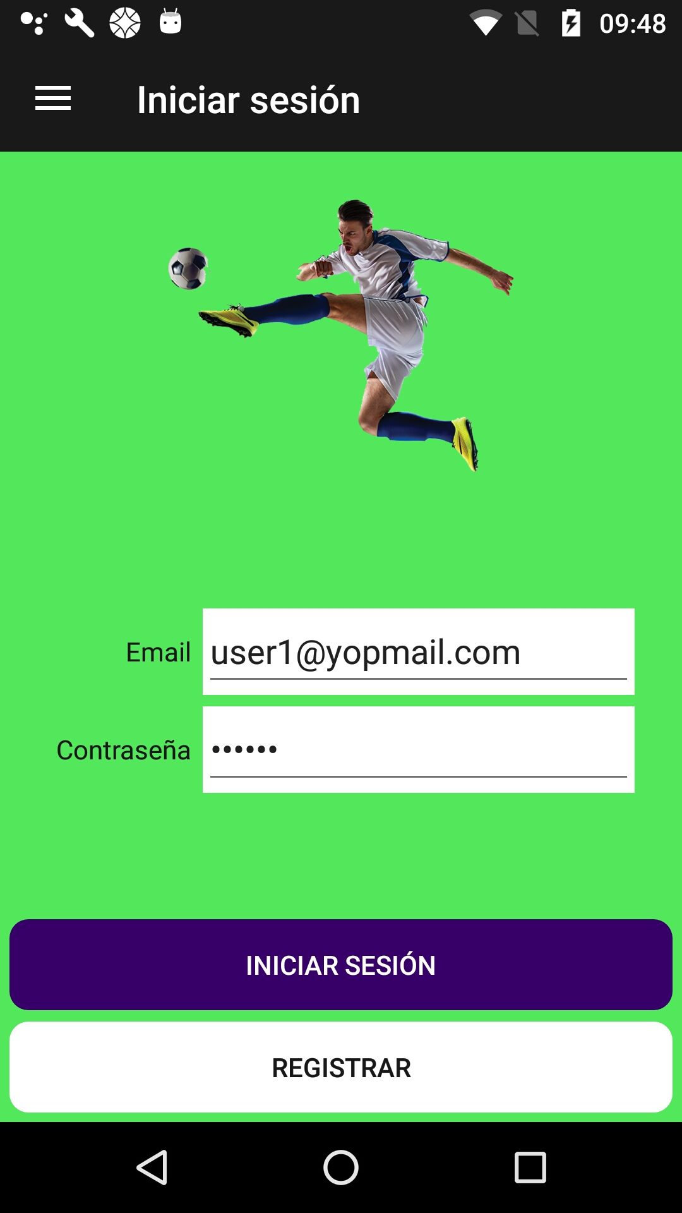 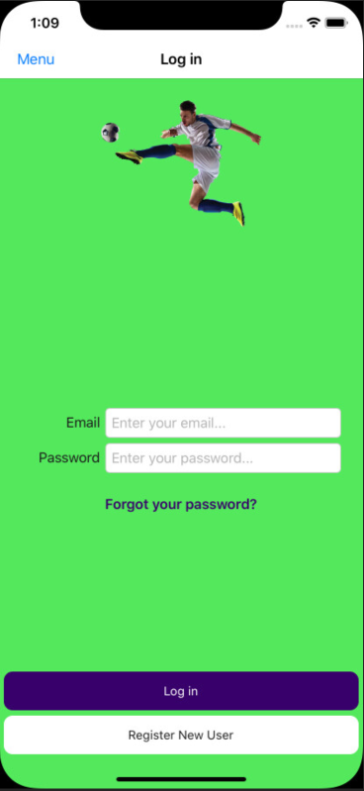

1. Modify the styles in **App**:

<!-- Styles -->

<Style TargetType="Button">

<Setter Property="BackgroundColor" Value="{StaticResource ColorAccent}" />

<Setter Property="HorizontalOptions" Value="FillAndExpand" />

<Setter Property="TextColor" Value="{StaticResource ColorFontInverse}" />

<Setter Property="CornerRadius" Value="10" />

</Style>

<Style TargetType="Label">

<Setter Property="TextColor" Value="{StaticResource ColorFont}" />

</Style>

<Style x:Key="SecondaryButton" TargetType="Button">

<Setter Property="BackgroundColor" Value="{StaticResource ColorSecondary}" />

</Style>

<Style x:Key="DangerButton" TargetType="Button">

<Setter Property="BackgroundColor" Value="{StaticResource ColorDanger}" />

<Setter Property="TextColor" Value="{StaticResource ColorFont}" />

</Style>

1. Add those literals:

**English**

<data name="Email" xml:space="preserve">

<value>Email</value>

</data>

<data name="EmailPlaceHolder" xml:space="preserve">

<value>Enter your email...</value>

</data>

<data name="EmailError" xml:space="preserve">

<value>You must enter an email.</value>

</data>

<data name="Password" xml:space="preserve">

<value>Password</value>

</data>

<data name="PasswordPlaceHolder" xml:space="preserve">

<value>Enter your password...</value>

</data>

<data name="PasswordError" xml:space="preserve">

<value>You must enter a password.</value>

</data>

<data name="Register" xml:space="preserve">

<value>Register</value>

</data>

**Spanish**

<data name="Email" xml:space="preserve">

<value>Email</value>

</data>

<data name="EmailPlaceHolder" xml:space="preserve">

<value>Entra tu email...</value>

</data>

<data name="EmailError" xml:space="preserve">

<value>Debes ingresar un correo electrónico...</value>

</data>

<data name="Password" xml:space="preserve">

<value>Contraseña</value>

</data>

<data name="PasswordPlaceHolder" xml:space="preserve">

<value>Entra tu contraseña...</value>

</data>

<data name="PasswordError" xml:space="preserve">

<value>Debe escribir una contraseña.</value>

</data>

<data name="Register" xml:space="preserve">

<value>Registrar</value>

</data>

**French**

<data name="Email" xml:space="preserve">

<value>Courrier électronique</value>

</data>

<data name="EmailPlaceHolder" xml:space="preserve">

<value>Entrez votre adresse e-mail</value>

</data>

<data name="EmailError" xml:space="preserve">

<value>Vous devez entrer un email.</value>

</data>

<data name="Password" xml:space="preserve">

<value>Mot de passe :</value>

</data>

<data name="PasswordPlaceHolder" xml:space="preserve">

<value>Entrez votre mot de passe</value>

</data>

<data name="PasswordError" xml:space="preserve">

<value>Vous devez entrer un mot de passe.</value>

</data>

<data name="Register" xml:space="preserve">

<value>Registres</value>

</data>

1. And add the properties in **Languages** class:

public static string Email => Resource.Email;

public static string EmailPlaceHolder => Resource.EmailPlaceHolder;

public static string EmailError => Resource.EmailError;

public static string Password => Resource.Password;

public static string PasswordError => Resource.PasswordError;

public static string PasswordPlaceHolder => Resource.PasswordPlaceHolder;

public static string Register => Resource.Register;

1. Modify the **LoginPage**:

<?xml version="1.0" encoding="utf-8" ?>

<ContentPage xmlns="http://xamarin.com/schemas/2014/forms"

xmlns:x="http://schemas.microsoft.com/winfx/2009/xaml"

xmlns:prism="http://prismlibrary.com"

xmlns:busyindicator="clr-namespace:Syncfusion.SfBusyIndicator.XForms;assembly=Syncfusion.SfBusyIndicator.XForms"

xmlns:i18n="clr-namespace:Soccer.Prism.Helpers"

prism:ViewModelLocator.AutowireViewModel="True"

x:Class="Soccer.Prism.Views.LoginPage"

BackgroundColor="{StaticResource ColorBackgroud}"

Title="{Binding Title}">

<AbsoluteLayout>

<StackLayout AbsoluteLayout.LayoutBounds="0,0,1,1"

AbsoluteLayout.LayoutFlags="All"

Padding="5">

<Image HeightRequest="150"

Margin="0,20,0,0"

Source="soccer"/>

<Grid Margin="20"

VerticalOptions="CenterAndExpand">

<Grid.ColumnDefinitions>

<ColumnDefinition Width="*"/>

<ColumnDefinition Width="3*"/>

</Grid.ColumnDefinitions>

<Label Grid.Column="0"

Grid.Row="0"

HorizontalTextAlignment="End"

Text="{i18n:Translate Email}"

VerticalOptions="Center"/>

<Entry Grid.Column="1"

Grid.Row="0"

BackgroundColor="{StaticResource ColorFontInverse}"

Keyboard="Email"

Placeholder="{i18n:Translate EmailPlaceHolder}"

Text="{Binding Email}"/>

<Label Grid.Column="0"

Grid.Row="1"

HorizontalTextAlignment="End"

Text="{i18n:Translate Password}"

VerticalOptions="Center"/>

<Entry Grid.Column="1"

Grid.Row="1"

BackgroundColor="{StaticResource ColorFontInverse}"

IsPassword="True"

Placeholder="{i18n:Translate PasswordPlaceHolder}"

Text="{Binding Password}"/>

</Grid>

<StackLayout>

<Button Command="{Binding LoginCommand}"

IsEnabled="{Binding IsEnabled}"

Text="{i18n:Translate Login}"/>

<Button Command="{Binding RegisterCommand}"

IsEnabled="{Binding IsEnabled}"

Text="{i18n:Translate Register}"

Style="{StaticResource DangerButton}"/>

</StackLayout>

</StackLayout>

<busyindicator:SfBusyIndicator AnimationType="Gear"

AbsoluteLayout.LayoutBounds=".5,.5,.5,.5"

AbsoluteLayout.LayoutFlags="All"

BackgroundColor="{StaticResource ColorAccent}"

HorizontalOptions="Center"

TextColor="{StaticResource ColorFontInverse}"

IsVisible="{Binding IsRunning}"

Title="{i18n:Translate Loading}"

VerticalOptions="Center"

ViewBoxWidth="80"

ViewBoxHeight="80" />

</AbsoluteLayout>

</ContentPage>

1. Modify the **LoginViewModel**:

using Prism.Commands;

using Prism.Navigation;

using Soccer.Prism.Helpers;

namespace Soccer.Prism.ViewModels

{

public class LoginPageViewModel : ViewModelBase

{

private bool _isRunning;

private bool _isEnabled;

private string _password;

private DelegateCommand _loginCommand;

private DelegateCommand _registerCommand;

public LoginPageViewModel(INavigationService navigationService) : base(navigationService)

{

Title = Languages.Login;

IsEnabled = true;

}

public DelegateCommand LoginCommand => _loginCommand ?? (_loginCommand = new DelegateCommand(LoginAsync));

public DelegateCommand RegisterCommand => _registerCommand ?? (_registerCommand = new DelegateCommand(RegisterAsync));

public bool IsRunning

{

get => _isRunning;

set => SetProperty(ref _isRunning, value);

}

public bool IsEnabled

{

get => _isEnabled;

set => SetProperty(ref _isEnabled, value);

}

public string Email { get; set; }

public string Password

{

get => _password;

set => SetProperty(ref _password, value);

}

private async void LoginAsync()

{

if (string.IsNullOrEmpty(Email))

{

await App.Current.MainPage.DisplayAlert(

Languages.Error,

Languages.EmailError,

Languages.Accept);

return;

}

if (string.IsNullOrEmpty(Password))

{

await App.Current.MainPage.DisplayAlert(

Languages.Error,

Languages.PasswordError,

Languages.Accept);

return;

}

}

private void RegisterAsync()

{

}

}

}

1. Test it.
2. Add the **TokenRequest** class:

namespace Soccer.Common.Models

{

public class TokenRequest

{

public string Username { get; set; }

public string Password { get; set; }

}

}

1. Add the **TokenResponse** class:

using System;

namespace Soccer.Common.Models

{

public class TokenResponse

{

public string Token { get; set; }

public DateTime Expiration { get; set; }

public DateTime ExpirationLocal => Expiration.ToLocalTime();

}

}

1. Add those methods to the **IApiService** interface:

Task<Response> GetTokenAsync(string urlBase, string servicePrefix, string controller, TokenRequest request);

Task<Response> GetUserByEmail(string urlBase, string servicePrefix, string controller, string tokenType, string accessToken, EmailRequest request);

1. Add the implementation in **ApiService** class:

public async Task<Response> GetTokenAsync(string urlBase, string servicePrefix, string controller, TokenRequest request)

{

try

{

string requestString = JsonConvert.SerializeObject(request);

StringContent content = new StringContent(requestString, Encoding.UTF8, "application/json");

HttpClient client = new HttpClient

{

BaseAddress = new Uri(urlBase)

};

string url = $"{servicePrefix}{controller}";

HttpResponseMessage response = await client.PostAsync(url, content);

string result = await response.Content.ReadAsStringAsync();

if (!response.IsSuccessStatusCode)

{

return new Response

{

IsSuccess = false,

Message = result,

};

}

TokenResponse token = JsonConvert.DeserializeObject<TokenResponse>(result);

return new Response

{

IsSuccess = true,

Result = token

};

}

catch (Exception ex)

{

return new Response

{

IsSuccess = false,

Message = ex.Message

};

}

}

public async Task<Response> GetUserByEmail(

string urlBase,

string servicePrefix,

string controller,

string tokenType,

string accessToken,

EmailRequest request)

{

try

{

string requestString = JsonConvert.SerializeObject(request);

StringContent content = new StringContent(requestString, Encoding.UTF8, "application/json");

HttpClient client = new HttpClient

{

BaseAddress = new Uri(urlBase)

};

client.DefaultRequestHeaders.Authorization = new AuthenticationHeaderValue(tokenType, accessToken);

string url = $"{servicePrefix}{controller}";

HttpResponseMessage response = await client.PostAsync(url, content);

string result = await response.Content.ReadAsStringAsync();

if (!response.IsSuccessStatusCode)

{

return new Response

{

IsSuccess = false,

Message = result,

};

}

UserResponse userResponse = JsonConvert.DeserializeObject<UserResponse>(result);

return new Response

{

IsSuccess = true,

Result = userResponse

};

}

catch (Exception ex)

{

return new Response

{

IsSuccess = false,

Message = ex.Message

};

}

}

1. Add literals for **LoginError**:

public static string LoginError => Resource.LoginError;

1. Modify the **Settings** class:

using Plugin.Settings;

using Plugin.Settings.Abstractions;

namespace Soccer.Common.Helpers

{

public static class Settings

{

private const string _tournament = "tournament";

private const string _user = "user";

private const string _token = "token";

private const string _isLogin = "isLogin";

private static readonly string _stringDefault = string.Empty;

private static readonly bool _boolDefault = false;

private static ISettings AppSettings => CrossSettings.Current;

public static string Tournament

{

get => AppSettings.GetValueOrDefault(_tournament, _stringDefault);

set => AppSettings.AddOrUpdateValue(_tournament, value);

}

public static string User

{

get => AppSettings.GetValueOrDefault(_user, _stringDefault);

set => AppSettings.AddOrUpdateValue(_user, value);

}

public static string Token

{

get => AppSettings.GetValueOrDefault(_token, _stringDefault);

set => AppSettings.AddOrUpdateValue(_token, value);

}

public static bool IsLogin

{

get => AppSettings.GetValueOrDefault(_isLogin, _boolDefault);

set => AppSettings.AddOrUpdateValue(_isLogin, value);

}

}

}

1. Modify the **LoginPageViewModel** class:

using Newtonsoft.Json;

using Prism.Commands;

using Prism.Navigation;

using Soccer.Common.Helpers;

using Soccer.Common.Models;

using Soccer.Common.Models.Soccer.Common.Models;

using Soccer.Common.Services;

using Soccer.Prism.Helpers;

namespace Soccer.Prism.ViewModels

{

public class LoginPageViewModel : ViewModelBase

{

private readonly INavigationService _navigationService;

private readonly IApiService _apiService;

private bool _isRunning;

private bool _isEnabled;

private string _password;

private DelegateCommand _loginCommand;

private DelegateCommand _registerCommand;

public LoginPageViewModel(INavigationService navigationService, IApiService apiService)

: base(navigationService)

{

_navigationService = navigationService;

_apiService = apiService;

Title = Languages.Login;

IsEnabled = true;

}

public DelegateCommand LoginCommand => _loginCommand ?? (_loginCommand = new DelegateCommand(LoginAsync));

public DelegateCommand RegisterCommand => _registerCommand ?? (_registerCommand = new DelegateCommand(RegisterAsync));

public bool IsRunning

{

get => _isRunning;

set => SetProperty(ref _isRunning, value);

}

public bool IsEnabled

{

get => _isEnabled;

set => SetProperty(ref _isEnabled, value);

}

public string Email { get; set; }

public string Password

{

get => _password;

set => SetProperty(ref _password, value);

}

private async void LoginAsync()

{

if (string.IsNullOrEmpty(Email))

{

await App.Current.MainPage.DisplayAlert(

Languages.Error,

Languages.EmailError,

Languages.Accept);

return;

}

if (string.IsNullOrEmpty(Password))

{

await App.Current.MainPage.DisplayAlert(

Languages.Error,

Languages.PasswordError,

Languages.Accept);

return;

}

IsRunning = true;

IsEnabled = false;

string url = App.Current.Resources["UrlAPI"].ToString();

bool connection = await _apiService.CheckConnectionAsync(url);

if (!connection)

{

IsRunning = true;

IsEnabled = false;

await App.Current.MainPage.DisplayAlert(Languages.Error, Languages.ConnectionError, Languages.Accept);

return;

}

TokenRequest request = new TokenRequest

{

Password = Password,

Username = Email

};

Response response = await _apiService.GetTokenAsync(url, "Account", "/CreateToken", request);

if (!response.IsSuccess)

{

IsRunning = false;

IsEnabled = true;

await App.Current.MainPage.DisplayAlert(Languages.Error, Languages.LoginError, Languages.Accept);

Password = string.Empty;

return;

}

TokenResponse token = (TokenResponse)response.Result;

EmailRequest request2 = new EmailRequest

{

CultureInfo = Languages.Culture,

Email = Email

};

Response response2 = await _apiService.GetUserByEmail(url, "api", "/Account/GetUserByEmail", "bearer", token.Token, request2);

UserResponse userResponse = (UserResponse)response2.Result;

Settings.User = JsonConvert.SerializeObject(userResponse);

Settings.Token = JsonConvert.SerializeObject(token);

Settings.IsLogin = true;

IsRunning = false;

IsEnabled = true;

await _navigationService.NavigateAsync("/SoccerMasterDetailPage/NavigationPage/TournamentsPage");

Password = string.Empty;

}

private void RegisterAsync()

{

}

}

}

1. Modify the **SoccerMasterDetailPage**:

<Image HeightRequest="150"

Source="soccer"/>

<Label FontAttributes="Bold"

FontSize="Large"

Text="{Binding User.FullName}"

TextColor="Black"/>

<ListView BackgroundColor="Transparent"

ItemsSource="{Binding Menus}"

1. Add a literal for **Logout**:

public static string Logout => Resource.Logout;

1. Modify the **SoccerMasterDetailPageViewModel**:

private UserResponse _user;

...

public SoccerMasterDetailPageViewModel(INavigationService navigationService) : base(navigationService)

{

_navigationService = navigationService;

LoadUser();

LoadMenus();

}

…

public UserResponse User

{

get => _user;

set => SetProperty(ref _user, value);

}

private void LoadUser()

{

if (Settings.IsLogin)

{

User = JsonConvert.DeserializeObject<UserResponse>(Settings.User);

}

}

…

new Menu

{

Icon = "login",

PageName = "LoginPage",

Title = Settings.IsLogin ? Languages.Logout : Languages.Login

}

1. Modify the **MenuItemViewModel**:

private async void SelectMenuAsync()

{

if (PageName == "LoginPage" && Settings.IsLogin)

{

Settings.IsLogin = false;

Settings.User = null;

Settings.Token = null;

}

await _navigationService.NavigateAsync($"/SoccerMasterDetailPage/NavigationPage/{PageName}");

}

1. Test it.
2. Now we are going to modify the menu by:

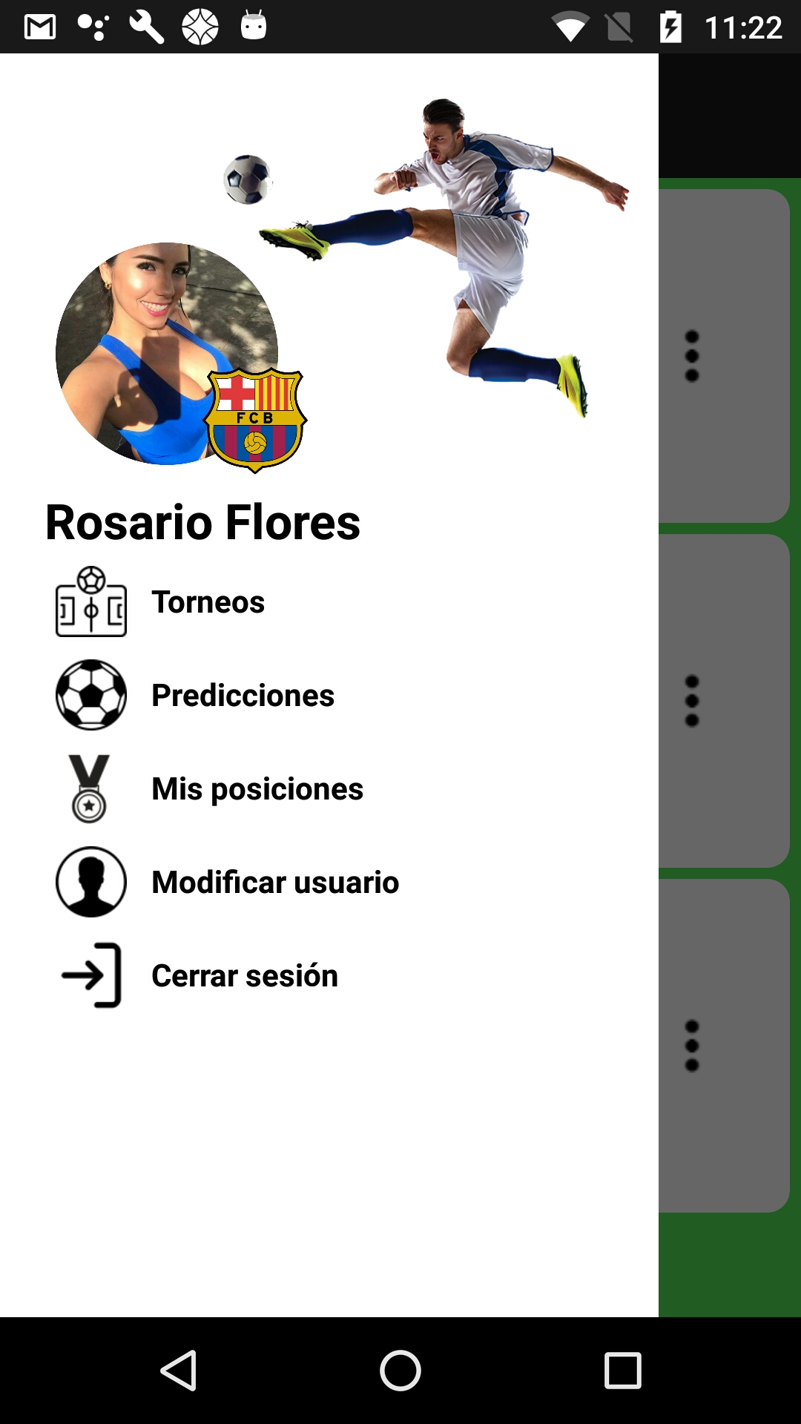

1. Add the NuGet: **Xamarin.FFImageLoading.Transformations** to all prism projects.
2. Modify the **SoccerMasterDetailPage**:

<?xml version="1.0" encoding="utf-8" ?>

<MasterDetailPage xmlns="http://xamarin.com/schemas/2014/forms"

xmlns:x="http://schemas.microsoft.com/winfx/2009/xaml"

xmlns:prism="http://prismlibrary.com"

xmlns:ffimageloading="clr-namespace:FFImageLoading.Forms;assembly=FFImageLoading.Forms"

xmlns:fftransformations="clr-namespace:FFImageLoading.Transformations;assembly=FFImageLoading.Transformations"

prism:ViewModelLocator.AutowireViewModel="True"

x:Class="Soccer.Prism.Views.SoccerMasterDetailPage">

<MasterDetailPage.Master>

<ContentPage Title="Menu"

BackgroundColor="{StaticResource ColorDanger}">

<StackLayout Padding="20">

<RelativeLayout>

<Image x:Name="Logo" HorizontalOptions="Center"

RelativeLayout.XConstraint="{ConstraintExpression Type=RelativeToParent,Property=X,Factor=1,Constant=60}"

HeightRequest="150"

Source="soccer"/>

<ffimageloading:CachedImage x:Name="Picture"

RelativeLayout.YConstraint="{ConstraintExpression Type=RelativeToView, ElementName=Logo,Property=Y,Factor=1,Constant=60}"

Aspect="AspectFill"

Source="{Binding User.PictureFullPath}"

CacheDuration= "50"

HeightRequest="100"

Margin="5"

RetryCount= "3"

RetryDelay= "600"

WidthRequest="100">

<ffimageloading:CachedImage.Transformations>

<fftransformations:CircleTransformation />

</ffimageloading:CachedImage.Transformations>

</ffimageloading:CachedImage>

<ffimageloading:CachedImage x:Name="Team"

RelativeLayout.YConstraint="{ConstraintExpression Type=RelativeToView, ElementName=Picture,Property=Y,Factor=1,Constant=50}"

RelativeLayout.XConstraint="{ConstraintExpression Type=RelativeToView, ElementName=Picture,Property=X,Factor=1,Constant=60}"

Aspect="AspectFill"

Source="{Binding User.Team.LogoFullPath}"

CacheDuration= "50"

HeightRequest="50"

Margin="5"

RetryCount= "3"

RetryDelay= "600"

WidthRequest="50">

<ffimageloading:CachedImage.Transformations>

<fftransformations:CircleTransformation />

</ffimageloading:CachedImage.Transformations>

</ffimageloading:CachedImage>

<Label RelativeLayout.YConstraint="{ConstraintExpression Type=RelativeToView, ElementName=Picture,Property=Y,Factor=1,Constant=110}"

FontAttributes="Bold"

FontSize="Large"

Text="{Binding User.FullName}"

TextColor="Black"/>

</RelativeLayout>

<ListView BackgroundColor="Transparent"

ItemsSource="{Binding Menus}"

HasUnevenRows="True"

SeparatorVisibility="None">

1. Test it.

## 

## Register users from App

We are going to make this screen:

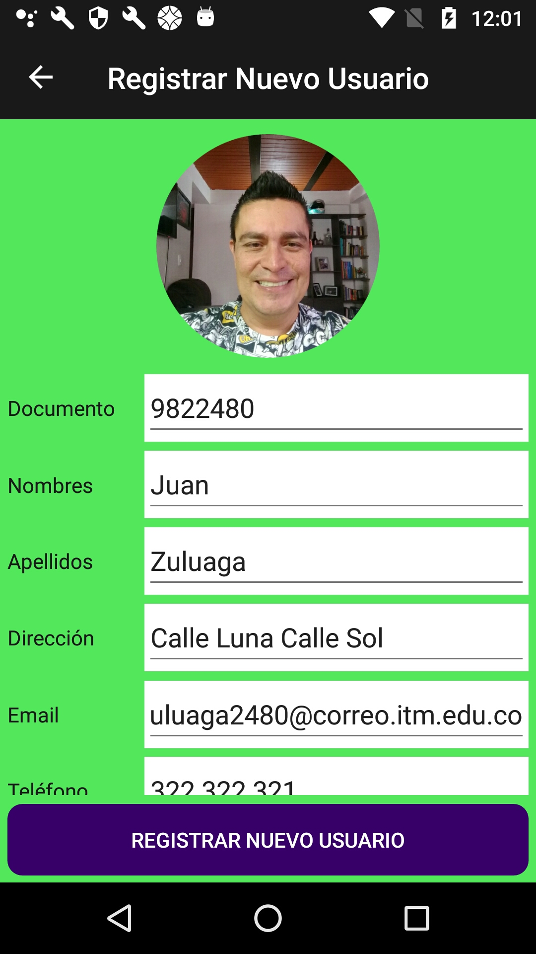 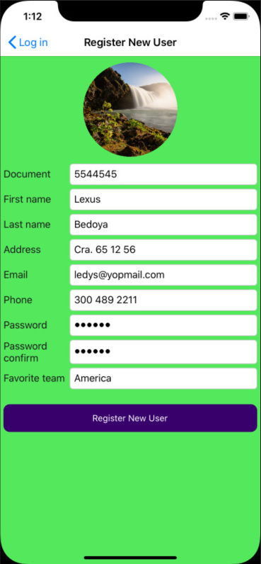

1. Add the **RegisterPage** page:

<?xml version="1.0" encoding="utf-8" ?>

<ContentPage xmlns="http://xamarin.com/schemas/2014/forms"

xmlns:x="http://schemas.microsoft.com/winfx/2009/xaml"

xmlns:prism="http://prismlibrary.com"

prism:ViewModelLocator.AutowireViewModel="True"

x:Class="Soccer.Prism.Views.RegisterPage"

BackgroundColor="{StaticResource ColorBackgroud}"

Title="{Binding Title}">

</ContentPage>

1. Modify the **RegisterPageViewModel** class:

using Prism.Navigation;

using Soccer.Prism.Helpers;

namespace Soccer.Prism.ViewModels

{

public class RegisterPageViewModel : ViewModelBase

{

public RegisterPageViewModel(INavigationService navigationService) : base(navigationService)

{

Title = Languages.Register;

}

}

}

1. Modify the **LoginPageViewModel** class:

private async void RegisterAsync()

{

await _navigationService.NavigateAsync(nameof(RegisterPage));

}

1. Add the **IRegexHelper**:

namespace Soccer.Common.Helpers

{

public interface IRegexHelper

{

bool IsValidEmail(string emailaddress);

}

}

1. Add the **RegexHelper**:

using System;

using System.Net.Mail;

namespace Soccer.Common.Helpers

{

public class RegexHelper : IRegexHelper

{

public bool IsValidEmail(string emailaddress)

{

try

{

new MailAddress(emailaddress);

return true;

}

catch (FormatException)

{

return false;

}

}

}

}

1. Add the injection for the new helper in **App.xmls.cs**:

containerRegistry.Register<ITransformHelper, TransformHelper>();

containerRegistry.Register<IRegexHelper, RegexHelper>();

containerRegistry.RegisterForNavigation<NavigationPage>();

1. Modify the styles in **App**:

<!-- Parameters -->

<x:String x:Key="UrlAPI">https://SoccerWeb0.azurewebsites.net/</x:String>

<x:String x:Key="UrlNoImage">https://SoccerWeb0.azurewebsites.net/images/noimage.png</x:String>

<!-- Colors -->

<Color x:Key="ColorBackgroud">#54E85D</Color>

<Color x:Key="ColorPrimary">#191919</Color>

<Color x:Key="ColorSecondary">#90FF69</Color>

<Color x:Key="ColorDanger">#FFFFFF</Color>

<Color x:Key="ColorAccent">#38006A</Color>

<Color x:Key="ColorFont">#191919</Color>

<Color x:Key="ColorFontInverse">#FFFFFF</Color>

<!-- Styles -->

<Style TargetType="Button">

<Setter Property="BackgroundColor" Value="{StaticResource ColorAccent}" />

<Setter Property="HorizontalOptions" Value="FillAndExpand" />

<Setter Property="TextColor" Value="{StaticResource ColorFontInverse}" />

<Setter Property="CornerRadius" Value="10" />

</Style>

<Style TargetType="Label">

<Setter Property="TextColor" Value="{StaticResource ColorFont}" />

</Style>

<Style TargetType="Entry">

<Setter Property="BackgroundColor" Value="{StaticResource ColorFontInverse}" />

</Style>

<Style TargetType="Picker">

<Setter Property="BackgroundColor" Value="{StaticResource ColorFontInverse}" />

</Style>

<Style x:Key="SecondaryButton" TargetType="Button">

<Setter Property="BackgroundColor" Value="{StaticResource ColorSecondary}" />

</Style>

<Style x:Key="DangerButton" TargetType="Button">

<Setter Property="BackgroundColor" Value="{StaticResource ColorDanger}" />

<Setter Property="TextColor" Value="{StaticResource ColorFont}" />

</Style>

1. Add those literals:

**English**

<data name="Document" xml:space="preserve">

<value>Document</value>

</data>

<data name="DocumentPlaceHolder" xml:space="preserve">

<value>Enter your document number...</value>

</data>

<data name="DocumentError" xml:space="preserve">

<value>You must enter a document.</value>

</data>

<data name="FirstName" xml:space="preserve">

<value>First name</value>

</data>

<data name="FirstNamePlaceHolder" xml:space="preserve">

<value>Enter your first name...</value>

</data>

<data name="FirstNameError" xml:space="preserve">

<value>You must enter a first name.</value>

</data>

<data name="LastName" xml:space="preserve">

<value>Last name</value>

</data>

<data name="LastNamePlaceHolder" xml:space="preserve">

<value>Enter your last name...</value>

</data>

<data name="LastNameError" xml:space="preserve">

<value>You must enter a last name.</value>

</data>

<data name="Address" xml:space="preserve">

<value>Address</value>

</data>

<data name="AddressPlaceHolder" xml:space="preserve">

<value>Enter your address...</value>

</data>

<data name="AddressError" xml:space="preserve">

<value>You must enter an address.</value>

</data>

<data name="Phone" xml:space="preserve">

<value>Phone</value>

</data>

<data name="PhoneError" xml:space="preserve">

<value>Enter your phone...</value>

</data>

<data name="PhonePlaceHolder" xml:space="preserve">

<value>You must enter a phone.</value>

</data>

<data name="FavoriteTeam" xml:space="preserve">

<value>Favorite team</value>

</data>

<data name="FavoriteTeamError" xml:space="preserve">

<value>You must select a favorite team.</value>

</data>

<data name="FavoriteTeamPlaceHolder" xml:space="preserve">

<value>Select your favorite team...</value>

</data>

<data name="PasswordConfirm" xml:space="preserve">

<value>Password confirm</value>

</data>

<data name="PasswordConfirmError1" xml:space="preserve">

<value>You must enter a password confirm.</value>

</data>

<data name="PasswordConfirmError2" xml:space="preserve">

<value>The password and confirm does not match.</value>

</data>

<data name="PasswordConfirmPlaceHolder" xml:space="preserve">

<value>Enter the password confirm...</value>

</data>

**Spanish**

<data name="Document" xml:space="preserve">

<value>Documento</value>

</data>

<data name="DocumentPlaceHolder" xml:space="preserve">

<value>Ingrese su número de documento...</value>

</data>

<data name="DocumentError" xml:space="preserve">

<value>Debe ingresar un documento.</value>

</data>

<data name="FirstName" xml:space="preserve">

<value>Nombres</value>

</data>

<data name="FirstNamePlaceHolder" xml:space="preserve">

<value>Ingrese sus nombres...</value>

</data>

<data name="FirstNameError" xml:space="preserve">

<value>Debe escribir un nombre.</value>

</data>

<data name="LastName" xml:space="preserve">

<value>Apellidos</value>

</data>

<data name="LastNamePlaceHolder" xml:space="preserve">

<value>Ingrese sus apellidos...</value>

</data>

<data name="LastNameError" xml:space="preserve">

<value>Debe escribir apellidos.</value>

</data>

<data name="Address" xml:space="preserve">

<value>Dirección</value>

</data>

<data name="AddressPlaceHolder" xml:space="preserve">

<value>Introduzca su dirección...</value>

</data>

<data name="AddressError" xml:space="preserve">

<value>Debe especificar una dirección.</value>

</data>

<data name="Phone" xml:space="preserve">

<value>Teléfono</value>

</data>

<data name="PhoneError" xml:space="preserve">

<value>Ingresa tu teléfono...</value>

</data>

<data name="PhonePlaceHolder" xml:space="preserve">

<value>Debes poner un número de teléfono.</value>

</data>

<data name="FavoriteTeam" xml:space="preserve">

<value>Equipo favorito</value>

</data>

<data name="FavoriteTeamError" xml:space="preserve">

<value>Debes seleccionar un equipo favorito</value>

</data>

<data name="FavoriteTeamPlaceHolder" xml:space="preserve">

<value>Selecciona tu equipo favorito...</value>

</data>

<data name="PasswordConfirm" xml:space="preserve">

<value>Confirmar contraseña</value>

</data>

<data name="PasswordConfirmError1" xml:space="preserve">

<value>Debes ingresar una contraseña</value>

</data>

<data name="PasswordConfirmError2" xml:space="preserve">

<value>La nueva contraseña y la confirmación de contraseña no son iguales.</value>

</data>

<data name="PasswordConfirmPlaceHolder" xml:space="preserve">

<value>Ingrese la confirmación de contraseña...</value>

</data>

<data name="PasswordError" xml:space="preserve">

<value>Debe ingresar una contraseña de al menos seis caracteres.</value>

</data>

**French**

<data name="Document" xml:space="preserve">

<value>Document</value>

</data>

<data name="DocumentPlaceHolder" xml:space="preserve">

<value>Entrez votre numéro de document ...!</value>

</data>

<data name="DocumentError" xml:space="preserve">

<value>Vous devez saisir un document.!</value>

</data>

<data name="FirstName" xml:space="preserve">

<value>Prénom</value>

</data>

<data name="FirstNamePlaceHolder" xml:space="preserve">

<value>Entrez votre prénom</value>

</data>

<data name="FirstNameError" xml:space="preserve">

<value>Vous devez entrer un prénom</value>

</data>

<data name="LastName" xml:space="preserve">

<value>Nom</value>

</data>

<data name="LastNamePlaceHolder" xml:space="preserve">

<value>Entrez votre nom</value>

</data>

<data name="LastNameError" xml:space="preserve">

<value>Vous devez entrer un nom</value>

</data>

<data name="Address" xml:space="preserve">

<value>Adresse</value>

</data>

<data name="AddressPlaceHolder" xml:space="preserve">

<value>Entrez votre adresse&amp;hellip;</value>

</data>

<data name="AddressError" xml:space="preserve">

<value>Vous devez indiquer une adresse.</value>

</data>

<data name="Phone" xml:space="preserve">

<value>Téléphone</value>

</data>

<data name="PhoneError" xml:space="preserve">

<value>Entrez votre téléphone</value>

</data>

<data name="PhonePlaceHolder" xml:space="preserve">

<value>Vous devez introduire un numéro de téléphone.</value>

</data>

<data name="FavoriteTeam" xml:space="preserve">

<value>Équipe favorite</value>

</data>

<data name="FavoriteTeamError" xml:space="preserve">

<value>Vous devez sélectionner une équipe préférée.!</value>

</data>

<data name="FavoriteTeamPlaceHolder" xml:space="preserve">

<value>ton équipe favorite</value>

</data>

<data name="PasswordConfirm" xml:space="preserve">

<value>Confirmer le mot de passe</value>

</data>

<data name="PasswordConfirmError1" xml:space="preserve">

<value>Vous devez saisir un mot de passe.</value>

</data>

<data name="PasswordConfirmError2" xml:space="preserve">

<value>Le mot de passe et sa confirmation ne coïncident pas.</value>

</data>

<data name="PasswordConfirmPlaceHolder" xml:space="preserve">

<value>Saisir le mot de passe, puis valider</value>

</data>

<data name="PasswordError" xml:space="preserve">

<value>Vous devez saisir un mot de passe d&amp;#39;au moins six caractères.!</value>

</data>

1. And add the properties in **Languages** class:

public static string DocumentError => Resource.DocumentError;

public static string FirstNameError => Resource.FirstNameError;

public static string LastNameError => Resource.LastNameError;

public static string Address => Resource.Address;

public static string AddressError => Resource.AddressError;

public static string AddressPlaceHolder => Resource.AddressPlaceHolder;

public static string Phone => Resource.Phone;

public static string PhoneError => Resource.PhoneError;

public static string PhonePlaceHolder => Resource.PhonePlaceHolder;

public static string FavoriteTeam => Resource.FavoriteTeam;

public static string FavoriteTeamError => Resource.FavoriteTeamError;

public static string FavoriteTeamPlaceHolder => Resource.FavoriteTeamPlaceHolder;

public static string PasswordConfirm => Resource.PasswordConfirm;

public static string PasswordConfirmError1 => Resource.PasswordConfirmError1;

public static string PasswordConfirmError2 => Resource.PasswordConfirmError2;

public static string PasswordConfirmPlaceHolder => Resource.PasswordConfirmPlaceHolder;

1. Modify the **RegisterPage**:

<?xml version="1.0" encoding="utf-8" ?>

<ContentPage xmlns="http://xamarin.com/schemas/2014/forms"

xmlns:x="http://schemas.microsoft.com/winfx/2009/xaml"

xmlns:prism="http://prismlibrary.com"

xmlns:busyindicator="clr-namespace:Syncfusion.SfBusyIndicator.XForms;assembly=Syncfusion.SfBusyIndicator.XForms"

xmlns:i18n="clr-namespace:Soccer.Prism.Helpers"

xmlns:ffimageloading="clr-namespace:FFImageLoading.Forms;assembly=FFImageLoading.Forms"

xmlns:fftransformations="clr-namespace:FFImageLoading.Transformations;assembly=FFImageLoading.Transformations"

prism:ViewModelLocator.AutowireViewModel="True"

x:Class="Soccer.Prism.Views.RegisterPage"

BackgroundColor="{StaticResource ColorBackgroud}"

Title="{Binding Title}">

<AbsoluteLayout>

<StackLayout AbsoluteLayout.LayoutBounds="0,0,1,1"

AbsoluteLayout.LayoutFlags="All"

Padding="5">

<ScrollView>

<StackLayout>

<ffimageloading:CachedImage Aspect="AspectFit"

Source="{Binding Image}"

CacheDuration= "50"

HeightRequest="150"

Margin="5"

RetryCount= "3"

RetryDelay= "600">

<ffimageloading:CachedImage.Transformations>

<fftransformations:CircleTransformation />

</ffimageloading:CachedImage.Transformations>

</ffimageloading:CachedImage>

<Grid>

<Grid.ColumnDefinitions>

<ColumnDefinition Width="*"/>

<ColumnDefinition Width="3*"/>

</Grid.ColumnDefinitions>

<Grid.RowDefinitions>

<RowDefinition Height="Auto"/>

<RowDefinition Height="Auto"/>

<RowDefinition Height="Auto"/>

<RowDefinition Height="Auto"/>

<RowDefinition Height="Auto"/>

<RowDefinition Height="Auto"/>

<RowDefinition Height="Auto"/>

<RowDefinition Height="Auto"/>

<RowDefinition Height="Auto"/>

</Grid.RowDefinitions>

<Label Grid.Row="0"

Grid.Column="0"

Text="{i18n:Translate Document}"

VerticalOptions="Center"/>

<Entry Grid.Row="0"

Grid.Column="1"

Keyboard="Numeric"

Placeholder="{i18n:Translate DocumentPlaceHolder}"

Text="{Binding User.Document}"/>

<Label Grid.Row="1"

Grid.Column="0"

Text="{i18n:Translate FirstName}"

VerticalOptions="Center"/>

<Entry Grid.Row="1"

Grid.Column="1"

Placeholder="{i18n:Translate FirstNamePlaceHolder}"

Text="{Binding User.FirstName}"/>

<Label Grid.Row="2"

Grid.Column="0"

Text="{i18n:Translate LastName}"

VerticalOptions="Center"/>

<Entry Grid.Row="2"

Grid.Column="1"

Placeholder="{i18n:Translate LastNamePlaceHolder}"

Text="{Binding User.LastName}"/>

<Label Grid.Row="3"

Grid.Column="0"

Text="{i18n:Translate Address}"

VerticalOptions="Center"/>

<Entry Grid.Row="3"

Grid.Column="1"

Placeholder="{i18n:Translate AddressPlaceHolder}"

Text="{Binding User.Address}"/>

<Label Grid.Row="4"

Grid.Column="0"

Text="{i18n:Translate Email}"

VerticalOptions="Center"/>

<Entry Grid.Row="4"

Grid.Column="1"

Keyboard="Email"

Placeholder="{i18n:Translate EmailPlaceHolder}"

Text="{Binding User.Email}"/>

<Label Grid.Row="5"

Grid.Column="0"

Text="{i18n:Translate Phone}"

VerticalOptions="Center"/>

<Entry Grid.Row="5"

Grid.Column="1"

Keyboard="Telephone"

Placeholder="{i18n:Translate PhonePlaceHolder}"

Text="{Binding User.Phone}"/>

<Label Grid.Row="6"

Grid.Column="0"

Text="{i18n:Translate Password}"

VerticalOptions="Center"/>

<Entry Grid.Row="6"

Grid.Column="1"

IsPassword="True"

Placeholder="{i18n:Translate PasswordPlaceHolder}"

Text="{Binding User.Password}"/>

<Label Grid.Row="7"

Grid.Column="0"

Text="{i18n:Translate PasswordConfirm}"

VerticalOptions="Center"/>

<Entry Grid.Row="7"

Grid.Column="1"

IsPassword="True"

Placeholder="{i18n:Translate PasswordConfirmPlaceHolder}"

Text="{Binding User.PasswordConfirm}"/>

<Label Grid.Row="8"

Grid.Column="0"

Text="{i18n:Translate FavoriteTeam}"

VerticalOptions="Center"/>

<Picker Grid.Row="8"

Grid.Column="1"

ItemDisplayBinding="{Binding Name}"

ItemsSource="{Binding Teams}"

SelectedItem="{Binding Team}"

Title="{i18n:Translate FavoriteTeamPlaceHolder}">

</Picker>

</Grid>

</StackLayout>

</ScrollView>

<Button Command="{Binding RegisterCommand}"

IsEnabled="{Binding IsEnabled}"

Text="{i18n:Translate Register}"/>

</StackLayout>

<busyindicator:SfBusyIndicator AnimationType="Gear"

AbsoluteLayout.LayoutBounds=".5,.5,.5,.5"

AbsoluteLayout.LayoutFlags="All"

BackgroundColor="{StaticResource ColorAccent}"

HorizontalOptions="Center"

TextColor="{StaticResource ColorFontInverse}"

IsVisible="{Binding IsRunning}"

Title="{i18n:Translate Loading}"

VerticalOptions="Center"

ViewBoxWidth="80"

ViewBoxHeight="80" />

</AbsoluteLayout>

</ContentPage>

1. Modify the **RegisterPageViewModel** class:

using Prism.Commands;

using Prism.Navigation;

using Soccer.Common.Helpers;

using Soccer.Common.Models;

using Soccer.Common.Services;

using Soccer.Prism.Helpers;

using System;

using System.Collections.Generic;

using System.Collections.ObjectModel;

using System.Linq;

using System.Threading.Tasks;

using Xamarin.Forms;

namespace Soccer.Prism.ViewModels

{

public class RegisterPageViewModel : ViewModelBase

{

private readonly INavigationService _navigationService;

private readonly IRegexHelper _regexHelper;

private readonly IApiService _apiService;

private ImageSource _image;

private UserRequest _user;

private TeamResponse _team;

private ObservableCollection<TeamResponse> _teams;

private bool _isRunning;

private bool _isEnabled;

private DelegateCommand _registerCommand;

public RegisterPageViewModel(

INavigationService navigationService,

IRegexHelper regexHelper,

IApiService apiService) : base(navigationService)

{

_navigationService = navigationService;

_regexHelper = regexHelper;

_apiService = apiService;

Title = Languages.Register;

Image = App.Current.Resources["UrlNoImage"].ToString();

IsEnabled = true;

User = new UserRequest();

LoadTeamsAsync();

}

public DelegateCommand RegisterCommand => _registerCommand ?? (_registerCommand = new DelegateCommand(RegisterAsync));

public ImageSource Image

{

get => _image;

set => SetProperty(ref _image, value);

}

public UserRequest User

{

get => _user;

set => SetProperty(ref _user, value);

}

public TeamResponse Team

{

get => _team;

set => SetProperty(ref _team, value);

}

public ObservableCollection<TeamResponse> Teams

{

get => _teams;

set => SetProperty(ref _teams, value);

}

public bool IsRunning

{

get => _isRunning;

set => SetProperty(ref _isRunning, value);

}

public bool IsEnabled

{

get => _isEnabled;

set => SetProperty(ref _isEnabled, value);

}

private async void RegisterAsync()

{

bool isValid = await ValidateDataAsync();

if (!isValid)

{

return;

}

IsRunning = true;

IsEnabled = false;

string url = App.Current.Resources["UrlAPI"].ToString();

bool connection = await _apiService.CheckConnectionAsync(url);

if (!connection)

{

IsRunning = false;

IsEnabled = true;

await App.Current.MainPage.DisplayAlert(Languages.Error, Languages.ConnectionError, Languages.Accept);

return;

}

}

private async Task<bool> ValidateDataAsync()

{

if (string.IsNullOrEmpty(User.Document))

{

await App.Current.MainPage.DisplayAlert(Languages.Error, Languages.DocumentError, Languages.Accept);

return false;

}

if (string.IsNullOrEmpty(User.FirstName))

{

await App.Current.MainPage.DisplayAlert(Languages.Error, Languages.FirstNameError, Languages.Accept);

return false;

}

if (string.IsNullOrEmpty(User.LastName))

{

await App.Current.MainPage.DisplayAlert(Languages.Error, Languages.LastNameError, Languages.Accept);

return false;

}

if (string.IsNullOrEmpty(User.Address))

{

await App.Current.MainPage.DisplayAlert(Languages.Error, Languages.AddressError, Languages.Accept);

return false;

}

if (string.IsNullOrEmpty(User.Email) || !_regexHelper.IsValidEmail(User.Email))

{

await App.Current.MainPage.DisplayAlert(Languages.Error, Languages.EmailError, Languages.Accept);

return false;

}

if (string.IsNullOrEmpty(User.Phone))

{

await App.Current.MainPage.DisplayAlert(Languages.Error, Languages.PhoneError, Languages.Accept);

return false;

}

if (Team == null)

{

await App.Current.MainPage.DisplayAlert(Languages.Error, Languages.FavoriteTeamError, Languages.Accept);

return false;

}

if (string.IsNullOrEmpty(User.Password) || User.Password?.Length < 6)

{

await App.Current.MainPage.DisplayAlert(Languages.Error, Languages.PasswordError, Languages.Accept);

return false;

}

if (string.IsNullOrEmpty(User.PasswordConfirm))

{

await App.Current.MainPage.DisplayAlert(Languages.Error, Languages.PasswordConfirmError1, Languages.Accept);

return false;

}

if (User.Password != User.PasswordConfirm)

{

await App.Current.MainPage.DisplayAlert(Languages.Error, Languages.PasswordConfirmError2, Languages.Accept);

return false;

}

return true;

}

private async void LoadTeamsAsync()

{

IsRunning = true;

IsEnabled = false;

string url = App.Current.Resources["UrlAPI"].ToString();

bool connection = await _apiService.CheckConnectionAsync(url);

if (!connection)

{

IsRunning = false;

IsEnabled = true;

await App.Current.MainPage.DisplayAlert(Languages.Error, Languages.ConnectionError, Languages.Accept);

return;

}

Response response = await _apiService.GetListAsync<TeamResponse>(url, "/api", "/Teams");

IsRunning = false;

IsEnabled = true;

if (!response.IsSuccess)

{

await App.Current.MainPage.DisplayAlert(Languages.Error, response.Message, Languages.Accept);

return;

}

List<TeamResponse> list = (List<TeamResponse>)response.Result;

Teams = new ObservableCollection<TeamResponse>(list.OrderBy(t => t.Name));

}

}

}

1. Test it.
2. Add the method **RegisterUserAsync** to interface **IApiService**:

Task<Response> RegisterUserAsync(string urlBase, string servicePrefix, string controller, UserRequest userRequest);

1. Add the method **RegisterUserAsync** to class **ApiService**:

public async Task<Response> RegisterUserAsync(string urlBase, string servicePrefix, string controller, UserRequest userRequest)

{

try

{

string request = JsonConvert.SerializeObject(userRequest);

StringContent content = new StringContent(request, Encoding.UTF8, "application/json");

HttpClient client = new HttpClient

{

BaseAddress = new Uri(urlBase)

};

string url = $"{servicePrefix}{controller}";

HttpResponseMessage response = await client.PostAsync(url, content);

string answer = await response.Content.ReadAsStringAsync();

if (!response.IsSuccessStatusCode)

{

return new Response

{

IsSuccess = false,

Message = answer

};

}

Response obj = JsonConvert.DeserializeObject<Response>(answer);

return obj;

}

catch (Exception ex)

{

return new Response

{

IsSuccess = false,

Message = ex.Message

};

}

}

1. Modify the **RegisterPageViewModel**:

private async void RegisterAsync()

{

bool isValid = await ValidateDataAsync();

if (!isValid)

{

return;

}

IsRunning = true;

IsEnabled = false;

string url = App.Current.Resources["UrlAPI"].ToString();

bool connection = await _apiService.CheckConnectionAsync(url);

if (!connection)

{

IsRunning = false;

IsEnabled = true;

await App.Current.MainPage.DisplayAlert(Languages.Error, Languages.ConnectionError, Languages.Accept);

return;

}

byte[] imageArray = null;

if (_file != null)

{

imageArray = _filesHelper.ReadFully(_file.GetStream());

}

User.TeamId = Team.Id;

User.PictureArray = imageArray;

User.CultureInfo = Languages.Culture;

Response response = await _apiService.RegisterUserAsync(url, "/api", "/Account", User);

IsRunning = false;

IsEnabled = true;

if (!response.IsSuccess)

{

await App.Current.MainPage.DisplayAlert(Languages.Error, response.Message, Languages.Accept);

return;

}

await App.Current.MainPage.DisplayAlert(Languages.Ok, response.Message, Languages.Accept);

await _navigationService.GoBackAsync();

}

1. Test it.

## Adding a picture to users

1. Add the NuGet **Xam.Plugin.Media** in all Xamarin Prism projects.
2. Modify the **MainActivity**:

using Android.App;

using Android.Content.PM;

using Android.OS;

using Android.Runtime;

using Plugin.CurrentActivity;

using Plugin.Permissions;

using Prism;

using Prism.Ioc;

using Syncfusion.SfBusyIndicator.XForms.Droid;

namespace Soccer.Prism.Droid

{

[Activity(

Label = "Soccer",

Icon = "@mipmap/ic_launcher",

Theme = "@style/MainTheme",

MainLauncher = false,

ConfigurationChanges = ConfigChanges.ScreenSize | ConfigChanges.Orientation)]

public class MainActivity : global::Xamarin.Forms.Platform.Android.FormsAppCompatActivity

{

protected override void OnCreate(Bundle bundle)

{

TabLayoutResource = Resource.Layout.Tabbar;

ToolbarResource = Resource.Layout.Toolbar;

base.OnCreate(bundle);

CrossCurrentActivity.Current.Init(this, bundle);

global::Xamarin.Forms.Forms.Init(this, bundle);

new SfBusyIndicatorRenderer();

FFImageLoading.Forms.Platform.CachedImageRenderer.Init(true);

LoadApplication(new App(new AndroidInitializer()));

}

public override void OnRequestPermissionsResult(int requestCode, string[] permissions, [GeneratedEnum] Permission[] grantResults)

{

PermissionsImplementation.Current.OnRequestPermissionsResult(requestCode, permissions, grantResults);

}

}

public class AndroidInitializer : IPlatformInitializer

{

public void RegisterTypes(IContainerRegistry containerRegistry)

{

// Register any platform specific implementations

}

}

}

1. Modify the **AndroidManifest**:

<?xml version="1.0" encoding="utf-8"?>

<manifest xmlns:android="http://schemas.android.com/apk/res/android" android:versionCode="1" android:versionName="1.0" package="com.companyname.appname" android:installLocation="auto">

<uses-sdk android:minSdkVersion="21" android:targetSdkVersion="28" />

<uses-permission android:name="android.permission.INTERNET" />

<uses-permission android:name="android.permission.ACCESS_WIFI_STATE" />

<uses-permission android:name="android.permission.ACCESS_NETWORK_STATE" />

<uses-permission android:name="android.permission.CAMERA" />

<uses-permission android:name="android.permission.WRITE_EXTERNAL_STORAGE" />

<uses-permission android:name="android.permission.READ_EXTERNAL_STORAGE" />

<application android:label="Soccer" android:icon="@mipmap/ic_launcher">

<provider android:name="android.support.v4.content.FileProvider"

android:authorities="${applicationId}.fileprovider"

android:exported="false"

android:grantUriPermissions="true">

<meta-data android:name="android.support.FILE_PROVIDER_PATHS"

android:resource="@xml/file_paths"></meta-data>

</provider>

</application>

</manifest>

1. Add the folder **xml** inside **Resources** and inside it, add the **file_paths.xml**:

<?xml version="1.0" encoding="utf-8" ?>

<paths xmlns:android="http://schemas.android.com/apk/res/android">

<external-files-path name="my_images" path="Pictures" />

<external-files-path name="my_movies" path="Movies" />

</paths>

1. Modify the **info.plist**:

<key>NSCameraUsageDescription</key>

<string>This app needs access to the camera to take photos.</string>

<key>NSPhotoLibraryUsageDescription</key>

<string>This app needs access to photos.</string>

<key>NSMicrophoneUsageDescription</key>

<string>This app needs access to microphone.</string>

<key>NSPhotoLibraryAddUsageDescription</key>

<string>This app needs access to the photo gallery.</string>

1. Add those literals: **PictureSource, Cancel, FromCamera** and **FromGallery**:

public static string PictureSource => Resource.PictureSource;

public static string Cancel => Resource.Cancel;

public static string FromCamera => Resource.FromCamera;

public static string FromGallery => Resource.FromGallery;

1. Modify the **RegisterPage**:

<ffimageloading:CachedImage Aspect="AspectFit"

Source="{Binding Image}"

CacheDuration= "50"

HeightRequest="150"

Margin="5"

RetryCount= "3"

RetryDelay= "600">

<ffimageloading:CachedImage.Transformations>

<fftransformations:CircleTransformation />

</ffimageloading:CachedImage.Transformations>

<ffimageloading:CachedImage.GestureRecognizers>

<TapGestureRecognizer Command="{Binding ChangeImageCommand}"/>

</ffimageloading:CachedImage.GestureRecognizers>

</ffimageloading:CachedImage>

1. Add the **IFilesHelper**:

using System.IO;

namespace Soccer.Common.Helpers

{

public interface IFilesHelper

{

byte[] ReadFully(Stream input);

}

}

1. Add the **FilesHelper**:

using System.IO;

namespace Soccer.Common.Helpers

{

public class FilesHelper : IFilesHelper

{

public byte[] ReadFully(Stream input)

{

using (MemoryStream ms = new MemoryStream())

{

input.CopyTo(ms);

return ms.ToArray();

}

}

}

}

1. Add the injection in **App**:

containerRegistry.Register<IFilesHelper, FilesHelper>();

1. Modify the **RegisterPageViewModel**:

private MediaFile _file;

private DelegateCommand _changeImageCommand;

…

public DelegateCommand ChangeImageCommand => _changeImageCommand ?? (_changeImageCommand = new DelegateCommand(ChangeImageAsync));

…

bool connection = await _apiService.CheckConnectionAsync(url);

if (!connection)

{

IsRunning = false;

IsEnabled = true;

await App.Current.MainPage.DisplayAlert(Languages.Error, Languages.ConnectionError, Languages.Accept);

return;

}

byte[] imageArray = null;

if (_file != null)

{

imageArray = _filesHelper.ReadFully(_file.GetStream());

}

User.TeamId = Team.Id;

User.PictureArray = imageArray;

Response response = await _apiService.RegisterUserAsync(url, "/api", "/Account", User);

IsRunning = false;

…

private async void ChangeImageAsync()

{

await CrossMedia.Current.Initialize();

string source = await Application.Current.MainPage.DisplayActionSheet(

Languages.PictureSource,

Languages.Cancel,

null,

Languages.FromGallery,

Languages.FromCamera);

if (source == Languages.Cancel)

{

_file = null;

return;

}

if (source == Languages.FromCamera)

{

_file = await CrossMedia.Current.TakePhotoAsync(

new StoreCameraMediaOptions

{

Directory = "Sample",

Name = "test.jpg",

PhotoSize = PhotoSize.Small,

}

);

}

else

{

_file = await CrossMedia.Current.PickPhotoAsync();

}

if (_file != null)

{

Image = ImageSource.FromStream(() =>

{

System.IO.Stream stream = _file.GetStream();

return stream;

});

}

}

1. Test it.

## Recover Password From App in Xamarin Forms

1. Add the literal for **PasswordRecover** and **ForgotPassword.**
2. Add the **RememberPasswordPage**:

<?xml version="1.0" encoding="utf-8" ?>

<ContentPage xmlns="http://xamarin.com/schemas/2014/forms"

xmlns:x="http://schemas.microsoft.com/winfx/2009/xaml"

xmlns:prism="http://prismlibrary.com"

xmlns:busyindicator="clr-namespace:Syncfusion.SfBusyIndicator.XForms;assembly=Syncfusion.SfBusyIndicator.XForms"

xmlns:i18n="clr-namespace:Soccer.Prism.Helpers"

prism:ViewModelLocator.AutowireViewModel="True"

x:Class="Soccer.Prism.Views.RememberPasswordPage"

BackgroundColor="{StaticResource ColorBackgroud}"

Title="{Binding Title}">

</ContentPage>

1. Modify the **RememberPasswordViewModel**:

using Prism.Navigation;

using Soccer.Prism.Helpers;

namespace Soccer.Prism.ViewModels

{

public class RememberPasswordPageViewModel : ViewModelBase

{

public RememberPasswordPageViewModel(INavigationService navigationService)

: base(navigationService)

{

Title = Languages.PasswordRecover;

}

}

}

1. Modify the **LoginPage**:

<StackLayout VerticalOptions="CenterAndExpand">

<Grid Margin="20">

<Grid.ColumnDefinitions>

<ColumnDefinition Width="*"/>

<ColumnDefinition Width="3*"/>

</Grid.ColumnDefinitions>

<Label Grid.Column="0"

Grid.Row="0"

HorizontalTextAlignment="End"

Text="{i18n:Translate Email}"

VerticalOptions="Center"/>

<Entry Grid.Column="1"

Grid.Row="0"

Keyboard="Email"

Placeholder="{i18n:Translate EmailPlaceHolder}"

Text="{Binding Email}"/>

<Label Grid.Column="0"

Grid.Row="1"

HorizontalTextAlignment="End"

Text="{i18n:Translate Password}"

VerticalOptions="Center"/>

<Entry Grid.Column="1"

Grid.Row="1"

IsPassword="True"

Placeholder="{i18n:Translate PasswordPlaceHolder}"

Text="{Binding Password}"/>

</Grid>

<Label FontAttributes="Bold"

HorizontalOptions="Center"

Text="{i18n:Translate ForgotPassword}"

TextColor="{StaticResource ColorAccent}">

<Label.GestureRecognizers>

<TapGestureRecognizer Command="{Binding ForgotPasswordCommand}"/>

</Label.GestureRecognizers>

</Label>

</StackLayout>

1. Modify the **LoginViewModel**:

…

private DelegateCommand _forgotPasswordCommand;

…

public DelegateCommand ForgotPasswordCommand => _forgotPasswordCommand ?? (_forgotPasswordCommand = new DelegateCommand(ForgotPasswordAsync));

…

private async void ForgotPasswordAsync()

{

await _navigationService.NavigateAsync(nameof(RememberPasswordPage));

}

1. Test the navigation.
2. Modify the **RememberPassword** page:

<?xml version="1.0" encoding="utf-8" ?>

<ContentPage xmlns="http://xamarin.com/schemas/2014/forms"

xmlns:x="http://schemas.microsoft.com/winfx/2009/xaml"

xmlns:prism="http://prismlibrary.com"

xmlns:busyindicator="clr-namespace:Syncfusion.SfBusyIndicator.XForms;assembly=Syncfusion.SfBusyIndicator.XForms"

xmlns:i18n="clr-namespace:Soccer.Prism.Helpers"

prism:ViewModelLocator.AutowireViewModel="True"

x:Class="Soccer.Prism.Views.RememberPasswordPage"

BackgroundColor="{StaticResource ColorBackgroud}"

Title="{Binding Title}">

<AbsoluteLayout>

<StackLayout AbsoluteLayout.LayoutBounds="0,0,1,1"

AbsoluteLayout.LayoutFlags="All"

Padding="5">

<Label Text="{i18n:Translate Email}"/>

<Entry Keyboard="Email"

HorizontalOptions="FillAndExpand"

Placeholder="{i18n:Translate EmailPlaceHolder}"

Text="{Binding Email}"/>

<Button

Command="{Binding RecoverCommand}"

IsEnabled="{Binding IsEnabled}"

HorizontalOptions="FillAndExpand"

Text="{i18n:Translate PasswordRecover}"

VerticalOptions="EndAndExpand"/>

</StackLayout>

<busyindicator:SfBusyIndicator AnimationType="Gear"

AbsoluteLayout.LayoutBounds=".5,.5,.5,.5"

AbsoluteLayout.LayoutFlags="All"

BackgroundColor="{StaticResource ColorAccent}"

HorizontalOptions="Center"

TextColor="{StaticResource ColorFontInverse}"

IsVisible="{Binding IsRunning}"

Title="{i18n:Translate Loading}"

VerticalOptions="Center"

ViewBoxWidth="80"

ViewBoxHeight="80" />

</AbsoluteLayout>

</ContentPage>

1. Add the method **RecoverPasswordAsync** to **IApiService**:

Task<Response> RecoverPasswordAsync(string urlBase, string servicePrefix, string controller, EmailRequest emailRequest);

1. Add the method **RecoverPasswordAsync** to **ApiService**:

public async Task<Response> RecoverPasswordAsync(string urlBase, string servicePrefix, string controller, EmailRequest emailRequest)

{

try

{

string request = JsonConvert.SerializeObject(emailRequest);

StringContent content = new StringContent(request, Encoding.UTF8, "application/json");

HttpClient client = new HttpClient

{

BaseAddress = new Uri(urlBase)

};

string url = $"{servicePrefix}{controller}";

HttpResponseMessage response = await client.PostAsync(url, content);

string answer = await response.Content.ReadAsStringAsync();

Response obj = JsonConvert.DeserializeObject<Response>(answer);

return obj;

}

catch (Exception ex)

{

return new Response

{

IsSuccess = false,

Message = ex.Message,

};

}

}

1. Modify the **RememberPasswordPageViewModel**:

using Prism.Commands;

using Prism.Navigation;

using Soccer.Common.Helpers;

using Soccer.Common.Models;

using Soccer.Common.Services;

using Soccer.Prism.Helpers;

using System.Threading.Tasks;

namespace Soccer.Prism.ViewModels

{

public class RememberPasswordPageViewModel : ViewModelBase

{

private readonly INavigationService _navigationService;

private readonly IApiService _apiService;

private readonly IRegexHelper _regexHelper;

private bool _isRunning;

private bool _isEnabled;

private DelegateCommand _recoverCommand;

public RememberPasswordPageViewModel(INavigationService navigationService, IApiService apiService, IRegexHelper regexHelper)

: base(navigationService)

{

_navigationService = navigationService;

_apiService = apiService;

_regexHelper = regexHelper;

Title = Languages.PasswordRecover;

IsEnabled = true;

}

public DelegateCommand RecoverCommand => _recoverCommand ?? (_recoverCommand = new DelegateCommand(RecoverAsync));

public string Email { get; set; }

public bool IsRunning

{

get => _isRunning;

set => SetProperty(ref _isRunning, value);

}

public bool IsEnabled

{

get => _isEnabled;

set => SetProperty(ref _isEnabled, value);

}

private async void RecoverAsync()

{

bool isValid = await ValidateData();

if (!isValid)

{

return;

}

IsRunning = true;

IsEnabled = false;

EmailRequest request = new EmailRequest

{

Email = Email,

CultureInfo = Languages.Culture

};

string url = App.Current.Resources["UrlAPI"].ToString();

Response response = await _apiService.RecoverPasswordAsync(url, "/api", "/Account/RecoverPassword", request);

IsRunning = false;

IsEnabled = true;

if (!response.IsSuccess)

{

await App.Current.MainPage.DisplayAlert(Languages.Error, response.Message, Languages.Accept);

return;

}

await App.Current.MainPage.DisplayAlert(Languages.Ok, response.Message, Languages.Accept);

await _navigationService.GoBackAsync();

}

private async Task<bool> ValidateData()

{

if (string.IsNullOrEmpty(Email) || !_regexHelper.IsValidEmail(Email))

{

await App.Current.MainPage.DisplayAlert(Languages.Error, Languages.EmailError, Languages.Accept);

return false;

}

return true;

}

}

}

1. Test it.

## Modify User From App in Xamarin Forms

We are going to build this screen:

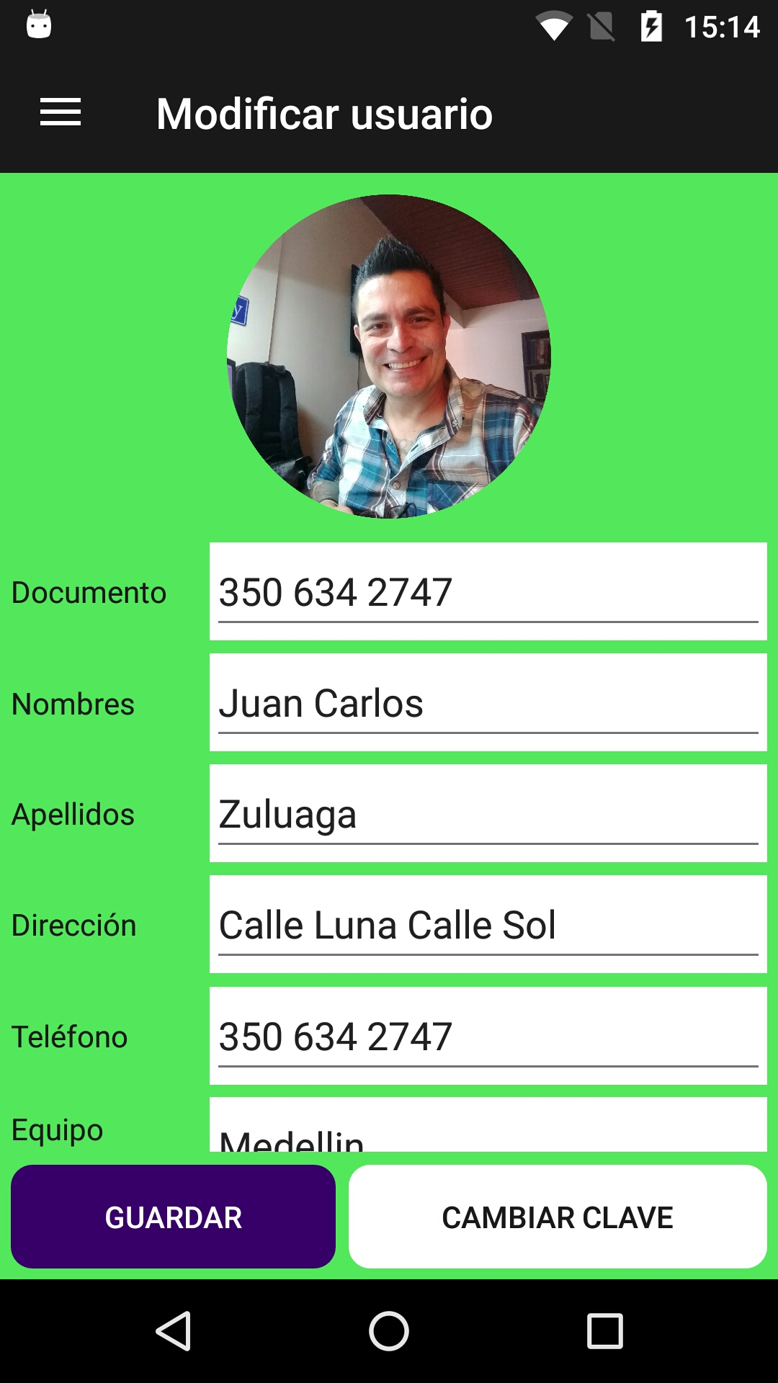 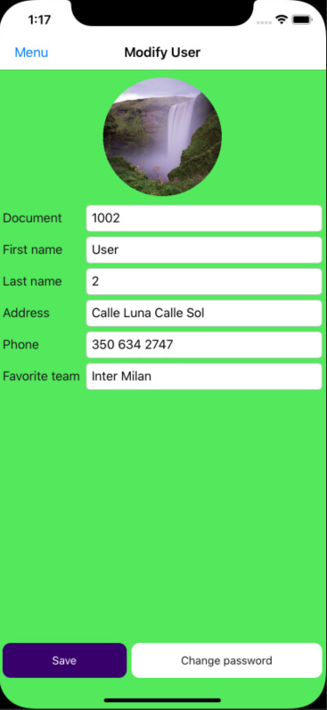

1. Add literals for **Save** and **ChangePassword**.

public static string Save => Resource.Save;

public static string ChangePassword => Resource.ChangePassword;

1. Modify the **ModifyUserPage**:

<?xml version="1.0" encoding="utf-8" ?>

<ContentPage xmlns="http://xamarin.com/schemas/2014/forms"

xmlns:x="http://schemas.microsoft.com/winfx/2009/xaml"

xmlns:prism="http://prismlibrary.com"

xmlns:busyindicator="clr-namespace:Syncfusion.SfBusyIndicator.XForms;assembly=Syncfusion.SfBusyIndicator.XForms"

xmlns:i18n="clr-namespace:Soccer.Prism.Helpers"

xmlns:ffimageloading="clr-namespace:FFImageLoading.Forms;assembly=FFImageLoading.Forms"

xmlns:fftransformations="clr-namespace:FFImageLoading.Transformations;assembly=FFImageLoading.Transformations"

prism:ViewModelLocator.AutowireViewModel="True"

x:Class="Soccer.Prism.Views.ModifyUserPage"

BackgroundColor="{StaticResource ColorBackgroud}"

Title="{Binding Title}">

<AbsoluteLayout>

<StackLayout AbsoluteLayout.LayoutBounds="0,0,1,1"

AbsoluteLayout.LayoutFlags="All"

Padding="5">

<ScrollView>

<StackLayout>

<ffimageloading:CachedImage Aspect="AspectFit"

Source="{Binding Image}"

CacheDuration= "50"

HeightRequest="150"

Margin="5"

RetryCount= "3"

RetryDelay= "600">

<ffimageloading:CachedImage.Transformations>

<fftransformations:CircleTransformation />

</ffimageloading:CachedImage.Transformations>

<ffimageloading:CachedImage.GestureRecognizers>

<TapGestureRecognizer Command="{Binding ChangeImageCommand}"/>

</ffimageloading:CachedImage.GestureRecognizers>

</ffimageloading:CachedImage>

<Grid>

<Grid.ColumnDefinitions>

<ColumnDefinition Width="*"/>

<ColumnDefinition Width="3*"/>

</Grid.ColumnDefinitions>

<Grid.RowDefinitions>

<RowDefinition Height="Auto"/>

<RowDefinition Height="Auto"/>

<RowDefinition Height="Auto"/>

<RowDefinition Height="Auto"/>

<RowDefinition Height="Auto"/>

<RowDefinition Height="Auto"/>

</Grid.RowDefinitions>

<Label Grid.Row="0"

Grid.Column="0"

Text="{i18n:Translate Document}"

VerticalOptions="Center"/>

<Entry Grid.Row="0"

Grid.Column="1"

Keyboard="Numeric"

Placeholder="{i18n:Translate DocumentPlaceHolder}"

Text="{Binding User.Document}"/>

<Label Grid.Row="1"

Grid.Column="0"

Text="{i18n:Translate FirstName}"

VerticalOptions="Center"/>

<Entry Grid.Row="1"

Grid.Column="1"

Placeholder="{i18n:Translate FirstNamePlaceHolder}"

Text="{Binding User.FirstName}"/>

<Label Grid.Row="2"

Grid.Column="0"

Text="{i18n:Translate LastName}"

VerticalOptions="Center"/>

<Entry Grid.Row="2"

Grid.Column="1"

Placeholder="{i18n:Translate LastNamePlaceHolder}"

Text="{Binding User.LastName}"/>

<Label Grid.Row="3"

Grid.Column="0"

Text="{i18n:Translate Address}"

VerticalOptions="Center"/>

<Entry Grid.Row="3"

Grid.Column="1"

Placeholder="{i18n:Translate AddressPlaceHolder}"

Text="{Binding User.Address}"/>

<Label Grid.Row="4"

Grid.Column="0"

Text="{i18n:Translate Phone}"

VerticalOptions="Center"/>

<Entry Grid.Row="4"

Grid.Column="1"

Keyboard="Telephone"

Placeholder="{i18n:Translate PhonePlaceHolder}"

Text="{Binding User.PhoneNumber}"/>

<Label Grid.Row="5"

Grid.Column="0"

Text="{i18n:Translate FavoriteTeam}"

VerticalOptions="Center"/>

<Picker Grid.Row="5"

Grid.Column="1"

ItemDisplayBinding="{Binding Name}"

ItemsSource="{Binding Teams}"

SelectedItem="{Binding Team}"

Title="{i18n:Translate FavoriteTeamPlaceHolder}"/>

</Grid>

</StackLayout>

</ScrollView>

<StackLayout Orientation="Horizontal"

VerticalOptions="EndAndExpand">

<Button Command="{Binding SaveCommand}"

IsEnabled="{Binding IsEnabled}"

Text="{i18n:Translate Save}"/>

<Button Command="{Binding ChangePasswordCommand}"

IsEnabled="{Binding IsEnabled}"

Text="{i18n:Translate ChangePassword}"

Style="{StaticResource DangerButton}"/>

</StackLayout>

</StackLayout>

<busyindicator:SfBusyIndicator AnimationType="Gear"

AbsoluteLayout.LayoutBounds=".5,.5,.5,.5"

AbsoluteLayout.LayoutFlags="All"

BackgroundColor="{StaticResource ColorAccent}"

HorizontalOptions="Center"

TextColor="{StaticResource ColorFontInverse}"

IsVisible="{Binding IsRunning}"

Title="{i18n:Translate Loading}"

VerticalOptions="Center"

ViewBoxWidth="80"

ViewBoxHeight="80" />

</AbsoluteLayout>

</ContentPage>

1. Modify the **ModifyUserPageViewModel**:

using Newtonsoft.Json;

using Plugin.Media;

using Plugin.Media.Abstractions;

using Prism.Commands;

using Prism.Navigation;

using System.Threading.Tasks;

using Soccer.Common.Helpers;

using Soccer.Common.Models;

using Soccer.Prism.Helpers;

using Xamarin.Forms;

using System.Collections.ObjectModel;

using Soccer.Common.Services;

using System.Collections.Generic;

using System.Linq;

namespace Soccer.Prism.ViewModels

{

public class ModifyUserPageViewModel : ViewModelBase

{

private readonly IApiService _apiService;

private bool _isRunning;

private bool _isEnabled;

private ImageSource _image;

private UserResponse _user;

private MediaFile _file;

private TeamResponse _team;

private ObservableCollection<TeamResponse> _teams;

private DelegateCommand _changeImageCommand;

private DelegateCommand _saveCommand;

public ModifyUserPageViewModel(INavigationService navigationService, IApiService apiService)

: base(navigationService)

{

_apiService = apiService;

Title = Languages.ModifyUser;

IsEnabled = true;

User = JsonConvert.DeserializeObject<UserResponse>(Settings.User);

Image = User.PictureFullPath;

LoadTeamsAsync();

}

public DelegateCommand ChangeImageCommand => _changeImageCommand ?? (_changeImageCommand = new DelegateCommand(ChangeImageAsync));

public DelegateCommand SaveCommand => _saveCommand ?? (_saveCommand = new DelegateCommand(SaveAsync));

public ImageSource Image

{

get => _image;

set => SetProperty(ref _image, value);

}

public TeamResponse Team

{

get => _team;

set => SetProperty(ref _team, value);

}

public ObservableCollection<TeamResponse> Teams

{

get => _teams;

set => SetProperty(ref _teams, value);

}

public UserResponse User

{

get => _user;

set => SetProperty(ref _user, value);

}

public bool IsRunning

{

get => _isRunning;

set => SetProperty(ref _isRunning, value);

}

public bool IsEnabled

{

get => _isEnabled;

set => SetProperty(ref _isEnabled, value);

}

private async void SaveAsync()

{

var isValid = await ValidateDataAsync();

if (!isValid)

{

return;

}

}

private async Task<bool> ValidateDataAsync()

{

if (string.IsNullOrEmpty(User.Document))

{

await App.Current.MainPage.DisplayAlert(Languages.Error, Languages.DocumentError, Languages.Accept);

return false;

}

if (string.IsNullOrEmpty(User.FirstName))

{

await App.Current.MainPage.DisplayAlert(Languages.Error, Languages.FirstNameError, Languages.Accept);

return false;

}

if (string.IsNullOrEmpty(User.LastName))

{

await App.Current.MainPage.DisplayAlert(Languages.Error, Languages.LastNameError, Languages.Accept);

return false;

}

if (string.IsNullOrEmpty(User.Address))

{

await App.Current.MainPage.DisplayAlert(Languages.Error, Languages.AddressError, Languages.Accept);

return false;

}

if (string.IsNullOrEmpty(User.PhoneNumber))

{

await App.Current.MainPage.DisplayAlert(Languages.Error, Languages.PhoneError, Languages.Accept);

return false;

}

return true;

}

private async void ChangeImageAsync()

{

await CrossMedia.Current.Initialize();

string source = await Application.Current.MainPage.DisplayActionSheet(

Languages.PictureSource,

Languages.Cancel,

null,

Languages.FromGallery,

Languages.FromCamera);

if (source == Languages.Cancel)

{

_file = null;

return;

}

if (source == Languages.FromCamera)

{

_file = await CrossMedia.Current.TakePhotoAsync(

new StoreCameraMediaOptions

{

Directory = "Sample",

Name = "test.jpg",

PhotoSize = PhotoSize.Small,

}

);

}

else

{

_file = await CrossMedia.Current.PickPhotoAsync();

}

if (_file != null)

{

Image = ImageSource.FromStream(() =>

{

System.IO.Stream stream = _file.GetStream();

return stream;

});

}

}

private async void LoadTeamsAsync()

{

IsRunning = true;

IsEnabled = false;

string url = App.Current.Resources["UrlAPI"].ToString();

bool connection = await _apiService.CheckConnectionAsync(url);

if (!connection)

{

IsRunning = false;

IsEnabled = true;

await App.Current.MainPage.DisplayAlert(Languages.Error, Languages.ConnectionError, Languages.Accept);

return;

}

Response response = await _apiService.GetListAsync<TeamResponse>(url, "/api", "/Teams");

IsRunning = false;

IsEnabled = true;

if (!response.IsSuccess)

{

await App.Current.MainPage.DisplayAlert(Languages.Error, response.Message, Languages.Accept);

return;

}

List<TeamResponse> list = (List<TeamResponse>)response.Result;

Teams = new ObservableCollection<TeamResponse>(list.OrderBy(t => t.Name));

Team = Teams.FirstOrDefault(t => t.Id == User.Team.Id);

}

}

}

1. Test it, that we do until this point.
2. Add the method **PutAsync** in **IApiService**:

Task<Response> PutAsync<T>(string urlBase, string servicePrefix, string controller, T model, string tokenType, string accessToken);

1. Add the method **PutAsync** in **ApiService**:

public async Task<Response> PutAsync<T>(string urlBase, string servicePrefix, string controller, T model, string tokenType, string accessToken)

{

try

{

string request = JsonConvert.SerializeObject(model);

StringContent content = new StringContent(request, Encoding.UTF8, "application/json");

HttpClient client = new HttpClient

{

BaseAddress = new Uri(urlBase)

};

client.DefaultRequestHeaders.Authorization = new AuthenticationHeaderValue(tokenType, accessToken);

string url = $"{servicePrefix}{controller}";

HttpResponseMessage response = await client.PutAsync(url, content);

string answer = await response.Content.ReadAsStringAsync();

if (!response.IsSuccessStatusCode)

{

return new Response

{

IsSuccess = false,

Message = answer,

};

}

return new Response

{

IsSuccess = true

};

}

catch (Exception ex)

{

return new Response

{

IsSuccess = false,

Message = ex.Message,

};

}

}

1. Add a literal for **UserUpdated**:

public static string UserUpdated => Resource.UserUpdated;

1. Modify the **ModifyUserPageViewModel**:

private readonly INavigationService _navigationService;

private readonly IFilesHelper _filesHelper;

…

public ModifyUserPageViewModel(INavigationService navigationService, IFilesHelper filesHelper, IApiService apiService)

: base(navigationService)

{

_navigationService = navigationService;

_filesHelper = filesHelper;

_apiService = apiService;

Title = Languages.ModifyUser;

IsEnabled = true;

User = JsonConvert.DeserializeObject<UserResponse>(Settings.User);

Image = User.PictureFullPath;

}

…

private async void SaveAsync()

{

bool isValid = await ValidateDataAsync();

if (!isValid)

{

return;

}

IsRunning = true;

IsEnabled = false;

byte[] imageArray = null;

if (_file != null)

{

imageArray = _filesHelper.ReadFully(_file.GetStream());

}

UserRequest userRequest = new UserRequest

{

Address = User.Address,

Document = User.Document,

Email = User.Email,

FirstName = User.FirstName,

LastName = User.LastName,

Password = "123456", // It doesn't matter what is sent here. It is only for the model to be valid

Phone = User.PhoneNumber,

PictureArray = imageArray,

TeamId = Team.Id,

CultureInfo = Languages.Culture

};

TokenResponse token = JsonConvert.DeserializeObject<TokenResponse>(Settings.Token);

string url = App.Current.Resources["UrlAPI"].ToString();

Response response = await _apiService.PutAsync(url, "/api", "/Account", userRequest, "bearer", token.Token);

IsRunning = false;

IsEnabled = true;

if (!response.IsSuccess)

{

await App.Current.MainPage.DisplayAlert(

"Error",

response.Message,

"Accept");

return;

}

Settings.User = JsonConvert.SerializeObject(User);

await App.Current.MainPage.DisplayAlert(Languages.Ok, Languages.UserUpdated, Languages.Accept);

}

1. Test it.
2. Modify the **SoccerMasterDetailPage**:

<RelativeLayout>

<RelativeLayout.GestureRecognizers>

<TapGestureRecognizer Command="{Binding ModifyUserCommand}"/>

</RelativeLayout.GestureRecognizers>

<Image x:Name="Logo" HorizontalOptions="Center"

RelativeLayout.XConstraint="{ConstraintExpression Type=RelativeToParent,Property=X,Factor=1,Constant=60}"

HeightRequest="150"

Source="soccer"/>

1. Modify the **SoccerMasterDetailPageViewModel**:

private DelegateCommand _modifyUserCommand;

…

public DelegateCommand ModifyUserCommand => _modifyUserCommand ?? (_modifyUserCommand = new DelegateCommand(ModifyUserAsync));

…

private async void ModifyUserAsync()

{

await _navigationService.NavigateAsync($"/SoccerMasterDetailPage/NavigationPage/{nameof(ModifyUserPage)}");

}

1. Test it.
2. Modify the **SoccerMasterDetailPageViewModel**:

private readonly IApiService _apiService;

private static SoccerMasterDetailPageViewModel _instance;

…

public SoccerMasterDetailPageViewModel(INavigationService navigationService, IApiService apiService)

: base(navigationService)

{

_instance = this;

_apiService = apiService;

_navigationService = navigationService;

LoadUser();

LoadMenus();

}

…

public static SoccerMasterDetailPageViewModel GetInstance()

{

return _instance;

}

public async void ReloadUser()

{

string url = App.Current.Resources["UrlAPI"].ToString();

bool connection = await _apiService.CheckConnectionAsync(url);

if (!connection)

{

return;

}

UserResponse user = JsonConvert.DeserializeObject<UserResponse>(Settings.User);

TokenResponse token = JsonConvert.DeserializeObject<TokenResponse>(Settings.Token);

EmailRequest emailRequest = new EmailRequest

{

CultureInfo = Languages.Culture,

Email = user.Email

};

Response response = await _apiService.GetUserByEmail(url, "api", "/Account/GetUserByEmail", "bearer", token.Token, emailRequest);

UserResponse userResponse = (UserResponse)response.Result;

Settings.User = JsonConvert.SerializeObject(userResponse);

LoadUser();

}

1. Modify the **ModifyUserPageViewModel**:

Settings.User = JsonConvert.SerializeObject(User);

SoccerMasterDetailPageViewModel.GetInstance().ReloadUser();

await App.Current.MainPage.DisplayAlert(Languages.Ok, Languages.UserUpdated, Languages.Accept);

1. Test it.

## 

## Modify Password From App in Xamarin Forms

We are going to build this screen:

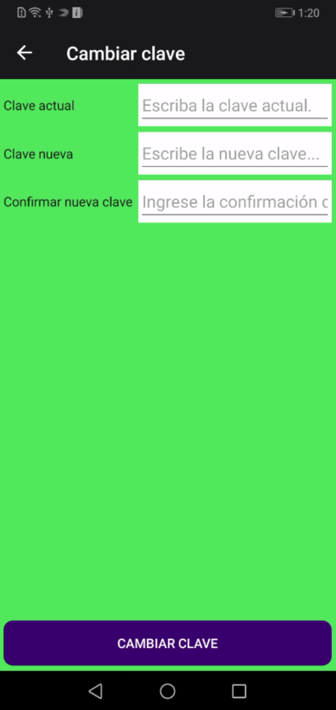 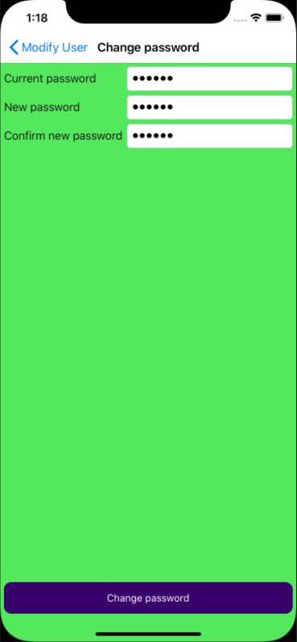

1. Add the method **ChangePasswordAsync** in **IApiService**:

Task<Response> ChangePasswordAsync(string urlBase, string servicePrefix, string controller, ChangePasswordRequest changePasswordRequest, string tokenType, string accessToken);

1. Add the method **ChangePasswordAsync** in **ApiService**:

public async Task<Response> ChangePasswordAsync(string urlBase, string servicePrefix, string controller, ChangePasswordRequest changePasswordRequest, string tokenType, string accessToken)

{

try

{

string request = JsonConvert.SerializeObject(changePasswordRequest);

StringContent content = new StringContent(request, Encoding.UTF8, "application/json");

HttpClient client = new HttpClient

{

BaseAddress = new Uri(urlBase)

};

client.DefaultRequestHeaders.Authorization = new AuthenticationHeaderValue(tokenType, accessToken);

string url = $"{servicePrefix}{controller}";

HttpResponseMessage response = await client.PostAsync(url, content);

string answer = await response.Content.ReadAsStringAsync();

Response obj = JsonConvert.DeserializeObject<Response>(answer);

return obj;

}

catch (Exception ex)

{

return new Response

{

IsSuccess = false,

Message = ex.Message,

};

}

}

1. Add literals for: **ConfirmNewPassword, ConfirmNewPasswordError, ConfirmNewPasswordError2, ConfirmNewPasswordPlaceHolder, CurrentPassword, CurrentPasswordError, CurrentPasswordPlaceHolder, NewPassword, NewPasswordError** and **NewPasswordPlaceHolder**.

public static string ConfirmNewPassword => Resource.ConfirmNewPassword;

public static string ConfirmNewPasswordError => Resource.ConfirmNewPasswordError;

public static string ConfirmNewPasswordError2 => Resource.ConfirmNewPasswordError2;

public static string ConfirmNewPasswordPlaceHolder => Resource.ConfirmNewPasswordPlaceHolder;

public static string CurrentPassword => Resource.CurrentPassword;

public static string CurrentPasswordError => Resource.CurrentPasswordError;

public static string CurrentPasswordPlaceHolder => Resource.CurrentPasswordPlaceHolder;

public static string NewPassword => Resource.NewPassword;

public static string NewPasswordError => Resource.NewPasswordError;

public static string NewPasswordPlaceHolder => Resource.NewPasswordPlaceHolder;

1. Add the **ChangePasswordPage**:

<?xml version="1.0" encoding="utf-8" ?>

<ContentPage xmlns="http://xamarin.com/schemas/2014/forms"

xmlns:x="http://schemas.microsoft.com/winfx/2009/xaml"

xmlns:prism="clr-namespace:Prism.Mvvm;assembly=Prism.Forms"

xmlns:i18n="clr-namespace:Soccer.Prism.Helpers"

xmlns:busyindicator="clr-namespace:Syncfusion.SfBusyIndicator.XForms;assembly=Syncfusion.SfBusyIndicator.XForms"

xmlns:ios="clr-namespace:Xamarin.Forms.PlatformConfiguration.iOSSpecific;assembly=Xamarin.Forms.Core"

ios:Page.UseSafeArea="true"

prism:ViewModelLocator.AutowireViewModel="True"

x:Class="Soccer.Prism.Views.ChangePasswordPage"

BackgroundColor="{StaticResource ColorBackgroud}"

Title="{Binding Title}">

<ScrollView>

<AbsoluteLayout>

<StackLayout AbsoluteLayout.LayoutBounds="0,0,1,1"

AbsoluteLayout.LayoutFlags="All"

Padding="5">

<Grid>

<Grid.ColumnDefinitions>

<ColumnDefinition Width="Auto"/>

<ColumnDefinition Width="*"/>

</Grid.ColumnDefinitions>

<Label Grid.Column="0"

Grid.Row="0"

Text="{i18n:Translate CurrentPassword}"

VerticalOptions="Center"/>

<Entry Grid.Column="1"

Grid.Row="0"

IsPassword="True"

Placeholder="{i18n:Translate CurrentPasswordPlaceHolder}"

Text="{Binding CurrentPassword}"/>

<Label Grid.Column="0"

Grid.Row="1"

Text="{i18n:Translate NewPassword}"

VerticalOptions="Center"/>

<Entry Grid.Column="1"

Grid.Row="1"

IsPassword="True"

Placeholder="{i18n:Translate NewPasswordPlaceHolder}"

Text="{Binding NewPassword}"/>

<Label Grid.Column="0"

Grid.Row="2"

Text="{i18n:Translate ConfirmNewPassword}"

VerticalOptions="Center"/>

<Entry Grid.Column="1"

Grid.Row="2"

IsPassword="True"

Placeholder="{i18n:Translate ConfirmNewPasswordPlaceHolder}"

Text="{Binding PasswordConfirm}"/>

</Grid>

<Button Command="{Binding ChangePasswordCommand}"

IsEnabled="{Binding IsEnabled}"

Text="{i18n:Translate ChangePassword}"

VerticalOptions="EndAndExpand"/>

</StackLayout>

<busyindicator:SfBusyIndicator AnimationType="Gear"

AbsoluteLayout.LayoutBounds=".5,.5,.5,.5"

AbsoluteLayout.LayoutFlags="All"

BackgroundColor="{StaticResource ColorAccent}"

HorizontalOptions="Center"

TextColor="{StaticResource ColorFontInverse}"

IsVisible="{Binding IsRunning}"

Title="{i18n:Translate Loading}"

VerticalOptions="Center"

ViewBoxWidth="80"

ViewBoxHeight="80" />

</AbsoluteLayout>

</ScrollView>

</ContentPage>

1. Modify the **ChangePasswordViewModel**:

using System.Threading.Tasks;

using Soccer.Common.Services;

using Prism.Commands;

using Prism.Navigation;

using Soccer.Prism.Helpers;

using Soccer.Common.Models;

using Newtonsoft.Json;

using Soccer.Common.Helpers;

namespace Soccer.Prism.ViewModels

{

public class ChangePasswordPageViewModel : ViewModelBase

{

private readonly INavigationService _navigationService;

private readonly IApiService _apiService;

private bool _isRunning;

private bool _isEnabled;

private DelegateCommand _changePasswordCommand;

public ChangePasswordPageViewModel(INavigationService navigationService, IApiService apiService)

: base(navigationService)

{

_navigationService = navigationService;

_apiService = apiService;

IsEnabled = true;

Title = Languages.ChangePassword;

}

public DelegateCommand ChangePasswordCommand => _changePasswordCommand ?? (_changePasswordCommand = new DelegateCommand(ChangePasswordAsync));

public string CurrentPassword { get; set; }

public string NewPassword { get; set; }

public string PasswordConfirm { get; set; }

public bool IsRunning

{

get => _isRunning;

set => SetProperty(ref _isRunning, value);

}

public bool IsEnabled

{

get => _isEnabled;

set => SetProperty(ref _isEnabled, value);

}

private async void ChangePasswordAsync()

{

var isValid = await ValidateDataAsync();

if (!isValid)

{

return;

}

}

private async Task<bool> ValidateDataAsync()

{

if (string.IsNullOrEmpty(CurrentPassword))

{

await App.Current.MainPage.DisplayAlert(Languages.Error, Languages.CurrentPasswordError, Languages.Accept);

return false;

}

if (string.IsNullOrEmpty(NewPassword) || NewPassword?.Length < 6)

{

await App.Current.MainPage.DisplayAlert(Languages.Error, Languages.NewPasswordError, Languages.Accept);

return false;

}

if (string.IsNullOrEmpty(PasswordConfirm))

{

await App.Current.MainPage.DisplayAlert(Languages.Error, Languages.ConfirmNewPasswordError, Languages.Accept);

return false;

}

if (NewPassword != PasswordConfirm)

{

await App.Current.MainPage.DisplayAlert(Languages.Error, Languages.ConfirmNewPasswordError2, Languages.Accept);

return false;

}

return true;

}

}

}

1. Modify the **ModifyUserPageViewModel**:

private DelegateCommand _changePasswordCommand;

…

public DelegateCommand ChangePasswordCommand => _changePasswordCommand ?? (_changePasswordCommand = new DelegateCommand(ChangePasswordAsync));

…

private async void ChangePasswordAsync()

{

await _navigationService.NavigateAsync(nameof(ChangePasswordPage));

}

1. Test it what we did until this moment.
2. Modify the **ChangePasswordPageViewModel**:

private async void ChangePasswordAsync()

{

var isValid = await ValidateDataAsync();

if (!isValid)

{

return;

}

IsRunning = true;

IsEnabled = false;

UserResponse user = JsonConvert.DeserializeObject<UserResponse>(Settings.User);

TokenResponse token = JsonConvert.DeserializeObject<TokenResponse>(Settings.Token);

ChangePasswordRequest request = new ChangePasswordRequest

{

Email = user.Email,

NewPassword = NewPassword,

OldPassword = CurrentPassword,

CultureInfo = Languages.Culture

};

string url = App.Current.Resources["UrlAPI"].ToString();

Response response = await _apiService.ChangePasswordAsync(url, "/api", "/Account/ChangePassword", request, "bearer", token.Token);

IsRunning = false;

IsEnabled = true;

if (!response.IsSuccess)

{

await App.Current.MainPage.DisplayAlert(Languages.Error, response.Message, Languages.Accept);

return;

}

await App.Current.MainPage.DisplayAlert(Languages.Ok, response.Message, Languages.Accept);

await _navigationService.GoBackAsync();

}

1. Test it.

## 

## Make predictions

We are going to build this screen:

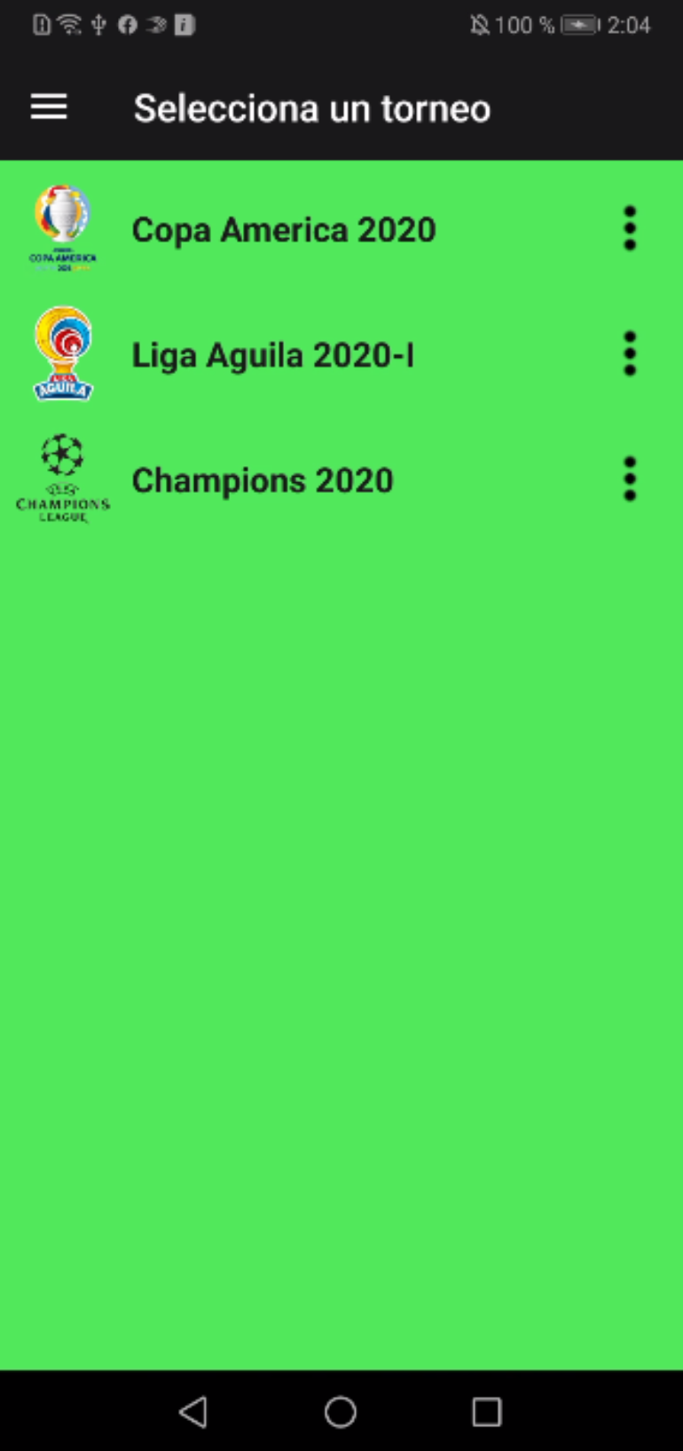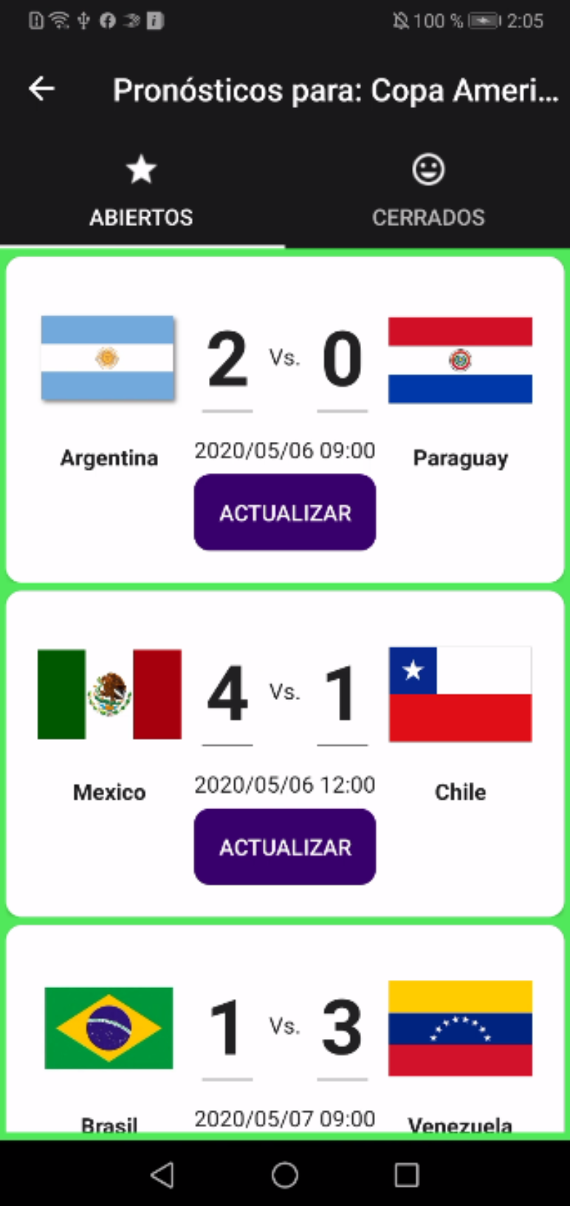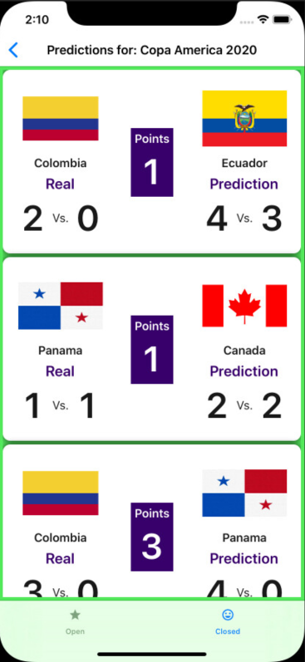

1. Add those literals:

**English**

<data name="SelectTournament" xml:space="preserve">

<value>Select a tournament</value>

</data>

<data name="PredictionsFor" xml:space="preserve">

<value>Predictions for</value>

</data>

<data name="IsUpdated" xml:space="preserve">

<value>Is Updated?</value>

</data>

<data name="Update" xml:space="preserve">

<value>Update</value>

</data>

<data name="LocalGoalsError" xml:space="preserve">

<value>You must enter the local goals.</value>

</data>

<data name="VisitorGoalsError" xml:space="preserve">

<value>You must enter the visitor goals.</value>

</data>

<data name="MatchAlreadyStarts" xml:space="preserve">

<value>You cannot record the prediction, because the match has already started.</value>

</data>

<data name="Open" xml:space="preserve">

<value>Open</value>

</data>

<data name="Real" xml:space="preserve">

<value>Real</value>

</data>

<data name="Points" xml:space="preserve">

<value>Points</value>

</data>

<data name="Prediction" xml:space="preserve">

<value>Prediction</value>

</data>

**Spanish**

<data name="SelectTournament" xml:space="preserve">

<value>Selecciona un torneo</value>

</data>

<data name="PredictionsFor" xml:space="preserve">

<value>Pronósticos para</value>

</data>

<data name="IsUpdated" xml:space="preserve">

<value>Listo?</value>

</data>

<data name="Update" xml:space="preserve">

<value>Actualizar</value>

</data>

<data name="LocalGoalsError" xml:space="preserve">

<value>Debe ingresar los goles del local.</value>

</data>

<data name="VisitorGoalsError" xml:space="preserve">

<value>Debe ingresar los goles del visitante.</value>

</data>

<data name="MatchAlreadyStarts" xml:space="preserve">

<value>No puedes grabar la predicción porque la partida ya ha comenzado.</value>

</data>

<data name="Open" xml:space="preserve">

<value>Abiertos</value>

</data>

<data name="Real" xml:space="preserve">

<value>Real</value>

</data>

<data name="Points" xml:space="preserve">

<value>Puntos</value>

</data>

<data name="Prediction" xml:space="preserve">

<value>Predicción</value>

</data>

**French**

<data name="SelectTournament" xml:space="preserve">

<value>Veuillez sélectionner un tourno</value>

</data>

<data name="PredictionsFor" xml:space="preserve">

<value>Prédictions pour</value>

</data>

<data name="IsUpdated" xml:space="preserve">

<value>Mis à jour</value>

</data>

<data name="Update" xml:space="preserve">

<value>Mettre à jour</value>

</data>

<data name="LocalGoalsError" xml:space="preserve">

<value>Vous devez entrer les objectifs locaux.!</value>

</data>

<data name="VisitorGoalsError" xml:space="preserve">

<value>Vous devez saisir les objectifs du visiteur.!</value>

</data>

<data name="MatchAlreadyStarts" xml:space="preserve">

<value>Vous ne pouvez pas enregistrer la prédiction, car le match a déjà commencé.</value>

</data>

<data name="Open" xml:space="preserve">

<value>Ouvrir</value>

</data>

<data name="Real" xml:space="preserve">

<value>Réel</value>

</data>

<data name="Points" xml:space="preserve">

<value>Points</value>

</data>

<data name="Prediction" xml:space="preserve">

<value>prédiction</value>

</data>

1. Modify the **Languages**:

public static string Real => Resource.Real;

public static string Prediction => Resource.Prediction;

public static string Points => Resource.Points;

public static string Open => Resource.Open;

public static string MatchAlreadyStarts => Resource.MatchAlreadyStarts;

public static string LocalGoalsError => Resource.LocalGoalsError;

public static string VisitorGoalsError => Resource.VisitorGoalsError;

public static string Update => Resource.Update;

public static string SelectTournament => Resource.SelectTournament;

public static string PredictionsFor => Resource.PredictionsFor;

1. Modify the **Menu**:

namespace Soccer.Common.Models

{

public class Menu

{

public string Icon { get; set; }

public string Title { get; set; }

public string PageName { get; set; }

public bool IsLoginRequired { get; set; }

}

}

1. Modify the **MenuItemViewModel**:

private async void SelectMenuAsync()

{

if (PageName == "LoginPage" && Settings.IsLogin)

{

Settings.IsLogin = false;

Settings.User = null;

Settings.Token = null;

}

if (IsLoginRequired && !Settings.IsLogin)

{

await _navigationService.NavigateAsync($"/SoccerMasterDetailPage/NavigationPage/LoginPage");

}

else

{

await _navigationService.NavigateAsync($"/SoccerMasterDetailPage/NavigationPage/{PageName}");

}

}

1. Modify the **SoccerMasterDetailPageViewModel**:

private void LoadMenus()

{

List<Menu> menus = new List<Menu>

{

new Menu

{

Icon = "tournament",

PageName = "TournamentsPage",

Title = Languages.Tournaments

},

new Menu

{

Icon = "prediction",

PageName = "MyPredictionsPage",

Title = Languages.MyPredictions,

IsLoginRequired = true

},

new Menu

{

Icon = "medal",

PageName = "MyPositionsPage",

Title = Languages.MyPositions,

IsLoginRequired = true

},

new Menu

{

Icon = "user",

PageName = "ModifyUserPage",

Title = Languages.ModifyUser,

IsLoginRequired = true

},

new Menu

{

Icon = "login",

PageName = "LoginPage",

Title = Settings.IsLogin ? Languages.Logout : Languages.Login

}

};

Menus = new ObservableCollection<MenuItemViewModel>(

menus.Select(m => new MenuItemViewModel(_navigationService)

{

Icon = m.Icon,

PageName = m.PageName,

Title = m.Title,

IsLoginRequired = m.IsLoginRequired

}).ToList());

}

1. Test it.
2. Add the **PredictionsForTournamentPage**:

<?xml version="1.0" encoding="utf-8" ?>

<ContentPage xmlns="http://xamarin.com/schemas/2014/forms"

xmlns:x="http://schemas.microsoft.com/winfx/2009/xaml"

xmlns:prism="http://prismlibrary.com"

xmlns:ios="clr-namespace:Xamarin.Forms.PlatformConfiguration.iOSSpecific;assembly=Xamarin.Forms.Core"

ios:Page.UseSafeArea="true"

prism:ViewModelLocator.AutowireViewModel="True"

x:Class="Soccer.Prism.Views.PredictionsForTournamentPage"

BackgroundColor="{StaticResource ColorBackgroud}"

Title="{Binding Title}">

</ContentPage>

1. Modify the **PredictionsForTournamentPageViewModel**:

using Prism.Navigation;

namespace Soccer.Prism.ViewModels

{

public class PredictionsForTournamentPageViewModel : ViewModelBase

{

public PredictionsForTournamentPageViewModel(INavigationService navigationService)

: base(navigationService)

{

Title = "Predictions for...";

}

}

}

1. Modify the **TournamentItemViewModel**:

private DelegateCommand _selectTournament2Command;

…

public DelegateCommand SelectTournament2Command => _selectTournament2Command ?? (_selectTournament2Command = new DelegateCommand(SelectTournamentForPredictionAsync));

…

private async void SelectTournamentForPredictionAsync()

{

NavigationParameters parameters = new NavigationParameters

{

{ "tournament", this }

};

await _navigationService.NavigateAsync(nameof(PredictionsForTournamentPage), parameters);

}

1. Modify the **MyPredictionsPage**:

<?xml version="1.0" encoding="utf-8" ?>

<ContentPage xmlns="http://xamarin.com/schemas/2014/forms"

xmlns:x="http://schemas.microsoft.com/winfx/2009/xaml"

xmlns:prism="http://prismlibrary.com"

prism:ViewModelLocator.AutowireViewModel="True"

xmlns:ffimageloading="clr-namespace:FFImageLoading.Forms;assembly=FFImageLoading.Forms"

xmlns:busyindicator="clr-namespace:Syncfusion.SfBusyIndicator.XForms;assembly=Syncfusion.SfBusyIndicator.XForms"

xmlns:ios="clr-namespace:Xamarin.Forms.PlatformConfiguration.iOSSpecific;assembly=Xamarin.Forms.Core"

ios:Page.UseSafeArea="true"

xmlns:i18n="clr-namespace:Soccer.Prism.Helpers"

x:Class="Soccer.Prism.Views.MyPredictionsPage"

BackgroundColor="{StaticResource ColorBackgroud}"

Title="{Binding Title}">

<AbsoluteLayout>

<StackLayout AbsoluteLayout.LayoutBounds="0,0,1,1"

AbsoluteLayout.LayoutFlags="All"

Padding="5">

<CollectionView ItemsSource="{Binding Tournaments}">

<CollectionView.ItemsLayout>

<GridItemsLayout Orientation="Vertical"

VerticalItemSpacing="5"/>

</CollectionView.ItemsLayout>

<CollectionView.ItemTemplate>

<DataTemplate>

<Grid>

<Grid.GestureRecognizers>

<TapGestureRecognizer Command="{Binding SelectTournament2Command}"/>

</Grid.GestureRecognizers>

<Grid.ColumnDefinitions>

<ColumnDefinition Width="Auto" />

<ColumnDefinition Width="*" />

<ColumnDefinition Width="Auto" />

</Grid.ColumnDefinitions>

<ffimageloading:CachedImage Grid.Column="0"

Aspect="AspectFill"

Source="{Binding LogoFullPath}"

CacheDuration= "50"

Margin="5"

RetryCount= "3"

RetryDelay= "600"

WidthRequest="50"/>

<Label Grid.Column="1"

Text="{Binding Name}"

FontAttributes="Bold"

FontSize="Medium"

VerticalOptions="Center"/>

<Image Grid.Column="2"

Source="ic_more_vert"/>

</Grid>

</DataTemplate>

</CollectionView.ItemTemplate>

</CollectionView>

</StackLayout>

<busyindicator:SfBusyIndicator AnimationType="Gear"

AbsoluteLayout.LayoutBounds=".5,.5,.5,.5"

AbsoluteLayout.LayoutFlags="All"

BackgroundColor="{StaticResource ColorAccent}"

HorizontalOptions="Center"

TextColor="{StaticResource ColorFontInverse}"

IsVisible="{Binding IsRunning}"

Title="{i18n:Translate Loading}"

VerticalOptions="Center"

ViewBoxWidth="80"

ViewBoxHeight="80" />

</AbsoluteLayout>

</ContentPage>

1. Modify the **MyPredictionsPageViewModel**.

using Prism.Navigation;

using Soccer.Common.Models;

using Soccer.Common.Services;

using Soccer.Prism.Helpers;

using System.Collections.Generic;

using System.Linq;

namespace Soccer.Prism.ViewModels

{

public class MyPredictionsPageViewModel : ViewModelBase

{

private readonly INavigationService _navigationService;

private readonly IApiService _apiService;

private List<TournamentItemViewModel> _tournaments;

private bool _isRunning;

public MyPredictionsPageViewModel(INavigationService navigationService, IApiService apiService)

: base(navigationService)

{

_navigationService = navigationService;

_apiService = apiService;

Title = Languages.SelectTournament;

LoadTournamentsAsync();

}

public bool IsRunning

{

get => _isRunning;

set => SetProperty(ref _isRunning, value);

}

public List<TournamentItemViewModel> Tournaments

{

get => _tournaments;

set => SetProperty(ref _tournaments, value);

}

private async void LoadTournamentsAsync()

{

IsRunning = true;

var url = App.Current.Resources["UrlAPI"].ToString();

var connection = await _apiService.CheckConnectionAsync(url);

if (!connection)

{

IsRunning = false;

await App.Current.MainPage.DisplayAlert(Languages.Error, Languages.ConnectionError, Languages.Accept);

return;

}

Response response = await _apiService.GetListAsync<TournamentResponse>(url, "/api", "/Tournaments/GetTournaments2");

IsRunning = false;

if (!response.IsSuccess)

{

await App.Current.MainPage.DisplayAlert(Languages.Error, response.Message, Languages.Accept);

return;

}

List<TournamentResponse> list = (List<TournamentResponse>)response.Result;

Tournaments = list.Select(t => new TournamentItemViewModel(_navigationService)

{

EndDate = t.EndDate,

Groups = t.Groups,

Id = t.Id,

IsActive = t.IsActive,

LogoPath = t.LogoPath,

Name = t.Name,

StartDate = t.StartDate

}).ToList();

}

}

}

1. Test it.
2. Modify the **IApiService**:

Task<Response> GetPredictionsForUserAsync(string urlBase, string servicePrefix, string controller, PredictionsForUserRequest predictionsForUserRequest, string tokenType, string accessToken);

1. Modify the **ApiService**:

public async Task<Response> GetPredictionsForUserAsync(string urlBase, string servicePrefix, string controller, PredictionsForUserRequest predictionsForUserRequest, string tokenType, string accessToken)

{

try

{

string request = JsonConvert.SerializeObject(predictionsForUserRequest);

StringContent content = new StringContent(request, Encoding.UTF8, "application/json");

HttpClient client = new HttpClient

{

BaseAddress = new Uri(urlBase)

};

client.DefaultRequestHeaders.Authorization = new AuthenticationHeaderValue(tokenType, accessToken);

string url = $"{servicePrefix}{controller}";

HttpResponseMessage response = await client.PostAsync(url, content);

string result = await response.Content.ReadAsStringAsync();

if (!response.IsSuccessStatusCode)

{

return new Response

{

IsSuccess = false,

Message = result,

};

}

List<PredictionResponse> list = JsonConvert.DeserializeObject<List<PredictionResponse>>(result);

return new Response

{

IsSuccess = true,

Result = list

};

}

catch (Exception ex)

{

return new Response

{

IsSuccess = false,

Message = ex.Message

};

}

}

1. Modify the **PredictionsForTournamentPage**:

<?xml version="1.0" encoding="utf-8" ?>

<ContentPage xmlns="http://xamarin.com/schemas/2014/forms"

xmlns:x="http://schemas.microsoft.com/winfx/2009/xaml"

xmlns:prism="http://prismlibrary.com"

xmlns:ffimageloading="clr-namespace:FFImageLoading.Forms;assembly=FFImageLoading.Forms"

xmlns:busyindicator="clr-namespace:Syncfusion.SfBusyIndicator.XForms;assembly=Syncfusion.SfBusyIndicator.XForms"

xmlns:ios="clr-namespace:Xamarin.Forms.PlatformConfiguration.iOSSpecific;assembly=Xamarin.Forms.Core"

xmlns:i18n="clr-namespace:Soccer.Prism.Helpers"

ios:Page.UseSafeArea="true"

prism:ViewModelLocator.AutowireViewModel="True"

x:Class="Soccer.Prism.Views.PredictionsForTournamentPage"

BackgroundColor="{StaticResource ColorBackgroud}"

Title="{Binding Title}">

<AbsoluteLayout>

<StackLayout AbsoluteLayout.LayoutBounds="0,0,1,1"

AbsoluteLayout.LayoutFlags="All"

Padding="5">

<CollectionView ItemsSource="{Binding Predictions}">

<CollectionView.ItemsLayout>

<GridItemsLayout Orientation="Vertical"

VerticalItemSpacing="5"/>

</CollectionView.ItemsLayout>

<CollectionView.ItemTemplate>

<DataTemplate>

<Frame CornerRadius="10">

<StackLayout>

<Grid>

<Grid.ColumnDefinitions>

<ColumnDefinition Width="Auto" />

<ColumnDefinition Width="*" />

<ColumnDefinition Width="Auto" />

</Grid.ColumnDefinitions>

<StackLayout Grid.Column="0">

<ffimageloading:CachedImage Aspect="AspectFit"

CacheDuration= "50"

HeightRequest="90"

RetryCount= "3"

RetryDelay= "600"

Source="{Binding Match.Local.LogoFullPath}"

WidthRequest="90"/>

<Label HorizontalOptions="Center"

HorizontalTextAlignment="Center"

FontAttributes="Bold"

LineBreakMode="TailTruncation"

MaxLines="2"

Text="{Binding Match.Local.Name}"

WidthRequest="90"/>

</StackLayout>

<StackLayout Grid.Column="1"

VerticalOptions="Center">

<StackLayout HorizontalOptions="Center"

Orientation="Horizontal">

<Entry FontAttributes="Bold"

FontSize="48"

HorizontalTextAlignment="Center"

Keyboard="Numeric"

Text="{Binding GoalsLocal}"

WidthRequest="45"/>

<Label Text="Vs."

VerticalOptions="Center"/>

<Entry FontAttributes="Bold"

FontSize="48"

HorizontalTextAlignment="Center"

Keyboard="Numeric"

Text="{Binding GoalsVisitor}"

WidthRequest="45"/>

</StackLayout>

<StackLayout Orientation="Vertical"

HorizontalOptions="Center">

<Label Text="{Binding Match.DateLocal, StringFormat='{0:yyyy/MM/dd HH:mm}'}"

VerticalOptions="Center" />

<Button Command="{Binding UpdatePredictionCommand}"

Text="{i18n:Translate Update}"/>

</StackLayout>

</StackLayout>

<StackLayout Grid.Column="2">

<ffimageloading:CachedImage Aspect="AspectFit"

CacheDuration= "50"

HeightRequest="90"

RetryCount= "3"

RetryDelay= "600"

Source="{Binding Match.Visitor.LogoFullPath}"

WidthRequest="90"/>

<Label HorizontalOptions="Center"

HorizontalTextAlignment="Center"

FontAttributes="Bold"

LineBreakMode="TailTruncation"

MaxLines="2"

Text="{Binding Match.Visitor.Name}"

WidthRequest="90"/>

</StackLayout>

</Grid>

</StackLayout>

</Frame>

</DataTemplate>

</CollectionView.ItemTemplate>

</CollectionView>

</StackLayout>

<busyindicator:SfBusyIndicator AnimationType="Gear"

AbsoluteLayout.LayoutBounds=".5,.5,.5,.5"

AbsoluteLayout.LayoutFlags="All"

BackgroundColor="{StaticResource ColorAccent}"

HorizontalOptions="Center"

TextColor="{StaticResource ColorFontInverse}"

IsVisible="{Binding IsRunning}"

Title="{i18n:Translate Loading}"

VerticalOptions="Center"

ViewBoxWidth="80"

ViewBoxHeight="80" />

</AbsoluteLayout>

</ContentPage>

1. Modify the **PredictionsForTournamentPageViewModel**:

using Newtonsoft.Json;

using Prism.Navigation;

using Soccer.Common.Helpers;

using Soccer.Common.Models;

using Soccer.Common.Services;

using Soccer.Prism.Helpers;

using System;

using System.Collections.Generic;

using System.Linq;

namespace Soccer.Prism.ViewModels

{

public class PredictionsForTournamentPageViewModel : ViewModelBase

{

private readonly IApiService _apiService;

private TournamentResponse _tournament;

private bool _isRunning;

private List<PredictionItemViewModel> _predictions;

public PredictionsForTournamentPageViewModel(INavigationService navigationService, IApiService apiService)

: base(navigationService)

{

_apiService = apiService;

Title = Languages.PredictionsFor;

}

public bool IsRunning

{

get => _isRunning;

set => SetProperty(ref _isRunning, value);

}

public List<PredictionItemViewModel> Predictions

{

get => _predictions;

set => SetProperty(ref _predictions, value);

}

public override void OnNavigatedTo(INavigationParameters parameters)

{

base.OnNavigatedTo(parameters);

_tournament = parameters.GetValue<TournamentResponse>("tournament");

Title = $"{Languages.PredictionsFor}: {_tournament.Name}";

LoadPredictionsAsync();

}

private async void LoadPredictionsAsync()

{

IsRunning = true;

var url = App.Current.Resources["UrlAPI"].ToString();

var connection = await _apiService.CheckConnectionAsync(url);

if (!connection)

{

IsRunning = false;

await App.Current.MainPage.DisplayAlert(Languages.Error, Languages.ConnectionError, Languages.Accept);

return;

}

UserResponse user = JsonConvert.DeserializeObject<UserResponse>(Settings.User);

TokenResponse token = JsonConvert.DeserializeObject<TokenResponse>(Settings.Token);

var request = new PredictionsForUserRequest

{

TournamentId = _tournament.Id,

UserId = new Guid(user.Id)

};

Response response = await _apiService.GetPredictionsForUserAsync(url, "/api", "/Predictions/GetPredictionsForUser", request, "bearer", token.Token);

IsRunning = false;

if (!response.IsSuccess)

{

await App.Current.MainPage.DisplayAlert(Languages.Error, response.Message, Languages.Accept);

return;

}

List<PredictionResponse> list = (List<PredictionResponse>)response.Result;

Predictions = list.Select(p => new PredictionItemViewModel

{

GoalsLocal = p.GoalsLocal,

GoalsVisitor = p.GoalsVisitor,

Id = p.Id,

Match = p.Match,

Points = p.Points,

User = p.User

})

.Where(p => !p.Match.IsClosed && p.Match.DateLocal > DateTime.Now)

.OrderBy(p => p.Match.Date)

.ToList();

}

}

}

1. Modify the **IApiService**:

Task<Response> MakePredictionAsync(string urlBase, string servicePrefix, string controller, PredictionRequest predictionRequest, string tokenType, string accessToken);

1. Modify the **ApiService**:

public async Task<Response> MakePredictionAsync(string urlBase, string servicePrefix, string controller, PredictionRequest predictionRequest, string tokenType, string accessToken)

{

try

{

string request = JsonConvert.SerializeObject(predictionRequest);

StringContent content = new StringContent(request, Encoding.UTF8, "application/json");

HttpClient client = new HttpClient

{

BaseAddress = new Uri(urlBase)

};

client.DefaultRequestHeaders.Authorization = new AuthenticationHeaderValue(tokenType, accessToken);

string url = $"{servicePrefix}{controller}";

HttpResponseMessage response = await client.PostAsync(url, content);

string result = await response.Content.ReadAsStringAsync();

if (!response.IsSuccessStatusCode)

{

return new Response

{

IsSuccess = false,

Message = result,

};

}

return new Response

{

IsSuccess = true

};

}

catch (Exception ex)

{

return new Response

{

IsSuccess = false,

Message = ex.Message

};

}

}

1. Add the **PredictionItemViewModel**:

using Newtonsoft.Json;

using Prism.Commands;

using Soccer.Common.Helpers;

using Soccer.Common.Models;

using Soccer.Common.Services;

using Soccer.Prism.Helpers;

using System;

using System.Threading.Tasks;

namespace Soccer.Prism.ViewModels

{

public class PredictionItemViewModel : PredictionResponse

{

private readonly IApiService _apiService;

private DelegateCommand _updatePredictionCommand;

public PredictionItemViewModel(IApiService apiService)

{

_apiService = apiService;

}

public DelegateCommand UpdatePredictionCommand => _updatePredictionCommand ?? (_updatePredictionCommand = new DelegateCommand(UpdatePredictionAsync));

private async void UpdatePredictionAsync()

{

bool isValid = await ValidateDataAsync();

if (!isValid)

{

return;

}

string url = App.Current.Resources["UrlAPI"].ToString();

bool connection = await _apiService.CheckConnectionAsync(url);

if (!connection)

{

await App.Current.MainPage.DisplayAlert(Languages.Error, Languages.ConnectionError, Languages.Accept);

return;

}

UserResponse user = JsonConvert.DeserializeObject<UserResponse>(Settings.User);

TokenResponse token = JsonConvert.DeserializeObject<TokenResponse>(Settings.Token);

PredictionRequest request = new PredictionRequest

{

GoalsLocal = GoalsLocal.Value,

GoalsVisitor = GoalsVisitor.Value,

MatchId = Match.Id,

UserId = new Guid(user.Id),

CultureInfo = Languages.Culture

};

Response response = await _apiService.MakePredictionAsync(url, "/api", "/Predictions", request, "bearer", token.Token);

if (!response.IsSuccess)

{

await App.Current.MainPage.DisplayAlert(Languages.Error, response.Message, Languages.Accept);

}

}

private async Task<bool> ValidateDataAsync()

{

if (GoalsLocal == null)

{

await App.Current.MainPage.DisplayAlert(Languages.Error, Languages.LocalGoalsError, Languages.Accept);

return false;

}

if (GoalsVisitor == null)

{

await App.Current.MainPage.DisplayAlert(Languages.Error, Languages.VisitorGoalsError, Languages.Accept);

return false;

}

if (Match.DateLocal <= DateTime.Now)

{

await App.Current.MainPage.DisplayAlert(Languages.Error, Languages.MatchAlreadyStarts, Languages.Accept);

return false;

}

return true;

}

}

}

1. Test it.
2. Modify the **PredictionsForTournamentPage**:

<StackLayout Orientation="Vertical"

HorizontalOptions="Center">

<Label Text="{Binding Match.DateLocal, StringFormat='{0:yyyy/MM/dd HH:mm}'}"

VerticalOptions="Center" />

<Button Command="{Binding UpdatePredictionCommand}"

Text="{i18n:Translate Update}"/>

</StackLayout>

1. Test it.
2. Add the **ClosedPredictionsForTournamentPage**:

<?xml version="1.0" encoding="utf-8" ?>

<ContentPage xmlns="http://xamarin.com/schemas/2014/forms"

xmlns:x="http://schemas.microsoft.com/winfx/2009/xaml"

xmlns:prism="http://prismlibrary.com"

prism:ViewModelLocator.AutowireViewModel="True"

xmlns:ffimageloading="clr-namespace:FFImageLoading.Forms;assembly=FFImageLoading.Forms"

xmlns:busyindicator="clr-namespace:Syncfusion.SfBusyIndicator.XForms;assembly=Syncfusion.SfBusyIndicator.XForms"

xmlns:ios="clr-namespace:Xamarin.Forms.PlatformConfiguration.iOSSpecific;assembly=Xamarin.Forms.Core"

xmlns:i18n="clr-namespace:Soccer.Prism.Helpers"

ios:Page.UseSafeArea="true"

x:Class="Soccer.Prism.Views.ClosedPredictionsForTournamentPage"

BackgroundColor="{StaticResource ColorBackgroud}"

Title="{Binding Title}">

<AbsoluteLayout>

<StackLayout AbsoluteLayout.LayoutBounds="0,0,1,1"

AbsoluteLayout.LayoutFlags="All"

Padding="5">

<CollectionView ItemsSource="{Binding Predictions}">

<CollectionView.ItemsLayout>

<GridItemsLayout Orientation="Vertical"

VerticalItemSpacing="5"/>

</CollectionView.ItemsLayout>

<CollectionView.ItemTemplate>

<DataTemplate>

<Frame CornerRadius="10">

<StackLayout>

<Grid>

<Grid.ColumnDefinitions>

<ColumnDefinition Width="Auto" />

<ColumnDefinition Width="*" />

<ColumnDefinition Width="Auto" />

</Grid.ColumnDefinitions>

<StackLayout Grid.Column="0">

<ffimageloading:CachedImage Aspect="AspectFit"

CacheDuration= "50"

HeightRequest="90"

RetryCount= "3"

RetryDelay= "600"

Source="{Binding Match.Local.LogoFullPath}"

WidthRequest="90"/>

<Label HorizontalOptions="Center"

HorizontalTextAlignment="Center"

FontAttributes="Bold"

LineBreakMode="TailTruncation"

MaxLines="2"

Text="{Binding Match.Local.Name}"

WidthRequest="90"/>

<Label HorizontalOptions="Center"

FontAttributes="Bold"

FontSize="Large"

Text="{i18n:Translate Real}"

TextColor="{StaticResource ColorAccent}"/>

<StackLayout HorizontalOptions="Center"

Orientation="Horizontal">

<Label FontAttributes="Bold"

FontSize="48"

HorizontalTextAlignment="Center"

Text="{Binding Match.GoalsLocal}"

WidthRequest="45"/>

<Label Text="Vs."

VerticalOptions="Center"/>

<Label FontAttributes="Bold"

FontSize="48"

HorizontalTextAlignment="Center"

Text="{Binding Match.GoalsVisitor}"

WidthRequest="45"/>

</StackLayout>

</StackLayout>

<StackLayout Grid.Column="1"

HorizontalOptions="Center"

VerticalOptions="Center">

<StackLayout BackgroundColor="{StaticResource ColorAccent}"

HorizontalOptions="Center"

Padding="5"

Orientation="Vertical">

<Label FontAttributes="Bold"

FontSize="Medium"

HorizontalTextAlignment="Center"

Text="{i18n:Translate Points}"

TextColor="{StaticResource ColorFontInverse}"/>

<Label FontAttributes="Bold"

FontSize="48"

HorizontalTextAlignment="Center"

Text="{Binding Points}"

TextColor="{StaticResource ColorFontInverse}"/>

</StackLayout>

</StackLayout>

<StackLayout Grid.Column="2">

<ffimageloading:CachedImage Aspect="AspectFit"

CacheDuration= "50"

HeightRequest="90"

RetryCount= "3"

RetryDelay= "600"

Source="{Binding Match.Visitor.LogoFullPath}"

WidthRequest="90"/>

<Label HorizontalOptions="Center"

HorizontalTextAlignment="Center"

FontAttributes="Bold"

LineBreakMode="TailTruncation"

MaxLines="2"

Text="{Binding Match.Visitor.Name}"

WidthRequest="90"/>

<Label HorizontalOptions="Center"

FontAttributes="Bold"

FontSize="Large"

Text="{i18n:Translate Prediction}"

TextColor="{StaticResource ColorAccent}"/>

<StackLayout HorizontalOptions="Center"

Orientation="Horizontal">

<Label FontAttributes="Bold"

FontSize="48"

HorizontalTextAlignment="Center"

Text="{Binding GoalsLocal}"

WidthRequest="45"/>

<Label Text="Vs."

VerticalOptions="Center"/>

<Label FontAttributes="Bold"

FontSize="48"

HorizontalTextAlignment="Center"

Text="{Binding GoalsVisitor}"

WidthRequest="45"/>

</StackLayout>

</StackLayout>

</Grid>

</StackLayout>

</Frame>

</DataTemplate>

</CollectionView.ItemTemplate>

</CollectionView>

</StackLayout>

<busyindicator:SfBusyIndicator AnimationType="Gear"

AbsoluteLayout.LayoutBounds=".5,.5,.5,.5"

AbsoluteLayout.LayoutFlags="All"

BackgroundColor="{StaticResource ColorAccent}"

HorizontalOptions="Center"

TextColor="{StaticResource ColorFontInverse}"

IsVisible="{Binding IsRunning}"

Title="{i18n:Translate Loading}"

VerticalOptions="Center"

ViewBoxWidth="80"

ViewBoxHeight="80" />

</AbsoluteLayout>

</ContentPage>

1. Modify the **ClosedPredictionsForTournamentPageViewModel**:

using Newtonsoft.Json;

using Prism.Navigation;

using Soccer.Common.Helpers;

using Soccer.Common.Models;

using Soccer.Common.Services;

using Soccer.Prism.Helpers;

using System;

using System.Collections.Generic;

using System.Collections.ObjectModel;

using System.Linq;

namespace Soccer.Prism.ViewModels

{

public class ClosedPredictionsForTournamentPageViewModel : ViewModelBase

{

private readonly IApiService _apiService;

private TournamentResponse _tournament;

private bool _isRunning;

private ObservableCollection<PredictionItemViewModel> _predictions;

public ClosedPredictionsForTournamentPageViewModel(INavigationService navigationService, IApiService apiService)

: base(navigationService)

{

_apiService = apiService;

Title = Languages.Closed;

}

public bool IsRunning

{

get => _isRunning;

set => SetProperty(ref _isRunning, value);

}

public ObservableCollection<PredictionItemViewModel> Predictions

{

get => _predictions;

set => SetProperty(ref _predictions, value);

}

public override void OnNavigatedTo(INavigationParameters parameters)

{

base.OnNavigatedTo(parameters);

_tournament = parameters.GetValue<TournamentResponse>("tournament");

LoadPredictionsAsync();

}

private async void LoadPredictionsAsync()

{

IsRunning = true;

var url = App.Current.Resources["UrlAPI"].ToString();

var connection = await _apiService.CheckConnectionAsync(url);

if (!connection)

{

IsRunning = false;

await App.Current.MainPage.DisplayAlert(Languages.Error, Languages.ConnectionError, Languages.Accept);

return;

}

UserResponse user = JsonConvert.DeserializeObject<UserResponse>(Settings.User);

TokenResponse token = JsonConvert.DeserializeObject<TokenResponse>(Settings.Token);

var request = new PredictionsForUserRequest

{

TournamentId = _tournament.Id,

UserId = new Guid(user.Id),

CultureInfo = Languages.Culture

};

Response response = await _apiService.GetPredictionsForUserAsync(url, "/api", "/Predictions/GetPredictionsForUser", request, "bearer", token.Token);

IsRunning = false;

if (!response.IsSuccess)

{

await App.Current.MainPage.DisplayAlert(Languages.Error, response.Message, Languages.Accept);

return;

}

List<PredictionResponse> list = (List<PredictionResponse>)response.Result;

Predictions = new ObservableCollection<PredictionItemViewModel>(list

.Select(p => new PredictionItemViewModel(_apiService)

{

GoalsLocal = p.GoalsLocal,

GoalsVisitor = p.GoalsVisitor,

Id = p.Id,

Match = p.Match,

Points = p.Points,

User = p.User

})

.Where(p => !p.Match.IsClosed && p.Match.DateLocal > DateTime.Now)

.OrderBy(p => p.Match.Date)

.ToList());

}

}

}

1. Modify the **TournamentItemViewModel**:

private async void SelectTournamentForPredictionAsync()

{

NavigationParameters parameters = new NavigationParameters

{

{ "tournament", this }

};

await _navigationService.NavigateAsync(nameof(ClosedPredictionsForTournamentPage), parameters);

}

1. Test it.
2. Add the **PredictionsTabbedPage**:

<?xml version="1.0" encoding="utf-8" ?>

<TabbedPage xmlns="http://xamarin.com/schemas/2014/forms"

xmlns:x="http://schemas.microsoft.com/winfx/2009/xaml"

xmlns:prism="http://prismlibrary.com"

prism:ViewModelLocator.AutowireViewModel="True"

xmlns:local="clr-namespace:Soccer.Prism.Views"

xmlns:ios="clr-namespace:Xamarin.Forms.PlatformConfiguration.iOSSpecific;assembly=Xamarin.Forms.Core"

ios:Page.UseSafeArea="true"

x:Class="Soccer.Prism.Views.PredictionsTabbedPage"

BackgroundColor="{StaticResource ColorBackgroud}"

Title="{Binding Title}">

<TabbedPage.Children>

<local:PredictionsForTournamentPage />

<local:ClosedPredictionsForTournamentPage />

</TabbedPage.Children>

</TabbedPage>

1. Modify the **PredictionsTabbedPageViewModel**:

using Prism.Navigation;

using Soccer.Common.Models;

using Soccer.Prism.Helpers;

namespace Soccer.Prism.ViewModels

{

public class PredictionsTabbedPageViewModel : ViewModelBase

{

private TournamentResponse _tournament;

public PredictionsTabbedPageViewModel(INavigationService navigationService) : base(navigationService)

{

Title = Languages.PredictionsFor;

}

public override void OnNavigatedTo(INavigationParameters parameters)

{

base.OnNavigatedTo(parameters);

if (parameters.ContainsKey("tournament"))

{

_tournament = parameters.GetValue<TournamentResponse>("tournament");

Title = $"{Languages.PredictionsFor}: {_tournament.Name}";

}

}

}

}

1. Modify the **TournamentItemViewModel**:

private async void SelectTournamentForPredictionAsync()

{

NavigationParameters parameters = new NavigationParameters

{

{ "tournament", this }

};

await _navigationService.NavigateAsync(nameof(PredictionsTabbedPage), parameters);

}

1. Modify the **ClosedPredictionsForTournamentPage**:

BackgroundColor="{StaticResource ColorBackgroud}"

IconImageSource="ic_action_tag_faces"

Title="{Binding Title}">

1. Modify the **PredictionsForTournamentPage**:

BackgroundColor="{StaticResource ColorBackgroud}"

IconImageSource="ic_action_grade"

Title="{Binding Title}">

1. Modify the **PredictionsTabbedPage.xaml.cs**:

using Prism.Navigation;

using Xamarin.Forms;

namespace Soccer.Prism.Views

{

public partial class PredictionsTabbedPage : TabbedPage, INavigatedAware

{

public PredictionsTabbedPage()

{

InitializeComponent();

}

public void OnNavigatedFrom(INavigationParameters parameters)

{

}

public void OnNavigatedTo(INavigationParameters parameters)

{

if (parameters.GetNavigationMode() == NavigationMode.New)

{

if (Children.Count == 1)

{

return;

}

for (var pageIndex = 1; pageIndex < Children.Count; pageIndex++)

{

var page = Children[pageIndex];

(page?.BindingContext as INavigationAware)?.OnNavigatedTo(parameters);

}

}

}

}

}

1. Test it.

## 

## Improve check connection to internet

1. Install the Nuget **Xamarin.Essentials** in all Prism projects.
2. UnInstall the Nuget **Xam.Plugin.Connectivity** in **Common** project.
3. Remove the method **CheckConnectionAsync** in **IApiService** and **ApiService**.
4. Build the project to identify the errors and replace the call to method **CheckConnectionAsync** for those lines:

if (Connectivity.NetworkAccess != NetworkAccess.Internet)

{

IsRunning = false;

await App.Current.MainPage.DisplayAlert(Languages.Error, Languages.ConnectionError, Languages.Accept);

return;

}

1. Test it.

## Improve navigation in Tabbed Page

1. Modify the **MatchesPageViewModel**:

using Prism.Navigation;

using Soccer.Common.Models;

using Soccer.Prism.Helpers;

using System.Collections.Generic;

using System.Linq;

namespace Soccer.Prism.ViewModels

{

public class MatchesPageViewModel : ViewModelBase

{

private TournamentResponse _tournament;

private List<MatchResponse> _matches;

public MatchesPageViewModel(INavigationService navigationService) : base(navigationService)

{

Title = Languages.Pending;

}

public List<MatchResponse> Matches

{

get => _matches;

set => SetProperty(ref _matches, value);

}

private void LoadMatches()

{

List<MatchResponse> matches = new List<MatchResponse>();

foreach (GroupResponse group in _tournament.Groups)

{

matches.AddRange(group.Matches);

}

Matches = matches.Where(m => !m.IsClosed).OrderBy(m => m.Date).ToList();

}

public override void OnNavigatedTo(INavigationParameters parameters)

{

base.OnNavigatedTo(parameters);

if (parameters.ContainsKey("tournament"))

{

_tournament = parameters.GetValue<TournamentResponse>("tournament");

LoadMatches();

}

}

}

}

1. Modify the **ClosedMatchesPageViewModel**:

using Newtonsoft.Json;

using Prism.Navigation;

using Soccer.Common.Helpers;

using Soccer.Common.Models;

using Soccer.Prism.Helpers;

using System.Collections.Generic;

using System.Linq;

namespace Soccer.Prism.ViewModels

{

public class ClosedMatchesPageViewModel : ViewModelBase

{

private TournamentResponse _tournament;

private List<MatchResponse> _matches;

public ClosedMatchesPageViewModel(INavigationService navigationService) : base(navigationService)

{

Title = Languages.Closed;

}

public List<MatchResponse> Matches

{

get => _matches;

set => SetProperty(ref _matches, value);

}

private void LoadMatches()

{

List<MatchResponse> matches = new List<MatchResponse>();

foreach (GroupResponse group in _tournament.Groups)

{

matches.AddRange(group.Matches);

}

Matches = matches.Where(m => m.IsClosed).OrderBy(m => m.Date).ToList();

}

public override void OnNavigatedTo(INavigationParameters parameters)

{

base.OnNavigatedTo(parameters);

if (parameters.ContainsKey("tournament"))

{

_tournament = parameters.GetValue<TournamentResponse>("tournament");

LoadMatches();

}

}

}

}

1. Modify the **TournamentItemViewModel**:

private async void SelectTournamentAsync()

{

NavigationParameters parameters = new NavigationParameters

{

{ "tournament", this }

};

await _navigationService.NavigateAsync(nameof(TournamentTabbedPage), parameters);

}

1. Test it, doesn’t work?
2. Modify the **TournamentTabbedPage**:

using Prism.Navigation;

using Xamarin.Forms;

namespace Soccer.Prism.Views

{

public partial class TournamentTabbedPage : TabbedPage, INavigatedAware

{

public TournamentTabbedPage()

{

InitializeComponent();

}

public void OnNavigatedFrom(INavigationParameters parameters)

{

}

public void OnNavigatedTo(INavigationParameters parameters)

{

if (parameters.GetNavigationMode() == NavigationMode.New)

{

if (Children.Count == 1)

{

return;

}

for (var pageIndex = 1; pageIndex < Children.Count; pageIndex++)

{

var page = Children[pageIndex];

(page?.BindingContext as INavigationAware)?.OnNavigatedTo(parameters);

}

}

}

}

}

1. Test it, again.

## 

## Improve image handle using Azure Blob Storage

1. Add an Azure Blob Storage:

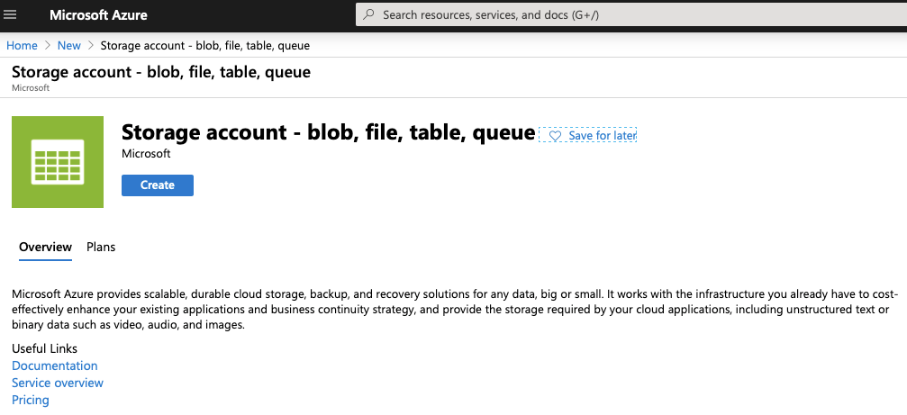

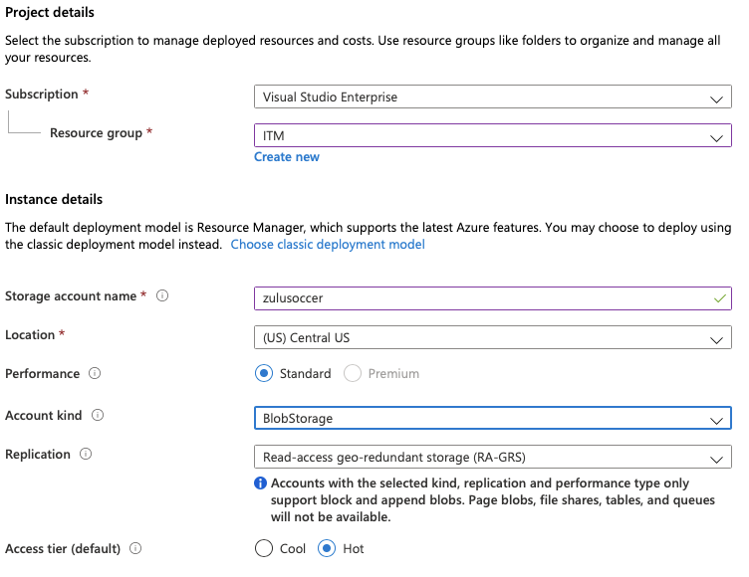

1. Now create the different containers, in out case: **teams, tournaments, users**:

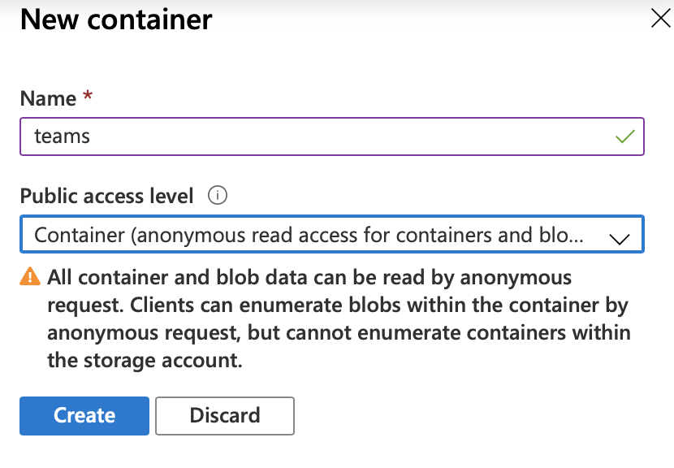

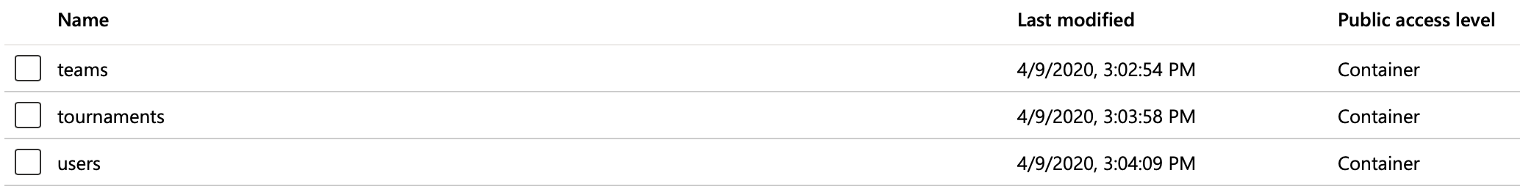

1. Now go to access keys and keep the connection string, we’ll in the next step:

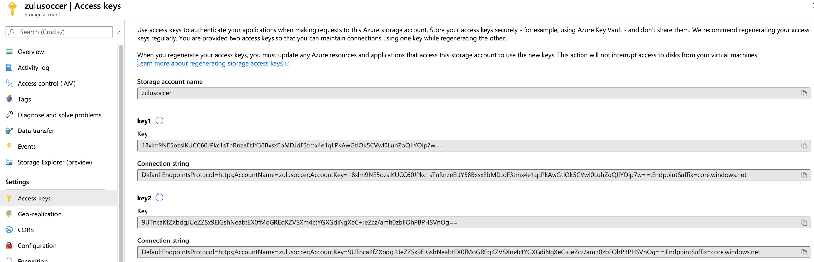

1. Modify the **appsettings.json**:

},

"Blob": {

"ConnectionString": "DefaultEndpointsProtocol=https;AccountName=zulusoccer;AccountKey=18xlm9NE5ozsIKUCC60JPkc1sTnRnzeEtJY58BxsxEbMDJdF3tmx4e1qLPkAwGtIOk5CVwl0LuhZoQIIYOip7w==;EndpointSuffix=core.windows.net"

}

}

1. Add the **IBlobHelper**:

using Microsoft.AspNetCore.Http;

using System.Threading.Tasks;

namespace Taxi.Web.Helpers

{

public interface IBlobHelper

{

Task<string> UploadBlobAsync(IFormFile file, string containerName);

Task<string> UploadBlobAsync(byte[] file, string containerName);

Task<string> UploadBlobAsync(string image, string containerName);

}

}

1. Add the **BlobHelper**:

using Microsoft.AspNetCore.Http;

using Microsoft.Extensions.Configuration;

using Microsoft.WindowsAzure.Storage;

using Microsoft.WindowsAzure.Storage.Blob;

using System;

using System.IO;

using System.Threading.Tasks;

namespace Taxi.Web.Helpers

{

public class BlobHelper : IBlobHelper

{

private readonly CloudBlobClient _blobClient;

public BlobHelper(IConfiguration configuration)

{

string keys = configuration["Blob:ConnectionString"];

CloudStorageAccount storageAccount = CloudStorageAccount.Parse(keys);

_blobClient = storageAccount.CreateCloudBlobClient();

}

public async Task<string> UploadBlobAsync(byte[] file, string containerName)

{

MemoryStream stream = new MemoryStream(file);

string name = $"{Guid.NewGuid()}";

CloudBlobContainer container = _blobClient.GetContainerReference(containerName);

CloudBlockBlob blockBlob = container.GetBlockBlobReference(name);

await blockBlob.UploadFromStreamAsync(stream);

return name;

}

public async Task<string> UploadBlobAsync(IFormFile file, string containerName)

{

Stream stream = file.OpenReadStream();

string name = $"{Guid.NewGuid()}";

CloudBlobContainer container = _blobClient.GetContainerReference(containerName);

CloudBlockBlob blockBlob = container.GetBlockBlobReference(name);

await blockBlob.UploadFromStreamAsync(stream);

return name;

}

public async Task<string> UploadBlobAsync(string image, string containerName)

{

Stream stream = File.OpenRead(image);

string name = $"{Guid.NewGuid()}";

CloudBlobContainer container = _blobClient.GetContainerReference(containerName);

CloudBlockBlob blockBlob = container.GetBlockBlobReference(name);

await blockBlob.UploadFromStreamAsync(stream);

return name;

}

}

}

1. Modify the **Startup**:

services.AddScoped<IMatchHelper, MatchHelper>();

services.AddScoped<IBlobHelper, BlobHelper>();

services.AddMvc().SetCompatibilityVersion(CompatibilityVersion.Version_2_1);

1. Modify the **TeamEntity**:

[Display(Name = "Logo")]

public string LogoFullPath => string.IsNullOrEmpty(LogoPath)

? "https://SoccerWeb0.azurewebsites.net//images/noimage.png"

: $"https://zulusoccer.blob.core.windows.net/teams/{LogoPath}";

1. Modify the **TeamResponse**:

public string LogoFullPath => string.IsNullOrEmpty(LogoPath)

? "https://SoccerWeb0.azurewebsites.net//images/noimage.png"

: $"https://zulusoccer.blob.core.windows.net/teams/{LogoPath}";

1. Modify the **TeamsController**:

private readonly IBlobHelper _blobHelper;

…

public TeamsController(

DataContext context,

IConverterHelper converterHelper,

IBlobHelper blobHelper)

{

_context = context;

_converterHelper = converterHelper;

_blobHelper = blobHelper;

}

…

[HttpPost]

[ValidateAntiForgeryToken]

public async Task<IActionResult> Create(TeamViewModel model)

{

if (ModelState.IsValid)

{

string path = string.Empty;

if (model.LogoFile != null)

{

path = await _blobHelper.UploadBlobAsync(model.LogoFile, "teams");

}

TeamEntity team = _converterHelper.ToTeamEntity(model, path, true);

_context.Add(team);

try

{

await _context.SaveChangesAsync();

return RedirectToAction(nameof(Index));

}

catch (Exception ex)

{

if (ex.InnerException.Message.Contains("duplicate"))

{

ModelState.AddModelError(string.Empty, "Already there is a record with the same name.");

}

else

{

ModelState.AddModelError(string.Empty, ex.InnerException.Message);

}

}

}

return View(model);

}

…

[HttpPost]

[ValidateAntiForgeryToken]

public async Task<IActionResult> Edit(TeamViewModel model)

{

if (ModelState.IsValid)

{

if (ModelState.IsValid)

{

string path = model.LogoPath;

if (model.LogoFile != null)

{

path = await _blobHelper.UploadBlobAsync(model.LogoFile, "teams");

}

TeamEntity team = _converterHelper.ToTeamEntity(model, path, false);

_context.Update(team);

try

{

await _context.SaveChangesAsync();

return RedirectToAction(nameof(Index));

}

catch (Exception ex)

{

if (ex.InnerException.Message.Contains("duplicate"))

{

ModelState.AddModelError(string.Empty, "Already there is a record with the same name.");

}

else

{

ModelState.AddModelError(string.Empty, ex.InnerException.Message);

}

}

}

}

return View(model);

}

1. Modify the **Index** view for **Tems**:

<td>

<img src="@item.LogoFullPath" style="width:100px;height:100px;max-width: 100%; height: auto;" />

</td>

1. Modify the **Details** view for **Tems**:

<dd>

<img src="@Model.LogoFullPath" style="width:100px;height:200px;max-width:200%; height: auto;" />

</dd>

1. Modify the **Edit** view for **Tems**:

<div class="col-md-4">

<img src="@Model.LogoFullPath" style="width:100px;height:200px;max-width:200%; height: auto;" />

</div>

1. Test it.
2. Modify the **TournamentEntity**:

[Display(Name = "Logo")]

public string LogoFullPath => string.IsNullOrEmpty(LogoPath)

? "https://SoccerWeb0.azurewebsites.net//images/noimage.png"

: $"https://zulusoccer.blob.core.windows.net/tournaments/{LogoPath}";

1. Modify the **TournamentResponse**:

public string LogoFullPath => string.IsNullOrEmpty(LogoPath)

? "https://SoccerWeb0.azurewebsites.net//images/noimage.png"

: $"https://zulusoccer.blob.core.windows.net/tournaments/{LogoPath}";

1. Modify the **TournamentsController**:

private readonly IBlobHelper _blobHelper;

…

public TournamentsController(

DataContext context,

IConverterHelper converterHelper,

ICombosHelper combosHelper,

IMatchHelper matchHelper,

IBlobHelper blobHelper)

{

_context = context;

_converterHelper = converterHelper;

_combosHelper = combosHelper;

_matchHelper = matchHelper;

_blobHelper = blobHelper;

}

…

[HttpPost]

[ValidateAntiForgeryToken]

public async Task<IActionResult> Create(TournamentViewModel model)

{

if (ModelState.IsValid)

{

string path = string.Empty;

if (model.LogoFile != null)

{

path = await _blobHelper.UploadBlobAsync(model.LogoFile, "tournaments");

}

var tournament = _converterHelper.ToTournamentEntity(model, path, true);

_context.Add(tournament);

await _context.SaveChangesAsync();

return RedirectToAction(nameof(Index));

}

return View(model);

}

…

[HttpPost]

[ValidateAntiForgeryToken]

public async Task<IActionResult> Edit(TournamentViewModel model)

{

if (ModelState.IsValid)

{

if (ModelState.IsValid)

{

var path = model.LogoPath;

if (model.LogoFile != null)

{

path = await _blobHelper.UploadBlobAsync(model.LogoFile, "tournaments");

}

var tournamentEntity = _converterHelper.ToTournamentEntity(model, path, false);

_context.Update(tournamentEntity);

await _context.SaveChangesAsync();

return RedirectToAction(nameof(Index));

}

}

return View(model);

}

1. Modify the **Index** view on **Tournaments**:

<td>

<img src="@item.LogoFullPath" style="width:100px;height:100px;max-width: 100%; height: auto;" />

</td>

1. Modify the **Details** view on **Tournaments**:

<div class="col-md-4">

<img src="@Model.LogoFullPath" style="width:150px;height:150px;max-width:200%; height: auto;" />

</div>

1. Modify the **Edit** view on **Tournaments**:

<div class="col-md-4">

<img src="@Model.LogoFullPath" style="width:200px;height:2000px;max-width:200%; height: auto;" />

</div>

1. Modify the **DetailsGroup** view on **Tournaments**:

<div class="col-md-4">

<img src="@Model.Tournament.LogoFullPath" style="width:150px;height:150px;max-width:200%; height: auto;" />

</div>

…

<td>

<img src="@item.Team.LogoFullPath" style="width:50px;height:50px;max-width: 100%; height: auto;" />

</td>

…

<td>

<img src="@item.Local.LogoFullPath" style="width:50px;height:50px;max-width: 100%; height: auto;" />

</td>

…

<td>

<img src="@item.Visitor.LogoFullPath" style="width:50px;height:50px;max-width: 100%; height: auto;" />

</td>

1. Test it.
2. Modify the **UserEntity**:

[Display(Name = "Picture")]

public string PictureFullPath => string.IsNullOrEmpty(PicturePath)

? "https://SoccerWeb0.azurewebsites.net//images/noimage.png"

: LoginType == LoginType.Soccer ? $"https://zulusoccer.blob.core.windows.net/users/{PicturePath}" : PicturePath;

1. Modify the **UserResponse**:

public string PictureFullPath => string.IsNullOrEmpty(PicturePath)

? "https://SoccerWeb0.azurewebsites.net//images/noimage.png"

: $"https://zulusoccer.blob.core.windows.net/users/{PicturePath}";

1. Modify the **EditUserViewModel**:

[Display(Name = "Picture")]

public string PictureFullPath => string.IsNullOrEmpty(PicturePath)

? "https://SoccerWeb0.azurewebsites.net//images/noimage.png"

: $"https://zulusoccer.blob.core.windows.net/users/{PicturePath}";

1. Modify the **AccountController**:

private readonly IBlobHelper _blobHelper;

…

public AccountController(

DataContext context,

IUserHelper userHelper,

ICombosHelper combosHelper,

IConfiguration configuration,

IMailHelper mailHelper,

IBlobHelper blobHelper)

{

_context = context;

_userHelper = userHelper;

_combosHelper = combosHelper;

_configuration = configuration;

_mailHelper = mailHelper;

_blobHelper = blobHelper;

}

…

if (model.PictureFile != null)

{

path = await _blobHelper.UploadBlobAsync(model.PictureFile, "users");

}

…

if (model.PictureFile != null)

{

path = await _blobHelper.UploadBlobAsync(model.PictureFile, "users");

}

1. Modify the **ChangeUserView** on **Account**:

<div class="col-md-4">

<img src="@Model.PictureFullPath" style="width:300px;height:300px;max-width:200%; height: auto;" />

</div>

1. Ensure that you have images for Teams, Tournaments and Users:

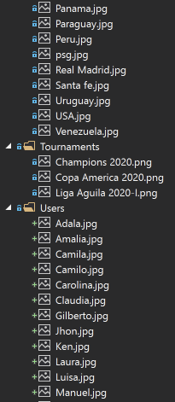

1. Modify the **SeedDb**:

using Soccer.Common.Enums;

using Soccer.Web.Data.Entities;

using Soccer.Web.Helpers;

using System;

using System.Collections.Generic;

using System.IO;

using System.Linq;

using System.Threading.Tasks;

namespace Soccer.Web.Data

{

public class SeedDb

{

private readonly DataContext _context;

private readonly IUserHelper _userHelper;

private readonly IBlobHelper _blobHelper;

private readonly Random _random;

public SeedDb(

DataContext context,

IUserHelper userHelper,

IBlobHelper blobHelper)

{

_context = context;

_userHelper = userHelper;

_blobHelper = blobHelper;

_random = new Random();

}

public async Task SeedAsync()

{

await _context.Database.EnsureCreatedAsync();

await CheckRolesAsync();

await CheckTeamsAsync();

await CheckTournamentsAsync();

await CheckUserAsync("1010", "Juan", "Zuluaga", "jzuluaga55@hotmail.com", "350 634 2747", "Calle Luna Calle Sol", UserType.Admin, "Zulu.jpg");

await CheckUsersAsync();

await CheckPreditionsAsync();

}

private async Task CheckUsersAsync()

{

List<Photo> photos = LoadPhotos();

int i = 0;

foreach (Photo photo in photos)

{

i++;

await CheckUserAsync($"100{i}", photo.Firstname, photo.Lastname, $"user{i}@yopmail.com", "350 634 2747", "Calle Luna Calle Sol", UserType.User, photo.Image);

}

}

private List<Photo> LoadPhotos()

{

return new List<Photo>

{

new Photo { Firstname = "Adala", Lastname = "Samir", Image = "Adala.jpg" },

new Photo { Firstname = "Amalia", Lastname = "Lopez", Image = "Amalia.jpg" },

new Photo { Firstname = "Camila", Lastname = "Cardona", Image = "Camila.jpg" },

new Photo { Firstname = "Carolina", Lastname = "Echavarria", Image = "Carolina.jpg" },

new Photo { Firstname = "Claudia", Lastname = "Sanchez", Image = "Claudia.jpg" },

new Photo { Firstname = "Gilberto", Lastname = "Medez", Image = "Gilberto.jpg" },

new Photo { Firstname = "Jhon", Lastname = "Smith", Image = "Jhon.jpg" },

new Photo { Firstname = "Ken", Lastname = "Rogers", Image = "Ken.jpg" },

new Photo { Firstname = "Laura", Lastname = "Zuluaga", Image = "Laura.jpg" },

new Photo { Firstname = "Luisa", Lastname = "Zapata", Image = "Luisa.jpg" },

new Photo { Firstname = "Manuel", Lastname = "Rodriguez", Image = "Manuel.jpg" },

new Photo { Firstname = "Manuela", Lastname = "Ateortua", Image = "Manuela.jpg" },

new Photo { Firstname = "Mario", Lastname = "Bedoya", Image = "Mario.jpg" },

new Photo { Firstname = "Monica", Lastname = "Cano", Image = "Monica.jpg" },

new Photo { Firstname = "Pedro", Lastname = "Correa", Image = "Pedro.jpg" },

new Photo { Firstname = "Penelope", Lastname = "Arias", Image = "Penelope.jpg" },

new Photo { Firstname = "Pepe", Lastname = "Lopez", Image = "Pepe.jpg" },

new Photo { Firstname = "Raul", Lastname = "Matinez", Image = "Raul.jpg" },

new Photo { Firstname = "Roberto", Lastname = "Rivas", Image = "Roberto.jpg" },

new Photo { Firstname = "Rosa", Lastname = "Velasquez", Image = "Rosa.jpg" },

new Photo { Firstname = "Rosario", Lastname = "Sandoval", Image = "Rosario.jpg" },

new Photo { Firstname = "Sandra", Lastname = "Machado", Image = "Sandra.jpg" },

new Photo { Firstname = "Sandro", Lastname = "Ruiz", Image = "Sandro.jpg" },

new Photo { Firstname = "Teresa", Lastname = "Santamaria", Image = "Teresa.jpg" }

};

}

private async Task CheckPreditionsAsync()

{

if (!_context.Predictions.Any())

{

foreach (UserEntity user in _context.Users)

{

if (user.UserType == UserType.User)

{

AddPrediction(user);

}

}

await _context.SaveChangesAsync();

}

}

private void AddPrediction(UserEntity user)

{

foreach (MatchEntity match in _context.Matches)

{

_context.Predictions.Add(new PredictionEntity

{

GoalsLocal = _random.Next(0, 5),

GoalsVisitor = _random.Next(0, 5),

Match = match,

User = user

});

}

}

private async Task<UserEntity> CheckUserAsync(

string document,

string firstName,

string lastName,

string email,

string phone,

string address,

UserType userType,

string image)

{

UserEntity user = await _userHelper.GetUserAsync(email);

if (user == null)

{

string path = Path.Combine(Directory.GetCurrentDirectory(), $"wwwroot\\images\\Users", image);

string imageId = await _blobHelper.UploadBlobAsync(path, "users");

int totalTeams = _context.Teams.Count();

int random = _random.Next(1, _context.Teams.Count());

TeamEntity team = _context.Teams.FirstOrDefault(t => t.Id == random);

user = new UserEntity

{

FirstName = firstName,

LastName = lastName,

Email = email,

UserName = email,

PhoneNumber = phone,

Address = address,

Document = document,

Team = team,

UserType = userType,

PicturePath = imageId

};

await _userHelper.AddUserAsync(user, "123456");

await _userHelper.AddUserToRoleAsync(user, userType.ToString());

string token = await _userHelper.GenerateEmailConfirmationTokenAsync(user);

await _userHelper.ConfirmEmailAsync(user, token);

}

return user;

}

private async Task CheckRolesAsync()

{

await _userHelper.CheckRoleAsync(UserType.Admin.ToString());

await _userHelper.CheckRoleAsync(UserType.User.ToString());

}

private async Task CheckTeamsAsync()

{

if (!_context.Teams.Any())

{

await AddTeamAsync("Ajax");

await AddTeamAsync("America");

await AddTeamAsync("Argentina");

await AddTeamAsync("Barcelona");

await AddTeamAsync("Bayer Leverkusen");

await AddTeamAsync("Bolivia");

await AddTeamAsync("Borussia Dortmund");

await AddTeamAsync("Brasil");

await AddTeamAsync("Bucaramanga");

await AddTeamAsync("Canada");

await AddTeamAsync("Chelsea");

await AddTeamAsync("Chile");

await AddTeamAsync("Colombia");

await AddTeamAsync("Costa Rica");

await AddTeamAsync("Ecuador");

await AddTeamAsync("Honduras");

await AddTeamAsync("Inter Milan");

await AddTeamAsync("Junior");

await AddTeamAsync("Juventus");

await AddTeamAsync("Liverpool");

await AddTeamAsync("Medellin");

await AddTeamAsync("Mexico");

await AddTeamAsync("Millonarios");

await AddTeamAsync("Nacional");

await AddTeamAsync("Once Caldas");

await AddTeamAsync("Panama");

await AddTeamAsync("Paraguay");

await AddTeamAsync("Peru");

await AddTeamAsync("PSG");

await AddTeamAsync("Real Madrid");

await AddTeamAsync("Santa Fe");

await AddTeamAsync("Uruguay");

await AddTeamAsync("USA");

await AddTeamAsync("Venezuela");

await _context.SaveChangesAsync();

}

}

private async Task AddTeamAsync(string name)

{

string path = Path.Combine(Directory.GetCurrentDirectory(), $"wwwroot\\images\\Teams", $"{name}.jpg");

string imageId = await _blobHelper.UploadBlobAsync(path, "teams");

_context.Teams.Add(new TeamEntity { Name = name, LogoPath = imageId });

}

private async Task CheckTournamentsAsync()

{

if (!_context.Tournaments.Any())

{

DateTime startDate = DateTime.Today.AddMonths(2).ToUniversalTime();

DateTime endDate = DateTime.Today.AddMonths(3).ToUniversalTime();

string imageIdCopaAmerica = await UploadImageTournamentAsync("Copa America 2020.png");

string imageIdLigaAguila = await UploadImageTournamentAsync("Liga Aguila 2020-I.png");

string imageIdChampions = await UploadImageTournamentAsync("Champions 2020.png");

_context.Tournaments.Add(new TournamentEntity

{

StartDate = startDate,

EndDate = endDate,

IsActive = true,

LogoPath = imageIdCopaAmerica,

Name = "Copa America 2020",

Groups = new List<GroupEntity>

{

new GroupEntity

{

Name = "A",

GroupDetails = new List<GroupDetailEntity>

{

new GroupDetailEntity { Team = _context.Teams.FirstOrDefault(t => t.Name == "Colombia") },

new GroupDetailEntity { Team = _context.Teams.FirstOrDefault(t => t.Name == "Ecuador") },

new GroupDetailEntity { Team = _context.Teams.FirstOrDefault(t => t.Name == "Panama") },

new GroupDetailEntity { Team = _context.Teams.FirstOrDefault(t => t.Name == "Canada") }

},

Matches = new List<MatchEntity>

{

new MatchEntity

{

Date = startDate.AddHours(14),

Local = _context.Teams.FirstOrDefault(t => t.Name == "Colombia"),

Visitor = _context.Teams.FirstOrDefault(t => t.Name == "Ecuador")

},

new MatchEntity

{

Date = startDate.AddHours(17),

Local = _context.Teams.FirstOrDefault(t => t.Name == "Panama"),

Visitor = _context.Teams.FirstOrDefault(t => t.Name == "Canada")

},

new MatchEntity

{

Date = startDate.AddDays(4).AddHours(14),

Local = _context.Teams.FirstOrDefault(t => t.Name == "Colombia"),

Visitor = _context.Teams.FirstOrDefault(t => t.Name == "Panama")

},

new MatchEntity

{

Date = startDate.AddDays(4).AddHours(17),

Local = _context.Teams.FirstOrDefault(t => t.Name == "Ecuador"),

Visitor = _context.Teams.FirstOrDefault(t => t.Name == "Canada")

},

new MatchEntity

{

Date = startDate.AddDays(9).AddHours(16),

Local = _context.Teams.FirstOrDefault(t => t.Name == "Canada"),

Visitor = _context.Teams.FirstOrDefault(t => t.Name == "Colombia")

},

new MatchEntity

{

Date = startDate.AddDays(9).AddHours(16),

Local = _context.Teams.FirstOrDefault(t => t.Name == "Ecuador"),

Visitor = _context.Teams.FirstOrDefault(t => t.Name == "Panama")

}

}

},

new GroupEntity

{

Name = "B",

GroupDetails = new List<GroupDetailEntity>

{

new GroupDetailEntity { Team = _context.Teams.FirstOrDefault(t => t.Name == "Argentina") },

new GroupDetailEntity { Team = _context.Teams.FirstOrDefault(t => t.Name == "Paraguay") },

new GroupDetailEntity { Team = _context.Teams.FirstOrDefault(t => t.Name == "Mexico") },

new GroupDetailEntity { Team = _context.Teams.FirstOrDefault(t => t.Name == "Chile") }

},

Matches = new List<MatchEntity>

{

new MatchEntity

{

Date = startDate.AddDays(1).AddHours(14),

Local = _context.Teams.FirstOrDefault(t => t.Name == "Argentina"),

Visitor = _context.Teams.FirstOrDefault(t => t.Name == "Paraguay")

},

new MatchEntity

{

Date = startDate.AddDays(1).AddHours(17),

Local = _context.Teams.FirstOrDefault(t => t.Name == "Mexico"),

Visitor = _context.Teams.FirstOrDefault(t => t.Name == "Chile")

},

new MatchEntity

{

Date = startDate.AddDays(5).AddHours(14),

Local = _context.Teams.FirstOrDefault(t => t.Name == "Argentina"),

Visitor = _context.Teams.FirstOrDefault(t => t.Name == "Mexico")

},

new MatchEntity

{

Date = startDate.AddDays(5).AddHours(17),

Local = _context.Teams.FirstOrDefault(t => t.Name == "Paraguay"),

Visitor = _context.Teams.FirstOrDefault(t => t.Name == "Chile")

},

new MatchEntity

{

Date = startDate.AddDays(10).AddHours(16),

Local = _context.Teams.FirstOrDefault(t => t.Name == "Chile"),

Visitor = _context.Teams.FirstOrDefault(t => t.Name == "Argentina")

},

new MatchEntity

{

Date = startDate.AddDays(10).AddHours(16),

Local = _context.Teams.FirstOrDefault(t => t.Name == "Paraguay"),

Visitor = _context.Teams.FirstOrDefault(t => t.Name == "Mexico")

}

}

},

new GroupEntity

{

Name = "C",

GroupDetails = new List<GroupDetailEntity>

{

new GroupDetailEntity { Team = _context.Teams.FirstOrDefault(t => t.Name == "Brasil") },

new GroupDetailEntity { Team = _context.Teams.FirstOrDefault(t => t.Name == "Venezuela") },

new GroupDetailEntity { Team = _context.Teams.FirstOrDefault(t => t.Name == "USA") },

new GroupDetailEntity { Team = _context.Teams.FirstOrDefault(t => t.Name == "Peru") }

},

Matches = new List<MatchEntity>

{

new MatchEntity

{

Date = startDate.AddDays(2).AddHours(14),

Local = _context.Teams.FirstOrDefault(t => t.Name == "Brasil"),

Visitor = _context.Teams.FirstOrDefault(t => t.Name == "Venezuela")

},

new MatchEntity

{

Date = startDate.AddDays(2).AddHours(17),

Local = _context.Teams.FirstOrDefault(t => t.Name == "USA"),

Visitor = _context.Teams.FirstOrDefault(t => t.Name == "Peru")

},

new MatchEntity

{

Date = startDate.AddDays(6).AddHours(14),

Local = _context.Teams.FirstOrDefault(t => t.Name == "Brasil"),

Visitor = _context.Teams.FirstOrDefault(t => t.Name == "USA")

},

new MatchEntity

{

Date = startDate.AddDays(6).AddHours(17),

Local = _context.Teams.FirstOrDefault(t => t.Name == "Venezuela"),

Visitor = _context.Teams.FirstOrDefault(t => t.Name == "Peru")

},

new MatchEntity

{

Date = startDate.AddDays(11).AddHours(16),

Local = _context.Teams.FirstOrDefault(t => t.Name == "Peru"),

Visitor = _context.Teams.FirstOrDefault(t => t.Name == "Brasil")

},

new MatchEntity

{

Date = startDate.AddDays(11).AddHours(16),

Local = _context.Teams.FirstOrDefault(t => t.Name == "Venezuela"),

Visitor = _context.Teams.FirstOrDefault(t => t.Name == "USA")

}

}

},

new GroupEntity

{

Name = "D",

GroupDetails = new List<GroupDetailEntity>

{

new GroupDetailEntity { Team = _context.Teams.FirstOrDefault(t => t.Name == "Uruguay") },

new GroupDetailEntity { Team = _context.Teams.FirstOrDefault(t => t.Name == "Bolivia") },

new GroupDetailEntity { Team = _context.Teams.FirstOrDefault(t => t.Name == "Costa Rica") },

new GroupDetailEntity { Team = _context.Teams.FirstOrDefault(t => t.Name == "Honduras") }

},

Matches = new List<MatchEntity>

{

new MatchEntity

{

Date = startDate.AddDays(3).AddHours(14),

Local = _context.Teams.FirstOrDefault(t => t.Name == "Uruguay"),

Visitor = _context.Teams.FirstOrDefault(t => t.Name == "Bolivia")

},

new MatchEntity

{

Date = startDate.AddDays(3).AddHours(17),

Local = _context.Teams.FirstOrDefault(t => t.Name == "Costa Rica"),

Visitor = _context.Teams.FirstOrDefault(t => t.Name == "Honduras")

},

new MatchEntity

{

Date = startDate.AddDays(7).AddHours(14),

Local = _context.Teams.FirstOrDefault(t => t.Name == "Uruguay"),

Visitor = _context.Teams.FirstOrDefault(t => t.Name == "Costa Rica")

},

new MatchEntity

{

Date = startDate.AddDays(7).AddHours(17),

Local = _context.Teams.FirstOrDefault(t => t.Name == "Bolivia"),

Visitor = _context.Teams.FirstOrDefault(t => t.Name == "Honduras")

},

new MatchEntity

{

Date = startDate.AddDays(12).AddHours(16),

Local = _context.Teams.FirstOrDefault(t => t.Name == "Honduras"),

Visitor = _context.Teams.FirstOrDefault(t => t.Name == "Uruguay")

},

new MatchEntity

{

Date = startDate.AddDays(12).AddHours(16),

Local = _context.Teams.FirstOrDefault(t => t.Name == "Bolivia"),

Visitor = _context.Teams.FirstOrDefault(t => t.Name == "Costa Rica")

}

}

}

}

});

startDate = DateTime.Today.AddMonths(1).ToUniversalTime();

endDate = DateTime.Today.AddMonths(4).ToUniversalTime();

_context.Tournaments.Add(new TournamentEntity

{

StartDate = startDate,

EndDate = endDate,

IsActive = true,

LogoPath = imageIdLigaAguila,

Name = "Liga Aguila 2020-I",

Groups = new List<GroupEntity>

{

new GroupEntity

{

Name = "A",

GroupDetails = new List<GroupDetailEntity>

{

new GroupDetailEntity { Team = _context.Teams.FirstOrDefault(t => t.Name == "America") },

new GroupDetailEntity { Team = _context.Teams.FirstOrDefault(t => t.Name == "Bucaramanga") },

new GroupDetailEntity { Team = _context.Teams.FirstOrDefault(t => t.Name == "Junior") },

new GroupDetailEntity { Team = _context.Teams.FirstOrDefault(t => t.Name == "Medellin") }

},

Matches = new List<MatchEntity>

{

new MatchEntity

{

Date = startDate.AddHours(14),

Local = _context.Teams.FirstOrDefault(t => t.Name == "America"),

Visitor = _context.Teams.FirstOrDefault(t => t.Name == "Bucaramanga")

},

new MatchEntity

{

Date = startDate.AddHours(17),

Local = _context.Teams.FirstOrDefault(t => t.Name == "Junior"),

Visitor = _context.Teams.FirstOrDefault(t => t.Name == "Medellin")

},

new MatchEntity

{

Date = startDate.AddDays(4).AddHours(14),

Local = _context.Teams.FirstOrDefault(t => t.Name == "America"),

Visitor = _context.Teams.FirstOrDefault(t => t.Name == "Junior")

},

new MatchEntity

{

Date = startDate.AddDays(4).AddHours(17),

Local = _context.Teams.FirstOrDefault(t => t.Name == "Bucaramanga"),

Visitor = _context.Teams.FirstOrDefault(t => t.Name == "Medellin")

},

new MatchEntity

{

Date = startDate.AddDays(9).AddHours(14),

Local = _context.Teams.FirstOrDefault(t => t.Name == "Medellin"),

Visitor = _context.Teams.FirstOrDefault(t => t.Name == "America")

},

new MatchEntity

{

Date = startDate.AddDays(9).AddHours(17),

Local = _context.Teams.FirstOrDefault(t => t.Name == "Bucaramanga"),

Visitor = _context.Teams.FirstOrDefault(t => t.Name == "Junior")

},

new MatchEntity

{

Date = startDate.AddDays(15).AddHours(14),

Local = _context.Teams.FirstOrDefault(t => t.Name == "Bucaramanga"),

Visitor = _context.Teams.FirstOrDefault(t => t.Name == "America")

},

new MatchEntity

{

Date = startDate.AddDays(15).AddHours(17),

Local = _context.Teams.FirstOrDefault(t => t.Name == "Medellin"),

Visitor = _context.Teams.FirstOrDefault(t => t.Name == "Junior")

},

new MatchEntity

{

Date = startDate.AddDays(19).AddHours(14),

Local = _context.Teams.FirstOrDefault(t => t.Name == "Junior"),

Visitor = _context.Teams.FirstOrDefault(t => t.Name == "America")

},

new MatchEntity

{

Date = startDate.AddDays(19).AddHours(17),

Local = _context.Teams.FirstOrDefault(t => t.Name == "Medellin"),

Visitor = _context.Teams.FirstOrDefault(t => t.Name == "Bucaramanga")

},

new MatchEntity

{

Date = startDate.AddDays(19).AddHours(14),

Local = _context.Teams.FirstOrDefault(t => t.Name == "America"),

Visitor = _context.Teams.FirstOrDefault(t => t.Name == "Medellin")

},

new MatchEntity

{

Date = startDate.AddDays(19).AddHours(17),

Local = _context.Teams.FirstOrDefault(t => t.Name == "Junior"),

Visitor = _context.Teams.FirstOrDefault(t => t.Name == "Bucaramanga")

}

}

},

new GroupEntity

{

Name = "B",

GroupDetails = new List<GroupDetailEntity>

{

new GroupDetailEntity { Team = _context.Teams.FirstOrDefault(t => t.Name == "Millonarios") },

new GroupDetailEntity { Team = _context.Teams.FirstOrDefault(t => t.Name == "Nacional") },

new GroupDetailEntity { Team = _context.Teams.FirstOrDefault(t => t.Name == "Once Caldas") },

new GroupDetailEntity { Team = _context.Teams.FirstOrDefault(t => t.Name == "Santa Fe") }

},

Matches = new List<MatchEntity>

{

new MatchEntity

{

Date = startDate.AddDays(1).AddHours(14),

Local = _context.Teams.FirstOrDefault(t => t.Name == "Millonarios"),

Visitor = _context.Teams.FirstOrDefault(t => t.Name == "Nacional")

},

new MatchEntity

{

Date = startDate.AddDays(1).AddHours(17),

Local = _context.Teams.FirstOrDefault(t => t.Name == "Once Caldas"),

Visitor = _context.Teams.FirstOrDefault(t => t.Name == "Santa Fe")

},

new MatchEntity

{

Date = startDate.AddDays(5).AddHours(14),

Local = _context.Teams.FirstOrDefault(t => t.Name == "Millonarios"),

Visitor = _context.Teams.FirstOrDefault(t => t.Name == "Once Caldas")

},

new MatchEntity

{

Date = startDate.AddDays(5).AddHours(17),

Local = _context.Teams.FirstOrDefault(t => t.Name == "Nacional"),

Visitor = _context.Teams.FirstOrDefault(t => t.Name == "Santa Fe")

},

new MatchEntity

{

Date = startDate.AddDays(10).AddHours(16),

Local = _context.Teams.FirstOrDefault(t => t.Name == "Santa Fe"),

Visitor = _context.Teams.FirstOrDefault(t => t.Name == "Millonarios")

},

new MatchEntity

{

Date = startDate.AddDays(10).AddHours(16),

Local = _context.Teams.FirstOrDefault(t => t.Name == "Nacional"),

Visitor = _context.Teams.FirstOrDefault(t => t.Name == "Once Caldas")

},

new MatchEntity

{

Date = startDate.AddDays(16).AddHours(14),

Local = _context.Teams.FirstOrDefault(t => t.Name == "Nacional"),

Visitor = _context.Teams.FirstOrDefault(t => t.Name == "Millonarios")

},

new MatchEntity

{

Date = startDate.AddDays(16).AddHours(17),

Local = _context.Teams.FirstOrDefault(t => t.Name == "Santa Fe"),

Visitor = _context.Teams.FirstOrDefault(t => t.Name == "Once Caldas")

},

new MatchEntity

{

Date = startDate.AddDays(20).AddHours(14),

Local = _context.Teams.FirstOrDefault(t => t.Name == "Once Caldas"),

Visitor = _context.Teams.FirstOrDefault(t => t.Name == "Millonarios")

},

new MatchEntity

{

Date = startDate.AddDays(20).AddHours(17),

Local = _context.Teams.FirstOrDefault(t => t.Name == "Santa Fe"),

Visitor = _context.Teams.FirstOrDefault(t => t.Name == "Nacional")

},

new MatchEntity

{

Date = startDate.AddDays(35).AddHours(16),

Local = _context.Teams.FirstOrDefault(t => t.Name == "Millonarios"),

Visitor = _context.Teams.FirstOrDefault(t => t.Name == "Santa Fe")

},

new MatchEntity

{

Date = startDate.AddDays(35).AddHours(16),

Local = _context.Teams.FirstOrDefault(t => t.Name == "Once Caldas"),

Visitor = _context.Teams.FirstOrDefault(t => t.Name == "Nacional")

}

}

}

}

});

startDate = DateTime.Today.AddMonths(1).ToUniversalTime();

endDate = DateTime.Today.AddMonths(2).ToUniversalTime();

_context.Tournaments.Add(new TournamentEntity

{

StartDate = startDate,

EndDate = endDate,

IsActive = true,

LogoPath = imageIdChampions,

Name = "Champions 2020",

Groups = new List<GroupEntity>

{

new GroupEntity

{

Name = "A",

GroupDetails = new List<GroupDetailEntity>

{

new GroupDetailEntity { Team = _context.Teams.FirstOrDefault(t => t.Name == "Ajax") },

new GroupDetailEntity { Team = _context.Teams.FirstOrDefault(t => t.Name == "Barcelona") }

},

Matches = new List<MatchEntity>

{

new MatchEntity

{

Date = startDate.AddHours(14),

Local = _context.Teams.FirstOrDefault(t => t.Name == "Ajax"),

Visitor = _context.Teams.FirstOrDefault(t => t.Name == "Barcelona")

},

new MatchEntity

{

Date = startDate.AddHours(17),

Local = _context.Teams.FirstOrDefault(t => t.Name == "Barcelona"),

Visitor = _context.Teams.FirstOrDefault(t => t.Name == "Ajax")

}

}

},

new GroupEntity

{

Name = "B",

GroupDetails = new List<GroupDetailEntity>

{

new GroupDetailEntity { Team = _context.Teams.FirstOrDefault(t => t.Name == "Bayer Leverkusen") },

new GroupDetailEntity { Team = _context.Teams.FirstOrDefault(t => t.Name == "Chelsea") }

},

Matches = new List<MatchEntity>

{

new MatchEntity

{

Date = startDate.AddDays(1).AddHours(14),

Local = _context.Teams.FirstOrDefault(t => t.Name == "Bayer Leverkusen"),

Visitor = _context.Teams.FirstOrDefault(t => t.Name == "Chelsea")

},

new MatchEntity

{

Date = startDate.AddDays(1).AddHours(17),

Local = _context.Teams.FirstOrDefault(t => t.Name == "Chelsea"),

Visitor = _context.Teams.FirstOrDefault(t => t.Name == "Bayer Leverkusen")

}

}

},

new GroupEntity

{

Name = "C",

GroupDetails = new List<GroupDetailEntity>

{

new GroupDetailEntity { Team = _context.Teams.FirstOrDefault(t => t.Name == "Borussia Dortmund") },

new GroupDetailEntity { Team = _context.Teams.FirstOrDefault(t => t.Name == "Inter Milan") }

},

Matches = new List<MatchEntity>

{

new MatchEntity

{

Date = startDate.AddDays(1).AddHours(14),

Local = _context.Teams.FirstOrDefault(t => t.Name == "Borussia Dortmund"),

Visitor = _context.Teams.FirstOrDefault(t => t.Name == "Inter Milan")

},

new MatchEntity

{

Date = startDate.AddDays(1).AddHours(17),

Local = _context.Teams.FirstOrDefault(t => t.Name == "Inter Milan"),

Visitor = _context.Teams.FirstOrDefault(t => t.Name == "Borussia Dortmund")

}

}

},

new GroupEntity

{

Name = "D",

GroupDetails = new List<GroupDetailEntity>

{

new GroupDetailEntity { Team = _context.Teams.FirstOrDefault(t => t.Name == "PSG") },

new GroupDetailEntity { Team = _context.Teams.FirstOrDefault(t => t.Name == "Real Madrid") }

},

Matches = new List<MatchEntity>

{

new MatchEntity

{

Date = startDate.AddDays(1).AddHours(14),

Local = _context.Teams.FirstOrDefault(t => t.Name == "PSG"),

Visitor = _context.Teams.FirstOrDefault(t => t.Name == "Real Madrid")

},

new MatchEntity

{

Date = startDate.AddDays(1).AddHours(17),

Local = _context.Teams.FirstOrDefault(t => t.Name == "Real Madrid"),

Visitor = _context.Teams.FirstOrDefault(t => t.Name == "PSG")

}

}

}

}

});

await _context.SaveChangesAsync();

}

}

private async Task<string> UploadImageTournamentAsync(string name)

{

string path = Path.Combine(Directory.GetCurrentDirectory(), $"wwwroot\\images\\Tournaments", name);

return await _blobHelper.UploadBlobAsync(path, "tournaments");

}

private class Photo

{

public string Firstname { get; set; }

public string Lastname { get; set; }

public string Image { get; set; }

}

}

}

1. Modify the **AccountController**:

[Authorize(Roles = "Admin")]

public async Task<IActionResult> Index()

{

return View(await _context.Users

.Include(u => u.Team)

.Include(u => u.Predictions)

.Where(u => u.UserType == UserType.User)

.OrderBy(u => u.FirstName)

.ThenBy(u => u.LastName)

.ToListAsync());

}

1. Add the view **Index**:

@model IEnumerable<Soccer.Web.Data.Entities.UserEntity>

@{

ViewData["Title"] = "Index";

}

<link rel="stylesheet" href="https://cdn.datatables.net/1.10.19/css/jquery.dataTables.min.css" />

<br />

<div class="row">

<div class="col-md-12">

<div class="panel panel-default">

<div class="panel-heading">

<h3 class="panel-title">Users</h3>

</div>

<div class="panel-body">

<table class="table table-hover table-responsive table-striped" id="MyTable">

<thead>

<tr>

<th>

@Html.DisplayNameFor(model => model.PictureFullPath)

</th>

<th>

@Html.DisplayNameFor(model => model.Email)

</th>

<th>

@Html.DisplayNameFor(model => model.Document)

</th>

<th>

@Html.DisplayNameFor(model => model.FirstName)

</th>

<th>

@Html.DisplayNameFor(model => model.LastName)

</th>

<th>

@Html.DisplayNameFor(model => model.Address)

</th>

<th>

@Html.DisplayNameFor(model => model.PhoneNumber)

</th>

<th>

@Html.DisplayNameFor(model => model.UserType)

</th>

<th>

@Html.DisplayNameFor(model => model.LoginType)

</th>

<th>

@Html.DisplayNameFor(model => model.Team.LogoFullPath)

</th>

<th>

@Html.DisplayNameFor(model => model.Points)

</th>

<th></th>

</tr>

</thead>

<tbody>

@foreach (var item in Model)

{

<tr>

<td>

<img src="@item.PictureFullPath" style="width:80px;height:80px;border-radius:50%" />

</td>

<td>

@Html.DisplayFor(modelItem => item.Email)

</td>

<td>

@Html.DisplayFor(modelItem => item.Document)

</td>

<td>

@Html.DisplayFor(modelItem => item.FirstName)

</td>

<td>

@Html.DisplayFor(modelItem => item.LastName)

</td>

<td>

@Html.DisplayFor(modelItem => item.Address)

</td>

<td>

@Html.DisplayFor(modelItem => item.PhoneNumber)

</td>

<td>

@Html.DisplayFor(modelItem => item.UserType)

</td>

<td>

@Html.DisplayFor(modelItem => item.LoginType)

</td>

<td>

<img src="@item.Team.LogoFullPath" style="width:80px;height:80px;max-width: 100%; height: auto;" />

</td>

<td>

@Html.DisplayFor(modelItem => item.Points)

</td>

<td>

<a asp-action="Details" asp-route-id="@item.Id" class="btn btn-info"><i class="glyphicon glyphicon glyphicon-align-justify"></i></a>

</td>

</tr>

}

</tbody>

</table>

</div>

</div>

</div>

</div>

@section Scripts {

@{await Html.RenderPartialAsync("_ValidationScriptsPartial");}

<script src="//cdn.datatables.net/1.10.19/js/jquery.dataTables.min.js"></script>

<script type="text/javascript">

$(document).ready(function () {

$('#MyTable').DataTable();

});

</script>

}

1. Modify the **_layout**:

@if (User.Identity.IsAuthenticated && User.IsInRole("Admin"))

{

<li><a asp-area="" asp-controller="Teams" asp-action="Index">Teams</a></li>

<li><a asp-area="" asp-controller="Tournaments" asp-action="Index">Tournaments</a></li>

<li><a asp-area="" asp-controller="Account" asp-action="Index">Users</a></li>

}

1. Modify the API **AccountController**:

private readonly IBlobHelper _blobHelper;

…

public AccountController(

DataContext dataContext,

IUserHelper userHelper,

IMailHelper mailHelper,

IConverterHelper converterHelper,

IBlobHelper blobHelper)

{

_dataContext = dataContext;

_userHelper = userHelper;

_mailHelper = mailHelper;

_converterHelper = converterHelper;

_blobHelper = blobHelper;

}

…

if (request.PictureArray != null && request.PictureArray.Length > 0)

{

picturePath = await _blobHelper.UploadBlobAsync(request.PictureArray, "users");

}

…

if (request.PictureArray != null && request.PictureArray.Length > 0)

{

picturePath = await _blobHelper.UploadBlobAsync(request.PictureArray, "users");

}

1. Drop the database and test it.
2. Drop the database in Azure and publish again.

## 

## Show positions for tournament

We are going to build this screen:

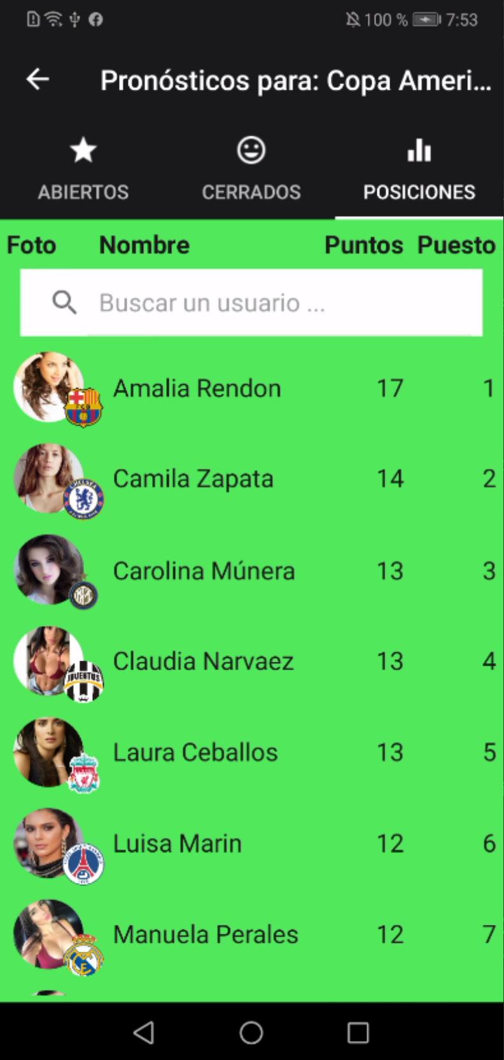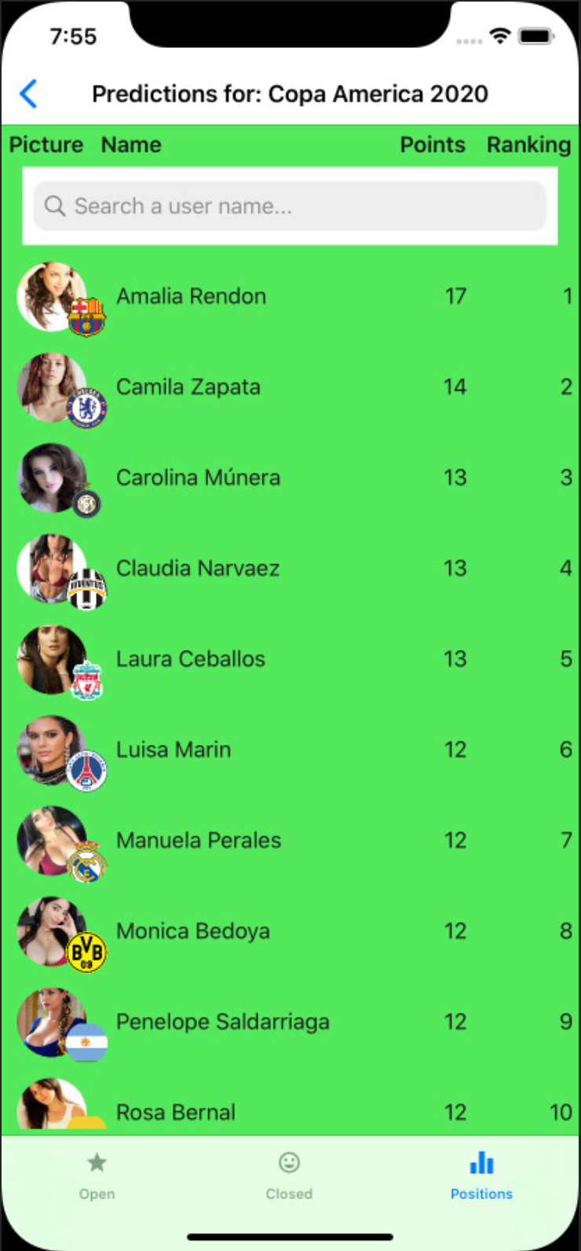

1. Modify the **Languages**:

public static string SearchUserPlaceHolder => Resource.SearchUserPlaceHolder;

public static string Ranking => Resource.Ranking;

public static string Positions => Resource.Positions;

public static string Picture => Resource.Picture;

1. Modify the **IApiService**:

Task<Response> GetListAsync<T>(string urlBase, string servicePrefix, string controller, string tokenType, string accessToken);

1. Modify the **ApiService**:

public async Task<Response> GetListAsync<T>(string urlBase, string servicePrefix, string controller, string tokenType, string accessToken)

{

try

{

HttpClient client = new HttpClient

{

BaseAddress = new Uri(urlBase),

};

client.DefaultRequestHeaders.Authorization = new AuthenticationHeaderValue(tokenType, accessToken);

string url = $"{servicePrefix}{controller}";

HttpResponseMessage response = await client.GetAsync(url);

string result = await response.Content.ReadAsStringAsync();

if (!response.IsSuccessStatusCode)

{

return new Response

{

IsSuccess = false,

Message = result,

};

}

List<T> list = JsonConvert.DeserializeObject<List<T>>(result);

return new Response

{

IsSuccess = true,

Result = list

};

}

catch (Exception ex)

{

return new Response

{

IsSuccess = false,

Message = ex.Message

};

}

}

1. Add the **PositionsInTournamentPage**:

<?xml version="1.0" encoding="utf-8" ?>

<ContentPage xmlns="http://xamarin.com/schemas/2014/forms"

xmlns:x="http://schemas.microsoft.com/winfx/2009/xaml"

xmlns:prism="http://prismlibrary.com"

prism:ViewModelLocator.AutowireViewModel="True"

xmlns:ffimageloading="clr-namespace:FFImageLoading.Forms;assembly=FFImageLoading.Forms"

xmlns:fftransformations="clr-namespace:FFImageLoading.Transformations;assembly=FFImageLoading.Transformations"

xmlns:busyindicator="clr-namespace:Syncfusion.SfBusyIndicator.XForms;assembly=Syncfusion.SfBusyIndicator.XForms"

xmlns:ios="clr-namespace:Xamarin.Forms.PlatformConfiguration.iOSSpecific;assembly=Xamarin.Forms.Core"

xmlns:i18n="clr-namespace:Soccer.Prism.Helpers"

ios:Page.UseSafeArea="true"

x:Class="Soccer.Prism.Views.PositionsInTournamentPage"

BackgroundColor="{StaticResource ColorBackgroud}"

IconImageSource="ic_action_equalizer"

Title="{Binding Title}">

<AbsoluteLayout>

<StackLayout AbsoluteLayout.LayoutBounds="0,0,1,1"

AbsoluteLayout.LayoutFlags="All"

Padding="5">

<Grid>

<Grid.RowDefinitions>

<RowDefinition Height="Auto"/>

</Grid.RowDefinitions>

<Grid.ColumnDefinitions>

<ColumnDefinition Width="60" />

<ColumnDefinition Width="*" />

<ColumnDefinition Width="60" />

<ColumnDefinition Width="70" />

</Grid.ColumnDefinitions>

<Label Grid.Column="0"

FontAttributes="Bold"

FontSize="Medium"

Text="{i18n:Translate Picture}"

VerticalOptions="Center"/>

<Label Grid.Column="1"

FontAttributes="Bold"

FontSize="Medium"

Text="{i18n:Translate Name}"

VerticalOptions="Center"/>

<Label Grid.Column="2"

FontAttributes="Bold"

FontSize="Medium"

HorizontalTextAlignment="End"

Text="{i18n:Translate Points}"

VerticalOptions="Center"/>

<Label Grid.Column="3"

FontAttributes="Bold"

FontSize="Medium"

HorizontalTextAlignment="End"

Text="{i18n:Translate Ranking}"

VerticalOptions="Center"/>

</Grid>

<SearchBar Margin="10,0"

Placeholder="{i18n:Translate SearchUserPlaceHolder}"

SearchCommand="{Binding SearchCommand}"

Text="{Binding Search}"/>

<CollectionView ItemsSource="{Binding Positions}">

<CollectionView.ItemsLayout>

<GridItemsLayout Orientation="Vertical"

VerticalItemSpacing="5"/>

</CollectionView.ItemsLayout>

<CollectionView.ItemTemplate>

<DataTemplate>

<Grid>

<Grid.ColumnDefinitions>

<ColumnDefinition Width="Auto" />

<ColumnDefinition Width="*" />

<ColumnDefinition Width="60" />

<ColumnDefinition Width="70" />

</Grid.ColumnDefinitions>

<RelativeLayout Grid.Column="0">

<ffimageloading:CachedImage x:Name="Picture"

Aspect="AspectFill"

Source="{Binding UserResponse.PictureFullPath}"

CacheDuration= "50"

Margin="5"

RetryCount= "3"

RetryDelay= "600"

WidthRequest="50">

<ffimageloading:CachedImage.Transformations>

<fftransformations:CircleTransformation />

</ffimageloading:CachedImage.Transformations>

</ffimageloading:CachedImage>

<ffimageloading:CachedImage x:Name="Team"

RelativeLayout.YConstraint="{ConstraintExpression Type=RelativeToView, ElementName=Picture,Property=Y,Factor=1,Constant=20}"

RelativeLayout.XConstraint="{ConstraintExpression Type=RelativeToView, ElementName=Picture,Property=X,Factor=1,Constant=30}"

Aspect="AspectFit"

Source="{Binding UserResponse.Team.LogoFullPath}"

CacheDuration= "50"

HeightRequest="30"

Margin="5"

RetryCount= "3"

RetryDelay= "600">

<ffimageloading:CachedImage.Transformations>

<fftransformations:CircleTransformation />

</ffimageloading:CachedImage.Transformations>

</ffimageloading:CachedImage>

</RelativeLayout>

<Label Grid.Column="1"

FontSize="Medium"

Text="{Binding UserResponse.FullName}"

VerticalOptions="Center"/>

<Label Grid.Column="2"

FontSize="Medium"

HorizontalTextAlignment="End"

Text="{Binding Points}"

VerticalOptions="Center"/>

<Label Grid.Column="3"

FontSize="Medium"

HorizontalTextAlignment="End"

Text="{Binding Ranking}"

VerticalOptions="Center"/>

</Grid>

</DataTemplate>

</CollectionView.ItemTemplate>

</CollectionView>

</StackLayout>

<busyindicator:SfBusyIndicator AnimationType="Gear"

AbsoluteLayout.LayoutBounds=".5,.5,.5,.5"

AbsoluteLayout.LayoutFlags="All"

BackgroundColor="{StaticResource ColorAccent}"

HorizontalOptions="Center"

TextColor="{StaticResource ColorFontInverse}"

IsVisible="{Binding IsRunning}"

Title="{i18n:Translate Loading}"

VerticalOptions="Center"

ViewBoxWidth="80"

ViewBoxHeight="80" />

</AbsoluteLayout>

</ContentPage>

1. Modify the **PositionsInTournamentPageViewModel**:

using Newtonsoft.Json;

using Prism.Commands;

using Prism.Navigation;

using Soccer.Common.Helpers;

using Soccer.Common.Models;

using Soccer.Common.Services;

using Soccer.Prism.Helpers;

using System.Collections.Generic;

using System.Collections.ObjectModel;

using System.Linq;

namespace Soccer.Prism.ViewModels

{

public class PositionsInTournamentPageViewModel : ViewModelBase

{

private readonly IApiService _apiService;

private TournamentResponse _tournament;

private bool _isRunning;

private ObservableCollection<PositionResponse> _positions;

private List<PositionResponse> _myPositions;

private string _search;

private DelegateCommand _searchCommand;

public PositionsInTournamentPageViewModel(INavigationService navigationService, IApiService apiService)

: base(navigationService)

{

_apiService = apiService;

Title = Languages.Positions;

LoadPositionsAsync();

}

public DelegateCommand SearchCommand => _searchCommand ?? (_searchCommand = new DelegateCommand(ShowPositions));

public bool IsRunning

{

get => _isRunning;

set => SetProperty(ref _isRunning, value);

}

public string Search

{

get => _search;

set

{

SetProperty(ref _search, value);

ShowPositions();

}

}

public ObservableCollection<PositionResponse> Positions

{

get => _positions;

set => SetProperty(ref _positions, value);

}

private async void LoadPositionsAsync()

{

IsRunning = true;

_tournament = JsonConvert.DeserializeObject<TournamentResponse>(Settings.Tournament);

string url = App.Current.Resources["UrlAPI"].ToString();

bool connection = await _apiService.CheckConnectionAsync(url);

if (!connection)

{

IsRunning = false;

await App.Current.MainPage.DisplayAlert(Languages.Error, Languages.ConnectionError, Languages.Accept);

return;

}

TokenResponse token = JsonConvert.DeserializeObject<TokenResponse>(Settings.Token);

Response response = await _apiService.GetListAsync<PositionResponse>(url, "/api", $"/Predictions/{_tournament.Id}", "bearer", token.Token);

IsRunning = false;

if (!response.IsSuccess)

{

await App.Current.MainPage.DisplayAlert(Languages.Error, response.Message, Languages.Accept);

return;

}

_myPositions = (List<PositionResponse>)response.Result;

ShowPositions();

}

private void ShowPositions()

{

if (string.IsNullOrEmpty(Search))

{

Positions = new ObservableCollection<PositionResponse>(_myPositions);

}

else

{

Positions = new ObservableCollection<PositionResponse>(

_myPositions.Where(p => p.UserResponse.FirstName.ToUpper().Contains(Search.ToUpper()) ||

p.UserResponse.LastName.ToUpper().Contains(Search.ToUpper())));

}

}

}

}

1. Modify the **PredictionsTabbedPage**:

<?xml version="1.0" encoding="utf-8" ?>

<TabbedPage xmlns="http://xamarin.com/schemas/2014/forms"

xmlns:x="http://schemas.microsoft.com/winfx/2009/xaml"

xmlns:prism="http://prismlibrary.com"

prism:ViewModelLocator.AutowireViewModel="True"

xmlns:local="clr-namespace:Soccer.Prism.Views"

xmlns:ios="clr-namespace:Xamarin.Forms.PlatformConfiguration.iOSSpecific;assembly=Xamarin.Forms.Core"

ios:Page.UseSafeArea="true"

x:Class="Soccer.Prism.Views.PredictionsTabbedPage"

BackgroundColor="{StaticResource ColorBackgroud}"

Title="{Binding Title}">

<TabbedPage.Children>

<local:PredictionsForTournamentPage />

<local:ClosedPredictionsForTournamentPage />

<local:PositionsInTournamentPage />

</TabbedPage.Children>

</TabbedPage>

1. Test it.

## 

## Show my positions (in general)

We are going to build this screen:

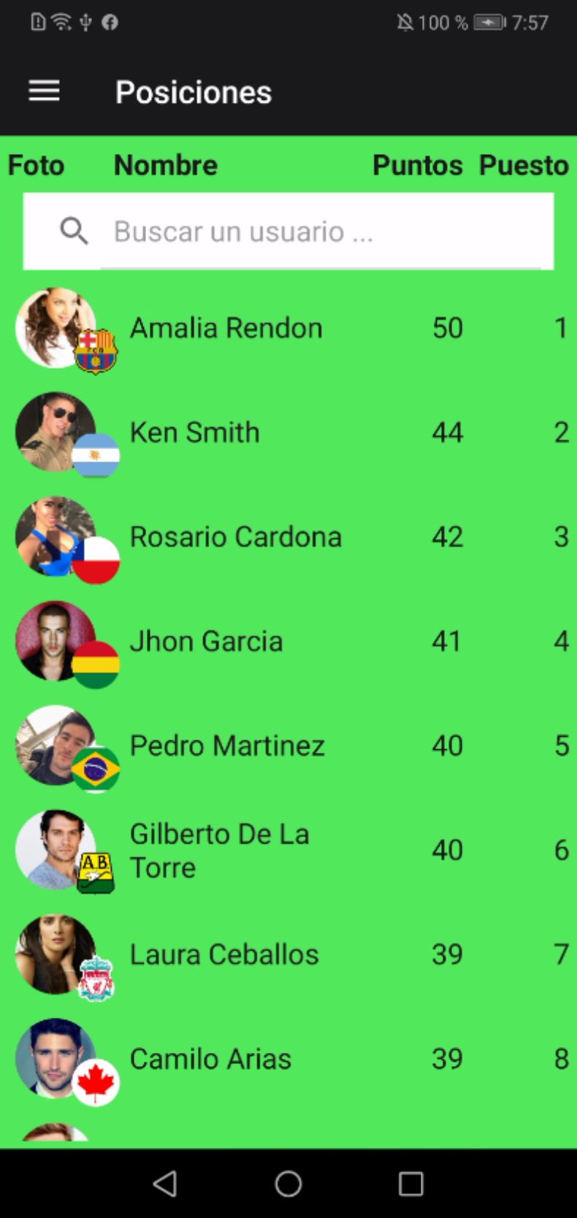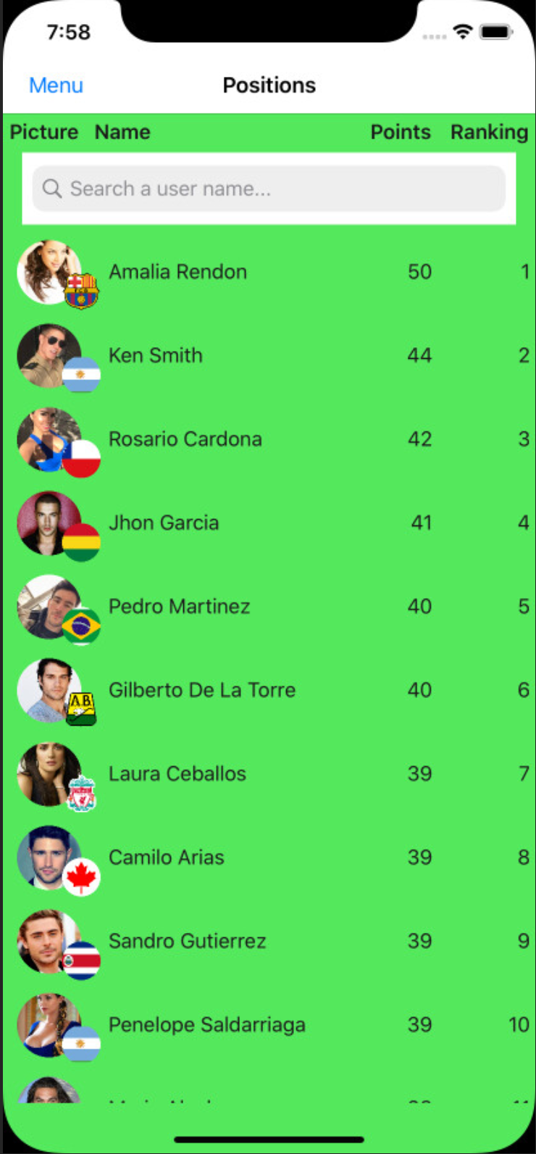

1. Modify the **App.xaml**:

<prism:PrismApplication xmlns="http://xamarin.com/schemas/2014/forms"

xmlns:x="http://schemas.microsoft.com/winfx/2009/xaml"

xmlns:ffimageloading="clr-namespace:FFImageLoading.Forms;assembly=FFImageLoading.Forms"

xmlns:fftransformations="clr-namespace:FFImageLoading.Transformations;assembly=FFImageLoading.Transformations"

xmlns:prism="clr-namespace:Prism.DryIoc;assembly=Prism.DryIoc.Forms"

x:Class="Soccer.Prism.App">

<Application.Resources>

…

<DataTemplate x:Key="PositionTemplate">

<Grid>

<Grid.ColumnDefinitions>

<ColumnDefinition Width="Auto" />

<ColumnDefinition Width="*" />

<ColumnDefinition Width="60" />

<ColumnDefinition Width="70" />

</Grid.ColumnDefinitions>

<RelativeLayout Grid.Column="0">

<ffimageloading:CachedImage x:Name="Picture"

Aspect="AspectFill"

Source="{Binding UserResponse.PictureFullPath}"

CacheDuration= "50"

Margin="5"

RetryCount= "3"

RetryDelay= "600"

WidthRequest="50">

<ffimageloading:CachedImage.Transformations>

<fftransformations:CircleTransformation />

</ffimageloading:CachedImage.Transformations>

</ffimageloading:CachedImage>

<ffimageloading:CachedImage x:Name="Team"

RelativeLayout.YConstraint="{ConstraintExpression Type=RelativeToView, ElementName=Picture,Property=Y,Factor=1,Constant=20}"

RelativeLayout.XConstraint="{ConstraintExpression Type=RelativeToView, ElementName=Picture,Property=X,Factor=1,Constant=30}"

Aspect="AspectFit"

Source="{Binding UserResponse.Team.LogoFullPath}"

CacheDuration= "50"

HeightRequest="30"

Margin="5"

RetryCount= "3"

RetryDelay= "600">

<ffimageloading:CachedImage.Transformations>

<fftransformations:CircleTransformation />

</ffimageloading:CachedImage.Transformations>

</ffimageloading:CachedImage>

</RelativeLayout>

<Label Grid.Column="1"

FontSize="Medium"

Text="{Binding UserResponse.FullName}"

VerticalOptions="Center"/>

<Label Grid.Column="2"

FontSize="Medium"

HorizontalTextAlignment="End"

Text="{Binding Points}"

VerticalOptions="Center"/>

<Label Grid.Column="3"

FontSize="Medium"

HorizontalTextAlignment="End"

Text="{Binding Ranking}"

VerticalOptions="Center"/>

</Grid>

</DataTemplate>

1. Modify the **PositionsInTournamentPage**:

<CollectionView ItemsSource="{Binding Positions}"

ItemTemplate="{StaticResource PositionTemplate}">

<CollectionView.ItemsLayout>

<GridItemsLayout Orientation="Vertical"

VerticalItemSpacing="5"/>

</CollectionView.ItemsLayout>

</CollectionView>

1. Modify the **MyPositionsPage**:

<?xml version="1.0" encoding="utf-8" ?>

<ContentPage xmlns="http://xamarin.com/schemas/2014/forms"

xmlns:x="http://schemas.microsoft.com/winfx/2009/xaml"

xmlns:prism="http://prismlibrary.com"

prism:ViewModelLocator.AutowireViewModel="True"

xmlns:busyindicator="clr-namespace:Syncfusion.SfBusyIndicator.XForms;assembly=Syncfusion.SfBusyIndicator.XForms"

xmlns:ios="clr-namespace:Xamarin.Forms.PlatformConfiguration.iOSSpecific;assembly=Xamarin.Forms.Core"

xmlns:i18n="clr-namespace:Soccer.Prism.Helpers"

ios:Page.UseSafeArea="true"

x:Class="Soccer.Prism.Views.MyPositionsPage"

BackgroundColor="{StaticResource ColorBackgroud}"

Title="{Binding Title}">

<AbsoluteLayout>

<StackLayout AbsoluteLayout.LayoutBounds="0,0,1,1"

AbsoluteLayout.LayoutFlags="All"

Padding="5">

<Grid>

<Grid.RowDefinitions>

<RowDefinition Height="Auto"/>

</Grid.RowDefinitions>

<Grid.ColumnDefinitions>

<ColumnDefinition Width="60" />

<ColumnDefinition Width="*" />

<ColumnDefinition Width="60" />

<ColumnDefinition Width="70" />

</Grid.ColumnDefinitions>

<Label Grid.Column="0"

FontAttributes="Bold"

FontSize="Medium"

Text="{i18n:Translate Picture}"

VerticalOptions="Center"/>

<Label Grid.Column="1"

FontAttributes="Bold"

FontSize="Medium"

Text="{i18n:Translate Name}"

VerticalOptions="Center"/>

<Label Grid.Column="2"

FontAttributes="Bold"

FontSize="Medium"

HorizontalTextAlignment="End"

Text="{i18n:Translate Points}"

VerticalOptions="Center"/>

<Label Grid.Column="3"

FontAttributes="Bold"

FontSize="Medium"

HorizontalTextAlignment="End"

Text="{i18n:Translate Ranking}"

VerticalOptions="Center"/>

</Grid>

<SearchBar Margin="10,0"

Placeholder="{i18n:Translate SearchUserPlaceHolder}"

SearchCommand="{Binding SearchCommand}"

Text="{Binding Search}"/>

<CollectionView ItemsSource="{Binding Positions}"

ItemTemplate="{StaticResource PositionTemplate}">

<CollectionView.ItemsLayout>

<GridItemsLayout Orientation="Vertical"

VerticalItemSpacing="5"/>

</CollectionView.ItemsLayout>

</CollectionView>

</StackLayout>

<busyindicator:SfBusyIndicator AnimationType="Gear"

AbsoluteLayout.LayoutBounds=".5,.5,.5,.5"

AbsoluteLayout.LayoutFlags="All"

BackgroundColor="{StaticResource ColorAccent}"

HorizontalOptions="Center"

TextColor="{StaticResource ColorFontInverse}"

IsVisible="{Binding IsRunning}"

Title="{i18n:Translate Loading}"

VerticalOptions="Center"

ViewBoxWidth="80"

ViewBoxHeight="80" />

</AbsoluteLayout>

</ContentPage>

1. Modify the **MyPositionsPageViewModel**:

using Newtonsoft.Json;

using Prism.Commands;

using Prism.Navigation;

using Soccer.Common.Helpers;

using Soccer.Common.Models;

using Soccer.Common.Services;

using Soccer.Prism.Helpers;

using System.Collections.Generic;

using System.Collections.ObjectModel;

using System.Linq;

namespace Soccer.Prism.ViewModels

{

public class MyPositionsPageViewModel : ViewModelBase

{

private readonly IApiService _apiService;

private bool _isRunning;

private ObservableCollection<PositionResponse> _positions;

private List<PositionResponse> _myPositions;

private string _search;

private DelegateCommand _searchCommand;

public MyPositionsPageViewModel(INavigationService navigationService, IApiService apiService)

: base(navigationService)

{

_apiService = apiService;

Title = Languages.Positions;

LoadPositionsAsync();

}

public DelegateCommand SearchCommand => _searchCommand ?? (_searchCommand = new DelegateCommand(ShowPositions));

public bool IsRunning

{

get => _isRunning;

set => SetProperty(ref _isRunning, value);

}

public string Search

{

get => _search;

set

{

SetProperty(ref _search, value);

ShowPositions();

}

}

public ObservableCollection<PositionResponse> Positions

{

get => _positions;

set => SetProperty(ref _positions, value);

}

private async void LoadPositionsAsync()

{

IsRunning = true;

string url = App.Current.Resources["UrlAPI"].ToString();

bool connection = await _apiService.CheckConnectionAsync(url);

if (!connection)

{

IsRunning = false;

await App.Current.MainPage.DisplayAlert(Languages.Error, Languages.ConnectionError, Languages.Accept);

return;

}

TokenResponse token = JsonConvert.DeserializeObject<TokenResponse>(Settings.Token);

Response response = await _apiService.GetListAsync<PositionResponse>(url, "/api", $"/Predictions", "bearer", token.Token);

IsRunning = false;

if (!response.IsSuccess)

{

await App.Current.MainPage.DisplayAlert(Languages.Error, response.Message, Languages.Accept);

return;

}

_myPositions = (List<PositionResponse>)response.Result;

ShowPositions();

}

private void ShowPositions()

{

if (string.IsNullOrEmpty(Search))

{

Positions = new ObservableCollection<PositionResponse>(_myPositions);

}

else

{

Positions = new ObservableCollection<PositionResponse>(

_myPositions.Where(p => p.UserResponse.FirstName.ToUpper().Contains(Search.ToUpper()) ||

p.UserResponse.LastName.ToUpper().Contains(Search.ToUpper())));

}

}

}

}

1. Modify the **PredictionsTabbedPage**:

<TabbedPage.Children>

<local:PredictionsForTournamentPage />

<local:ClosedPredictionsForTournamentPage />

<local:PositionsInTournamentPage />

</TabbedPage.Children>

1. Test it.

## 

## Login with Facebook

We are going to build this screen:

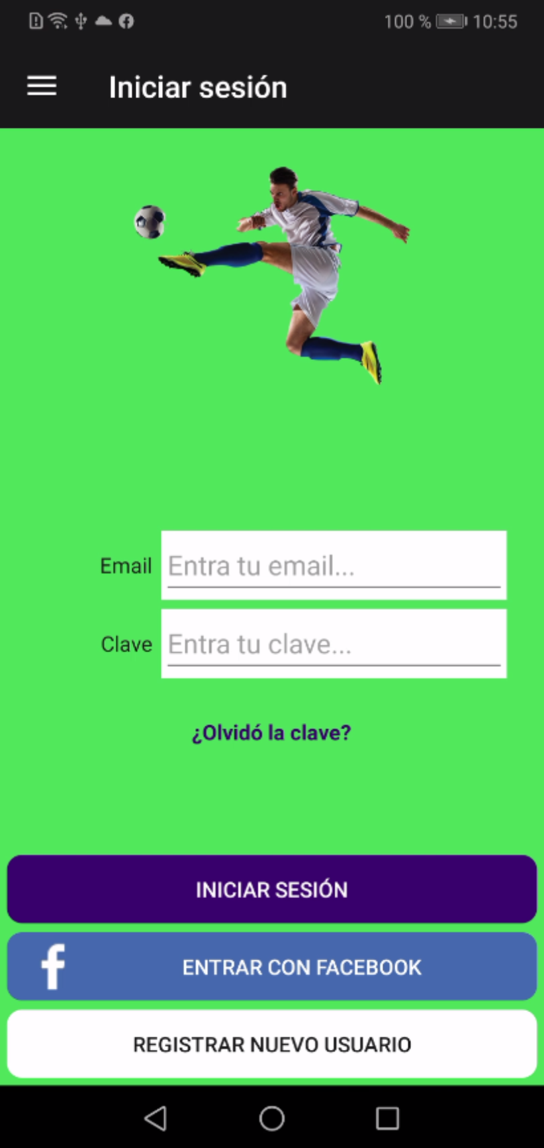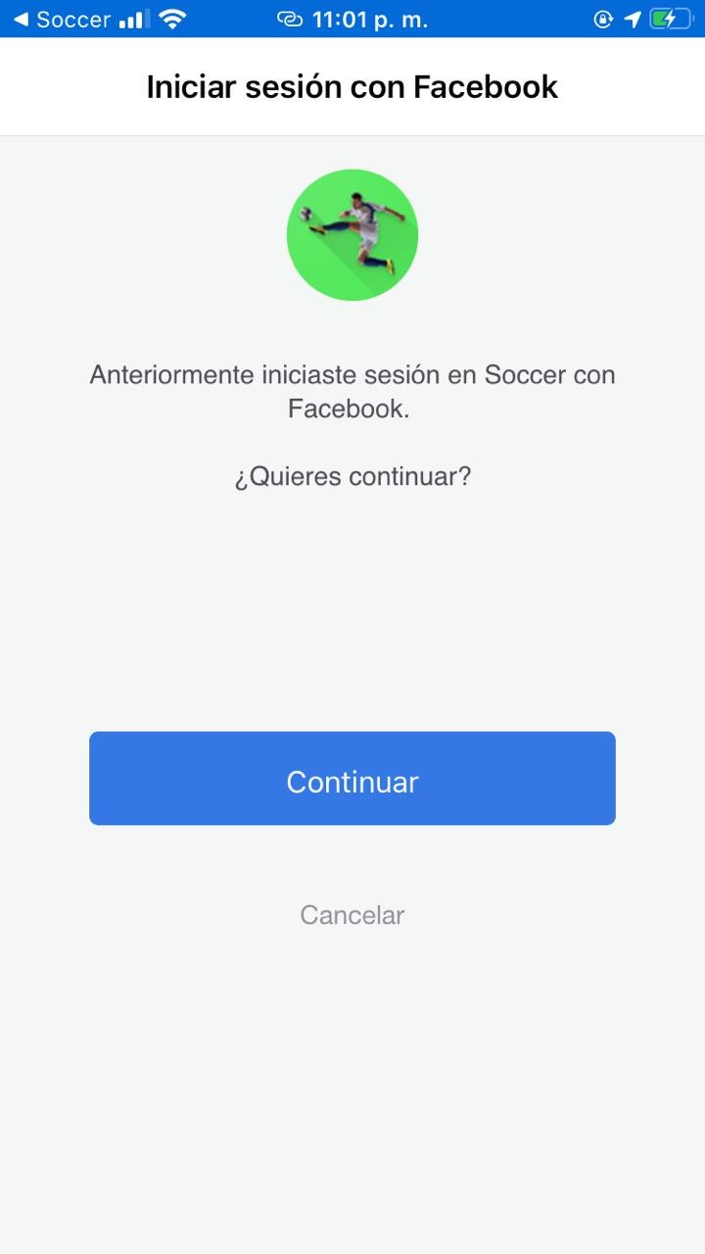

### Create a Facebook App

1. You need a Hash for Android setup, temporarily modify the **MainActivity** with this:

GetAppHash();

LoadApplication(new App(new AndroidInitializer()));

}

private void GetAppHash()

{

try

{

PackageInfo info = Android.App.Application.Context.PackageManager.GetPackageInfo(Android.App.Application.Context.PackageName, PackageInfoFlags.Signatures);

foreach (var signature in info.Signatures)

{

MessageDigest md = MessageDigest.GetInstance("SHA");

md.Update(signature.ToByteArray());

var hash = Convert.ToBase64String(md.Digest());

}

}

catch (NoSuchAlgorithmException e)

{

System.Diagnostics.Debug.WriteLine(e);

}

catch (Exception e)

{

System.Diagnostics.Debug.WriteLine(e);

}

}

//public override void OnRequestPermissionsResult(int requestCode, string[] permissions, [GeneratedEnum] Permission[] grantResults)

//{

// PermissionsImplementation.Current.OnRequestPermissionsResult(requestCode, permissions, grantResults);

//}

1. For my case the hash is: **VYYP5sM22k69xXqTKjc2uIBDbr0=** keep this value, we will need it soon, and return MainActivity to their original state.
2. Login to [https://developers.facebook.com](https://developers.facebook.com/) and create a new application:

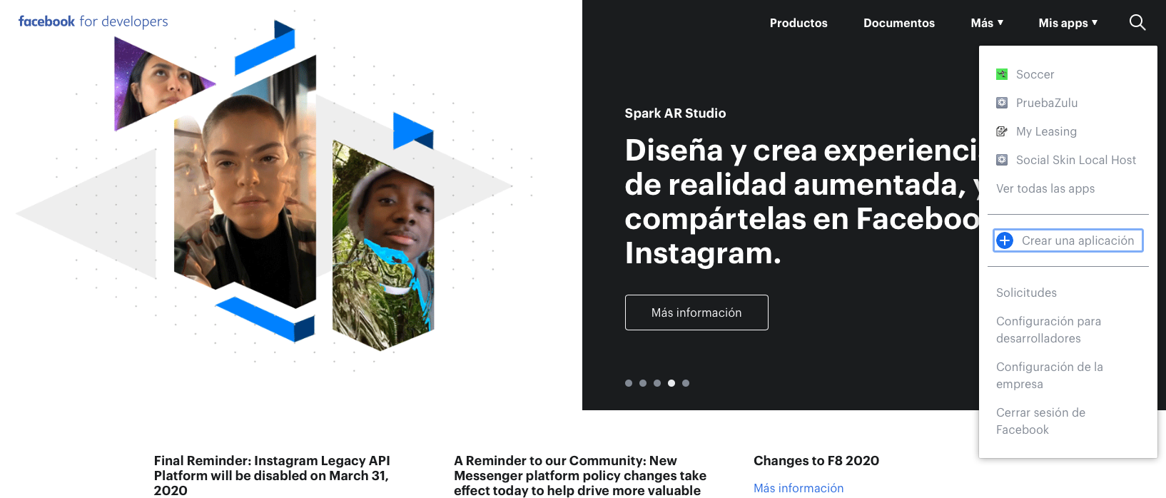

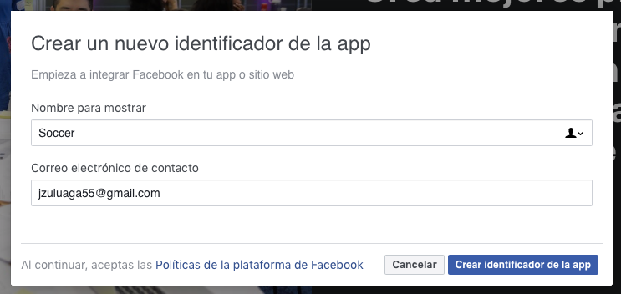

1. Go to basic configuration and fill these parameters:

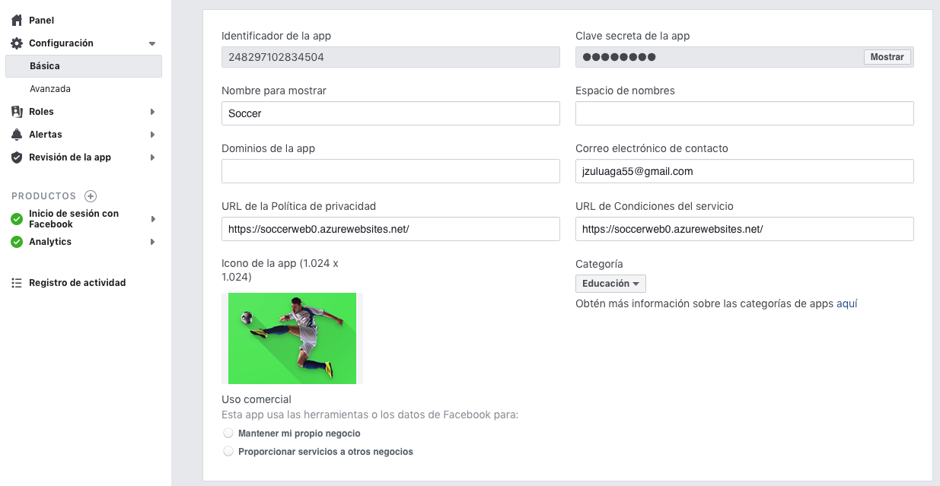

1. Go to settings section to add your android and ios platforms.
2. Click on add platform and then select Android.

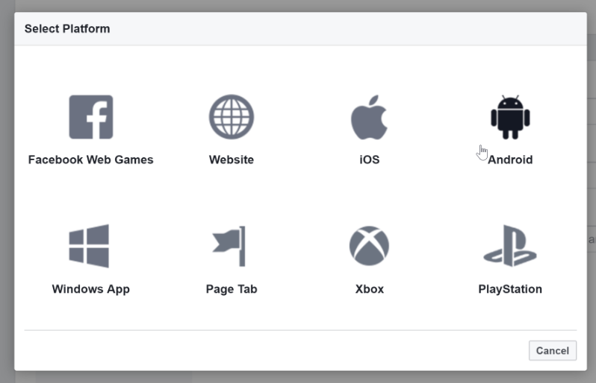

1. Add your package name and full class name for your Activity.

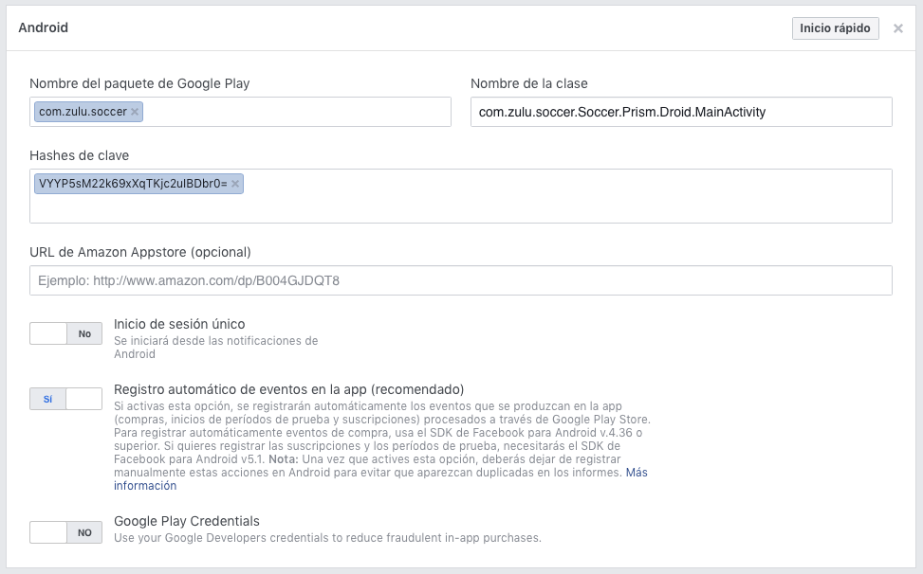

1. Click on add platform then select iOS.

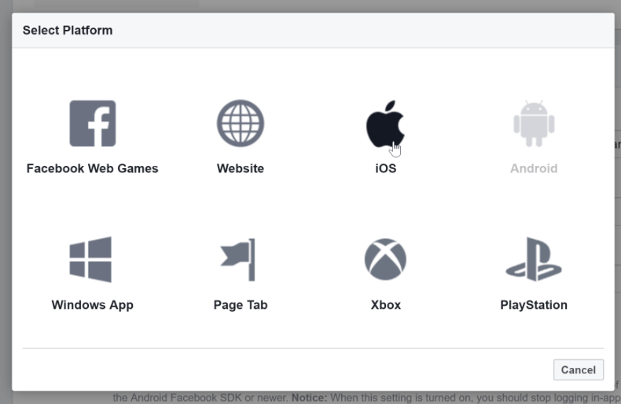

1. Modify the **App.xaml**:

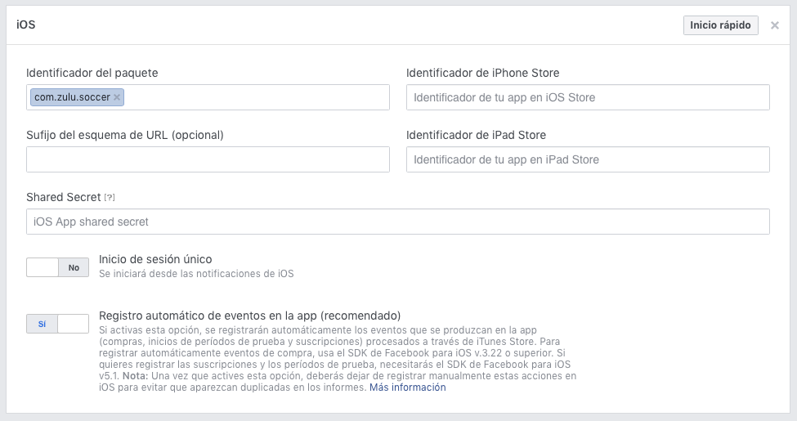

1. Save changes and publish your application in Facebook.

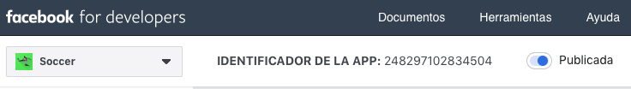

### General Setup

1. Install the plugin [**Plugin.FacebookClient**](http://www.nuget.org/packages/Plugin.FacebookClient) in all your projects.
2. Modify the **MainActivity**:

protected override void OnCreate(Bundle bundle)

{

TabLayoutResource = Resource.Layout.Tabbar;

ToolbarResource = Resource.Layout.Toolbar;

base.OnCreate(bundle);

FacebookClientManager.Initialize(this);

CrossCurrentActivity.Current.Init(this, bundle);

global::Xamarin.Forms.Forms.Init(this, bundle);

new SfBusyIndicatorRenderer();

FFImageLoading.Forms.Platform.CachedImageRenderer.Init(true);

LoadApplication(new App(new AndroidInitializer()));

}

protected override void OnActivityResult(int requestCode, Result resultCode, Intent data)

{

base.OnActivityResult(requestCode, resultCode, data);

FacebookClientManager.OnActivityResult(requestCode, resultCode, data);

}

public override void OnRequestPermissionsResult(int requestCode, string[] permissions, [GeneratedEnum] Permission[] grantResults)

{

PermissionsImplementation.Current.OnRequestPermissionsResult(requestCode, permissions, grantResults);

}

1. Add the **Strings.xml** to the project and add this values (replace the id for your facebook app id):

<?xml version="1.0" encoding="utf-8"?>

<resources>

<string name="hello">Hello World, Click Me!</string>

<string name="app_name">Soccer</string>

<string name="facebook_app_name">Soccer</string>

<string name="facebook_app_id">248297102834504</string>

<string name="fb_login_protocol_scheme">fb248297102834504</string>

</resources>

1. Modify the **AndroidManifest.xml**:

<application android:label="Soccer" android:icon="@mipmap/ic_launcher">

<provider android:name="android.support.v4.content.FileProvider" android:authorities="${applicationId}.fileprovider" android:exported="false" android:grantUriPermissions="true">

<meta-data android:name="android.support.FILE_PROVIDER_PATHS" android:resource="@xml/file_paths"></meta-data>

</provider>

<meta-data android:name="com.facebook.sdk.ApplicationId" android:value="@string/facebook_app_id"/>

<activity android:name="com.facebook.FacebookActivity"

android:configChanges="keyboard|keyboardHidden|screenLayout|screenSize|orientation"

android:label="@string/facebook_app_name" />

<activity

android:name="com.facebook.CustomTabActivity"

android:exported="true">

<intent-filter>

<action android:name="android.intent.action.VIEW" />

<category android:name="android.intent.category.DEFAULT" />

<category android:name="android.intent.category.BROWSABLE" />

<data android:scheme="@string/fb_login_protocol_scheme" />

</intent-filter>

</activity>

</application>

1. Modify the **AppDelegate**:

public override bool FinishedLaunching(UIApplication app, NSDictionary options)

{

global::Xamarin.Forms.Forms.Init();

FFImageLoading.Forms.Platform.CachedImageRenderer.Init();

new SfBusyIndicatorRenderer();

LoadApplication(new App(new iOSInitializer()));

FacebookClientManager.Initialize(app, options);

return base.FinishedLaunching(app, options);

}

public override void OnActivated(UIApplication uiApplication)

{

base.OnActivated(uiApplication);

FacebookClientManager.OnActivated();

}

public override bool OpenUrl(UIApplication app, NSUrl url, NSDictionary options)

{

return FacebookClientManager.OpenUrl(app, url, options);

}

public override bool OpenUrl(UIApplication application, NSUrl url, string sourceApplication, NSObject annotation)

{

return FacebookClientManager.OpenUrl(application, url, sourceApplication, annotation);

}

1. Modify the **Info.plist**, change the ID for your facebook app ID:

<key>NSAppTransportSecurity</key>

<dict>

<key>NSExceptionDomains</key>

<dict>

<key>facebook.com</key>

<dict>

<key>NSIncludesSubdomains</key>

<true/>

<key>NSThirdPartyExceptionRequiresForwardSecrecy</key>

<false/>

</dict>

<key>fbcdn.net</key>

<dict>

<key>NSIncludesSubdomains</key>

<true/>

<key>NSThirdPartyExceptionRequiresForwardSecrecy</key>

<false/>

</dict>

<key>akamaihd.net</key>

<dict>

<key>NSIncludesSubdomains</key>

<true/>

<key>NSThirdPartyExceptionRequiresForwardSecrecy</key>

<false/>

</dict>

</dict>

<key>NSAllowsArbitraryLoadsInWebContent</key>

<true/>

</dict>

<key>otherExternalDomainYouNeedToCall</key>

<dict>

<key>NSIncludesSubdomains</key>

<true/>

<key>NSExceptionAllowsInsecureHTTPLoads</key>

<true/>

<key>NSAllowsArbitraryLoads</key>

<true/>

</dict>

<key>CFBundleURLTypes</key>

<array>

<dict>

<key>CFBundleURLName</key>

<string>fb</string>

<key>CFBundleURLSchemes</key>

<array>

<string>fb248297102834504</string>

</array>

</dict>

<dict>

<key>CFBundleURLName</key>

<string>google</string>

<key>CFBundleURLSchemes</key>

<array>

<string>com.googleusercontent.apps.60015114581-8t3d8n4r2s38fvltdqrnf8ip7thqcntu</string>

</array>

<key>CFBundleTypeRole</key>

<string>Editor</string>

</dict>

</array>

<key>FacebookAppID</key>

<string>248297102834504</string>

<key>FacebookDisplayName</key>

<string>SocialMediaAuthentication</string>

<key>LSApplicationQueriesSchemes</key>

<array>

<string>fbapi</string>

<string>fb-messenger-api</string>

<string>fbauth2</string>

<string>fbshareextension</string>

</array>

### Integration with Soccer App

1. Add the **FacebookProfile**:

using Newtonsoft.Json;

namespace Soccer.Common.Models

{

public class Data

{

[JsonProperty("is_silhouette")]

public bool IsSilhouette { get; set; }

public int Height { get; set; }

public string Url { get; set; }

public int Width { get; set; }

}

public class Picture

{

public Data Data { get; set; }

}

public class FacebookProfile

{

public string Email { get; set; }

public string Id { get; set; }

public Picture Picture { get; set; }

[JsonProperty("last_name")]

public string LastName { get; set; }

[JsonProperty("first_name")]

public string FirstName { get; set; }

}

}

1. Add the **ic_fb.png**.
2. Modify the **Languages**:

public static string LoginFacebook => Resource.LoginFacebook;

1. Modify the **LoginPage**:

<StackLayout>

<Button Command="{Binding LoginCommand}"

HeightRequest="45"

IsEnabled="{Binding IsEnabled}"

Text="{i18n:Translate Login}"/>

<Button BackgroundColor="#4768AD"

Command="{Binding LoginFacebookCommand}"

HeightRequest="45"

IsEnabled="{Binding IsEnabled}"

ImageSource="ic_fb"

Text="{i18n:Translate LoginFacebook}"

TextColor="#FFFFFF"/>

<Button Command="{Binding RegisterCommand}"

HeightRequest="45"

IsEnabled="{Binding IsEnabled}"

Text="{i18n:Translate Register}"

Style="{StaticResource DangerButton}"/>

</StackLayout>

1. Modify the **LoginPageViewModel**:

private readonly IFacebookClient _facebookService = CrossFacebookClient.Current;

…

private DelegateCommand _loginFacebookCommand;

…

public DelegateCommand LoginFacebookCommand => _loginFacebookCommand ?? (_loginFacebookCommand = new DelegateCommand(LoginFacebookAsync));

…

private async void LoginFacebookAsync()

{

try

{

if (_facebookService.IsLoggedIn)

{

_facebookService.Logout();

}

async void userDataDelegate(object sender, FBEventArgs<string> e)

{

switch (e.Status)

{

case FacebookActionStatus.Completed:

FacebookProfile facebookProfile = await Task.Run(() => JsonConvert.DeserializeObject<FacebookProfile>(e.Data));

break;

case FacebookActionStatus.Canceled:

await App.Current.MainPage.DisplayAlert("Facebook Auth", "Canceled", "Ok");

break;

case FacebookActionStatus.Error:

await App.Current.MainPage.DisplayAlert("Facebook Auth", "Error", "Ok");

break;

case FacebookActionStatus.Unauthorized:

await App.Current.MainPage.DisplayAlert("Facebook Auth", "Unauthorized", "Ok");

break;

}

_facebookService.OnUserData -= userDataDelegate;

}

_facebookService.OnUserData += userDataDelegate;

string[] fbRequestFields = { "email", "first_name", "picture", "gender", "last_name" };

string[] fbPermisions = { "email" };

await _facebookService.RequestUserDataAsync(fbRequestFields, fbPermisions);

}

catch (Exception ex)

{

Debug.WriteLine(ex.ToString());

}

}

1. Test what we do until this moment.
2. Add the **LoginType**:

namespace Soccer.Common.Enums

{

public enum LoginType

{

Soccer,

Facebook

}

}

1. Modify the **UserResponse**:

public LoginType LoginType { get; set; }

public string PictureFullPath => string.IsNullOrEmpty(PicturePath)

? "https://SoccerWeb0.azurewebsites.net//images/noimage.png"

: LoginType == LoginType.Soccer ? $"https://SoccerWeb0.azurewebsites.net{PicturePath.Substring(1)}" : PicturePath;

1. Modify the **UserEntity**:

[Display(Name = "User Type")]

public UserType UserType { get; set; }

[Display(Name = "Login Type")]

public LoginType LoginType { get; set; }

[Display(Name = "Favorite Team")]

public TeamEntity Team { get; set; }

1. Modify the **SeedDb**:

await CheckUserAsync("1010", "Juan", "Zuluaga", "jzuluaga55@hotmail.com", "350 634 2747", "Calle Luna Calle Sol", UserType.Admin);

1. Add the migration, drop and update the database.
2. Modify the **ConverterHelper**:

public UserResponse ToUserResponse(UserEntity user)

{

if (user == null)

{

return null;

}

return new UserResponse

{

Address = user.Address,

Document = user.Document,

Email = user.Email,

FirstName = user.FirstName,

Id = user.Id,

LastName = user.LastName,

PhoneNumber = user.PhoneNumber,

PicturePath = user.PicturePath,

Team = ToTeamResponse(user?.Team),

UserType = user.UserType,

LoginType = user.LoginType

};

}

1. Modify the **IUserHelper**:

Task<UserEntity> AddUserAsync(FacebookProfile model);

1. Modify the **UserHelper**:

public async Task<UserEntity> AddUserAsync(FacebookProfile model)

{

UserEntity userEntity = new UserEntity

{

Address = "...",

Document = "...",

Email = model.Email,

FirstName = model.FirstName,

LastName = model.LastName,

PicturePath = model.Picture?.Data?.Url,

PhoneNumber = "...",

Team = await _context.Teams.FirstOrDefaultAsync(t => t.Name == "Colombia"),

UserName = model.Email,

UserType = UserType.User,

LoginType = LoginType.Facebook

};

IdentityResult result = await _userManager.CreateAsync(userEntity, model.Id);

if (result != IdentityResult.Success)

{

return null;

}

UserEntity newUser = await GetUserAsync(model.Email);

await AddUserToRoleAsync(newUser, userEntity.UserType.ToString());

return newUser;

}

1. Modify the **AccountController**:

[HttpPost]

public async Task<IActionResult> LoginFacebook([FromBody] FacebookProfile model)

{

if (ModelState.IsValid)

{

UserEntity user = await _userHelper.GetUserAsync(model.Email);

if (user == null)

{

await _userHelper.AddUserAsync(model);

}

else

{

user.PicturePath = model.Picture.Data.Url;

user.FirstName = model.FirstName;

user.LastName = model.LastName;

await _userHelper.UpdateUserAsync(user);

}

object results = GetToken(model.Email);

return Created(string.Empty, results);

}

return BadRequest();

}

[HttpPost]

public async Task<IActionResult> CreateToken([FromBody] LoginViewModel model)

{

if (ModelState.IsValid)

{

UserEntity user = await _userHelper.GetUserAsync(model.Username);

if (user != null)

{

Microsoft.AspNetCore.Identity.SignInResult result = await _userHelper.ValidatePasswordAsync(user, model.Password);

if (result.Succeeded)

{

object results = GetToken(user.Email);

return Created(string.Empty, results);

}

}

}

return BadRequest();

}

private object GetToken(string email)

{

Claim[] claims = new[]

{

new Claim(JwtRegisteredClaimNames.Sub, email),

new Claim(JwtRegisteredClaimNames.Jti, Guid.NewGuid().ToString())

};

SymmetricSecurityKey key = new SymmetricSecurityKey(Encoding.UTF8.GetBytes(_configuration["Tokens:Key"]));

SigningCredentials credentials = new SigningCredentials(key, SecurityAlgorithms.HmacSha256);

JwtSecurityToken token = new JwtSecurityToken(

_configuration["Tokens:Issuer"],

_configuration["Tokens:Audience"],

claims,

expires: DateTime.UtcNow.AddDays(15),

signingCredentials: credentials);

return new

{

token = new JwtSecurityTokenHandler().WriteToken(token),

expiration = token.ValidTo

};

}

1. Delete the database on Azure, create it again and re-publish.
2. Modify the **Languages**:

public static string ChangePhotoNoSoccerUser => Resource.ChangePhotoNoSoccerUser; // Users created by social networks, must change the photo or password on the social network.

1. Modify the **SoccerMasterDetailPage**:

<RelativeLayout>

<RelativeLayout.GestureRecognizers>

<TapGestureRecognizer Command="{Binding ModifyUserCommand}"/>

</RelativeLayout.GestureRecognizers>

<Image x:Name="Logo" HorizontalOptions="Center"

RelativeLayout.XConstraint="{ConstraintExpression Type=RelativeToParent,Property=X,Factor=1,Constant=60}"

HeightRequest="150"

Source="soccer"/>

<ffimageloading:CachedImage x:Name="Picture"

RelativeLayout.YConstraint="{ConstraintExpression Type=RelativeToView, ElementName=Logo,Property=Y,Factor=1,Constant=60}"

Aspect="AspectFill"

Source="{Binding User.PictureFullPath}"

CacheDuration= "50"

HeightRequest="100"

Margin="5"

RetryCount= "3"

RetryDelay= "600"

WidthRequest="100">

<ffimageloading:CachedImage.Transformations>

<fftransformations:CircleTransformation />

</ffimageloading:CachedImage.Transformations>

</ffimageloading:CachedImage>

<ffimageloading:CachedImage x:Name="Team"

RelativeLayout.YConstraint="{ConstraintExpression Type=RelativeToView, ElementName=Picture,Property=Y,Factor=1,Constant=50}"

RelativeLayout.XConstraint="{ConstraintExpression Type=RelativeToView, ElementName=Picture,Property=X,Factor=1,Constant=60}"

Aspect="AspectFill"

Source="{Binding User.Team.LogoFullPath}"

CacheDuration= "50"

HeightRequest="50"

Margin="5"

RetryCount= "3"

RetryDelay= "600"

WidthRequest="50">

<ffimageloading:CachedImage.Transformations>

<fftransformations:CircleTransformation />

</ffimageloading:CachedImage.Transformations>

</ffimageloading:CachedImage>

<Label RelativeLayout.YConstraint="{ConstraintExpression Type=RelativeToView, ElementName=Picture,Property=Y,Factor=1,Constant=110}"

FontAttributes="Bold"

FontSize="Large"

Text="{Binding User.FullName}"

TextColor="Black"/>

</RelativeLayout>

1. Modify the **ModifyUserPage**:

<Label Grid.Row="1"

Grid.Column="0"

Text="{i18n:Translate FirstName}"

VerticalOptions="Center"/>

<Entry Grid.Row="1"

Grid.Column="1"

IsEnabled="{Binding IsSoccerUser}"

Placeholder="{i18n:Translate FirstNamePlaceHolder}"

Text="{Binding User.FirstName}"/>

<Label Grid.Row="2"

Grid.Column="0"

Text="{i18n:Translate LastName}"

VerticalOptions="Center"/>

<Entry Grid.Row="2"

Grid.Column="1"

IsEnabled="{Binding IsSoccerUser}"

Placeholder="{i18n:Translate LastNamePlaceHolder}"

Text="{Binding User.LastName}"/>

1. Modify the **IApiService**:

Task<Response> GetTokenAsync(string urlBase, string servicePrefix, string controller, FacebookProfile request);

1. Modify the **ApiService**:

public async Task<Response> GetTokenAsync(string urlBase, string servicePrefix, string controller, FacebookProfile request)

{

try

{

string requestString = JsonConvert.SerializeObject(request);

StringContent content = new StringContent(requestString, Encoding.UTF8, "application/json");

HttpClient client = new HttpClient

{

BaseAddress = new Uri(urlBase)

};

string url = $"{servicePrefix}{controller}";

HttpResponseMessage response = await client.PostAsync(url, content);

string result = await response.Content.ReadAsStringAsync();

if (!response.IsSuccessStatusCode)

{

return new Response

{

IsSuccess = false,

Message = result,

};

}

TokenResponse token = JsonConvert.DeserializeObject<TokenResponse>(result);

return new Response

{

IsSuccess = true,

Result = token

};

}

catch (Exception ex)

{

return new Response

{

IsSuccess = false,

Message = ex.Message

};

}

}

1. Modify the **LoginPageViewModel**:

private async void LoginFacebookAsync()

{

try

{

if (_facebookService.IsLoggedIn)

{

_facebookService.Logout();

}

async void userDataDelegate(object sender, FBEventArgs<string> e)

{

switch (e.Status)

{

case FacebookActionStatus.Completed:

FacebookProfile facebookProfile = await Task.Run(() => JsonConvert.DeserializeObject<FacebookProfile>(e.Data));

await LoginFacebookAsync(facebookProfile);

break;

case FacebookActionStatus.Canceled:

await App.Current.MainPage.DisplayAlert("Facebook Auth", "Canceled", "Ok");

break;

case FacebookActionStatus.Error:

await App.Current.MainPage.DisplayAlert("Facebook Auth", "Error", "Ok");

break;

case FacebookActionStatus.Unauthorized:

await App.Current.MainPage.DisplayAlert("Facebook Auth", "Unauthorized", "Ok");

break;

}

_facebookService.OnUserData -= userDataDelegate;

}

_facebookService.OnUserData += userDataDelegate;

string[] fbRequestFields = { "email", "first_name", "picture.width(999)", "gender", "last_name" };

string[] fbPermisions = { "email" };

await _facebookService.RequestUserDataAsync(fbRequestFields, fbPermisions);

}

catch (Exception ex)

{

Debug.WriteLine(ex.ToString());

}

}

private async Task LoginFacebookAsync(FacebookProfile facebookProfile)

{

IsRunning = true;

IsEnabled = false;

string url = App.Current.Resources["UrlAPI"].ToString();

Response response = await _apiService.GetTokenAsync(url, "Account", "/LoginFacebook", facebookProfile);

if (!response.IsSuccess)

{

IsRunning = false;

IsEnabled = true;

await App.Current.MainPage.DisplayAlert(Languages.Error, Languages.LoginError, Languages.Accept);

Password = string.Empty;

return;

}

TokenResponse token = (TokenResponse)response.Result;

EmailRequest request2 = new EmailRequest

{

CultureInfo = Languages.Culture,

Email = facebookProfile.Email

};

Response response2 = await _apiService.GetUserByEmail(url, "api", "/Account/GetUserByEmail", "bearer", token.Token, request2);

UserResponse userResponse = (UserResponse)response2.Result;

Settings.User = JsonConvert.SerializeObject(userResponse);

Settings.Token = JsonConvert.SerializeObject(token);

Settings.IsLogin = true;

IsRunning = false;

IsEnabled = true;

await _navigationService.NavigateAsync("/SoccerMasterDetailPage/NavigationPage/TournamentsPage");

Password = string.Empty;

}

1. Modify the **ModifyUserPageViewModel**:

private bool _isSoccerUser;

…

public ModifyUserPageViewModel(INavigationService navigationService, IApiService apiService, IFilesHelper filesHelper)

: base(navigationService)

{

_navigationService = navigationService;

_apiService = apiService;

_filesHelper = filesHelper;

Title = Languages.ModifyUser;

IsEnabled = true;

User = JsonConvert.DeserializeObject<UserResponse>(Settings.User);

IsSoccerUser = User.LoginType == LoginType.Soccer;

Image = User.PictureFullPath;

LoadTeamsAsync();

}

…

public bool IsSoccerUser

{

get => _isSoccerUser;

set => SetProperty(ref _isSoccerUser, value);

}

…

private async void ChangeImageAsync()

{

if (!IsSoccerUser)

{

await App.Current.MainPage.DisplayAlert(Languages.Error, Languages.ChangePhotoNoSoccerUser, Languages.Accept);

return;

}

await CrossMedia.Current.Initialize();

…

private async void ChangePasswordAsync()

{

if (!IsSoccerUser)

{

await App.Current.MainPage.DisplayAlert(Languages.Error, Languages.ChangePhotoNoSoccerUser, Languages.Accept);

return;

}

await _navigationService.NavigateAsync(nameof(ChangePasswordPage));

}

1. Test it.

## Push notifications

### Setup Android Services

1. Add a new project in <https://console.firebase.google.com/>:

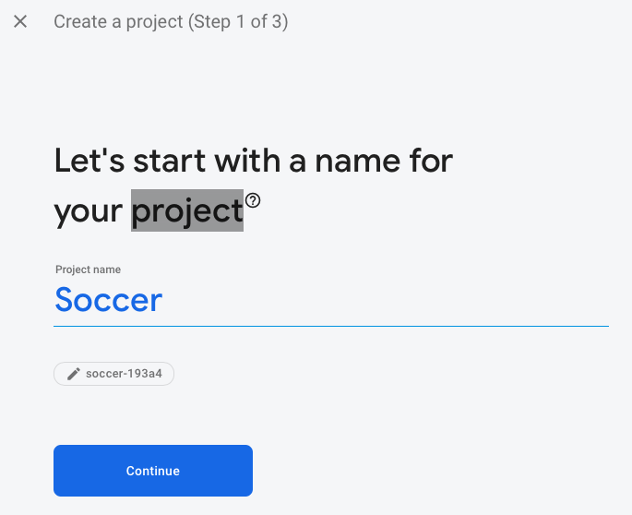 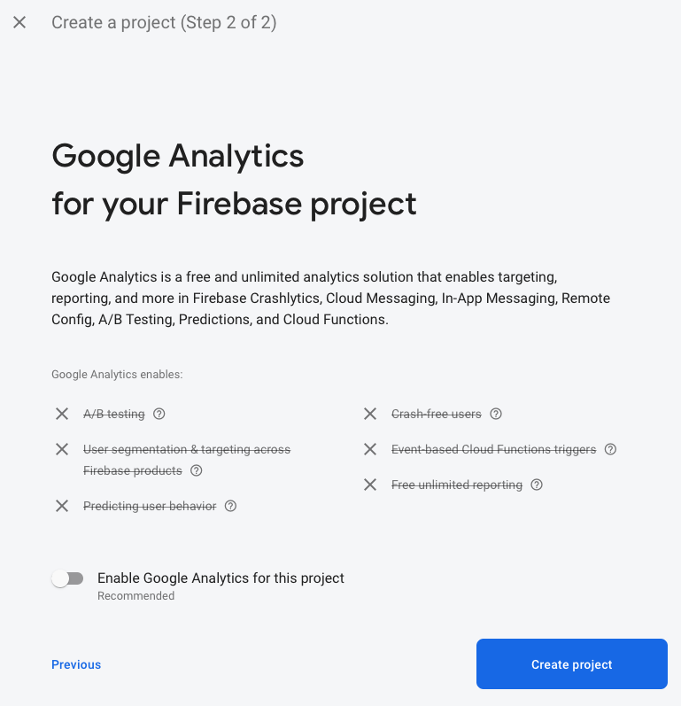

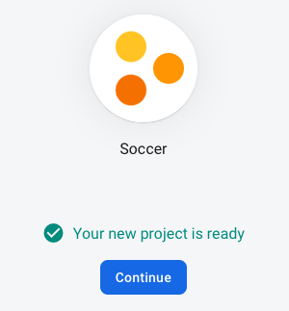 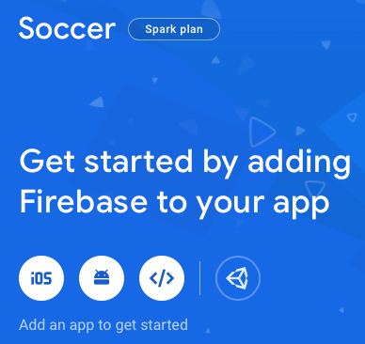

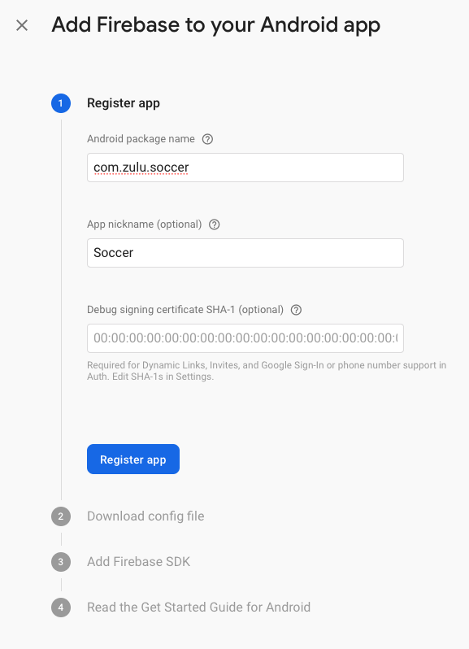 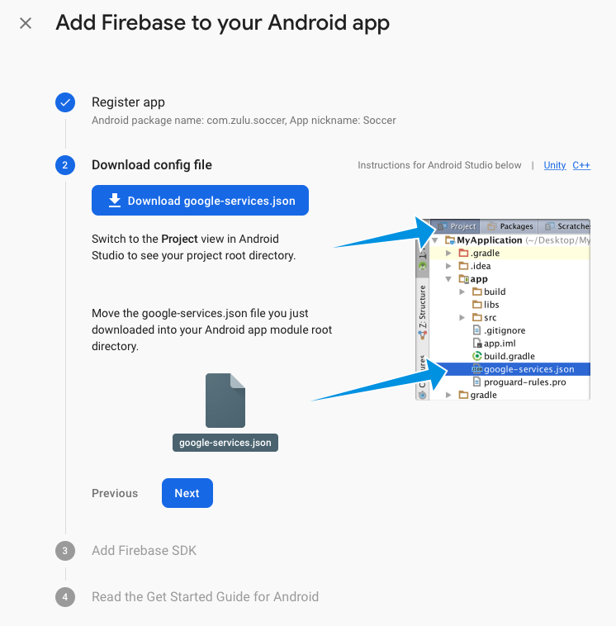

Download the **gogle-services.json** you will need soon.

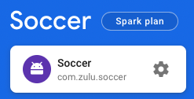

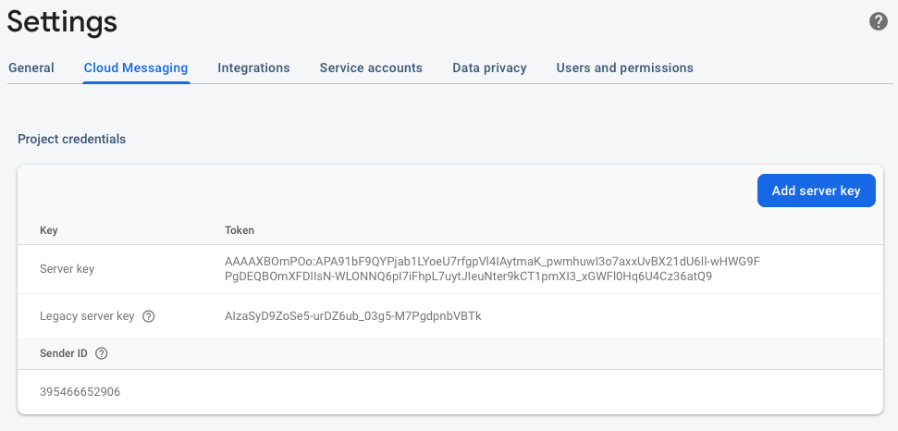

Keep the values for **server key** and **sender ID**, you will need soon.

1. Add a new **Azure Notification Hub**:

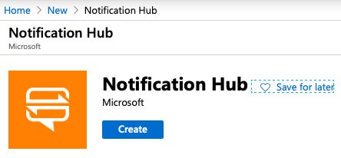

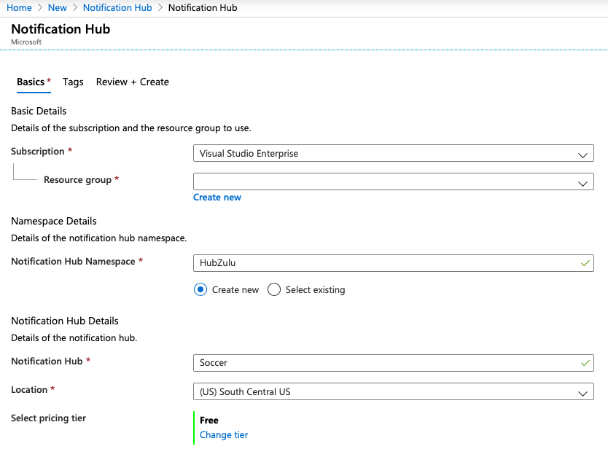

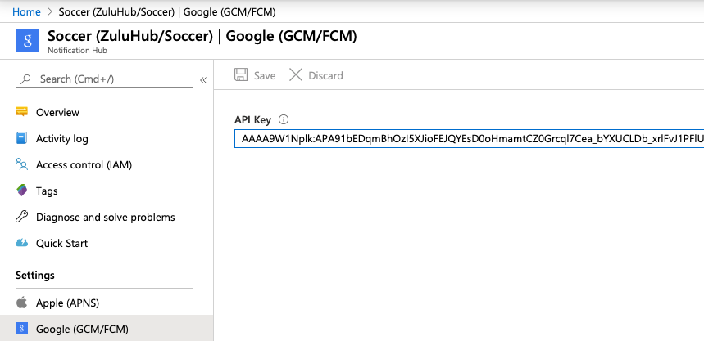

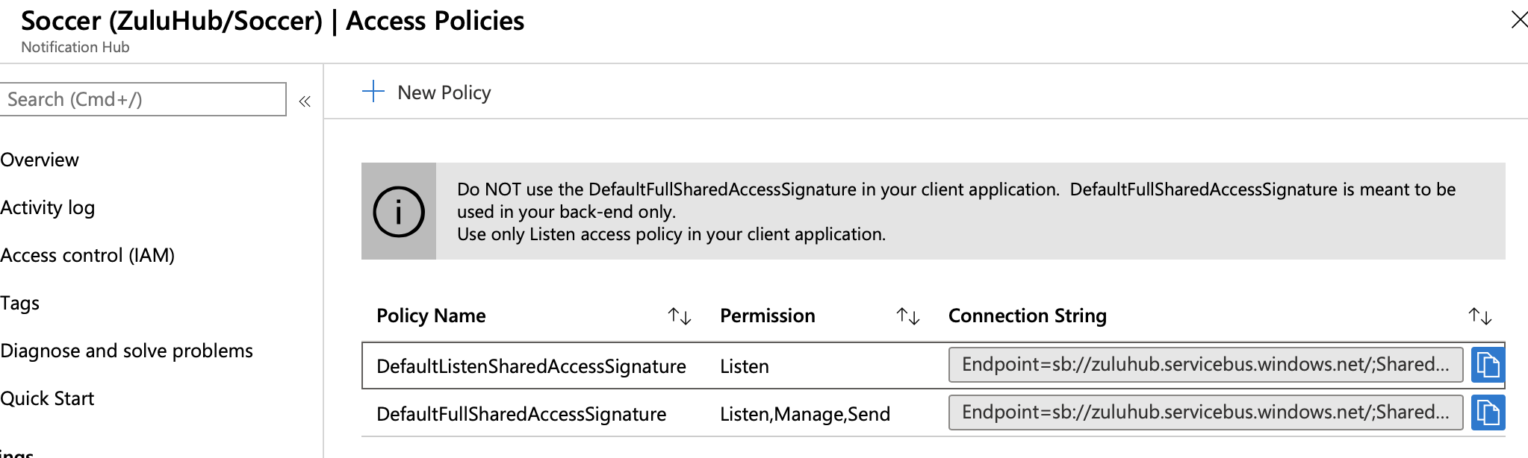

### Android Implementation

1. Add the following nuggets: **Xamarin.GooglePlayServices.Base**, **Xamarin.Firebase.Messaging** and **Xamarin.Azure.NotificationHubs.Android** on Android project.
2. Add the **AppConstants**, replace for your own values:

namespace Soccer.Common.Constants

{

public static class AppConstants

{

/// <summary>

/// Notification channels are used on Android devices starting with "Oreo"

/// </summary>

public static string NotificationChannelName { get; set; } = "XamarinNotifyChannel";

/// <summary>

/// This is the name of your Azure Notification Hub, found in your Azure portal.

/// </summary>

public static string NotificationHubName { get; set; } = "Soccer";

/// <summary>

/// This is the "DefaultListenSharedAccessSignature" connection string, which is

/// found in your Azure Notification Hub portal under "Access Policies".

///

/// You should always use the ListenShared connection string. Do not use the

/// FullShared connection string in a client application.

/// </summary>

public static string ListenConnectionString { get; set; } = "Endpoint=sb://zuluhub.servicebus.windows.net/;SharedAccessKeyName=DefaultFullSharedAccessSignature;SharedAccessKey=Y1kfDexEW0GCNAJi2El8BAAH7u+BKfE0y8eYAefD3x8=";

/// <summary>

/// Tag used in log messages to easily filter the device log

/// during development.

/// </summary>

public static string DebugTag { get; set; } = "XamarinNotify";

/// <summary>

/// The tags the device will subscribe to. These could be subjects like

/// news, sports, and weather. Or they can be tags that identify a user

/// across devices.

/// </summary>

public static string[] SubscriptionTags { get; set; } = { "default" };

/// <summary>

/// This is the template json that Android devices will use. Templates

/// are defined by the device and can include multiple parameters.

/// </summary>

public static string FCMTemplateBody { get; set; } = "{\"data\":{\"message\":\"$(messageParam)\"}}";

/// <summary>

/// This is the template json that Apple devices will use. Templates

/// are defined by the device and can include multiple parameters.

/// </summary>

public static string APNTemplateBody { get; set; } = "{\"aps\":{\"alert\":\"$(messageParam)\"}}";

}

}

1. Add the **ic_launcher** in **drawable**.
2. Add the downloaded file **google-services.json** in your android project. Make sure the build action is: **GoogleServicesJson**.

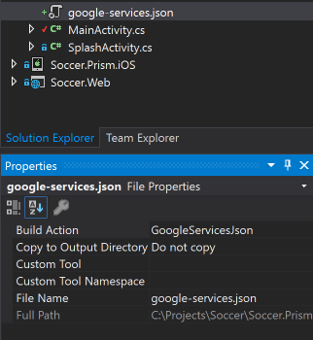

1. Modify the **TournamentsPageViewModel**:

private static TournamentsPageViewModel _instance;

…

public TournamentsPageViewModel(INavigationService navigationService, IApiService apiService)

: base(navigationService)

{

_instance = this;

_navigationService = navigationService;

_apiService = apiService;

Title = "Soccer";

LoadTournamentsAsync();

}

…

public static TournamentsPageViewModel GetInstance()

{

return _instance;

}

public void AddMessage(string message)

{

Device.BeginInvokeOnMainThread(() =>

{

App.Current.MainPage.DisplayAlert(Languages.Ok, message, Languages.Accept);

});

}

1. Modify the **AndroidManifest.xml**:

<data android:scheme="@string/fb_login_protocol_scheme" />

</intent-filter>

</activity>

<receiver android:name="com.google.firebase.iid.FirebaseInstanceIdInternalReceiver" android:exported="false" />

<receiver android:name="com.google.firebase.iid.FirebaseInstanceIdReceiver" android:exported="true" android:permission="com.google.android.c2dm.permission.SEND">

<intent-filter>

<action android:name="com.google.android.c2dm.intent.RECEIVE" />

<action android:name="com.google.android.c2dm.intent.REGISTRATION" />

<category android:name="${applicationId}" />

</intent-filter>

</receiver>

<uses-library android:name="org.apache.http.legacy" android:required="false" />

</application>

</manifest>

1. Add the **FirebaseService**:

using Android.App;

using Android.Content;

using Android.OS;

using Android.Support.V4.App;

using Android.Util;

using Firebase.Messaging;

using Soccer.Common.Constants;

using Soccer.Prism.ViewModels;

using System;

using System.Linq;

using WindowsAzure.Messaging;

namespace Soccer.Prism.Droid

{

[Service]

[IntentFilter(new[] { "com.google.firebase.MESSAGING_EVENT" })]

public class FirebaseService : FirebaseMessagingService

{

public override void OnMessageReceived(RemoteMessage message)

{

base.OnMessageReceived(message);

string messageBody = string.Empty;

if (message.GetNotification() != null)

{

messageBody = message.GetNotification().Body;

}

// NOTE: test messages sent via the Azure portal will be received here

else

{

messageBody = message.Data.Values.First();

}

// convert the incoming message to a local notification

SendLocalNotification(messageBody);

// send the incoming message directly to the MainPage

SendMessageToMainPage(messageBody);

}

public override void OnNewToken(string token)

{

// TODO: save token instance locally, or log if desired

SendRegistrationToServer(token);

}

private void SendLocalNotification(string body)

{

Intent intent = new Intent(this, typeof(MainActivity));

intent.AddFlags(ActivityFlags.ClearTop);

intent.PutExtra("message", body);

PendingIntent pendingIntent = PendingIntent.GetActivity(this, 0, intent, PendingIntentFlags.OneShot);

NotificationCompat.Builder notificationBuilder = new NotificationCompat.Builder(this, AppConstants.NotificationChannelName)

.SetContentTitle(AppConstants.NotificationHubName)

.SetSmallIcon(Resource.Drawable.ic_launcher)

.SetContentText(body)

.SetAutoCancel(true)

.SetShowWhen(false)

.SetContentIntent(pendingIntent);

if (Build.VERSION.SdkInt >= BuildVersionCodes.O)

{

notificationBuilder.SetChannelId(AppConstants.NotificationChannelName);

}

NotificationManager notificationManager = NotificationManager.FromContext(this);

notificationManager.Notify(0, notificationBuilder.Build());

}

private void SendMessageToMainPage(string body)

{

TournamentsPageViewModel.GetInstance().AddMessage(body);

}

private void SendRegistrationToServer(string token)

{

try

{

NotificationHub hub = new NotificationHub(AppConstants.NotificationHubName, AppConstants.ListenConnectionString, this);

// register device with Azure Notification Hub using the token from FCM

Registration registration = hub.Register(token, AppConstants.SubscriptionTags);

// subscribe to the SubscriptionTags list with a simple template.

string pnsHandle = registration.PNSHandle;

TemplateRegistration templateReg = hub.RegisterTemplate(pnsHandle, "defaultTemplate", AppConstants.FCMTemplateBody, AppConstants.SubscriptionTags);

}

catch (Exception e)

{

Log.Error(AppConstants.DebugTag, $"Error registering device: {e.Message}");

}

}

}

}

1. Modify the **MainActivity**:

protected override void OnCreate(Bundle bundle)

{

TabLayoutResource = Resource.Layout.Tabbar;

ToolbarResource = Resource.Layout.Toolbar;

base.OnCreate(bundle);

FacebookClientManager.Initialize(this);

CrossCurrentActivity.Current.Init(this, bundle);

global::Xamarin.Forms.Forms.Init(this, bundle);

new SfBusyIndicatorRenderer();

FFImageLoading.Forms.Platform.CachedImageRenderer.Init(true);

LoadApplication(new App(new AndroidInitializer()));

if (IsPlayServiceAvailable() == false)

{

throw new Exception("This device does not have Google Play Services and cannot receive push notifications.");

}

CreateNotificationChannel();

}

private bool IsPlayServiceAvailable()

{

int resultCode = GoogleApiAvailability.Instance.IsGooglePlayServicesAvailable(this);

if (resultCode != ConnectionResult.Success)

{

if (GoogleApiAvailability.Instance.IsUserResolvableError(resultCode))

{

Log.Debug(AppConstants.DebugTag, GoogleApiAvailability.Instance.GetErrorString(resultCode));

}

else

{

Log.Debug(AppConstants.DebugTag, "This device is not supported");

}

return false;

}

return true;

}

private void CreateNotificationChannel()

{

// Notification channels are new as of "Oreo".

// There is no need to create a notification channel on older versions of Android.

if (Build.VERSION.SdkInt >= BuildVersionCodes.O)

{

string channelName = AppConstants.NotificationChannelName;

string channelDescription = string.Empty;

NotificationChannel channel = new NotificationChannel(channelName, channelName, NotificationImportance.Default)

{

Description = channelDescription

};

NotificationManager notificationManager = (NotificationManager)GetSystemService(NotificationService);

notificationManager.CreateNotificationChannel(channel);

}

}

1. Test on Azure:

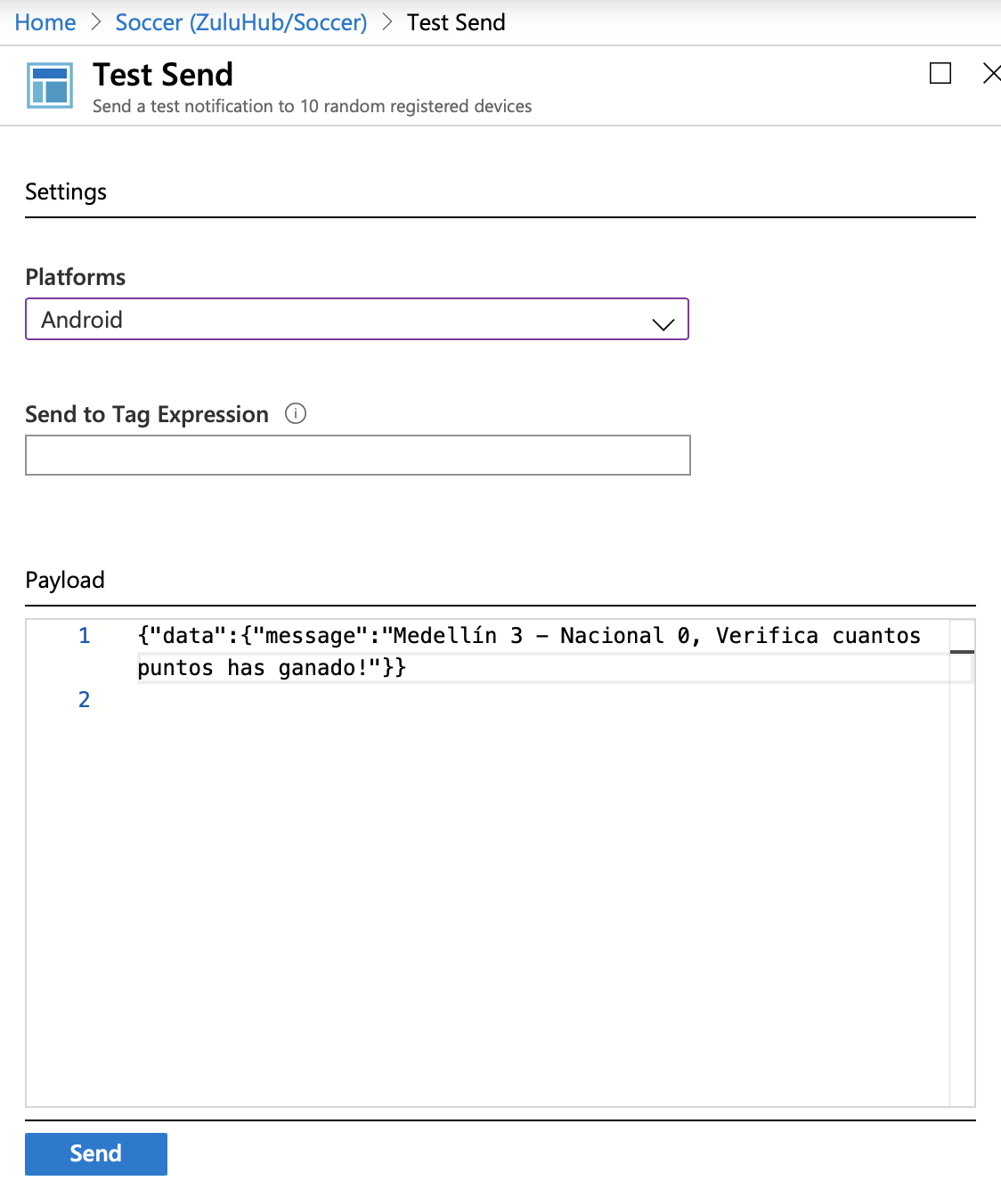

You must get this screen:

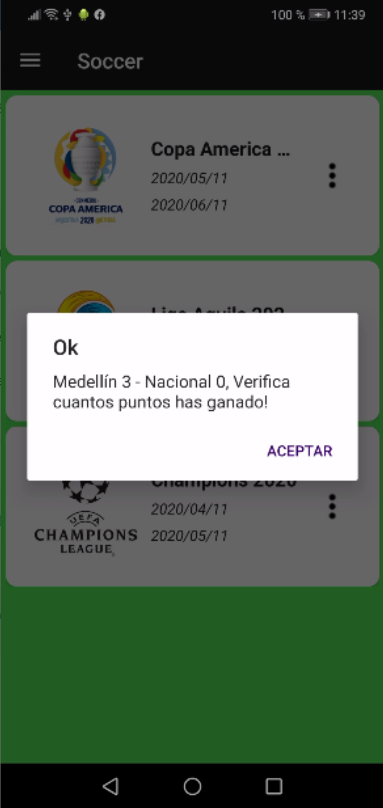 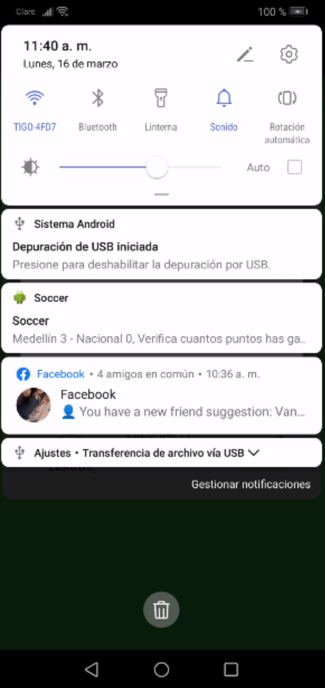

### Create a notification dispatcher

1. Add a new console project called: **Soccer.NotificationTest**.
2. Install the plugin **Microsoft.Azure.NotificationHubs** in **Soccer.NotificationTest** project.
3. Modify the **Program** class:

using Microsoft.Azure.NotificationHubs;

using Soccer.Common.Constants;

using System;

using System.Collections.Generic;

namespace Soccer.NotificationTest

{

public class Program

{

private static NotificationHubClient _hub;

public static void Main(string[] args)

{

_hub = NotificationHubClient.CreateClientFromConnectionString(

AppConstants.ListenConnectionString,

AppConstants.NotificationHubName);

do

{

Console.WriteLine("Type a new message:");

string message = Console.ReadLine();

SendNotificationAsync(message);

Console.WriteLine("The message was sent...");

} while (true);

}

private static async void SendNotificationAsync(string message)

{

Dictionary<string, string> templateParameters = new Dictionary<string, string>();

foreach (string tag in AppConstants.SubscriptionTags)

{

templateParameters["messageParam"] = message;

try

{

await _hub.SendTemplateNotificationAsync(templateParameters, tag);

Console.WriteLine($"Sent message to {tag} subscribers.");

}

catch (Exception ex)

{

Console.WriteLine($"Failed to send template notification: {ex.Message}");

}

}

}

}

}

1. Run the **Soccer.Primsn.Android** and **Soccer.NotificationTest** projects and test it.

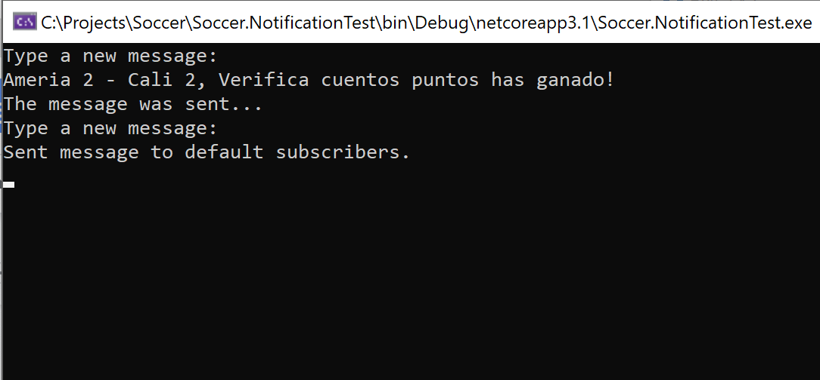 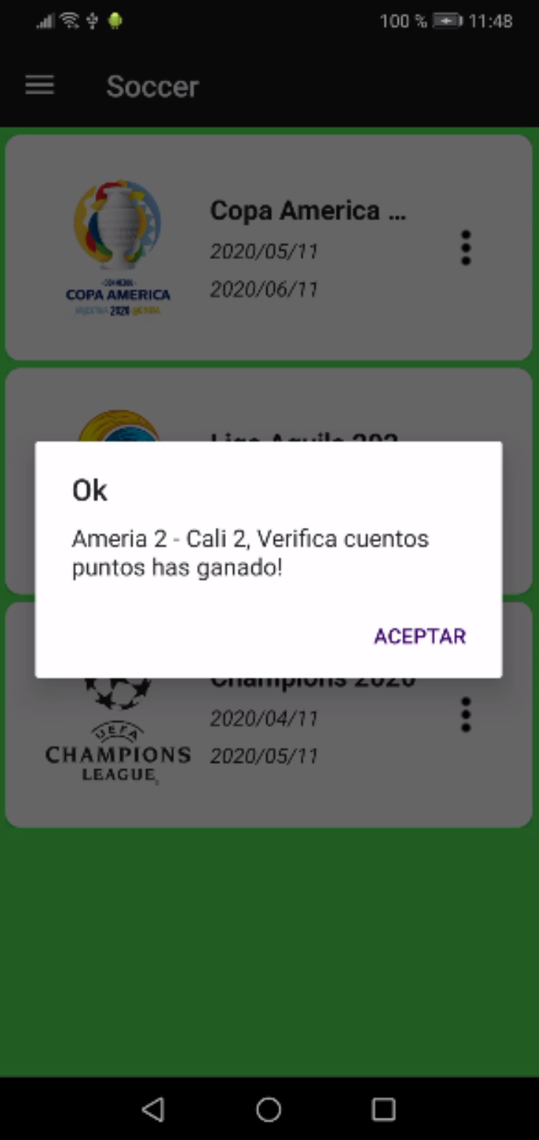

### Modify the backend to send notifications

1. Install the plugin **Microsoft.Azure.NotificationHubs** in **Soccer.Web** project.
2. Modify the **Languages**:

public static string Notification => Resource.Notification;

public static string CheckPointsEarned => Resource.CheckPointsEarned; // Check how many points you have earned!

1. Modify the **TournamentsController**:

[HttpPost]

[ValidateAntiForgeryToken]

public async Task<IActionResult> CloseMatch(CloseMatchViewModel model)

{

if (ModelState.IsValid)

{

await _matchHelper.CloseMatchAsync(model.MatchId, model.GoalsLocal.Value, model.GoalsVisitor.Value);

model.Local = await _context.Teams.FindAsync(model.LocalId);

model.Visitor = await _context.Teams.FindAsync(model.VisitorId);

await SendNotificationAsync(model);

return RedirectToAction($"{nameof(DetailsGroup)}/{model.GroupId}");

}

model.Group = await _context.Groups.FindAsync(model.GroupId);

model.Local = await _context.Teams.FindAsync(model.LocalId);

model.Visitor = await _context.Teams.FindAsync(model.VisitorId);

return View(model);

}

private async Task SendNotificationAsync(CloseMatchViewModel model)

{

NotificationHubClient hub = NotificationHubClient.CreateClientFromConnectionString(

AppConstants.ListenConnectionString,

AppConstants.NotificationHubName);

Dictionary<string, string> templateParameters = new Dictionary<string, string>();

foreach (string tag in AppConstants.SubscriptionTags)

{

templateParameters["messageParam"] = $"MATCH: {model.Local.Name} {model.GoalsLocal} - {model.GoalsVisitor} {model.Visitor.Name}";

try

{

await hub.SendTemplateNotificationAsync(templateParameters, tag);

}

catch (Exception ex)

{

ex.ToString();

}

}

}

1. Publish again in Azure.
2. Modify the **TournamentsPageViewModel**:

public void AddMessage(string message)

{

Device.BeginInvokeOnMainThread(() =>

{

if (message.StartsWith("MATCH: "))

{

message = $"{message.Substring(7)}, {Languages.CheckPointsEarned}";

}

App.Current.MainPage.DisplayAlert(Languages.Notification, message, Languages.Accept);

});

}

1. Modify the **FirebaseService**:

private void SendLocalNotification(string body)

{

if (body.StartsWith("MATCH: "))

{

body = $"{body.Substring(7)}, {Languages.CheckPointsEarned}";

}

Intent intent = new Intent(this, typeof(MainActivity));

1. Run the App and close some matches to test it.

### Setup iOS Services

1. Click **Keychain Access**, expand **Certificate Assistant**, then click **Request a Certificate from a Certificate Authority...**.

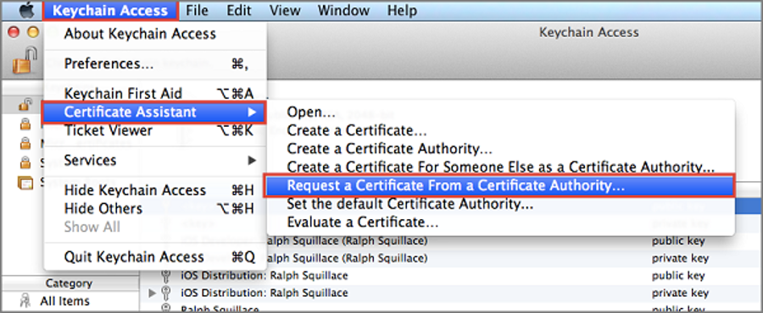

Select your **User Email Address** and **Common Name** , make sure that **Saved to disk** is selected, and then click **Continue**.Leave the **CA Email Address** field blank as it is not required.

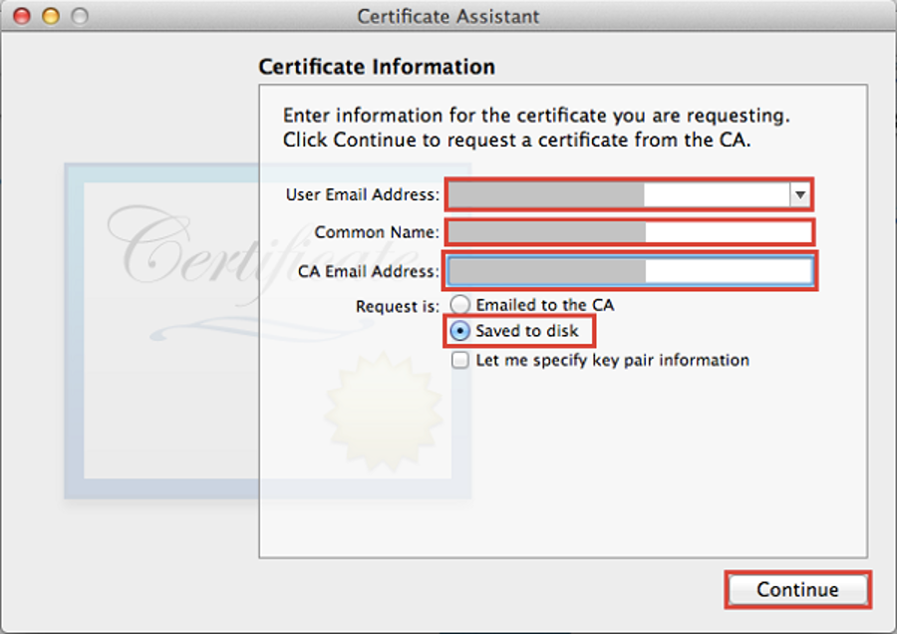

Type a name for the Certificate Signing Request (CSR) file in **Save As**, select the location in **Where**, then click **Save**.

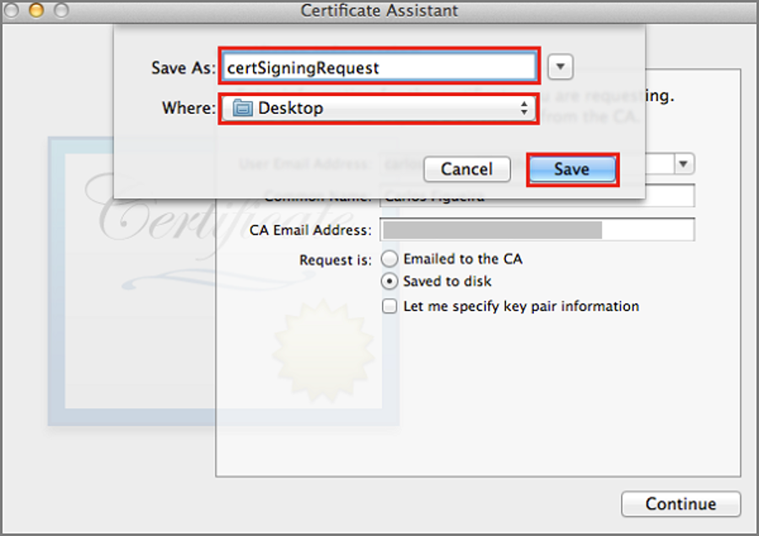

This saves the CSR file in the selected location; the default location is in the Desktop. Remember the location chosen for this file.

Next, you will register your app with Apple, enable push notifications, and upload this exported CSR to create a push certificate.

1. If you have not already registered your app, navigate to the [iOS Provisioning Portal](http://go.microsoft.com/fwlink/p/?LinkId=272456) at the Apple Developer Center, log on with your Apple ID, click Identifiers, then click App IDs, and finally click on the + sign to register a new app.

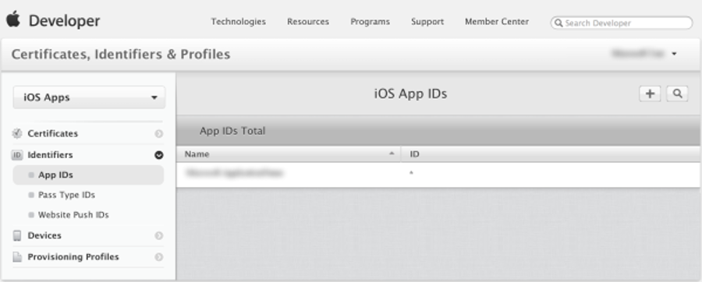

Update the following three fields for your new app and then click **Continue**:

* **Name**: Type a descriptive name for your app in the **Name** field in the **App ID Description** section.
* **Bundle Identifier**: Under the **Explicit App ID** section, enter a **Bundle Identifier** in the form <Organization Identifier>.<Product Name>as mentioned in the [App Distribution Guide](https://developer.apple.com/library/mac/documentation/IDEs/Conceptual/AppDistributionGuide/ConfiguringYourApp/ConfiguringYourApp.html#//apple_ref/doc/uid/TP40012582-CH28-SW8). The *Organization Identifier*and *Product Name* you use must match the organization identifier and product name you will use when you create your XCode project. In the screeshot below *NotificationHubs* is used as a organization idenitifier and *GetStarted* is used as the product name. Making sure this matches the values you will use in your XCode project will allow you to use the correct publishing profile with XCode.
* **Push Notifications**: Check the **Push Notifications** option in the **App Services** section.

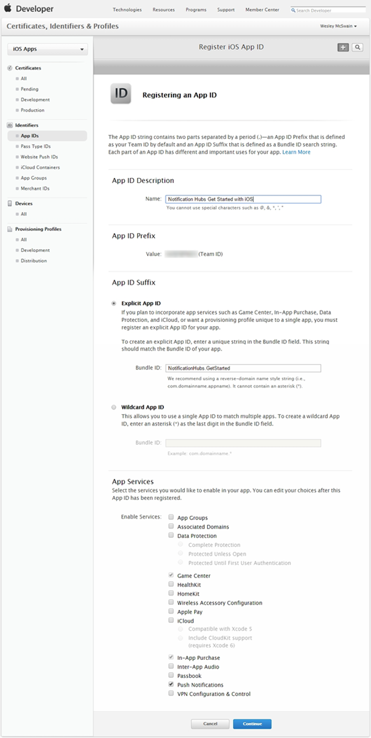

This generates your App ID and requests you to confirm the information. Click **Register** to confirm the new App ID. Once you click **Register**, you will see the **Registration complete** screen, as shown below. Click **Done**.

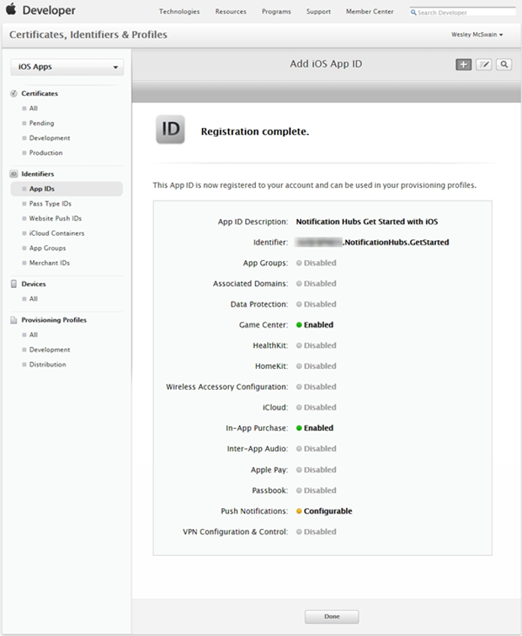

In the Developer Center, under App IDs, locate the app ID that you just created, and click on its row.

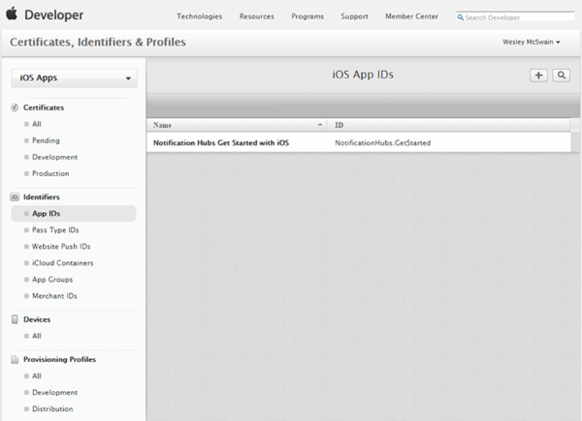

Clicking on the app ID will display the app details. Click the **Edit** button at the bottom.

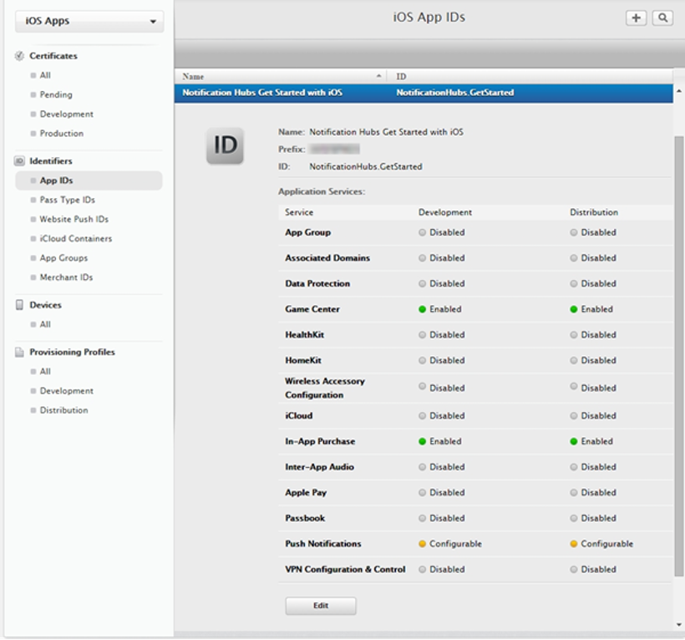

Scroll to the bottom of the screen, and click the **Create Certificate...** button under the section **Development Push SSL Certificate**.

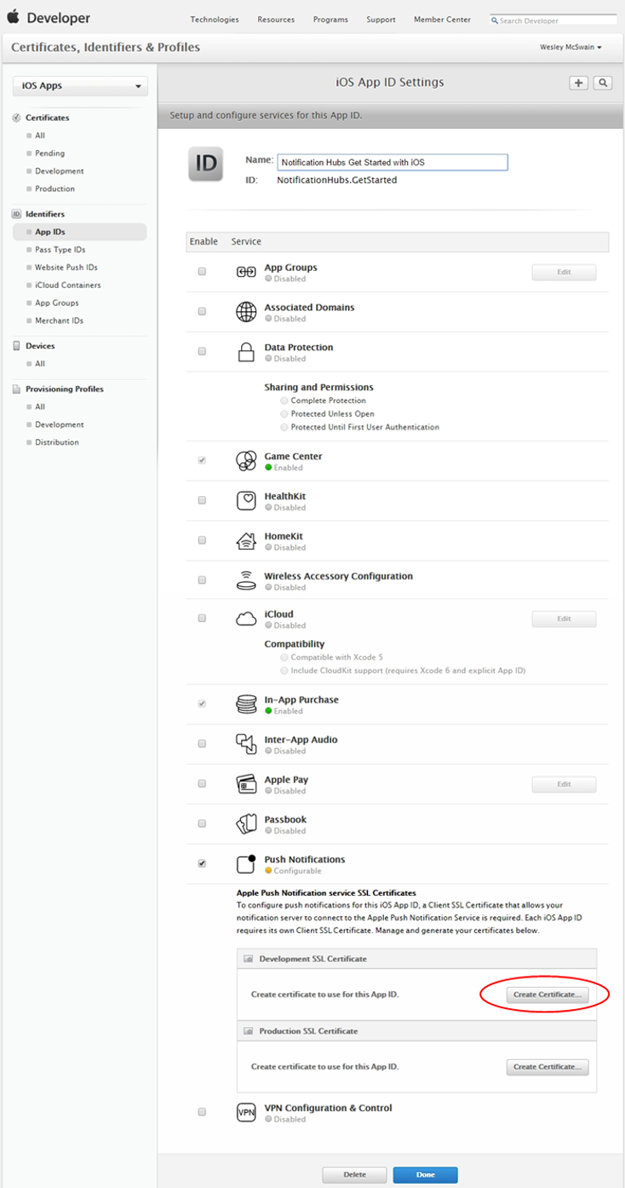

This displays the "Add iOS Certificate" assistant.

1. Click **Choose File**, browse to the location where you saved the CSR file that you created in the first task, then click **Generate**.

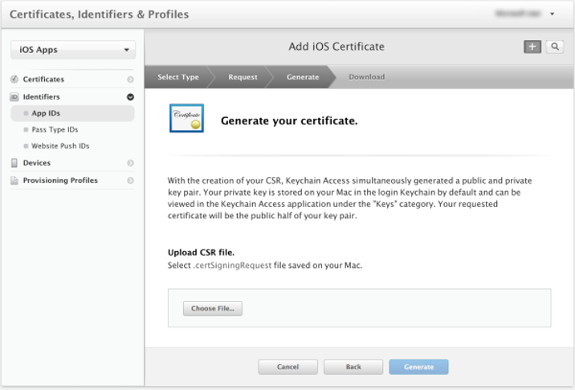

1. After the certificate is created by the portal, click the **Download** button, and click **Done**.

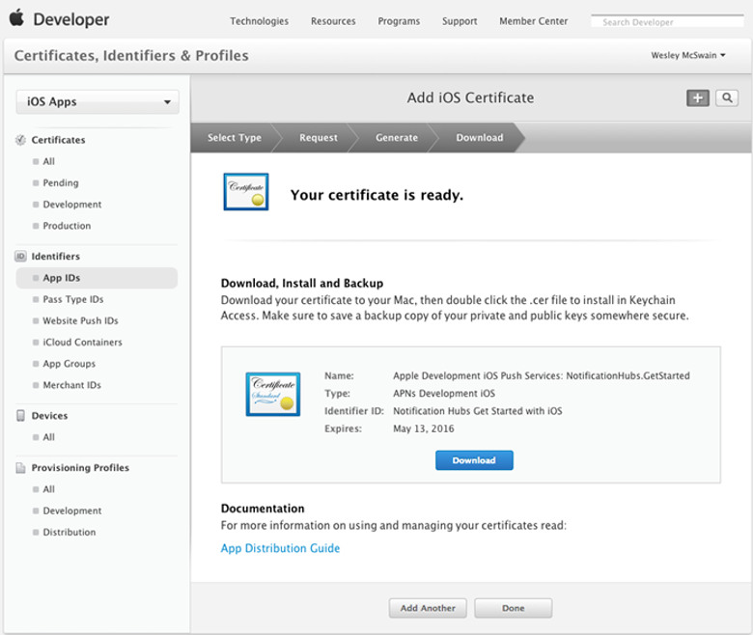

This downloads the certificate and saves it to your computer in your Downloads folder.

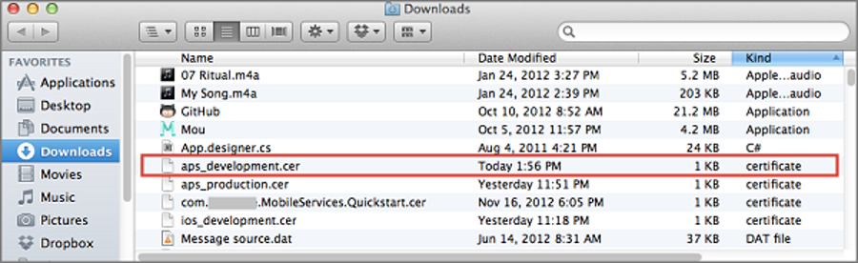

Double-click the downloaded push certificate **aps_development.cer**.

This installs the new certificate in the Keychain, as shown below:

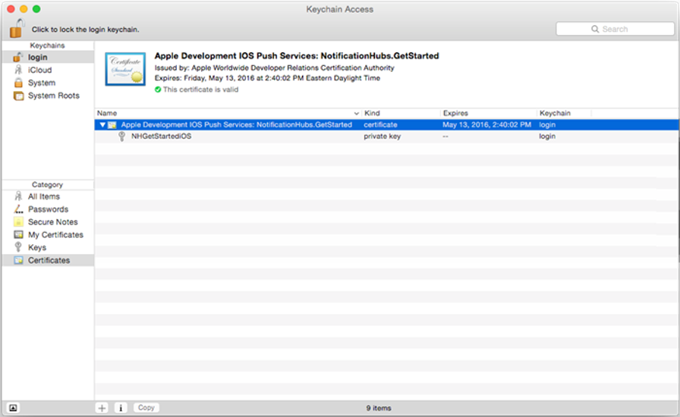

1. In Keychain Access, right-click the new push certificate that you created in the **Certificates** category. Click **Export**, name the file, select the **.p12** format, and then click **Save**.

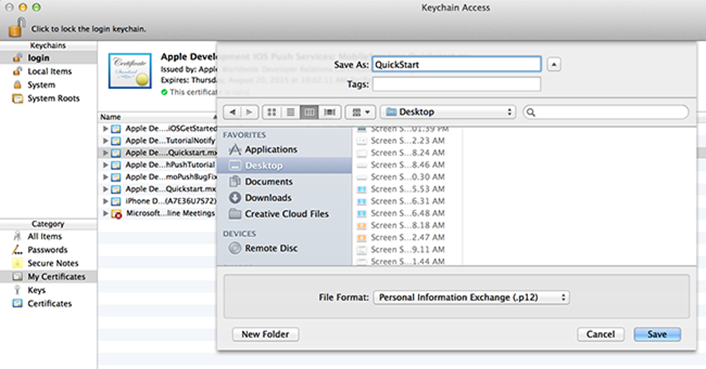

Make a note of the file name and location of the exported .p12 certificate. It will be used to enable authentication with APNS.

1. Back in the [iOS Provisioning Portal](http://go.microsoft.com/fwlink/p/?LinkId=272456), select **Provisioning Profiles**, select **All**, and then click the **+** button to create a new profile. This launches the **Add iOS Provisiong Profile** Wizard

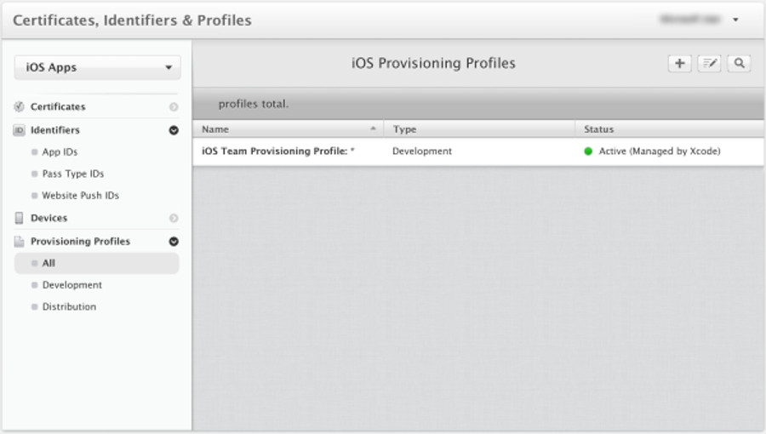

1. Select iOS App Development under Development as the provisiong profile type, and click Continue.

1. Next, select the app ID you just created from the App ID drop-down list, and click Continue

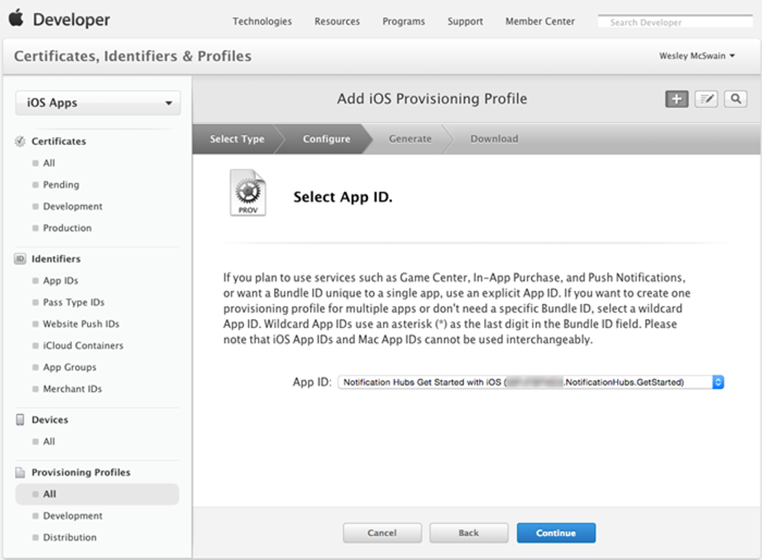

1. In the **Select certificates** screen, select your usual development certificate used for code signing, and click **Continue**. This is not the push certificate you just created.

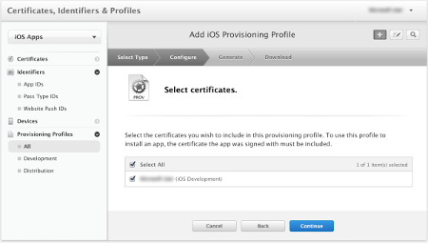

1. Next, select the **Devices** to use for testing, and click **Continue**

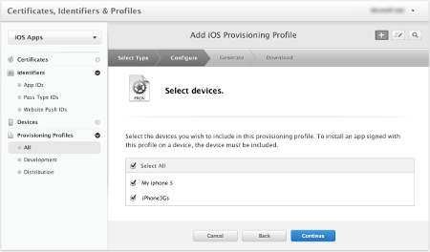

1. Finally, pick a name for the profile in Profile Name, click Generate.

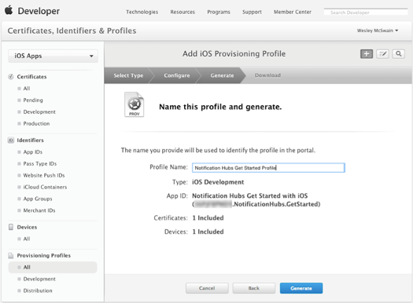

1. When the new provisioning profile is created click to download it and install it on your Xcode development machine. Then click **Done**.

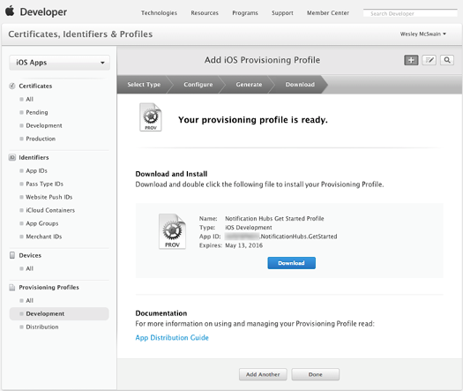

1. As we want to configure the APNS connection, in the Azure Portal, open your Notification Hub settings, ande click on Notification Services, and then click the Apple (APNS) item in the list. Once done, click on Upload Certificate and select the .p12 certificate that you exported earlier, as well as the password for the certificate.

Make sure to select Sandbox mode since you will be sending push messages in a development environment. Only use the Production setting if you want to send push notifications to users who already purchased your app from the store.

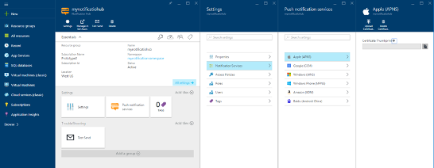 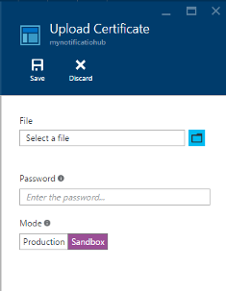

Your notification hub is now configured to work with APNS, and you have the connection strings to register your app and send push notifications.

### iOS Implementation

1. Add the nugget: **Xamarin.Azure.NotificationHubs.iOS**.
2. Modify the Entitlements.plist:

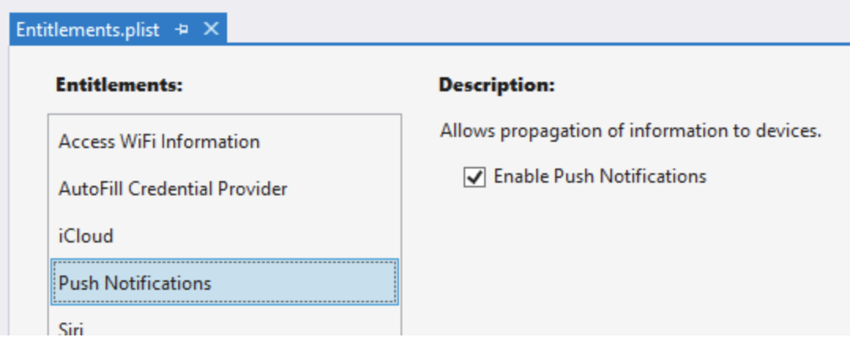

1. Modify the **AppDelegate**:

private SBNotificationHub Hub { get; set; }

public override bool FinishedLaunching(UIApplication app, NSDictionary options)

{

global::Xamarin.Forms.Forms.Init();

FFImageLoading.Forms.Platform.CachedImageRenderer.Init();

new SfBusyIndicatorRenderer();

LoadApplication(new App(new iOSInitializer()));

FacebookClientManager.Initialize(app, options);

base.FinishedLaunching(app, options);

RegisterForRemoteNotifications();

return true;

}

private void RegisterForRemoteNotifications()

{

// register for remote notifications based on system version

if (UIDevice.CurrentDevice.CheckSystemVersion(10, 0))

{

UNUserNotificationCenter.Current.RequestAuthorization(UNAuthorizationOptions.Alert |

UNAuthorizationOptions.Sound |

UNAuthorizationOptions.Sound,

(granted, error) =>

{

if (granted)

{

InvokeOnMainThread(UIApplication.SharedApplication.RegisterForRemoteNotifications);

}

});

}

else if (UIDevice.CurrentDevice.CheckSystemVersion(8, 0))

{

UIUserNotificationSettings pushSettings = UIUserNotificationSettings.GetSettingsForTypes(

UIUserNotificationType.Alert | UIUserNotificationType.Badge | UIUserNotificationType.Sound,

new NSSet());

UIApplication.SharedApplication.RegisterUserNotificationSettings(pushSettings);

UIApplication.SharedApplication.RegisterForRemoteNotifications();

}

else

{

UIRemoteNotificationType notificationTypes = UIRemoteNotificationType.Alert | UIRemoteNotificationType.Badge | UIRemoteNotificationType.Sound;

UIApplication.SharedApplication.RegisterForRemoteNotificationTypes(notificationTypes);

}

}

public override void RegisteredForRemoteNotifications(UIApplication application, NSData deviceToken)

{

Hub = new SBNotificationHub(AppConstants.ListenConnectionString, AppConstants.NotificationHubName);

// update registration with Azure Notification Hub

Hub.UnregisterAll(deviceToken, (error) =>

{

if (error != null)

{

Debug.WriteLine($"Unable to call unregister {error}");

return;

}

NSSet tags = new NSSet(AppConstants.SubscriptionTags.ToArray());

Hub.RegisterNative(deviceToken, tags, (errorCallback) =>

{

if (errorCallback != null)

{

Debug.WriteLine($"RegisterNativeAsync error: {errorCallback}");

}

});

string templateExpiration = DateTime.Now.AddDays(120).ToString(System.Globalization.CultureInfo.CreateSpecificCulture("en-US"));

Hub.RegisterTemplate(deviceToken, "defaultTemplate", AppConstants.APNTemplateBody, templateExpiration, tags, (errorCallback) =>

{

if (errorCallback != null)

{

if (errorCallback != null)

{

Debug.WriteLine($"RegisterTemplateAsync error: {errorCallback}");

}

}

});

});

}

public override void ReceivedRemoteNotification(UIApplication application, NSDictionary userInfo)

{

ProcessNotification(userInfo, false);

}

private void ProcessNotification(NSDictionary options, bool fromFinishedLaunching)

{

// make sure we have a payload

if (options != null && options.ContainsKey(new NSString("aps")))

{

// get the APS dictionary and extract message payload. Message JSON will be converted

// into a NSDictionary so more complex payloads may require more processing

NSDictionary aps = options.ObjectForKey(new NSString("aps")) as NSDictionary;

string payload = string.Empty;

NSString payloadKey = new NSString("alert");

if (aps.ContainsKey(payloadKey))

{

payload = aps[payloadKey].ToString();

}

if (!string.IsNullOrWhiteSpace(payload))

{

TournamentsPageViewModel.GetInstance().AddMessage(payload);

}

}

else

{

Debug.WriteLine($"Received request to process notification but there was no payload.");

}

}

1. Test it.

# End